Configuration Steps for AHIS Installation

This document is used for installing AHIS wildfly installer in staging environments. AT had upgraded from jboss application server to Wildfly instance. New installers are based on wildfly versions. Also, single sign-on facility is used for integrating other AT products. For single sign-on, keycloak application is used.

**Note: - This will cover the major aspects in installation, but steps and procedures may vary / change based on customer or case to case basis. So this has to be ensured and validated from corresponding development team before proceeding.**

# Prerequisites

1. MySql 5.6.13 version needs to be installed with all privileges granted
2. Java 8 needs to be configured. Preferred version is java 8 version 202.
3. Site license and hardware license needs to be procured from respective team.
4. AHIS Installer

# Installation of AHIS

Download the installer and its release files from AT Upload or from the respective url where installer is uploaded. After downloading, copy the files to respective folder where it is saved safely.

From menu, take terminal. From terminal, navigate to the location where installer is been saved.

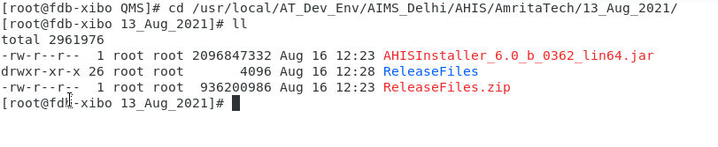

From the terminal, execute following command for running the installer file. Java path needs to be corrected as per the staging configurations.

**/usr/local/Java/jdk-8u202/bin/java -jar AHISInstaller_6.0_b_0362_lin64.jar**

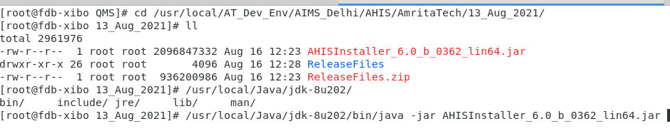

After entering the above command in terminal, a new installer window will pop up for installing AHIS with welcome page.

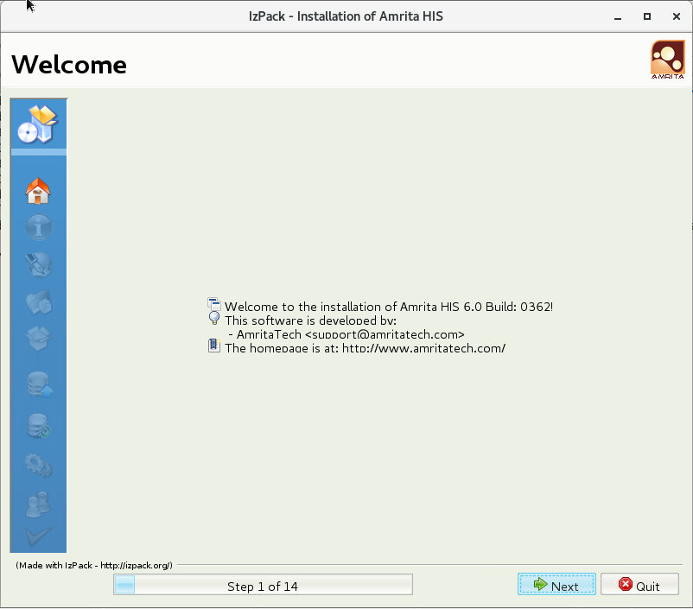

Click next for continuing to next step or click Quit for quit the installation in between. On clicking next button, information page will be displayed in installation screen.

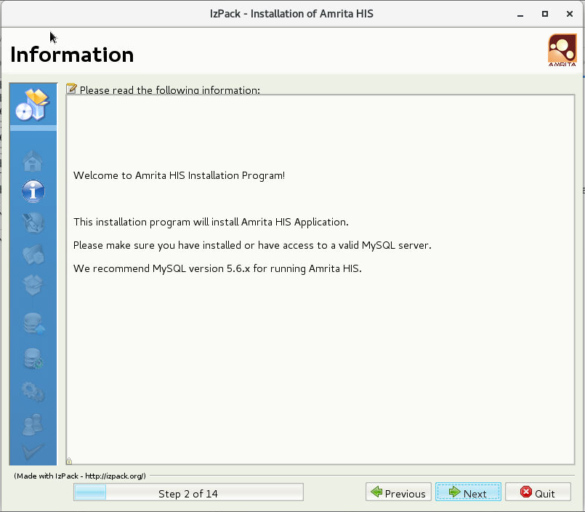

On clicking the next button, installer will navigate to ‘Licensing Agreements’ screen. User has to agree the agreements to proceed further. Upon agreeing only, next button will get enabled. Otherwise, user has to quit the installation.

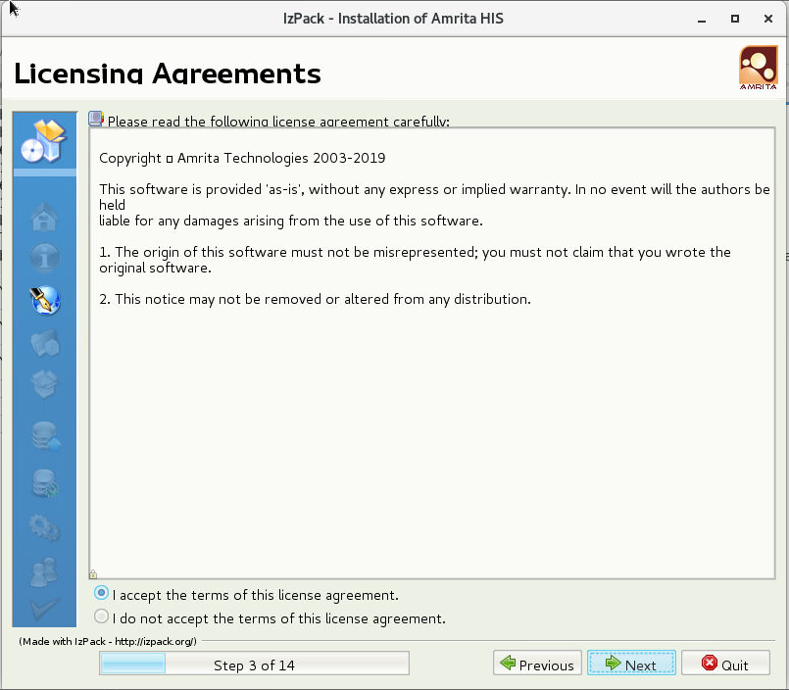

After agreeing the agreements and on clicking Next button, installer will navigate to next step to give the installation path for installing the installer. Installer will deploy the installed files in path mentioned in this screen.

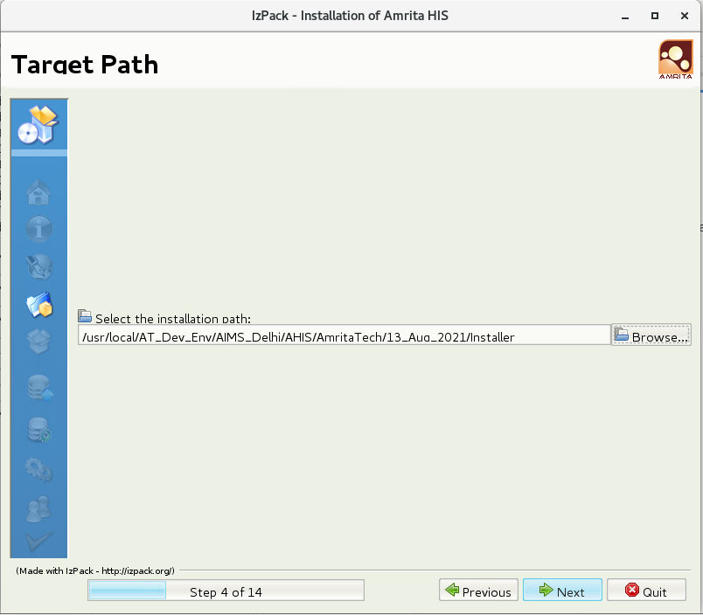

On clicking next button from above screen, system will check whether above mentioned path is there or not. If path is already available and files are already available in that location, installer will replace the files with new files.

After the checking the path, next step is to select the installation packages. Here Keycloak and open office are optional packages. But for single sign on, keycloak integration is required. At the time of installation, keycloak is also checked.

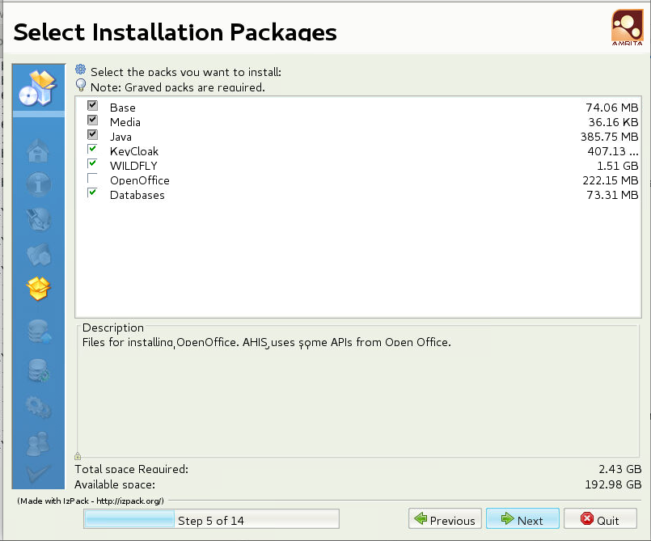

After selecting the required packages, click next button for going to next step. On clicking next button, user data screen will appears. In the screen, IP address needs to be mentioned where application has to be hosted. Also, some Java Parameters such as Xss, Xms, Xmx, Metaspacesize, MaxMetaspacesize needs to be provided in MB. If values are not know, kindly left as default values without changing.

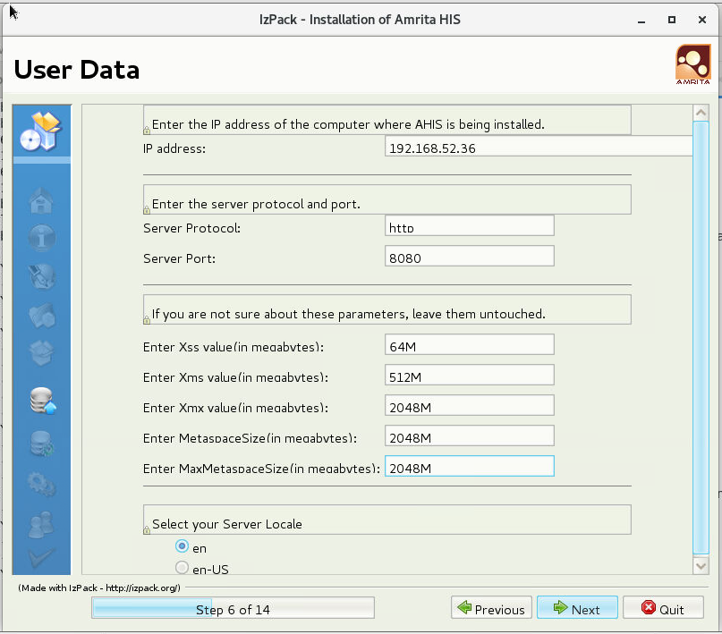

Server locale needs to be selected as en if the application is installed other than in US.

On clicking Next button, next step is to provide the site details and database credentials. Enter the site code based on the customer. For E.g. aimsfbd

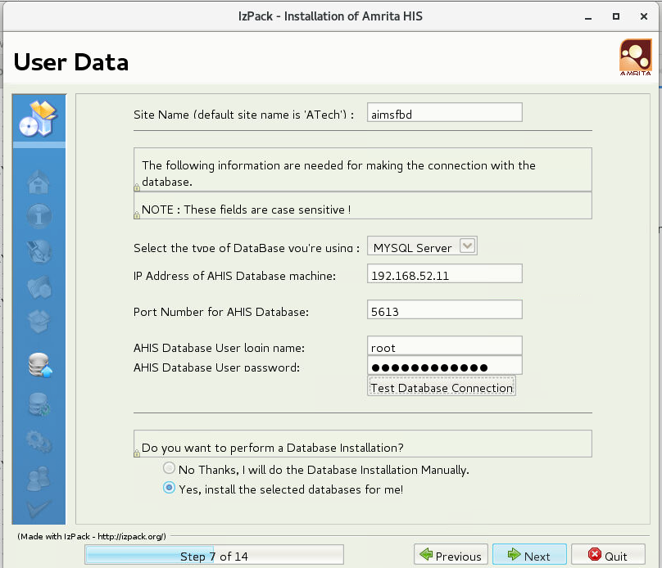

After entering the site code details, enter the host name, password and port details of database server where AHIS databases needs to be installed. For validating the credentials, user can click “Test Database Connection”. It will verify the connection parameters.

There are two options for installing the databases. One option is to install the databases along with the installation. Alternate option is that, we can manually install the database. In live environment, preferred one is manual installation since already a database is running with live server. So in that case database will be upgraded with by executing the scripts manually. Otherwise, database will be installed along with installer.

Here in this document, fresh installation of database is followed. On clicking next button, Screen will be showing to select the required databases to install and renaming provision for renaming the databases in case already a database is available with that name.

Mainly in staging environments, database used to be renamed for comparing with old database and to retain the old database.

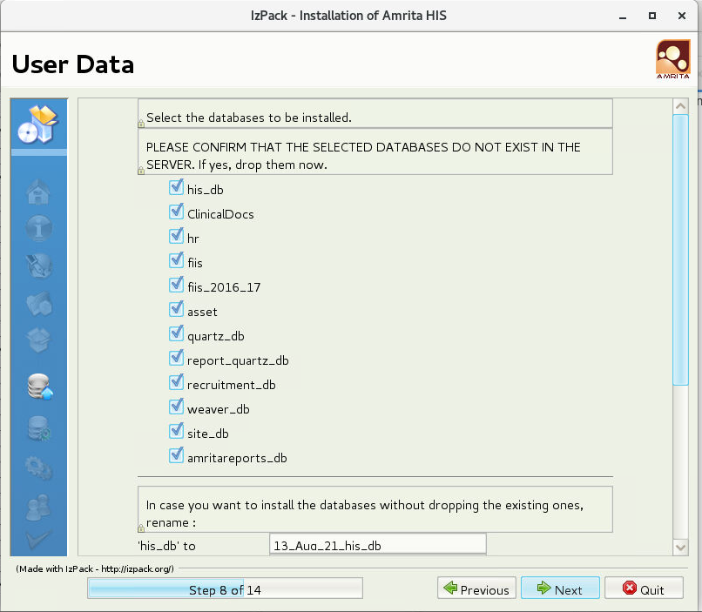

On clicking Next button, Screen will comes for entering the keycloak details. This screen will appears only if keycloak package is enabled for installation otherwise, this screen will be skipped off.

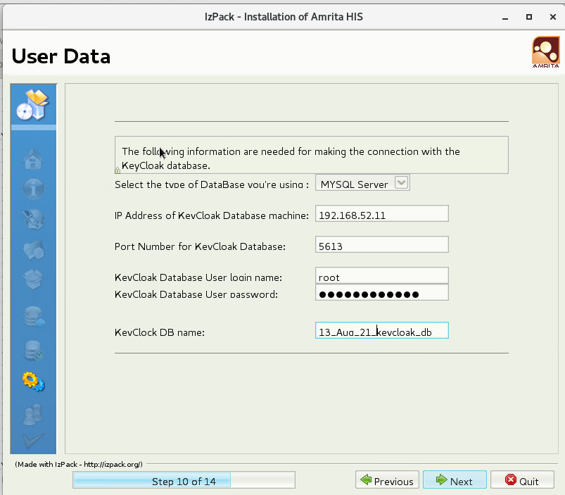

From this screen, user will enter Keycloak database IP Address, database details.

After entering the keycloak database details, user will click Next button for continuing. On clicking Next button, installer will start installing the files and will copy the installed files to installation directory.

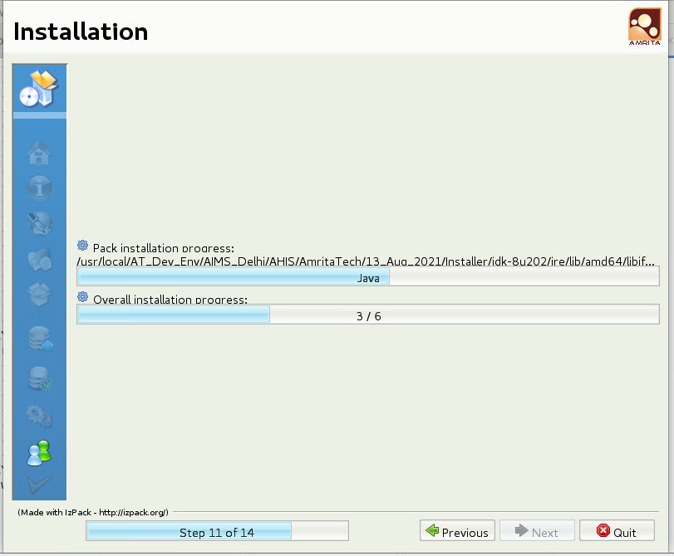

After finishing the installation, next button will appears for going to next step. On clicking next button, database installation page will appears. From this screen, database will be installed.

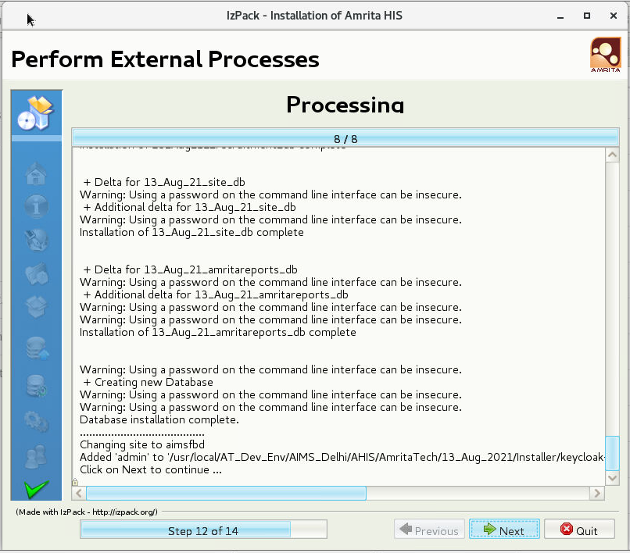

On clicking the next button, system will complete the installation process. Installation successfully message will appears in the screen. On clicking Done button, installer window will get closed.

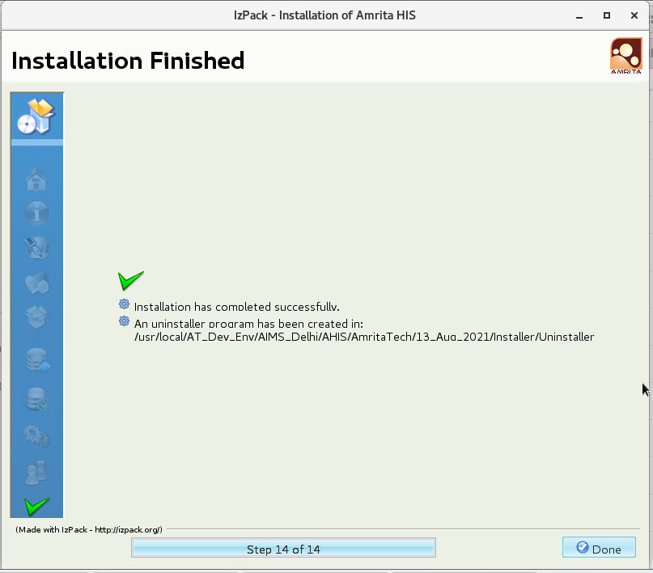

# Customer Specific Configuration

After installing the build, there will be customer based configurations. It will be both at database level as well as in configurations files. Default configuration will be installed when a build was installed. Default configuration will be based on the release branch provided. For e.g. for AIMS FBD one installer is provided, default configuration will be for AIMS FBD. There will be zipped file provided along with release. File name is ReleaseFiles.zip. In the zip file, customer based configurations are provided. Mainly customer based changes are coming in CustomerSpecificScripts folder and in his_config folder.

During installation HIS configuration files will be mostly customer based only. So no need to for additional deployment in case, if it is installed freshly.

From customer specific scripts folder, all the scripts mentioned in respective database folder needs to be executed in respective databases. But before executing the DML and DDL scripts of his_db, actions has to be executed in his_db.

For executing actions, Actions.txt needs to be converted to Actions.sql. For that, an executable sh file (security_script_v2.0.sh) has to be procured from release team. On running the sh file, it will converts actions.txt to Actions.sql. SQL scripts will be generated automatically.

First Actions scripts have to be done in his_db, and then DDL statements and then DML statements will be executed in respective databases.

**[Optional]**

In case of any existing configuration / database, then file comparison will be done between old version and new version. For this comparison, a tool named Meld is being used. It will highlight the difference of compared versions. Those differences will be incorporated in respective areas in configuration files or will execute the differences in database in case scripts.

# License Installation

AHIS requires license for its working. Two licenses are required. One is for site license and another one is for hardware license. License file names will be license.lic and license.lz

Copy the license files to license folder in installed location.

For installing the license, execute following command.

**/usr/local/Java/jdk-8u202/bin/java -jar sitesinstallerwildfly.jar**

On entering the above command, it will ask for the locations of license files and his_config locations. Two times above command needs to be executed. Once is for installing site license and other is for installing hardware license.

For more clarity, please refer below screen shots

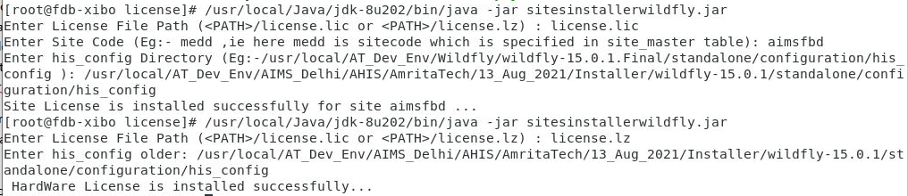

# Smart Agent Configurations and whitelisting

The applet functionality has been replaced with SmartAgents, the following changes needs to be done in the client machine.

For running the smart agent, jre is required in client machines. For configuring this, collect a jre folder from Release team where it consists of jre versions which are compatible for both windows and linux versions. Copy the jre folder to wildfly folder.

Path of the wildfly folder is **<Installation_path>/wildfly-15.0.1/**

Server Side Configurations for SmartAgent

Please make sure that smartagent.whitelist.urls list contains https://local.amritatech.net.in:8282 and http://<<staging server ip>>:<<port> in the his-config.properties file <installerPath>>/wildfly-15.0.1/standalone/configuration/his_config/<sitecode>)

smartagent.whitelist.urls = https://local.amritatech.net.in:8282, http://<<staging server ip>>:<<port>

Note: Please provide impl staging server ip for <<staging server ip>> and port for <<port> respectively.

Client Side Configurrations for SmartAgent

After setting up the server, download the SmartAgent.jnlp using the url given below

http://<<staging server ip>>:<<port>>/his/SmartAgent.jnlp

Go to the path where SmartAgent.jnlp is downloaded and run the following command. Java 1.8 needs to be there in client side for the command to work

javaws SmartAgent.jnlp

If the SmartAgent.jnlp gets successfully executed, it will create SmartAgent folder inside <user.home> like <user.home>/SmartAgent. You can use <user.home>/SmartAgent/log/SmartAgent.log to check whether the server is up or not.

If the server is up and running, the same can be verified in the SmartAgent.log file. The following entry will be availble in the log.

Server started :https://local.amritatech.net.in:8282

If the above url is loaded in the browser, a pop up saying that "SmartAgent is running ..." message on browser window.

# New UI configurations

For enabling new UI / responsive UI in installer, following changes has to be done in server.

1. Download latest rpms [his-cloud-module, his-cloud-ui,his-cloud-module-ui and his-cloud-ui-compiler] provided along with the release (CloudUI.zip).

* his-cloud-module-1.0.0-86.noarch.rpm,
* his-cloud-ui-0.1.412-1.el7.noarch.rpm,
* his-cloud-module-ui-0.1.63-1.el7.noarch.rpm,
* his-cloud-ui-compiler-0.9.0-216.noarch.rpm

[Better to create a folder named CloudUI in server machine and copy the downloaded files into this folder]

1. Install these rpm files using following commands;

rpm -U his-cloud-module-1.0.0-86.noarch.rpm

rpm -U his-cloud-ui-0.1.412-1.el7.noarch.rpm

rpm -U his-cloud-module-ui-0.1.63-1.el7.noarch.rpm

rpm -U his-cloud-ui-compiler-0.9.0-216.noarch.rpm

1. Change the **standalone.sh** inside <Wildfly_Home>/bin.

Search for **if [ "x$JBOSS_MODULEPATH" = "x" ]**

and add **":/opt/amritatech/modules**"

like below.

**if [ "x$JBOSS_MODULEPATH" = "x" ]; then**

**JBOSS_MODULEPATH="$JBOSS_HOME/modules:/opt/amritatech/modules"**

**fi**

1. Add dependency on module to **WEB-INF/jboss-deployment-structure.xml** inside his WAR

<module name="cloud" services="import" optional="true" />

<module name="cloud-module" services="import" optional="true" />

1. Add context path to **standalone-ahis.xml** in **<<InstallerPath>>/wildfly-15.0.1/standalone/configuration/**

Add following property name under <system-properties>

<property name="cloud-ui" value="/opt/amritatech/cloud-ui"/>

[After <property name="java.util.prefs.systemRoot" value="${jboss.server.temp.dir}"/> ]

Add following location name under <location name>

<location name="/cloud-ui" handler="cloud-ui"/>

[After <location name="/opclwar" handler="opclproxy"/> ]

Add following file name under <handlers>

<file name="cloud-ui" path="/opt/amritatech/cloud-ui"/>

[After <file name="welcome-content" path="${jboss.home.dir}/welcome-content"/>]

1. Un comment following lines in **routes.js** file in **/opt/amritatech/cloud-ui/js/components (This Step can be skipped)**

**import EMR_ROUTES from '../../ext/cloud-ui-emr/index.js';**

**ROUTES.push(...EMR_ROUTES);**

For correcting alignment issues in new UI

Copy the .pages.json (availalble in CloudUI.zip) file provided as part of release to the home folder of the application server.

For example, in servers the application was run as root user, hence it was placed in /root/.pages.json

# ActiveMQ configuration

ActiveMQ is required for integrating Alert Manager and Amrita Weaver. Apache ActiveMQ is an open source message broker written in Java together with a full Java Message Service (JMS) client. It provides "Enterprise Features" which in this case means fostering the communication from more than one client or server.

Downloaded ActiveMQ from http://activemq.apache.org/ (5.15.9) and extracted to same machine or some other machine “/usr/local/AT_Dev_Env/apache-activemq-5.15.9”. Here activemq and AHIS is installed in same machine. For starting activemq Java 1.8 is required.

1. Edit the **<*ActiveMQ Installation Directory*>/apache-activemq-5.15.9/conf/activemq.xml** to add virtualtopic configuration just after "</destinationPolicy>" tag.

<destinationInterceptors>

<virtualDestinationInterceptor>

<virtualDestinations>

<virtualTopic name="VirtualTopic.>" prefix="Consumer.*." selectorAware="false"/>

</virtualDestinations>

</virtualDestinationInterceptor>

</destinationInterceptors>

To start the activemq server go to the bin directory and execute **“./activemq start**”

To know the status of the server by executing,

**./activemq status**

On executing the above command, terminal will display a message as follows

INFO: Loading '/usr/local/AT_Dev_Env/apache-activemq-5.15.9//bin/env'

INFO: Using java '/usr/local/AT_Dev_Env/Java/jdk1.8.0_181/bin/java'

INFO: Starting - inspect logfiles specified in logging.properties and log4j.properties to get details

INFO: pidfile created : '/usr/local/AT_Dev_Env/apache-activemq-5.15.9//data/activemq.pid' (pid '3394')

To access from browser.

http://<ip>:8161

Active MQ configuration in AHIS

For configuring ActiveMQ in AHIS, Active MQ parameters needs to be mentioned in **standalone-ahis.xml** file of configuration folder.

Edit the resource-adapters to specify the remote or local activemq server url. For this, activemq url is configured in two places. One for "ServerUrl" and second one for "brokerURL".

<subsystem xmlns="urn:jboss:domain:resource-adapters:5.0">

<config-property name="ServerUrl">

tcp://localhost:61616?jms.rmIdFromConnectionId=true

</config-property>

<admin-object class-name="org.apache.activemq.ActiveMQXAConnectionFactory" jndi-name="java:jboss/activemq/activeMQXAConnectionFactory" use-java-context="true" pool-name="activeMQXAConnectionFactory">

<config-property name="brokerURL">

tcp://localhost:61616?jms.rmIdFromConnectionId=true

</config-property>

</admin-object>

</subsystem>

NOTE :- Here **localhost** is the activemq server ip address since both activeMQ and AHIS is installed in same server otherwise ActiveMQ server IP address has to be mentioned here..

# Alert manager Configuration

Amrita Alert Manager is used for sending alerts such as mail, sms, etc from his, also used for making triggers, task generation, timestamp capturing purposes, etc.

Alert Manager Files will be available in ReleaseFiles.zip file. Extract the zip file and navigate to AlertManager folder.

Inside the folder, following files will be available.

AlertManager/am-6.0.war

AlertManager/AlertManagerConf

AlertManager/db

AlertManager/ChangeLog.txt

Copy AlertManager /am-6.0.war into the <wildfly>/deployment folder and AlertManager /AlertManagerConf into server(say <wildfly>/standalone/configuration folder).

Ensure AlertManagerConf contains the following sub directory.

* config/alerts/<site>/*.xml
* config/deleted-alerts/*.xml/<site>/*.xml
* config/hibernate/**/**/**/**/AlertStatus.hbm.xml
* config/schema/*.*
* config/templates/*.vm
* config/AlertDigestor.xml
* alertmanager.properties

Create new db called "AlertManager" and execute AlertManager/db/quartz.sql and AlertManager/db /am.sql for preparing schema.

**Note:** - Please use the correct sitecode in "user_sitemap" table to use the sitecode which used to install jboss.

Edit the alertmanager.properties file to specify the correct <AlertManagerConf> folder as per server folder structure.

Give site wise database properties in alertmanager.properties file.

Eg: for site aimsfbd

**Note:-** DONT change dblist values given below.

aimsfbd.dblist=his_db,clinicaldocs,fiis_db,asset_db

**Note:-** Below portion is for setting the actual his db name used in this case actual db name is "13_Aug_21_his_db".

aimsfbd.his_db.jdbc.url=jdbc:mysql://192.168.52.11:5613/13_Aug_21_his_db?useOldAliasMetadataBehavior=true&jdbcCompliantTruncation=false&processEscapeCodesForPrepStmts=false&zeroDateTimeBehavior=convertToNull

aimsfbd.his_db.jdbc.user=root

aimsfbd.his_db.jdbc.password=amma

Similarly other db configurations needs to be edited also.

Edit the provider url and add the site code entry and IP address as follows

aimsfbd.provider.url=192.168.52.11:1099

Setup the email configuration for any of the mail server.

To send email from amritatech

email.smtp.host=mail.atech.net

email.smtp.userid=amritahis@aims.amrita.edu

email.smtp.password=amrita

email.smtp.port=465

email.smtp.protocol=SSL

To send email from gmail

email.smtp.host=smtp.gmail.com

email.smtp.userid=amritapms@gmail.com

email.smtp.password=amma

email.smtp.port=465

email.smtp.protocol =SSL

Also from email address to be configured as mandatory for the current site.

[aimsfbd.email.from.address=aimsfbdam@amritatech.com](mailto:aimsfbd.email.from.address=aimsfbdam@amritatech.com)

Setup the SMS configuration

For setting up the SMS gate way detaisl, an active user account of any bulk sms package is required. The alertmanager.properties changes for using andriod sms gateway is as follows

# for bulk sms config starts

sms.proxyhost=192.168.18.3

sms.proxyport=3128

# for android gateway config starts

sms.params-in-url=true

sms.url=http://cloud.fowiz.com/api/message_http_api.php

sms.param.phonenumber=$number

sms.param.message=$message

sms.param.passcode=amma123

sms.param.username=smsuser

# for android gateway config ends

**In the context of AIMS FBD only, following configuration needs to be done.**

For communicating weaver application and AHIS, it is done through alertmanager . For that communication, weaver properties need to be configured in alertmanager.properties. Changes are as follows. Task host should be same as IP address of weaver integrated AHIS.

task.host=192.168.52.11

task.port=8080

task.protocol=http

#task.protocol=http

task.auth.type=Weaver

task.auth.apibase=/weaver/api

task.username=admin

task.password=amma

Standalong-ahis.xml changes for alert manager

Edit standalone-ahis.xml file as follows

**NOTE:-** Along with installer entries will be already available check and verify its correctness

Add the below properties also

<property name="myclientId" value="alertaimsfbdConsumer"/>

<property name="mysubscription" value="AIMSFBD_Durable_Subscriber"/>

<property name="myselector" value="aimsfbdalertmanager='true'"/>

**NOTE :-** Please note here "aimsfbd" is the sitecode used in this installation.

Edit datasource configuration to mention the alertmanager db connection details , in this example the dburl is "192.168.52.11:5613" , dbname is "AlertManager", user/pwd is root/amma

<subsystem xmlns="urn:jboss:domain:datasources:5.0">

<!-- Alert manager configuration started -->

<datasource jta="true" jndi-name="java:jboss/datasources/AMSqlDS" pool-name="AMSqlDS" enabled="true" use-ccm="false">

<connection-url>jdbc:mysql://atechdb1.dev.atech.net:5613/AlertManager</connection-url>

<driver>mysql</driver>

<security>

<user-name>root</user-name>

<password>amma</password>

</security>

<validation>

<valid-connection-checker class-name="org.jboss.jca.adapters.jdbc.extensions.mysql.MySQLValidConnectionChecker"/>

<background-validation>true</background-validation>

<exception-sorter class-name="org.jboss.jca.adapters.jdbc.extensions.mysql.MySQLExceptionSorter"/>

</validation>

</datasource>

<!-- Alert manager configuration end -->

</subsystem>

# Key Cloak Configuration

Keycloak is an open source identity and access management solution which mainly aims at applications and services. Users can authenticate with Keycloak rather than individual applications. So, the applications don't have to deal with login forms, authenticating users and storing users. This section is describing how to integrate AHIS application with Keycloak server.

Key cloak setup

Logon to keycloak using admin, by browsing the following URL from browser

URL : http://<IP>:8280/auth

For e.g. http://192.168.52.11:8280/auth

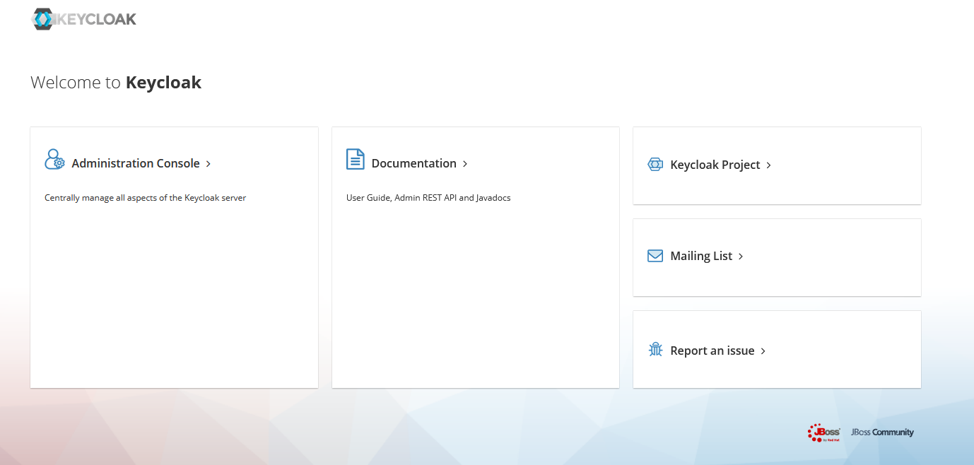

Login to Administration console using following credentials

Username : admin

Password: admin

Default realm called “Master” can be seen at left site of the screen, “Add Realm” button can be seen, once it is mouse over above the Master realm. Click on the “Add Realm” button, supposed to create realm for aimsfbd site then give the name as “site-aimsfbd”

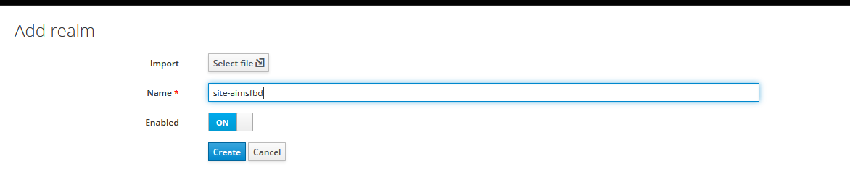

After the realm creation, some tabs like “General”, “Login”,...,”Secrity Defences” etc. will be visible. Click on Security Defences and modify the values of following:

ALLOW-FROM http://<the current site code>:8080/his

Content-Security-Policy: frame-ancestors 'self' http://<the current site code>:8080/his

eg:

X-Frame-Options: ALLOW-FROM http://aimsfbd:8080/his

Content-Security-Policy: frame-ancestors 'self' http://aimsfbd:8080/his

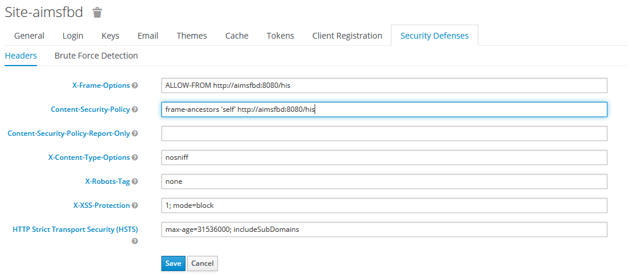

Client creation

For HIS application, the client name is “his”(context name). For client creation, click on “Clients” menu and click “Create” button.

Give the client id as “his” and give root url as http://<sitecode>:<port>/his’

eg: http://aimsfbd:8080/his

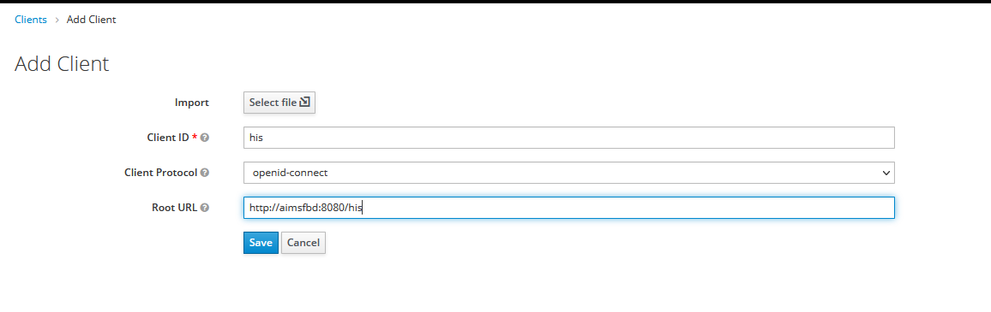

Role creation

For creating the roles, click on “Roles” menu and click “Add Role” button.

Create a role named “hisuser”

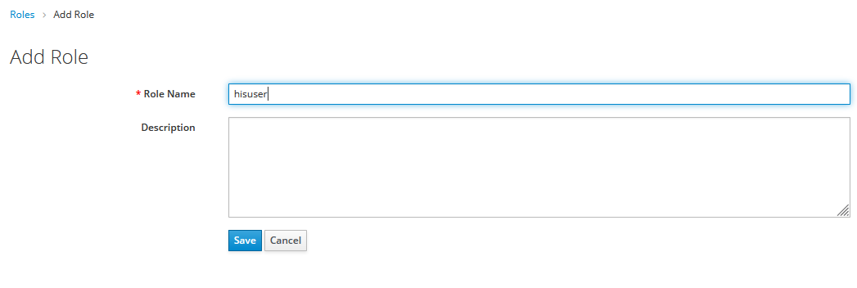

Site based theme configuration

Login to keycloak admin and from the“Realm settings” of the site, then go to “General” tab and change the “Display name” as “Amrita Healthcare Management Sute”

All the site based themes available in $KEYCLOAK_HOME/themes then all the site based themes will be listed here, the name will be <sitecode>

Suppose our site is “aimsfbd” then click “Theme” tab and select theme for “Login Theme” as “fbd”

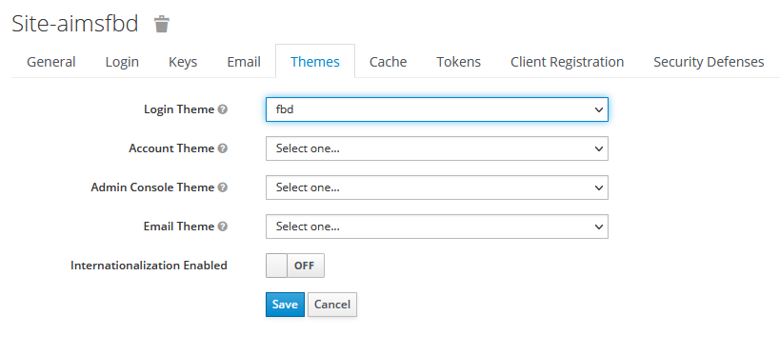

Define User Federation

User federation is used for login to application using HIS user.

Go to the site realm, here it is “site-aimsfbd”, then click on “User Federation”, a drop down menu will be displayed. Click on the dropdown list and select “amrita-user-provider” then new page will come and click “Save”

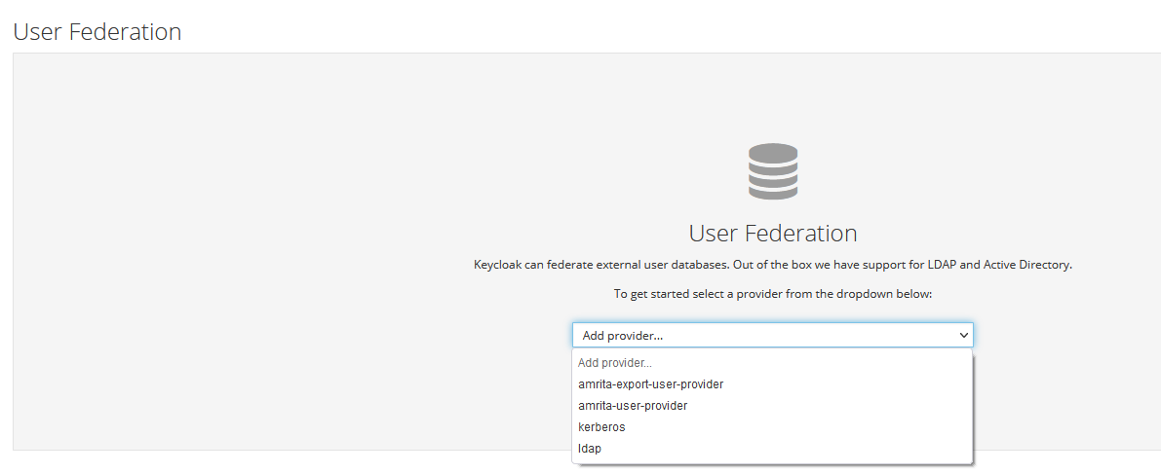

# How to Start AHIS

In case there is no key cloak configured, then please follow the steps mentioned below for starting AHIS.

Go to <installerPath>>/wildfly-15.0.1/bin and execute following command

sh standalone.sh -c standalone-ahis.xml

In a key cloak configured HIS configuration, AHSI needs to be started along with keycloak. For starting the key cloak and HIS, please execute following commands

**For starting HIS**

Go to **$WILDFLY_HOME/bin** and start the server like: $

**sh standalone.sh -b <IP> -c standalone-ahis.xml**

For e.g. sh /usr/local/AT_Dev_Env/AIMS_Delhi/AHIS/AmritaTech/13_Aug_2021/Installer/wildfly-15.0.1/bin/standalone.sh -b 192.168.52.11 -c standalone-ahis.xml

**For Starting Key Cloak**

Go to keycloak **$WILDFLY_HOME/bin** Start the server using IP like

**sh standalone.sh -b <IP> -Djboss.socket.binding.port-offset=200**

For e.g. sh /usr/local/AT_Dev_Env/AIMS_Delhi/AHIS/AmritaTech/13_Aug_2021/Installer/keycloak-9.0/bin/standalone.sh -b 192.168.52.11 -Djboss.socket.binding.port-offset=200