UPGRADE – 5.21.0 to 5.30.0

Requirements:
- Java SE 11 or later (Used jdk-11.0.15)
- Wildfly-26.1.2.Final
- MySQL 8.0.29 (MYSQL 8.0.29 is the recommended version, implemented using MYSQL 5.7.09)
- ApacheDS 2.0.0-M20
- keycloak-15.1.1
- keycloak-oidc-wildfly-adapter-15.1.1.zip
- dcm4chee-arc-5.30.0-mysql-secure.zip

Copy the upgrade-5.21-5.30 folder to currently installed APACSVNA folder.
Replace the highlighted IPs, Ports etc in the document with the correct values.

Set the full path of APACSVNA installed folder as APACSVNA_HOME.
APACSVNA_HOME=Full path of APACSVNA installed folder

DB updation:
Execute DB scripts on current APACSVNA_DB from the folder $APACSVNA_HOME/upgrade-5.21-5.30/dcm4chee-arc-5.30.0-mysql-secure/sql/mysql

update-5.22-mysql.sql
update-5.23-mysql.sql
update-5.24-mysql.sql
update-5.25-mysql.sql
update-5.26-mysql.sql
update-5.27-mysql.sql
update-5.28-mysql.sql
update-5.29-mysql.sql
update-5.30-mysql.sql

ApacheDS Server Updation:

Make sure that the ApacheDS server of current APACSVNA is in running state. Stop currently running wildfly and keycloak servers. Set jdk 11 as your JAVA HOME.

APACSVNA_HOME=Full path of APACSVNA installed folder

cd $APACSVNA_HOME/upgrade-5.21-5.30
./upgrade.sh

Keycloak Standalone Server Configuration

Make sure existing keycloak server is stopped before starting keycloak configuration.

cd $APACSVNA_HOME
./stopkeycloak.sh

Then copy the new keycloak server from $APACSVNA_HOME/upgrade-5.21-5.30/servers to $APACSVNA_HOME folder.

cp $APACSVNA_HOME/upgrade-5.21-5.30/servers/keycloak-15.1.1.zip $APACSVNA_HOME

unzip $APACSVNA_HOME/keycloak-15.1.1.zip

Set the below given path in the terminal window that you are working on. Also extract the keycloak adapter and set the path.

APACSVNA_HOME=Full path of APACSVNA installed folder

KEYCLOAK_HOME=$APACSVNA_HOME/keycloak-15.1.1

KEYCLOAK_WILDFLY_ADAPTER=$APACSVNA_HOME/upgrade-5.21-5.30/servers/keycloak-oidc-wildfly-adapter-15.1.1

DCM4CHEE_ARC=$APACSVNA_HOME/upgrade-5.21-5.30/dcm4chee-arc-5.30.0-mysql-secure

Unzip the modules/system/add-ons from Keycloak Client Adapter for Wildfly zip into $KEYCLOAK_HOME/modules/system. Unzip also the DCM4CHE libraries as JBoss modules in $KEYCLOAK_HOME/modules location:

> cd $KEYCLOAK_HOME
> unzip $DCM4CHEE_ARC/jboss-modules/dcm4che-jboss-modules-5.30.0.zip
> cp -R $KEYCLOAK_WILDFLY_ADAPTER/modules/system/add-ons $KEYCLOAK_HOME/modules/system

Copy ldap.properties from your release package into Keycloak and keystores into the Keycloak installation in location $KEYCLOAK_HOME/standalone/configuration

> cd $KEYCLOAK_HOME/standalone/configuration
> mkdir keycloak
> cp $DCM4CHEE_ARC/configuration/dcm4chee-arc/ldap.properties keycloak/

Modify ldap.properties under $KEYCLOAK_HOME/standalone/configuration as given below.

java.naming.factory.initial=com.sun.jndi.ldap.LdapCtxFactory
java.naming.ldap.attributes.binary=dicomVendorData
java.naming.provider.url=ldap://localhost:10389/dc=dcm4che,dc=org
java.naming.security.principal=uid=admin,ou=system
java.naming.security.credentials=secret

Copy keystore and truststore files from your release package into Keycloak

> cd $KEYCLOAK_HOME/standalone/configuration
> cp -R $DCM4CHEE_ARC/configuration/keystores .

Update the standalone.xml file inside $APACSVNA_HOME/keycloak-15.1.1/standalone/configuration with the db details. Comment the default details and add new db details.

<!--<datasource jndi-name="java:jboss/datasources/KeycloakDS" pool-name="KeycloakDS" enabled="true" use-java-context="true" statistics-enabled="${wildfly.datasources.statistics-enabled:${wildfly.statistics-enabled:false}}">
<connection-url>jdbc:h2:${jboss.server.data.dir}/keycloak;AUTO_SERVER=TRUE</connection-url>
<driver>h2</driver>
<security>
<user-name>sa</user-name>
<password>sa</password>
</security>
</datasource> -->

<datasource enabled="true" jndi-name="java:jboss/datasources/KeycloakDS" pool-name="KeycloakDS" use-java-context="true">
<connection-url>jdbc:mysql://<MYSQL_IP>:<MYSQL_PORT>/<KEYCLOAKDB_OF_CURRENT_KEYCLOAK>?autoReconnect=true&amp;useSSL=false</connection-url>
<driver>mysql</driver>
<security>
<user-name><USERNAME></user-name>
<password><PASSWORD></password>
</security>
</datasource>

<driver name="mysql" module="com.mysql">
<xa-datasource-class>com.mysql.jdbc.jdbc2.optional.MysqlXADataSource</xa-datasource-class>
</driver>

Copy $APACSVNA_HOME/upgrade-5.21-5.30/servers/MYSQL_5709_connector_jar/mysql folder to $APACSVNA_HOME/keycloak-15.1.1/modules/system/layers/keycloak/com folder which contains mysql-connector-java-5.1.42-bin.jar and module.xml file. This connector jar is for MYSQL 5.7.09.

Copy $APACSVNA_HOME/upgrade-5.21-5.30/servers/MYSQL_8029_connector_jar/mysql folder to $APACSVNA_HOME/keycloak-15.1.1/modules/system/layers/keycloak/com folder which contains mysql-connector-java-5.1.46-bin.jar and module.xml file. Copy this connector jar if you are using MYSQL 8.0.29.

There is a property in the standalone.xml file.
<property name="migrationStrategy" value="update"/>
If you keep the value as update, the database will be automatically upgraded. You may change it to manual so that database will not be updated automatically and will generate the script on starting keycloak which we can manually execute to upgrade. The script will be generated under the path $APACSVNA_HOME/keycloak-15.1.1/.

We need to edit few scripts to execute without any errors. You need to check the ID of apacsvna from the table REALM of keycloak database. Then replace the values of REALM.ID in few scripts with this ID. The queries are:

1) INSERT INTO keycloakdb07_bkup.KEYCLOAK_ROLE (ID, CLIENT_REALM_CONSTRAINT, CLIENT_ROLE, DESCRIPTION, NAME, REALM_ID, REALM) VALUES ('4ea46a8c-4110-4e83-92ea-d12c448069d2', 'apacsvna', 0, '${role_default-roles-apacsvna}', 'default-roles-apacsvna', 'apacsvna', 'apacsvna');

2) UPDATE keycloakdb07_bkup.REALM SET DEFAULT_ROLE = '4ea46a8c-4110-4e83-92ea-d12c448069d2' WHERE REALM.ID='apacsvna';

3) INSERT INTO keycloakdb07_bkup.COMPOSITE_ROLE (COMPOSITE, CHILD_ROLE) SELECT '4ea46a8c-4110-4e83-92ea-d12c448069d2', ROLE_ID FROM keycloakdb07_bkup.REALM_DEFAULT_ROLES WHERE REALM_ID = 'apacsvna';

4) INSERT INTO keycloakdb07_bkup.COMPOSITE_ROLE (COMPOSITE, CHILD_ROLE) SELECT '4ea46a8c-4110-4e83-92ea-d12c448069d2', keycloakdb07_bkup.CLIENT_DEFAULT_ROLES.ROLE_ID FROM keycloakdb07_bkup.CLIENT_DEFAULT_ROLES INNER JOIN keycloakdb07_bkup.CLIENT ON keycloakdb07_bkup.CLIENT.ID = keycloakdb07_bkup.CLIENT_DEFAULT_ROLES.CLIENT_ID AND keycloakdb07_bkup.CLIENT.REALM_ID = 'apacsvna';

Replace these scripts with the Realm ID in the place of apacsvna. Here the ID of apacsvna in my REALM table is 0567a41a-7104-48fa-ad89-99ab66629e29

1) INSERT INTO keycloakdb07_bkup.KEYCLOAK_ROLE (ID, CLIENT_REALM_CONSTRAINT, CLIENT_ROLE, DESCRIPTION, NAME, REALM_ID, REALM) VALUES ('4ea46a8c-4110-4e83-92ea-d12c448069d2', '0567a41a-7104-48fa-ad89-99ab66629e29', 0, '${role_default-roles-apacsvna}', 'default-roles-apacsvna', '0567a41a-7104-48fa-ad89-99ab66629e29', '0567a41a-7104-48fa-ad89-99ab66629e29');

2) UPDATE keycloakdb07_bkup.REALM SET DEFAULT_ROLE = '4ea46a8c-4110-4e83-92ea-d12c448069d2' WHERE REALM.ID='0567a41a-7104-48fa-ad89-99ab66629e29';

3) INSERT INTO keycloakdb07_bkup.COMPOSITE_ROLE (COMPOSITE, CHILD_ROLE) SELECT '4ea46a8c-4110-4e83-92ea-d12c448069d2', ROLE_ID FROM keycloakdb07_bkup.REALM_DEFAULT_ROLES WHERE REALM_ID = '0567a41a-7104-48fa-ad89-99ab66629e29';

4) INSERT INTO keycloakdb07_bkup.COMPOSITE_ROLE (COMPOSITE, CHILD_ROLE) SELECT '4ea46a8c-4110-4e83-92ea-d12c448069d2', keycloakdb07_bkup.CLIENT_DEFAULT_ROLES.ROLE_ID FROM keycloakdb07_bkup.CLIENT_DEFAULT_ROLES INNER JOIN keycloakdb07_bkup.CLIENT ON keycloakdb07_bkup.CLIENT.ID = keycloakdb07_bkup.CLIENT_DEFAULT_ROLES.CLIENT_ID AND keycloakdb07_bkup.CLIENT.REALM_ID = '0567a41a-7104-48fa-ad89-99ab66629e29';

Execute the script on your existing keycloakdb and Start your Keycloak Standalone Server.

> $KEYCLOAK_HOME/bin/standalone.sh

Start JBoss CLI on another terminal window.

> $KEYCLOAK_HOME/bin/jboss-cli.sh -c

Add following system properties.

/system-property=super-user-role:add(value=admin)
/system-property=org.dcm4che.audit-keycloak.AppName:add(value=keycloak)
/system-property=keycloak.DeviceName:add(value=keycloak)

To be able to connect to LDAP over TLS, add following system property in Keycloak configuration

/system-property=com.sun.jndi.ldap.object.disableEndpointIdentification:add(value=true)

If your application setup requires that a user's authentication events shall be logged, configure audit logging by adding Events Listener and corresponding events.

/subsystem=keycloak-server/:list-add(name=providers,index=1,value=module:org.dcm4che.audit-keycloak)
/subsystem=keycloak-server/spi=eventsListener:add()
/subsystem=keycloak-server/spi=eventsListener/provider=dcm4che-audit:add(enabled=true)

Login to Keycloak admin console at and create a Keycloak admin user eg. admin\admin

http://localhost:8080/auth/

Go to the Administration console and login with the user you created above.

No need to do the below given steps. These details will get automatically updated from db. Verify each step and check the details.

Add a new realm and name it as apacsvna.

Next create an OIDC client with below values and Save.

Client ID : dcm4chee-arc-ui
Root URL : http://<archive-host>:8080/dcm4chee-arc/ui2
Web Origins : http://<archive-host>:8080
Valid Redirect URI : http://<archive-host>:8080/dcm4chee-arc/ui2/*

If audit logging module and events listener was configured in Keycloak as specified in one of the above points, then go to Events -> Config, add dcm4che-audit in addition to existing jboss-logging for Event Listeners field.

In Login Events Settings, turn ON the field Save Events. In the list of Saved Types, ensure following six events are saved.
LOGIN
LOGIN_ERROR
LOGOUT
LOGOUT_ERROR
UPDATE_PASSWORD
UPDATE_PASSWORD_ERROR
In Admin Events Settings, turn ON the field Save Events.

LDAP Configuration and Keycloak User Federation

Login to Keycloak Administration Console and Add Provider as ldap in User Federation. Following fields shall have values as shown below, rest shall be kept unchanged. By default, the Console Display Name is shown as ldap, which can be changed if required.

Edit Mode : WRITABLE
Sync Registrations : ON
Vendor : Other
Connection URL : ldap://localhost:10389
Users DN : ou=users,dc=dcm4che,dc=org
Bind DN : uid=admin,ou=system
Bind Credential : secret
Validate Password Policy : ON

Use Test Connection and Test Authentication to test if the connections to LDAP and its authentication are working correctly.

Save the settings and click on Synchronize All Users.

To enable assignment of roles, create a role-ldap-mapper using the Mappers tab

Name : role
Mapper Type : role-ldap-mapper
LDAP Roles DN : ou=users,dc=dcm4che,dc=org

and Save. Use Sync LDAP Roles to Keycloak. Note : If you configured different value Users DN during LDAP installation, change the above value accordingly.
To enable assignment of realm-management roles, create a role-ldap-mapper using the Mappers tab

Name : realm-management
Mapper Type : role-ldap-mapper
Client ID : realm-management
LDAP Roles DN : ou=realm-management,dc=dcm4che,dc=org
Use Realm Roles Mapping : OFF

and Save. Use Sync LDAP Roles to Keycloak.

Verify import of users admin, user, and root in left-hand menu Users page.
Verify import of roles admin, auditlog, ADMINISTRATOR, root and user in left-hand menu Roles page.

Manually fix account client role mappings to users.

Root
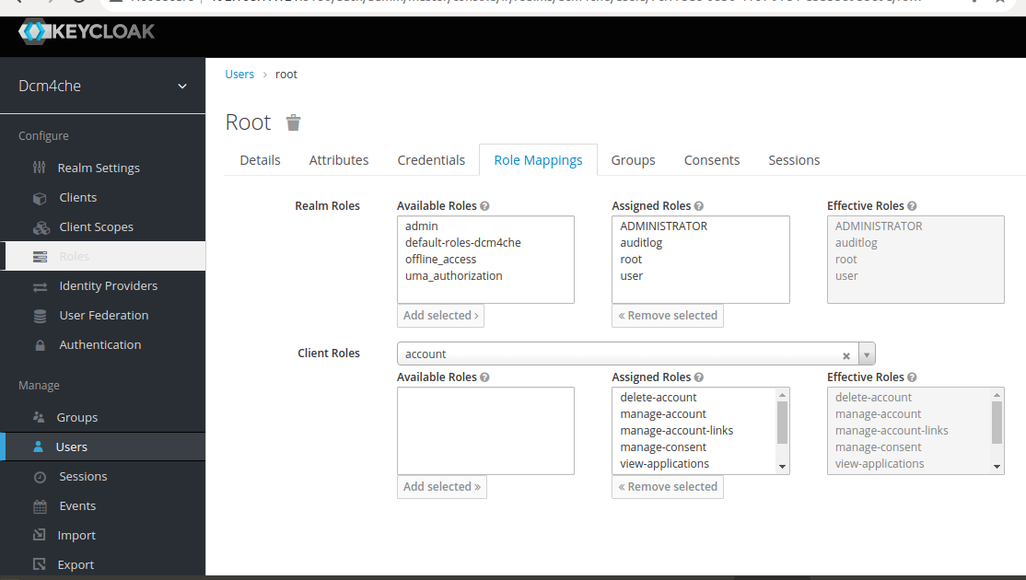

Admin:

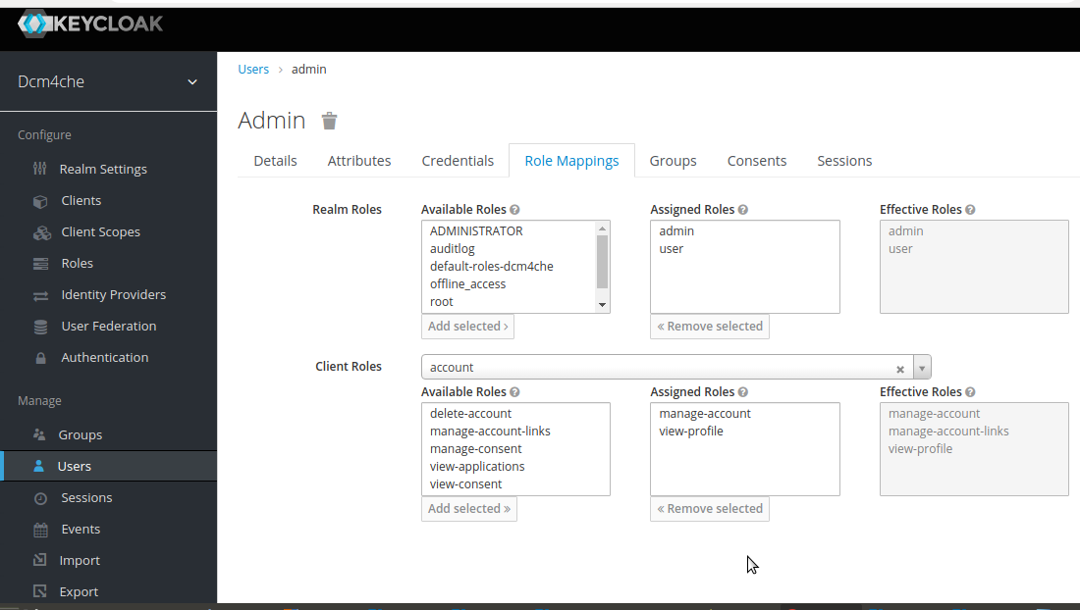

User:

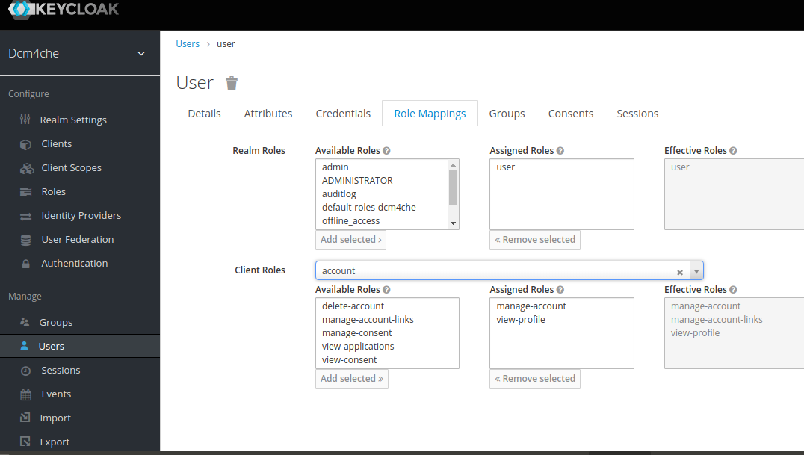

Restart the keycloak server using the command:
cd $KEYCLOAK_HOME/bin
./standalone.sh -Djboss.socket.binding.port-offset=100 -b <KEYCLOAK_IP>

Wildfly Configuration

Make sure that existing wildfly server is stopped before starting new wildfly configuration.

cd $APACSVNA_HOME
./stopwildfly.sh

Then copy the new wildfly server from $APACSVNA_HOME/upgrade-5.21-5.30/servers to APACSVNA folder.

cp $APACSVNA_HOME/upgrade-5.21-5.30/servers/wildfly-26.1.2.Final.zip $APACSVNA_HOME

unzip $APACSVNA_HOME/wildfly-26.1.2.Final.zip
mv wildfly-26.1.2.Final wildfly-26.1.2

Set the below given path in the terminal window that you are working on.

APACSVNA=Full path of APACSVNA installed folder.

WILDFLY_HOME=$APACSVNA_HOME/wildfly-26.1.2

KEYCLOAK_WILDFLY_ADAPTER=$APACSVNA_HOME/upgrade-5.21-5.30/servers/keycloak-oidc-wildfly-adapter-15.1.1

DCM4CHEE_ARC=$APACSVNA_HOME/upgrade-5.21-5.30/dcm4chee-arc-5.30.0-mysql-secure

Then from inside of your wildfly location unzip the Keycloak Client Adapter for Wildfly.

> cd WILDFLY_HOME
> unzip $APACSVNA_HOME/upgrade-5.21-5.30/servers/keycloak-oidc-wildfly-adapter-15.1.1.zip

Copy configuration files into the WildFly installation:

> cp -r $DCM4CHEE_ARC/configuration $WILDFLY_HOME/standalone

Ensure that one's LDAP specific values are present in the file $APACSVNA_HOME/wildfly-26.1.2/standalone/configuration/dcm4chee-arc/ldap.properties

java.naming.factory.initial=com.sun.jndi.ldap.LdapCtxFactory
java.naming.ldap.attributes.binary=dicomVendorData
java.naming.provider.url=ldap://localhost:10389/dc=dcm4che,dc=org
java.naming.security.principal=uid=admin,ou=system
java.naming.security.credentials=secret

> cd $WILDFLY_HOME/standalone/configuration/
> cp standalone.xml dcm4chee-arc.xml

Install JBoss module containing DCM4CHE libraries, Keycloak admin client and Apache commons.

> cd $WILDFLY_HOME
> unzip $DCM4CHEE_ARC/jboss-modules/dcm4che-jboss-modules-5.30.0.zip

Install JAI Image IO 1.2 libraries as JBoss module (needed for compression/decompression, does not work on Windows 64 bit and Mac OS X caused by missing native components for these platforms):

> cd $WILDFLY_HOME
> unzip $DCM4CHEE_ARC/jboss-modules/jai_imageio-jboss-modules-1.2-pre-dr-b04.zip

Install jclouds 2.2.1 libraries as JBoss modules:

> cd $WILDFLY_HOME
> unzip $DCM4CHEE_ARC/jboss-modules/jclouds-jboss-modules-2.5.0-noguava.zip

Install ecs-object-client 3.0.0 libraries as JBoss modules:

> cd $WILDFLY_HOME
> unzip $DCM4CHEE_ARC/jboss-modules/ecs-object-client-jboss-modules-3.0.0.zip

Install the JDBC Driver for the database:
> cd $WILDFLY_HOME
> unzip $DCM4CHEE_ARC/jboss-modules/jdbc-jboss-modules-mysql-8.0.29.zip

Start WildFly in standalone mode with the correct configuration file:

> $WILDFLY_HOME/bin/standalone.sh -c dcm4chee-arc.xml

Install the Keycloak Wildfly Adapter on another terminal window

Open adapter-elytron-install-offline.cli file inside $WILDFLY_HOME/bin and edit the first line embed-server –server-config=${server.config:standalone.xml} as
embed-server --server-config=${server.config:dcm4chee-arc.xml}

> cd $WILDFLY_HOME/bin/
> $WILDFLY_HOME/bin/jboss-cli.sh -c --file=adapter-elytron-install-offline.cli

If you are not able to execute adapter-elytron-install-offline.cli file then try with adapter-elytron-install.cli

Add JDBC Driver into the server configuration using JBoss CLI in a new console window:

> $WILDFLY_HOME/bin/jboss-cli.sh -c

/subsystem=datasources/jdbc-driver=mysql:add(driver-name=mysql,driver-module-name=com.mysql)

Create and enable a new Data Source bound to JNDI name java:/PacsDS using JBoss CLI:

data-source add --name=PacsDS --driver-name=mysql --connection-url=jdbc:mysql://<MYSQL_IP>:<MYSQL_PORT>/<APACSVNADB_OF_CURRENT_WILDFLY> --jndi-name=java:/PacsDS --user-name=<USERNAME> --password=<PASSWORD>

data-source enable --name=PacsDS

/subsystem=ee:write-attribute(name=spec-descriptor-property-replacement,value=true)
/subsystem=ee/managed-executor-service=default:undefine-attribute(name=hung-task-threshold)
/subsystem=ee/managed-executor-service=default:write-attribute(name=long-running-tasks,value=true)
/subsystem=ee/managed-executor-service=default:write-attribute(name=core-threads,value=2)
/subsystem=ee/managed-executor-service=default:write-attribute(name=max-threads,value=100)
/subsystem=ee/managed-executor-service=default:write-attribute(name=queue-length,value=0)
/subsystem=ee/managed-scheduled-executor-service=default:undefine-attribute(name=hung-task-threshold)
/subsystem=ee/managed-scheduled-executor-service=default:write-attribute(name=long-running-tasks,value=true)
/subsystem=ee/managed-scheduled-executor-service=default:write-attribute(name=core-threads,value=2)

Add following system properties

/system-property=super-user-role:add(value=admin)
/system-property=realm-name:add(value=apacsvna)
/system-property=auth-server-url:add(value=http://<KEYCLOAK_IP>:8180/auth)

/subsystem=undertow/server=default-server/http-listener=default:write-attribute(name=max-post-size,value=10000000000)
/subsystem=undertow/server=default-server/https-listener=https:write-attribute(name=max-post-size,value=10000000000)

Restart Wildfly.

Add Keycloak Standalone Server specific settings to your DCM4CHEE Archive's Wildfly as shown below

/subsystem=keycloak/secure-deployment=dcm4chee-arc-ui2-5.30.0-secure.war/:add(realm=apacsvna,resource=dcm4chee-arc-ui,auth-server-url=http://<KEYCLOAK_IP>:8180/auth,public-client=true,allow-any-hostname=true)

/subsystem=keycloak/secure-deployment=dcm4chee-arc-war-5.30.0-secure.war/:add(realm=apacsvna,resource=dcm4chee-arc-rs,auth-server-url=http://<KEYCLOAK_IP>:8180/auth,bearer-only=true,allow-any-hostname=true)

Edit the dcm4chee-arc.xml file inside $WILDFLY_HOME/standalone/configuration/ as given below:

I)
<subsystem xmlns="urn:jboss:domain:ejb3:9.0">
-
-
<application-security-domains>
<application-security-domain name="other" security-domain="ApplicationDomain"/>
</application-security-domains>

</subsystem>

Modify the above segment as:

<subsystem xmlns="urn:jboss:domain:ejb3:9.0">
-
-
<application-security-domains>
<application-security-domain name="other" security-domain="KeycloakDomain"/>
</application-security-domains>

</subsystem>

II)
<subsystem xmlns="urn:jboss:domain:undertow:12.0" default-server="default-server" default-virtual-host="default-host" default-servlet-container="default" default-security-domain="other" statistics-enabled="${wildfly.undertow.statistics-enabled:${wildfly.statistics-enabled:false}}">
-
-
<application-security-domains>
<application-security-domain name="other" security-domain="ApplicationDomain"/>
</application-security-domains>
</subsystem>

Modify the above segment as:

<subsystem xmlns="urn:jboss:domain:undertow:12.0" default-server="default-server" default-virtual-host="default-host" default-servlet-container="default" default-security-domain="other" statistics-enabled="${wildfly.undertow.statistics-enabled:${wildfly.statistics-enabled:false}}">
-
-
<application-security-domains>
<application-security-domain name="other" http-authentication-factory="keycloak-http-authentication"/>
</application-security-domains>
</subsystem>

III)

Add ‘?autoReconnect=true&amp;useSSL=false’ in the connection URL.
Example: <connection-url>jdbc:mysql://<MYSQL_IP>:<MYSQL_PORT>/<APACSVNADB>?autoReconnect=true&amp;useSSL=false</connection-url>

Restart Wildfly Server.

Extract ApacheDirectoryStudio-2.0.0.v20180908-M14-linux.gtk.x86_64.tar.gz inside the path $APACSVNA_HOME/upgrade-5.21-5.30/servers and double click the file ApacheDirectoryStudio from the extracted folder.

This will open the Apache Directory Studio application. Click on New Connection and create a new LDAP Connection using the given values.

Network Parameter:
Hostname: localhost
Port: 10389
Authentication Parameter:
Bind DN or user: uid=admin,ou=system
Bind password: secret

Version 5.22.5 onwards, replaced the key.jks and cacerts.jks in $WILDFLY_HOME/standalone/configuration/keystores with key.p12 and cacerts.p12 files. So we need to update these values in LDAP before deploying ear.

dc=dcm4che,dc=org
└── cn=DICOM Configuration
└── cn=Devices
└── dicomDeviceName=dcm4chee-arc

dcmKeyStorePin - secret
dcmKeyStoreType – PKCS12
dcmKeyStoreURL - ${jboss.server.config.url}/keystores/key.p12
dcmTrustStorePin – secret
dcmTrustStoreType – PKCS12
dcmTrustStoreURL- ${jboss.server.config.url}/keystores/cacerts.p12

dc=dcm4che, dc=org
└── cn=DICOM Configuration
└── cn=Devices
└── dicomDeviceName=keycloak

dcmKeyStorePin - secret
dcmKeyStoreType – PKCS12
dcmKeyStoreURL - ${jboss.server.config.url}/keystores/key.p12
dcmTrustStorePin – secret
dcmTrustStoreType – PKCS12
dcmTrustStoreURL- ${jboss.server.config.url}/keystores/cacerts.p12

Restart the wildfly server and deploy:

$WILDFLY_HOME/bin/jboss-cli.sh -c
deploy APACSVNA_FULL_PATH/upgrade-5.21-5.30/dcm4chee-arc-5.30.0-mysql-secure/deploy/dcm4chee-arc-ear-5.30.0-mysql-secure.ear
deploy APACSVNA_FULL_PATH/upgrade-5.21-5.30/dcm4chee-arc-5.30.0-mysql-secure/deploy/dcm4chee-arc-ui2-5.30.0-secure.war

Add wildfly-console and wildfly-management to Keycloak Standalone Server subsystem in your DCM4CHEE Archive's Wildfly as shown below

/subsystem=keycloak/secure-deployment=wildfly-console/:add(realm=apacsvna,resource=wildfly-console,auth-server-url=http://<KEYCLOAK_IP>:8180/auth,public-client=true,allow-any-hostname=true)

/subsystem=keycloak/secure-deployment=wildfly-management/:add(realm=apacsvna,resource=wildfly-management,auth-server-url=http://<KEYCLOAK_IP>:8180/auth,bearer-only=true,allow-any-hostname=true)

Restart Wildfly using the command
./standalone.sh -c dcm4chee-arc.xml -b <WILDFLY_IP>

Login to the application using http://<WILDFLY_IP>:8080/dcm4chee-arc/ui2 using credentials admin/changeit.

For any existing vendor data present in archive, download it (present in Configuration -> Devices -> dcm4chee-arc)
Login to http://<APACSVNA_IP>:8080/dcm4chee-arc/ui2/ and select the Menu from left top corner of the page and select the option Configuration which will display the devices page and click on edit dcm4chee-arc device. Under the Attributes section, there is an option Vendor Device Data. Download the existing vendor-data from this option and compare the contents with vendordata.zip inside the folder $APACSVNA_HOME/upgrade-5.21-5.30/dcm4chee-arc-5.30.0-mysql-secure/ldap. If there are differences in the stylesheets provided by archive, then delete the vendor-data by clicking the ‘X’ button against Vendor Device Data and update the new Vendor Data from the folder $APACSVNA_HOME/upgrade-5.21-5.30/dcm4chee-arc-5.30.0-mysql-secure/ldap.

Import AET_updation.ldif after starting the servers. Use Apache Directory Studio to import the ldif file.
Right click on the connection and select the option Import -> LDIF Import. Browse the AET_updation.ldif file from the path $APACSVNA_HOME/upgrade-5.21-5.30/ldif and import it.

Check the below given files inside $APACSVNA_HOME and modify keycloak path(Replace keycloak-9.0.0 with keycloak-15.1.1) and wildfly path (Replace wildfly-17.0.1 with wildfly-26.1.2) .

startall.sh
startapacheds.sh
startkeycloak.sh
startwildfly.sh
stopall.sh
stopapacheds.sh
stopkeycloak.sh
stopwildfly.sh

Save the modified files and now you will be able to start APACSVNA using startall.sh and stop APACSVNA using stopall.sh.

Server starting commands

Apacheds Server:
cd apacheds-2.0.0-M20/bin
./apacheds.sh start

Wildfly Server:
cd wildfly-26.1.2/bin
./standalone.sh -c dcm4chee-arc.xml -b <WILDFLY_IP>

Keycloak Server:
cd keycloak-15.1.1/bin
./standalone.sh -Djboss.socket.binding.port-offset=100 -b <KEYCLOAK_IP>

Issues : If you are facing redirect issue on accessing the page http://<WILDFLY_IP>:8080/dcm4chee-arc/ui2 , then clear browser cache and restart your browser.

