破解教程
1、下载地址：http://idea.lanyus.com/jar/JetbrainsCrack-3.1-release-enc.jar
2、将下载好的JetbrainsCrack-2.6.2.jar拷贝到你的Idea安装目录的bin目录下，如图所示：
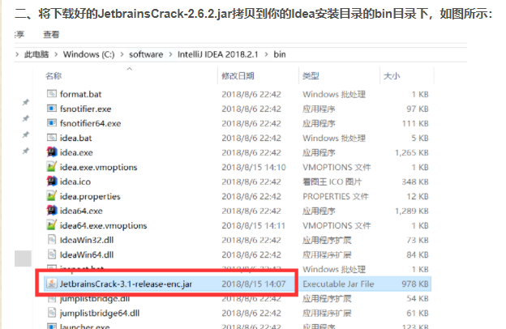

- 修改配置文件：
打开idea安装目录下的文件：idea64.exe.vmoptions和idea.exe.vmoptions，在文件末尾分别加上：
-javaagent:C:\software\IntelliJ IDEA 2018.2.1\bin\JetbrainsCrack-3.1-release-enc.jar
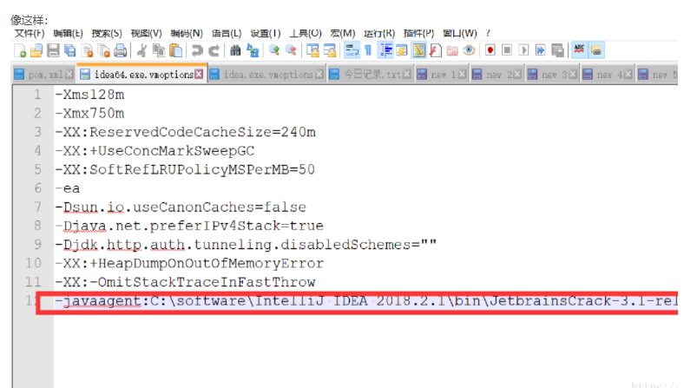

注意：C:\software\IntelliJ IDEA 2018.2.1\bin\JetbrainsCrack-3.1-release-enc.jar是刚刚下载的jar包的完整路径，自己需要修改。
ThisCrackLicenseId-{
"licenseId":"ThisCrackLicenseId",
"licenseeName":"idea",
"assigneeName":"",
"assigneeEmail":"idea@163.com",
"licenseRestriction":"For This Crack, Only Test! Please support genuine!!!",
"checkConcurrentUse":false,
"products":[
{"code":"II","paidUpTo":"2099-12-31"},
{"code":"DM","paidUpTo":"2099-12-31"},
{"code":"AC","paidUpTo":"2099-12-31"},
{"code":"RS0","paidUpTo":"2099-12-31"},
{"code":"WS","paidUpTo":"2099-12-31"},
{"code":"DPN","paidUpTo":"2099-12-31"},
{"code":"RC","paidUpTo":"2099-12-31"},
{"code":"PS","paidUpTo":"2099-12-31"},
{"code":"DC","paidUpTo":"2099-12-31"},
{"code":"RM","paidUpTo":"2099-12-31"},
{"code":"CL","paidUpTo":"2099-12-31"},
{"code":"PC","paidUpTo":"2099-12-31"}
],
"hash":"2911276/0",
"gracePeriodDays":7,
"autoProlongated":false}

