EasyUi学习文档

1、面板

1）创建面板
用户面板工具<hr>
<div id="p" style="padding:10px;" data-options="iconCls:'icon-save',closable:true,collapsible:true,minimizable:true,maximizable:true">
</div>
<script type="text/javascript">
$('#p').panel({
width:500,
height:150,
title:'My Panel',
tools:[{
iconCls:'icon-add',
handler:function(){alert('new')}
},{
iconCls:'icon-save',
handler:function(){alert('save')}
}]
});
</script>
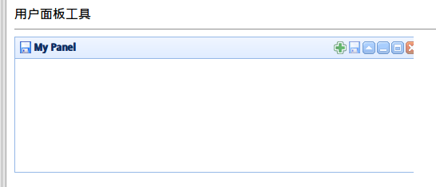

2）面板的加载
$('#p').panel({
href:'panel01.jsp',
onLoad:function(){
alert('loaded successfully');
}
});
<div id="p" style="padding:10px;" data-options="iconCls:'icon-save',closable:true,collapsible:true,minimizable:true,maximizable:true">
</div>
<script type="text/javascript">
$('#p').panel({
width:500,
height:150,
title:'My Panel',
tools:[{
iconCls:'icon-add',
handler:function(){alert('new')}
},{
iconCls:'icon-save',
handler:function(){alert('save')}
}]
});
$('#p').panel({
href:'panel2.jsp',
});
</script>
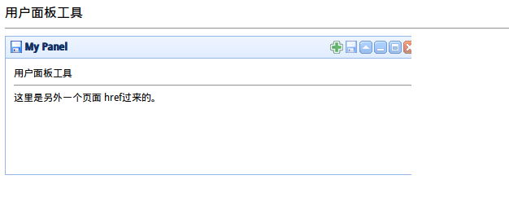

2、标签

1）创建标签
这是一个tab，tab依附在tab上
<div id="tt"></div>
<script type="text/javascript">
$('#tt').tabs({
border:false,
width:200,
height:200,
onSelect:function(title){
alert(title+' is selected');
}
});
</script>
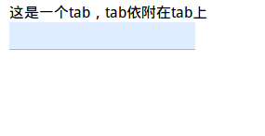

2）标签的增加
$('#tt').tabs('add',{
title:'New Tab',
content:'Tab Body',
closable:true,
tools:[{
iconCls:'icon-mini-refresh',
handler:function(){
alert('refresh');
}
}]
});

3）获取相应的标签对象
// 获取选中的标签页面板（tab panel）和它的标签页（tab）对象
var pp = $('#tt').tabs('getSelected');
var tab = pp.panel('options').tab; // 相应的标签页（tab）对象

3、折叠面板
accordion

1）创建折叠面板
<div id="aa" class="easyui-accordion" style="width:300px;height:200px;">
<div title="Title1" data-options="iconCls:'icon-save'" style="overflow:auto;padding:10px;">
<h3 style="color:#0099FF;">Accordion for jQuery</h3>
<p>Accordion is a part of easyui framework for jQuery.
It lets you define your accordion component on web page more easily.</p>
</div>
<div title="Title2" data-options="iconCls:'icon-reload',selected:true" style="padding:10px;">
content2
</div>
<div title="Title3">
content3
</div>
</div>
<div id="aa"> </div>
$('#aa').accordion({
width:200,
height:600,
animate:false
});

2）折叠面板实例
<div id="aa">
<div id="tt1">
<div class="ttt1"></div>
<div class="ttt1"></div>
<div class="ttt1"></div>
<div class="ttt1"></div>
</div>
<div id="tt2"></div>
<div id="tt3"></div>
<div id="tt4"></div>
</div>

<script type="text/javascript">
$("#tt1").panel({
title:'面板一',
width:200,
});
$("#tt2").panel({
title:'面板二',
width:200,
});
$("#tt3").panel({
title:'面板三',
width:200,
});
$("#tt4").panel({
title:'面板四',
width:200,
});
$(".ttt1").panel({
title:'面板一 ==>面一',
width:200,
});

$('#aa').accordion({
width:200,
height:600,
animate:false
});
</script>
刷新折叠面板的内容
var pp = $('#aa').accordion('getSelected'); // 获取选中的面板（panel）
if (pp){
pp.panel('refresh','new_content.php'); // 调用 'refresh' 方法加载新内容
}

4、布局
layout

1）通过标记创建布局（Layout）
<div id="cc" class="easyui-layout" data-options="fit:true">
<div data-options="region:'north',title:'North Title',iconCls:'icon-ok'," style="height:100px;"></div>
<div data-options="region:'south',title:'South Title'" style="height:100px;"></div>
<div data-options="region:'east',title:'East',split:true" style="width:100px;"></div>
<div data-options="region:'west',title:'West',split:true" style="width:100px;"></div>
<div data-options="region:'center',title:'center title',href:'panel01.jsp'" style="padding:5px;background:#eee;"></div>
</div>

2）在整个页面上创建布局
<body class="easyui-layout">
<div data-options="region:'north',title:'North Title',split:true" style="height:100px;"></div>
<div data-options="region:'south',title:'South Title',split:true" style="height:100px;"></div>
<div data-options="region:'east',title:'East',split:true" style="width:100px;"></div>
<div data-options="region:'west',title:'West',split:true" style="width:100px;"></div>
<div data-options="region:'center',title:'center title'" style="padding:5px;background:#eee;"></div>
</body>

3）创建嵌套布局
<body class="easyui-layout">
<div data-options="region:'north'" style="height:100px"></div>
<div data-options="region:'center'">
<div class="easyui-layout" data-options="fit:true">
<div data-options="region:'west',collapsed:true" style="width:180px"></div>
<div data-options="region:'center'"></div>
</div>
</div>
</body>

4）通过 ajax 加载内容
<body class="easyui-layout">
<div data-options="region:'west',href:'west_content.php'" style="width:180px" ></div>
<div data-options="region:'center',href:'center_content.php'" ></div>
</body>

5）折叠布局面板（Collpase Layout Panel）
$('#cc').layout();
// collapse the west panel
$('#cc').layout('collapse','west');

6）通过工具按钮添加西区面板
$('#cc').layout('add',{
region: 'west',
width: 180,
title: 'West Title',
split: true,
tools: [{
iconCls:'icon-add',
handler:function(){alert('add')}
},{
iconCls:'icon-remove',
handler:function(){alert('remove')}
}]
});

