15.01.07
CALCULUS II
TEST II

NAME...........................................................................................................

1. (10p) Use the Taylors Formula for f(x,y)

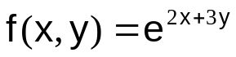

to find the quadratic (n = 2) approximation at the origin (0,0). Estimate the value of

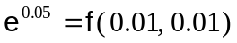.

2. (10p) Sketch the region of integration, reverse the order of integration

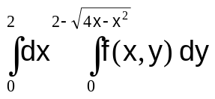

3. (10p) Find the volume of the region that lies below the graph of 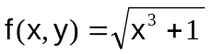, and above the region 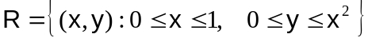.

4. (10p) Evaluate the given integral by changing to polar coordinates

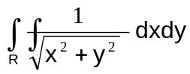,
where the region R is bounded by the curves :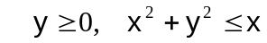.

5. (10p) Evaluate the following improper integral

