13.11.07
CALCULUS II
TEST I

NAME...........................................................................................................

1.(7p) Let z = x² + 2 y² - 2 , draw two level curves:
(a) one that passes through the point (1,1)
(b) one that lies on the xy-plane.

2.(7p) Show that the limit
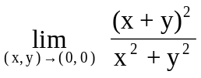
does not exist.

3. (7p) Show that 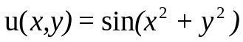 is a solution of the following differential equation
u_{xy} = 4xy u.

4. (7p) Use the chain Rule to find the partial derivatives 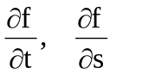 of

f(x,y) = x ln(x + 2y), x = t² + s, y = t s

5. (8p) Find all the critical points of f(x,y) = 9xy – x³ – y³.

6. (8p) Find the largest and smallest value of

f(x,y) = x² - 2y² - 6x
in the circle 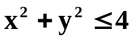.

7. (6p) True or False?
(a) Let f be defined on some neighbourhood of point (0,0) and both of the partial derivatives f_{x}(0,0), f_{y}(0,0) exist, then the function f is continuous ?

(b) If 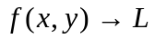 as 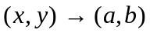 along every straight line through (a,b), then


