CIS 525 Software Development of Parallel and Distributed Systems

C/E PETRI-NETS –
SOME DEFINITIONS AND EXAMPLES

- Subnet:

Let N₁ = (B₁ , E₁ , F₁) and N₂ = (B₂ , E₂ , F₂) be a pair of nets. Then N₁ is a subnet of N₂ if and only if B₁B₂ and E₁ E₂ and F₁ = F₂ ∩ ((B₁ x E₁) U (B₂ x E₂))

Example 1: N₁ is a subset of N₂:
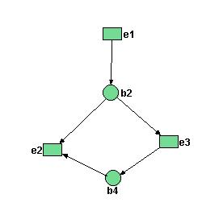
Figure 1: Subnet N₁

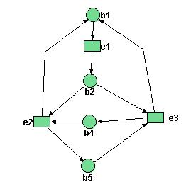
Figure 2: Net N₂

- Dual Net:
Let N = (B,E,F) be a net. Then the dual of N, denoted as 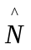, is the triplet = (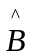,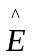,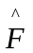), where = E, = B and = F⁻¹

Example 2: The dual of N₂ from example 1 is:
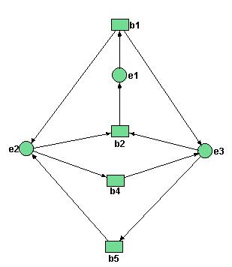
Figure 3: Dual net 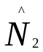

Theorem 1: Let N₁ and N₂ be two nets
- 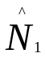, the dual of N₁ is also a net.
- 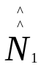 = N₁
- N₁ is a subnet of N₂ ⬄ is a subnet of

Why one discusses contact-free C/E systems?

- the simplest possible C/E systems
- the notion of non-sequential process generated by C/E systems can be formulated in a clean way only for contact-free C/E systems
- contact-free C/E nets can be generated smoothly into arbitrary C/E net.
Definition: The C/E system N=(B,E,F,C_{in}) is contact-free if and only if
V V [˙e C => e˙ ∩ C = ∅]
eєE CєC_{N}

Theorem 2: Let N=(B,E,F,C_{in}) is contact-free C/E system, C є C_{N} and G E. Then

C[G> iff ˙G C and V [e₁ e₂ => ˙e₁ ∩˙e₂
e₁,e₂ є G

Fundamental behavioral situations:

For given case C of a C/E system, two events e₁, e₂ can be related to each other in at least 3 ways:
- Sequence: e₁ can occur at C but not e₂; however, after e₁ has occurred e₂ can occur.
- Conflict: e₁ and e₂ can occur individually at C but not both; in other words {e₁} and {e₂} are steps at C while {e₁,e₂} is not a step at C.
- Concurrency: both e₁ and e₂ can occur at C with no order specified over their occurrences. In other words, {e₁,e₂} is a step at C.

Fact: Net theory separates these relationships conceptually, graphically, and mathematically.

Sequence:

Graphically
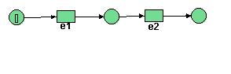
Figure 4. A sequence of two events e1 and e2.

Conceptually: “Occurrence of e₂ must be preceded by that of e₁”

Definition: Let C є C_{N}, and e₁, e₂ є E_{N}, where N is a C/E system; we say, mathematically: e₁ and e₂ are in sequence at C ⬄ C[e₁> and ┐(C[e₂ >) and C’[e₂> where C[e₁>C’

Conflict: e₁ and e₂ can occur individually; but due to “shared” condition b, {e₁, e₂} is not a step.
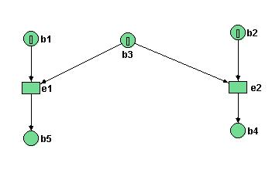
Figure 5. Petri net with conflict of events.

Reachability graph

b1, b, b2
b2, b3
b1, b4
e₂
e₁
Figure 6. Fragment of Reachability graph.

Fact: either e₁ or e₂ can occur ≡ non-determinism

Definition: Let e₁ and e₂ be two events and C a case of a C/E system. e₁ and e₂ are in conflict at C iff C[e₁> and C[e₂> but not C[{e₁,e₂}>

Concurrency:
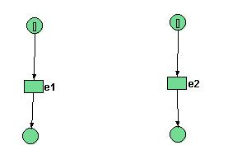
Figure 7. Two concurrent events.

e₁ and e₂ can occur without interfering with each other. No order is specified over their occurrences. Hence in general the occurrences of events and the resulting holdings of conditions will be partially ordered; C/E system can exhibit non-sequential behavior.

Definition: Let e₁ and e₂ be two events and C a case of the C/E system. e₁ and e₂ can occur concurrently at C iff C[{e₁, e₂}>

Conclusions:
  - Sequence= sequential behavior = linear ordering of events
  - Conflict= non determinism(with restrictions)= choice
  - Concurrency= non-sequentially behavior= partial ordering of events

Confusion = concurrency + conflict
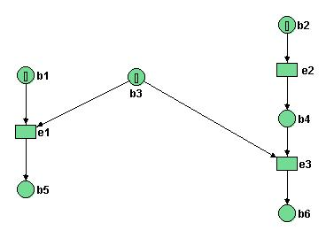
Figure 8. Petri net with confusion.

C = {b₁, b₂, b₃}
C’ = {b₄, b₅}
------------------------
C[{e₁,e₂}>C’

Ci confusion (Conflict – increasing confusion)

Cfl{e₁, C} = ∅
(C, e₁, e₂) is confusion because
cfl(e₁,C) = ∅, and cfl(e₁,C₂) = e₃, where C₂ = {b₁,b₂,b₃}

Disagreement over whether or not a conflict was resolved in going from the case C to C’ via the step {e₁, e₂}. Potential interpretations:

Observer1 (no conflict point of view): e₁ occurred first without being in conflict with any other event. And then e₂ occurred.

Observer 2 (conflict point of view): e₂ occurred first. As a result e₁ and e₃ got in conflict. This conflict was resolved in favor of e₁ which then occurred.

Example: switching circuit confusion= glitch problem= synchronization failure problem

Fact:

1> Systems with confusion are difficult to analyze, because “the intermediate cases” determined by the elements of the step could differ. As a result one cannot take advantage of concurrency and analyze the cases generated just by one possible sequentialization of a step one must analyze every possible sequentialization.

2> Net theory suggests that it is not the combination of choice and concurrency that causes difficulties; rather it is those combinations of “choice” and “concurrency” resulting in confusion that cause trouble. Choice and concurrency can be combined in confusion - free manner.

3> It is not always possible to avoid confusion.

Example: (mutual exclusion problem)
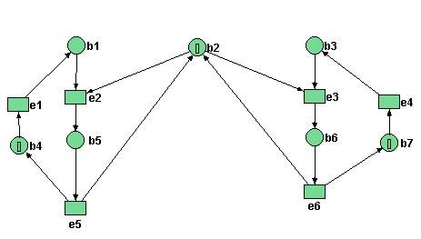
Figure 9. Petri net model of mutual exclusion.

Reachability Graph:

C={b2, b4, b7}

b2, b4, b7
b1, b2, b7
b1, b2, b3
b2, b3, b4
b3, b5
b1, b6
b1, b2, b7
b2, b3, b4
e1
e4
e1
e4
{e1, e4}
e1
e3
e5
e6
e2
e1
e3
{e1,e3}
{e1,e3}
C={ b4, b6}
cfl(e₂,C₂) = {e₄}
where C₂ = {b₃,b₄}

Figure 10. Reachability graph.

Formalization of confusion:

Definition: Let N= (B, E, F, C_{N}) be and C/E system, let C є C_{N} and let e є E be such that C[e>. The conflict set of e at C, denoted cfl(e, C) is defined

Cfl(e,c) = {e’ є E: C[e’> and ┐C[{e,e’}>}

i.e. the conflict set of e at C is the set of all events that are in conflict with e at C.

Definition:
Let N= (B, E, F, C_{in}) be an C/E system let C є C_{N} and let e₁, e₂ be two distinct events in E such that C[{e₁,e₂}>. The triplet(C, e₁, e₂) is a confusion at C. We say that N is confused at C iff, there is a confusion at C.

Thus a triplet (C,e₁,e₂) is a confusion if{e₁,e₂} is a step at C and the occurrence of e₂ at C change the conflict set of e₁.

Classification of confusion:

Let N be an C/E system, C є C_{N,} e₁,e₂ є E_{N}. Let γ = (C,e₁,e₂) be a confusion and let C[e₁>C₂.

(i) γ is a conflict – increasing confusion (c_{i} confusion )
iff cfl(e₁,C) cfl (e₁,C₂).

(ii) γ is a conflict – decreasing confusion (c_{d} confusion )
iff cfl(e1,C₂) cfl (e₁,C).

Example:
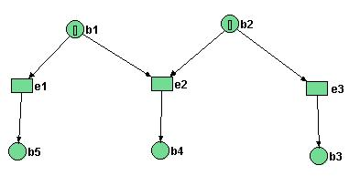
Figure 11. Illustration of confusion.

C = {b₁, b₂}

(C,e₁,e₂) is a confusion because, where C₂ = {b₁,b₃}

Since cfl (e₁,C₂) cfl (e₁,C)

(C, e₁, e₂) is a c_{d} confusion.

Example: Confusion that is neither c_{i} nor c_{d} confusion.
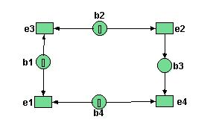
Figure 12. Illustration of confusion.

For C = {b₁,b₂,b₄}; (C,e₁,e₂) is a confusion because cfl (e₁,C) = {e₃}{e₄} = cfl(e₁,C₂) where C₂ = {b₁,b₃,b₄}. Note that (C,e₁,e₂) is neither a c_{i} confusion nor a c_{d} confusion.

Conclusions:

1. The distinctions between c_{i} and c_{d} confusion is not “exhaustive” there are confusions that are neither c_{i} nor c_{d}.

2. The fact that (C,e₁,e₂) is a confusion expresses certain “influence” of e₂ on e₁ at C. It is also important to know whether or not also e₁ can influence e₂ in a similar fashion.

Definition: Let γ = (C, e₁,e₂) be a confusion;

γ is symmetric ⬄ (C,e₂,e₁) is also a confusion other wise γ is asymmetric.

Examples:
1. γ = (C,e₁,e₂) is a c_{i} confusion that is asymmetric
(C,e₂,e₁) is not a confusion.
Figure 13. Illustration of confusion.

2.
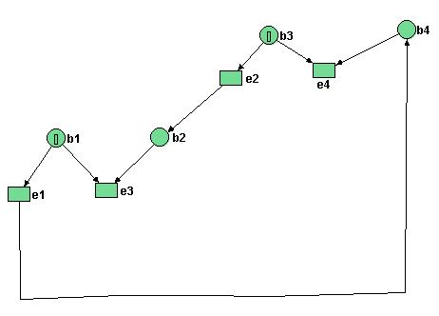
Figure 14. Illustration of confusion.

cfl(e,C) = ∅
cfl(e,C₂) = {e₃}
where C₂ = {b₁,b₂}

C={b₁, b₃}
γ = (C, e₁, e₂) is a c_{i} confusion. -->

C={ b4, b6}
cfl(e₂,C₂) = {e₄}
where C₂ = {b₃,b₄}

γ’ = (C, e₂, e₁) is a c_{i} confusion -->

(C, e₁, e₂) is a c_{i} confusion that is symmetric

3.
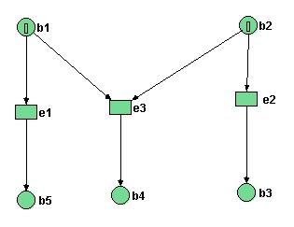
Figure 15. Illustration of confusion.

(C, e₁, e₂) is a c_{d} confusion that is symmetric.
C = {b₁,b₂}

(C,e₁,e₂) C[e₂>{b₁,b₃}=C₂
cfl(e₁,C) = {e₃}
cfl(e₁,C₂) = ∅

(C,e₂,e₁) C[e₁>C₂={b₂,b₅}
cfl(e₂,C) = {e₃}
cfl(e₂,C₂) = ∅

4. The confusion(C, e₁, e₂) for system is a symmetric confusion that is neither a c_{i} confusion nor a c_{d} confusion.

Remark:
C_{d} Confusions are always symmetric.

