NET MORPHISMS

1. MOTIVATION:

- homogeneous formalism to represent models of different layers (relations between models can be expressed in a uniform way)

- examples of relations between models:

- abstractions from details
-composition of subcomponents (properties of subcomponents deduced from respective properties of the whole system and properties of subparts carry over to the composed system)

- Petri nets support: causality, choice (conflicts, and concurrency)

- S-elements and T-elements are dual to each other as choice and concurrency are dual concepts

- S-components and T-components (S-component is a subnet where only S-elements are branched)

- computation of S-components or covering of a net by S-components is a highly complex task

- well-designed system can be modeled as a composition of simple subparts

- transformations of nets which preserve certain properties

- net morphisms: a method of relating nets N and N': a mapping from elements of a source net to elements of a target net which respects the bipartision and the flow relation of the source net

- vicinity respecting morphisms: if two elements are similar enough to be mapped to the same element, then their effect on the environment should be the same as well (effect on environment - adjacent elements)

- structure and semantics are not independent (net covered by S-components is bounded independetly of the marking class considered - structural property preserved by morphisms).

2. DEFINITIONS:

- definition of a net N=(S,T,F)

- some notation: 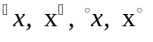

- subnet, S-subnet, T-subnet

- adjacency relation of a net 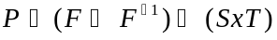

- net morphism:

Let N an N' be nets. A mapping f: X --->X' is called net morphism, denoted by f: N --->N' if for every a,b in X the following properties hold:

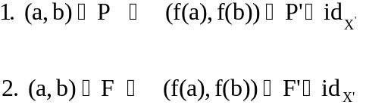

where, 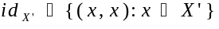.

Theorem: Let f:N--->N' be a net morphism. Then

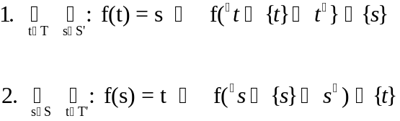

Morphisms respect the flow relation of the source net. Sequences of arcs are also respected in a certain sense.

Morphisms are surjective mappings (net N is a more detailed model of a system than N').

Composing nets is a special case of identifying elements.

Transformations or generation of nets (only source net and some information about the mapping is given; target net is given only implicitly; target net is generated by the morphism).

Given the partition of the elements which is generated by the equivalence relation 'is mapped to the same element', the generated target net is unique up to isomorphism. These morphisms are called quotients.

A surjective net morphism f: N --->N' is called quotient if

Remark:

Only few properties are transferred from a source net to a target net by a morphism and even less by a quotient.

Vicinity respecting morphisms

- the pre-set of each element i mapped surjectively to the pre-set of its image, i.e. 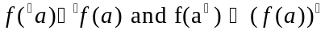 for each element a

(this approach means that S-elements are mapped into S-elements and T-elements into T-elements)

Fig.4 - 'line-reducing morphisms' do not respect vicinities in this sense.

- we want to keep the possibility of mapping an element together with (a part of) its pre-set and (a part of) its post-set to one element of the target net

- A net morphism f:N---->N' is said to be S-vicinity respecting if 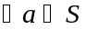:

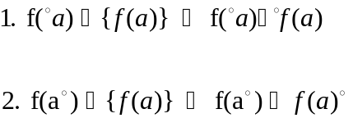

Fig.4 - S-vicinity respecting morphisms.

