HOMEWORK #3

INTERORGANIZATIONAL WORKFLOWS – CORRECTNESS ISSUES; APPLICATIONS IN ELECTRONIC COMMERCE

Problem 1: Correctness of Individual WF nets – Soundness vs. Liveness and Boundedness (2 points)

For a given WF net as in Fig. 1 design a short-circuited WF net related to WF net in Fig.1. Compute S-components (place invariants) for this new net. Compute occurrence graph for original WF net and for short-circuited net. Compare both occurrence graphs (1 point).
Consider again WF net as in Fig. 2 that is a modification of WF from Fig. 1. For WF net as in Fig.2 repeat the same computations as for workflow in Fig. 1 (1 point).
Draw any conclusions from these computations in terms of soundness, liveness, and boundedness of both workflows.

Problem 2: Correctness of Inter-organizational Workflows – Soundness

Design an IOWF with LC (Loosely Coupled architecture) composed of at least two business partners such that local workflows are sound but the global workflow is not sound. Assume that both synchronous and asynchronous communication is permitted between business partners. Use arguments (explain) why local workflows are sound and why global workflow is not sound. Indicate needed changes in global workflow to achieve soundness of the IOWF.

Problem 3: Correctness of Inter-organizational Workflows – Consistency

The MSC (Message Sequence Charts) can be seen as a partial specification of an IOWF. It is interesting to decide whether IOWF with MSC meets the original specification. This is known as the consistency problem. For Fig. 4 (MSC) and Fig. 5 (IOWF) explain whether IOWF from in Fig. 4 is consistent with MSC in Fig. 4.

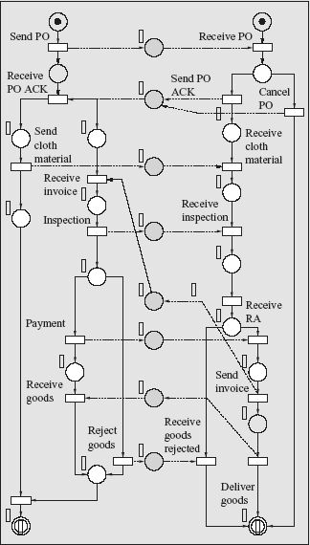

Sieć będzie poprawna (sound) ponieważ:
- start z każdego stanu „i” może nas doprowadzić do stanu końcowego „o”
- każdy dostępny stan „M” dostępny ze stanu i doprowadzi nas do stanu „o”
- diagram ukończony oznacza zużycie dostępnych materiałów
- każda z dostępnych tranzycji może być ew. wywołana
- każdy z wyborów może być ew. dokonany i nie doprowadza do nieskończonych pętli

Problem 4: Case Transfer Architecture for Inter-organizational Workflows (1 point)
CT-IOWF (Case-Transfer Architecture for Inter-organizational Workflow) is described in Fig.3 for three business partners: insurance company-A, the primary agencies-B and secondary agencies-C. In this architecture each business partner uses the same business process definition. However, some tasks can be only executed by some business partners and a case always resides at exactly one location
Consider the following scenario: a customer reports a claim at a secondary agency, the claim is classified a complex, the claim is rejected, and only the insurance company and the secondary agency are involved in the process. Show that in this particular scenario, at least five transfers are necessary to complete the case. Identify these transfers.

