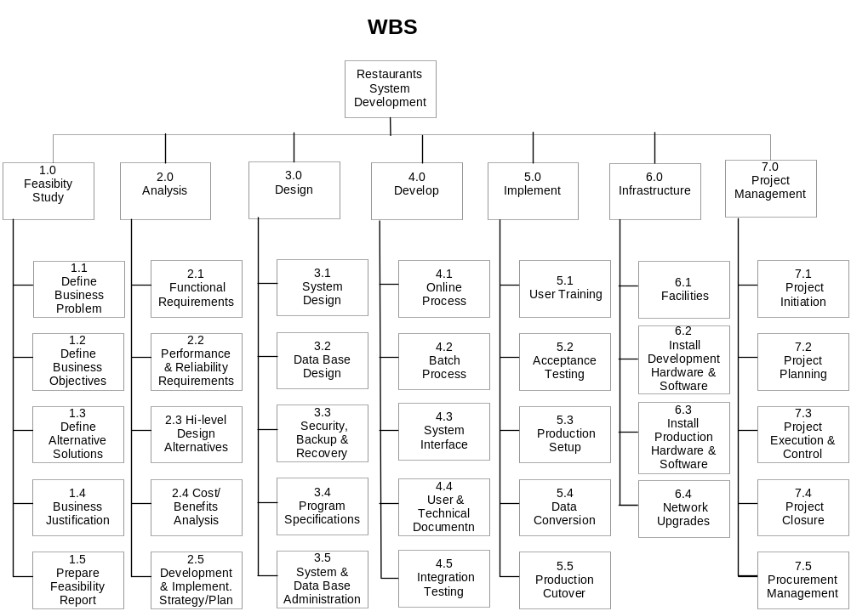

RAM:
According to WBS: | 1.1, 1.2, 1.3, 1.4, 1.5 | 2.1, 2.2, 2.3, 2.4, 2.5 | 3.1, 3.2, 3.3, 3.4, 3.5 | 4.1,4.2,4.3,4.4 | 4.5 | 5.1 | 5.2 | 5.3, 5.4, 5.5 | 6.1, 6.2, 6.3, 6.4 | 7.1, 7.2, 7.3, 7.4, 7.5
Analyst team | V | V
Designers team |  |  | V
Programmers |  |  |  | V
Testing team |  |  |  |  | V
Quality assurance team | V | V | V | V | V | V | V | V | V | V
Installation team |  |  |  |  |  |  | V | V | V
Training team |  |  |  |  |  | V |  |  |  | V

