1. Introduction 2. Page Layout
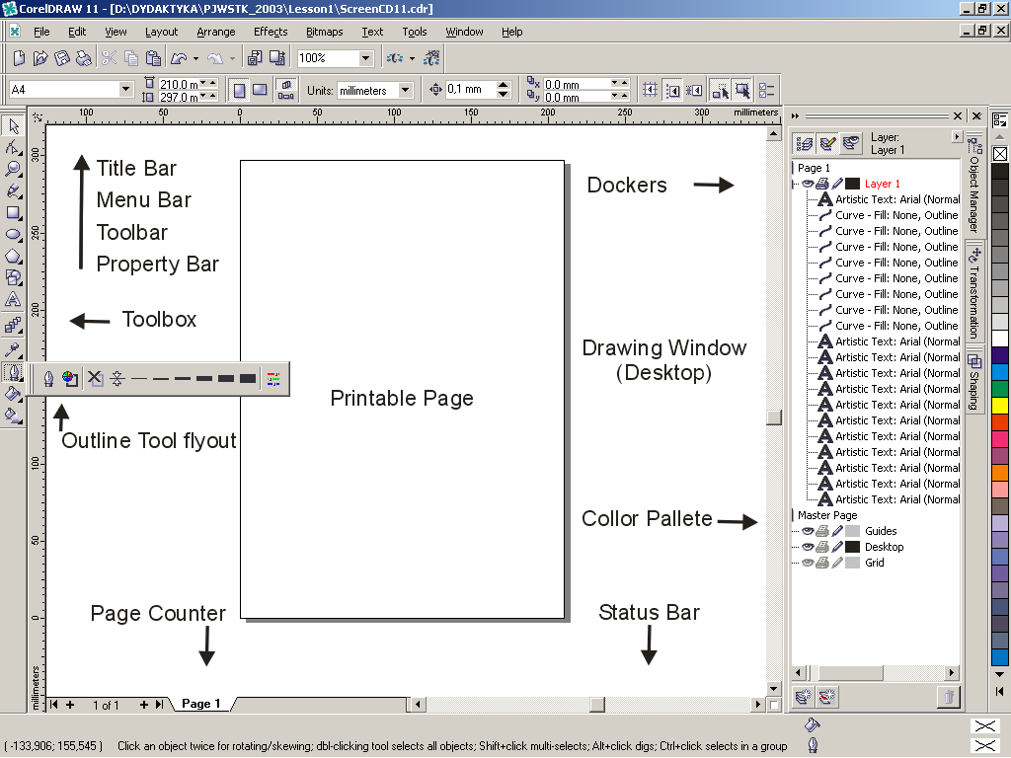
The Property Bar - a context-sensitive toolbar that displays different information and controls depending on the selected tool or object.
The Status Bar is displayed along the bottom of the Application Window. The Status Bar shows: the fill pattern, the outline pattern and absolute coordinates of the cursor. The Color Palette you will find along the right side of the Application Window. This is used to apply outline and fill colors. There exist different way for do this operation. Dockers (Docker Windows) are a variation of the dialog boxes but it can be docked to the side of the application window. Example: Choose WINDOW/Dockers/Object Manager to activate the Object Manager Docker Window. Layer is the transparent plane on which you can place objects in a drawing, in the form of stack. Each new drawing contains four default layers. There is one Layer (called Layer1) for drawing.
Toolbox:
On the left hand side of the screen is the Toolbox with drawing tools and other operative tools. The Toolbox contains all of the CorelDRAW tools and flyouts. The small arrows on a tool indicate that there is a flyout associated with that tool.
- The Pick Tool: For selecting objects. Also for moving, sizing, rotating, and skewing objects.
- The Shape Edit Tool: For editing the shapes of the diagramming objects and text. The Shape edit flyout gives you access to the Shape, Knife, Eraser, Smudge Brush, Roughen Brush and Free Transform tools.
- The Zoom Tool: For changing views. The Zoom flyout gives you access to the Zoom and Hand tools.
- The Freehand (Curve) Tool: For drawing straight lines and curves. The Freehand flyout gives you access to the Freehand, Bezier (Curve), Artistic Media, Pen, Polyline, 3 Point Curve, Dimension Line tool, Interactive Connector and Dimension tools.
- The Rectangle Tool: For drawing rectangles and squares. The Rectangle flyout gives you access to the Rectangle and 3 Point Rectangle tools.
- The Ellipse Tool: For drawing ellipses and circles. The Ellipse flyout gives you access to the Ellipse and 3 Point Ellipse tools.
- The Polygon Tool: For drawing multi-sided shapes like stars or polygons. The Polygon flyout gives you access to the Polygon, Graph paper and Spiral tool.
- The Text Tool: For placing two different types of text object Artistic Text and Paragraph Text.
- Interactive Tools: For applying effects interactively. The Interactive Tools flyout gives you accesses to the Interactive Blend, Interactive Contour, Interactive Distortion; Interactive Envelope, Interactive Extrude, Interactive Drop Shadow and Interactive Transparency tools.
- The Eyedropper Tool: For selection of a fill color of an object in a drawing. The Eyedropper flyout gives you access to the Eyedropper Tool and Paintbucket Tool.
- The Outline Tool: For setting outline thickness and color. For creating line ending attributes. For creating calligraphic effects. For applying dash line patterns. The Outline flyout gives you access to the Outline Pen Dialog, Outline Color Dialog, No Outline, Hairline –1/2 to 24 point outline and Color Docker Window icon.
- The Fill Tool: For setting fill colors and screens. For creating fountain fills. For applying pattern tile fills. For applying texture fills. For applying special PostScript fills. The Fill flyout gives you access to the Fill Color Dialog, Fountain Fill Dialog, Pattern Fill Dialog, Texture Fill Dialog, Postscript Fill Dialog, No Fill and Color Docker Window icon
- Interactive Fill Tool: For placing various fills interactively. The Interactive Fill Tool flyout gives you accesses to the Interactive Fill Tool and Interactive Mesh Fill Tool.
3. Draw an object 4. The Pick Tool 5. Using basic Menu Options 6. The Shape Tool 7. Using additional Menu Options
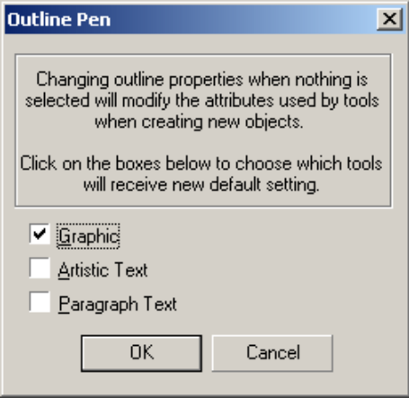
Exercise 1: Rectangles
- Draw a rectangle with the blue 8 point outline and fountain fill between two favorite colors.
- Add the cycles with the uniform fill accurately on the four corners of the rectangle
- On the upper right corner add square without the fill.
Exercise 2: Ellipses
- Draw a big ellipse with the yellow fill. (Observe: The ellipse is selected).
- In the Transformation Docker (WINDOW/Dockers/Transformations) choose Scale and Mirror tab.
- Deselect the Non-proportional check-box and type 85% value in the H or V Scale white window.
- Select the white check-box representing the upper left corner.
- Click five (5) times the Apply to Duplicate button.
- Select all objects. (Tip: Use Pick tool.)
- Choose ARRANGE/Combine.

Exercise 3: Arrows (Note: The figure must be exactly symmetrical)
- Draw a horizontal line.
- Add arrows from Arrows section of the Outline Tool dialog box (or Property Bar). The left-hand arrow icon represents the start of a line, and the right-hand arrow icon represents the end of the line. (If you don’t see the arrow on your drawing increase the width of the line).
- Duplicate the line and rotate to vertical position. (Open Object Manager Docker)
- In the Transformation Docker activate the Rotate tab.
- Set the appropriate value of rotation angle and appropriate center.
- Choose the Apply or Apply to Duplicate buttons (several times).
- Select and align all objects: Choose ARRANGE/Align and Distribute/Center to Page or Align and Distribute… and Align tab.
- Select Align to Center of page check box.
- In this same way draw the shortest line.
Exercise 4: Perspective
- Set the horizontal orientation of the page.
- Draw a rectangle (not too big) with the yellow fill. (select it)
- Choose EFFECTS/Add Perspective. (Observe: The Shape tool is now selected.)
- Hold down CTRL and drag lower left node vertically down to see the x marker.
- Move the x marker (vanishing point marker) to the upper right corner of the Drawing Page.
- Type any Artistic Text on the screen (Arial Black font, Cyan color). Select it.
- Choose EFFECTS/Copy Effect/Perspective from.
- Click on the rectangle with the cursor.
- Put the Text on the rectangle.
- Select the Shape tool.
- Edit the text perspective by moving the nodes to align the x marker to the upper right corner of the page.
Exercise 5: Cross of Merit
- Draw a square with the yellow fill.
- Draw a horizontal rectangle with the yellow fill.
- Duplicate it and rotate to vertical position.
- Align all objects in the center of page.
- Weld objects: Select all objects. Choose ARRANGE/Shaping/Weld. Observe the result curve object in the Object Manager Dockers.
- Choose Shape Tool and select 8 most internal nodes of object (with Shift key).
- Choose Stretch and Scale Nodes button. (from the Property Bar).
- Drag with Shift key any corner selection handle (black square, no node) towards the center of object.
Exercise 6: Arms of a town
- Draw a big rectangle with the red fill.
- Draw a horizontal rectangle with the yellow fill. Duplicate it two times. Distribute all 3 yellow rectangles over the red one.
- Group all 3 yellow rectangle.
- Open the Interactive Tools flyout, and click the Interactive Envelope tool.
- Choose the Envelope Strait line Mode on the Property Bar.
- Click on the lower, left envelope node and drag it horizontally towards the center of the horizontal line with the Shift key hold down.
- Choose the Pick tool. Deselect all objects. Click and release the right mouse button on the red rectangle. Choose the Convert To Curves.
- Choose the Shape tool. Select the right, upper node of the red curve. Choose the Convert Line To Curves on the Property Bar.
- Click in the middle on the upper horizontal line of the red curve and drag it down.
- Double click in the center of the lower horizontal line of the red curve (add the node). Select the new node and drag it down. Choose the Convert Line To Curves on the Property Bar.
- Select the left, lower node of the red curve. Choose the Convert Line To Curves on the Property Bar. Select the controls point (the black square). Drag it to position below the node. Do it the same for the lower right node.
- Select the center, lower node of the red curve. Drag the two control points to position above the node.
- Type the artistic text outside the rectangles. Select it. Choose the TEXT/Fit Text To Path and click the cursor on the upper part on the red curve.
- Deselect all objects and select the text wit the Pick Tool. Set the Distance from Path using the Property Bar to 5 mm.
Exercise 7: The Map
- Draw a map similar to example. Note: The main road symbol must be exactly symmetrical. The road symbols running towards the outer dash line must look as is they were slanted.

