1. Introduction
- When you create an image, you choose the color mode, background paper color, image size and resolution.
- When you open or create an image in Corel PHOTO-PAINT, it opens within its own window, called the Image Window.
- In Corel PHOTO-PAINT, objects are independent bitmaps that float above the background image.
- The active object is displayed with a red outline in the Objects Docker window.

2. Page Layout
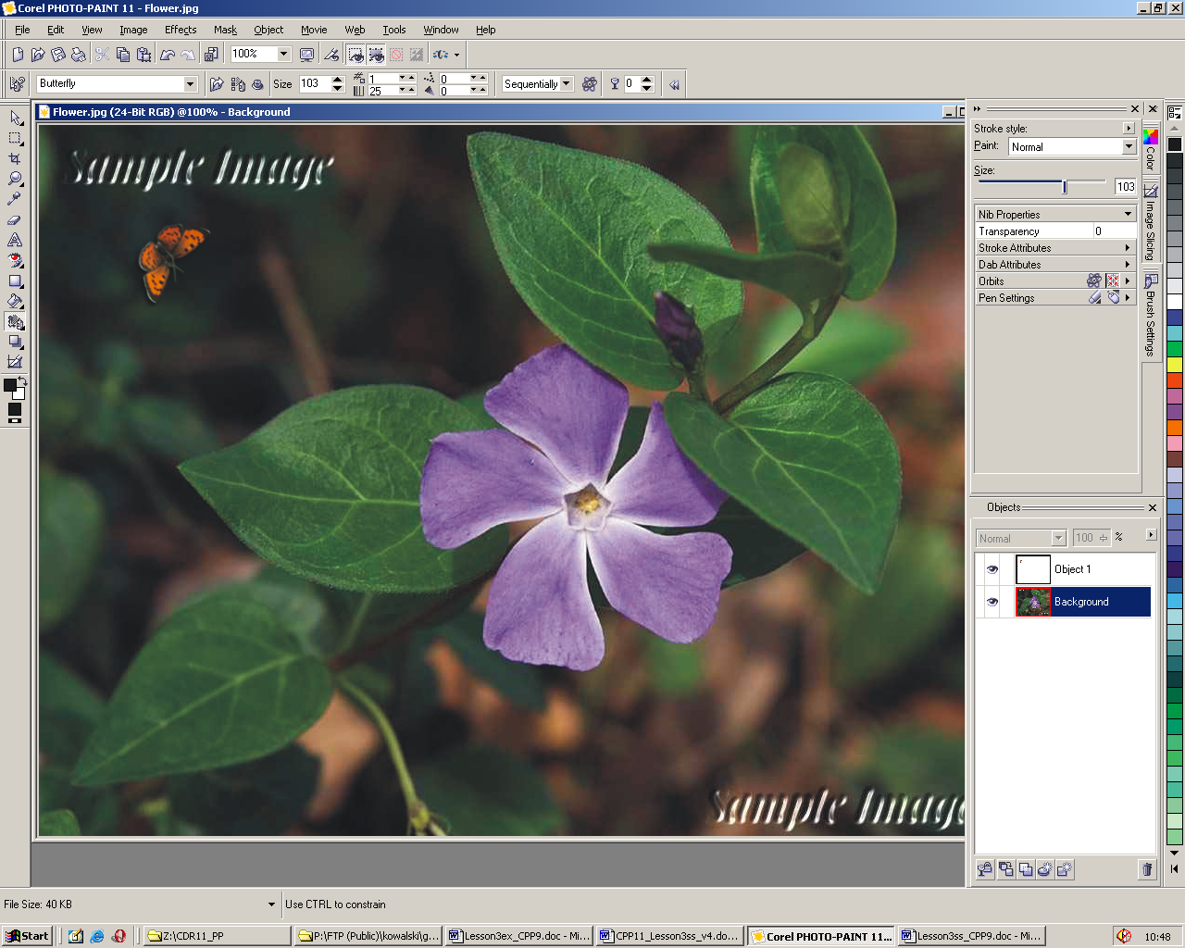

Above the Image Window, there are:
- The Title Bar that extends across the top of the window.
- The Menu Bar contains commands that can be accessed by clicking any of the menu names.
- The Toolbar. Beneath the Menu Bar, you will find a collection of buttons.
- The Property Bar - a context-sensitive toolbar that displays different information and controls depending on the selected tool or object.
- The Color Palette you will find along the right side of the Application Window. This is used to apply outline, paper and fill colors. There are different ways to do this operation.
- The Status Bar is displayed along the bottom of the Application Window. The status bar displays information about the image, system memory, and the active tool.
Docker Windows: The important dockers are: the Object Manager, the Info, the Color and the Undo/Redo.
Undoing and redoing a series of changes. Use the Undo/Redo docker to undo a series of changes that you’ve made to an image. If you undo a series of operations and then decide that you don’t like the result, you can redo the series of operations again by using Undo/Redo docker. When you use the EDIT/Checkpoint commands, Corel PHOTO-PAINT records the image. You can return to an image that you have saved as a checkpoint by choosing the EDIT/Restore To Checkpoint command.

2. Toolbox:
On the left hand side of the screen is the Toolbox with paint and operative tools.
- Object flyout:
- Object Pick Tool: For selecting objects. Also for moving, sizing, rotating, skewing, distorting and creating perspective of the objects.
- Mask Transform Tool. For moving, sizing, rotating, skewing, distorting and creating perspective of the mask.
- Mask Tools flyout:
- Rectangle Mask Tool, Ellipse Mask Tool, Freehand Mask Tool: Lets you define rectangular, elliptical and irregularly shaped or polygonal editable areas.
- Lasso Mask Tool: Lets you define editable areas that are irregular in shape and surrounded by pixels of similar colors.
- Magnetic Mask Tool: Lets you detect edges of elements in your image, that is, the outline of areas that are in contrasting color to their surroundings, and place the mask marquee along that edge.
- Magic Wand Mask Tool: Lets you define irregularly shaped editable areas that include all adjacent pixels that are similar in color to the pixel you first selected.
- Brush mask Tool: Lets you define an editable area by brushing an area as if you were painting.
- Crop Tool. Cropping cuts away selected areas on an image without affecting the resolution or dimensions of the areas that remain.
- Zoom flyout: Zoom Tool, Pan tool. For changing views.
- The Eyedropper Tool. For selecting a sample color from the image on screen as the foreground color.
- Eraser Tool. Lets you erase image areas or object areas to reveal the object or background underneath.
- Text Tool: For placing text and edit existing text.
- Touch-up flyout:
- Red-Eye Removal Tool: Lets you remove the red-eye effect from the eyes of subjects in photos.
- Clone Tool: Lets you duplicate part of an image and apply it to another part of the image or to another image.
- Shape flyout: Rectangle Tool, Ellipse Tool, Polygon Tool, Line Tool and Path Tool. For drawing vector line shapes and creating and editing the path.
- Fill flyout: Fill Tool, Interactive Fill Tool: For placing various fills on the image
- Brush flyout:
- Paint Tool: Lets you paint on an image using the foreground color,
- Effect Tool: Lets you perform local color and tonal corrections on the image,
- Image Sprayer Tool: Lets you load one or more images and paint them on your image.
- Undo Brush Tool: Lets you restore image areas to how they looked before your last brush stroke.
- Replace Color Brush Tool: Lets you replace the foreground color in your image with the background color.
- The Object Interactive/Transparency flyout:
- Interactive Dropshadow Tool: Lets you add shadows to objects.
- Interactive Object Transparency Tool: Lets you make the colors of an object fade gradually towards the image background color
- Color Transparency Tool: Lets you make pixels with a specific color value in an object transparent.
- Object Transparency Brush Tool: Lets you brush areas on an object to make them more transparent.
- Image Slicing Tool: Lets you cut a large image into smaller sections that can be modified for the Web.
Color control area: Lets you choose colors and fills. Consists of three swatches: a Foreground color swatch, a Background color swatch, and a Fill color swatch. The arrow lets you swap the foreground color and background color, and the Reset color icon lets you return to the default colors.

3. Using masks to make selections
When you select part of an image using a tool from the Mask flyout, the area surrounding the selection is masked or protected. When you apply a mask to an image, a dashed outline, called the mask marquee, identifies which areas of the image have not been protected (i.e., the selected or editable area). To hide the mask marquee use MASK/Marquee Visible commands.

Mask behavior
Because masks are protective layers that cover your image, you can move, rotate, skew, distort, and stretch them without affecting the underlying picture. And since masks are only temporary tools that simplify your image editing tasks, you must save them in a mask channel, save them to disk, or save the image in an appropriate file format, to preserve them.

Mask types
There are two types of masks: regular and color-sensitive. Regular masks define selections based on discernible shapes in the image. Color-sensitive masks define selections based on the color of the pixels in the image.

Mask modes
Corel PHOTO-PAINT provides four mask modes that fine-tune the shape and behavior of masks on your image: Normal, Additive, Subtractive, and XOR. The Normal mode is the default state which lets you create a single mask on your image. If you make a selection in Normal mode, all other selections are automatically removed from the image. The Additive mode lets you expand selections by removing parts of existing masks. Conversely, the Subtractive mode lets you expand masks by removing parts of existing selections. The XOR mode lets you create complex masks in which the overlapping areas are protected.

Moving the selection
You can move a selected area on the image using the mask tools with the Normal mask mode enabled. Choose one of these mask tools and drag the selection to its new location. By default, the pixels inside the marquee are cut from the image when the mask is moved. A background colored area in the shape of the selection is left on the image where it was originally located. If you choose the Float command from the Mask menu before moving it (or hold down ALT), you create a floating selection. This means that the selected area is copied to a new location while the underlying image remains intact. While the selection is floating, you can paste copies of it onto the image much like using a stamp to replicate a signature or shape. Clicking outside the floating selection automatically merges it with the background. You can also float or defloat a selection by enabling and disabling the Float/Defloat Mask button on the Property Bar.

Mask overlay
A mask overlay is a red-tinted, transparent sheet that you can superimpose over your image. When the overlay is applied, the masked areas on your image are displayed in varying degrees of red (according to their transparency) and the editable areas on your image are transparent. The deeper the saturation of the red tint, the greater the degree of protection. You can apply the mask overlay by enabling the MASK/Mask Overlay command or by clicking the Mask Overlay button on the Standard toolbar.

