UNIVERSITY OF REGINA
Department of Computer Science
CS420 2003 Fall

FINAL EXAMINATION

DATE: December 11, 2003

TIME: 3 hours

INSTRUCTOR: Dominik Slezak

NAME:_______________________________________________________
(Last) (First)

STUDENT NUMBER:__________________________________________

SIGNATURE:_________________________________________________

INSTRUCTIONS:
- This is a closed book exam.
- Verify that this document consists of 6 pages (including this one).
- Use the attached examination booklets to solve the tasks.
- Remember about signing the examination booklet.
- Return both the examination booklet and this document.

Mark Breakdown:
- Choose 5 of 7 tasks.
- For every task you can get maximally 10 marks.
- If you solve more than 5 tasks, then you get 5-mark bonus for each extra task.

TOTAL: 50 marks (+ 10-mark bonus for extra tasks)

Task 1
Consider the following formula, where P,Q,R are propositional variables:

[ ( P ∧ Q ) ∨ ¬ R ] → [ ( R ∨ P ) ∧ ¬ Q ]

Design the neural network, which models this formula in the following sense:
- There are three inputs corresponding to P,Q,R, which can be labeled with 0 or 1 depending on the particular truth assignment (0 for false, 1 for truth)
- There is one output, which equals 1, if and only if the inputs correspond to the truth assignment that satisfies the above formula, and 0 otherwise

In the design process, first rewrite the above formula in its DNF form. For each obtained conjunction, create a corresponding neuron in the hidden layer. Finally, set up the output neuron as representing the disjunction of these conjunctions.

Use the activation functions from the standard perceptron model. Provide calculations verifying that the obtained network works correctly (substitute various truth assignments to the input layer and compute the outputs).

Task 2 (continued on the next page)
Consider the following joint probability distribution:

X=… | Y=… | Z=… | P(X=…,Y=…,Z=…)=…
0 | 0 | 0 | 0.0
0 | 0 | 1 | 0.0
0 | 1 | 0 | 0.3
0 | 1 | 1 | 0.3
1 | 0 | 0 | 0.2
1 | 0 | 1 | 0.0
1 | 1 | 0 | 0.2
1 | 1 | 1 | 0.0

Show what cases of probabilistic conditional independence among the variables X,Y,Z can be derived from this distribution (if there are any such cases).

Task 2 (continuation from the previous page)
Consider the following directed acyclic graphs:

X
Y
Z
X
Y
Z

Explain which graph better represents the facts about probabilistic conditional independence in the above distribution by using the criterion of d-separation.

Task 3
Consider the expert system based on the following rules:
IF the engine is getting gas AND the engine turns over
THEN the problem is spark plugs
IF the engine does not turn over AND the lights do not come on
THEN the problem is battery or cables
IF the engine does not turn over AND the lights come on
THEN the problem is the starter motor
IF there is gas in the fuel tank AND there is gas in the carburator
THEN the engine is getting gas
Rewrite these rules as the clauses (disjunctions of literals, which are variables or their negations). Use the following interpretation of propositional variables:
F1 : the engine is getting gas
F2 : the engine turns over
F3 : the lights come on
F4 : there is gas in the fuel tank
F5 : there is gas in the carburator
P1 : the problem is spark plugs
P2 : the problem is battery
P3 : the problem is cables
P4 : the problem is the starter motor
Construct the resolution tree for showing that if there is gas in the fuel tank and the carburator, and we know that there are no problems with battery, cables, as well as the starter motor, then there must be the problem with spark plugs.

Task 4
Consider the speed control system based on the following rules:
IF it is too slow now AND it was too slow a moment ago THEN speed up
IF it is too fast now AND it was too fast a moment ago THEN slow down
IF it is too slow now AND it was too fast a moment ago THEN slow down
IF it is too fast now AND it was too slow a moment ago THEN slow down
Consider the following fuzzy sets for the concepts occurring in the above rules:
km/h
- 10
+ 10
1
it is too slow now
- 10
+ 10
1
it is too fast now
km/h
km/h
- 15
+ 15
1
it was too slow a moment ago
km/h
- 15
+ 15
1
it was too fast a moment ago
km/h
- 5
+ 5
1
slow down
km/h
- 5
+ 5
1
speed up

Show, in which of the following cases we will obtain the highest speed up:
- It is 3 km/h too slow now and it was 5 km/h too slow a moment ago
- It is 4 km/h too slow now and it was 4 km/h too slow a moment ago
- It is 5 km/h too slow now and it was 3 km/h too slow a moment ago
Use the standard fuzzification and defuzzification operations.

Task 5
Show what will be the result of the standard tic-tac-toe game, if both players use the “most wins” heuristic discussed during the lecture (that is: at each step both players try to maximize the number of still possible future winning configurations).

Task 6
Consider the following optimization problem concerning undirected graphs G=(V,E), where V denotes the set of nodes and E⊆V×V denoted the set of undirected edges linking the nodes.

Problem: Given G=(V,E), find the minimal dominating set, that is the smallest subset X⊆V such that any node x∉X is linked by an edge e∈E with some y∈X.

Design the greedy algorithm for solving the above problem (by using any kind of “pseudo-code” you like).

Explain (step by step) the performance of your algorithm using the following example of the graph G=(V,E) :
v1
v2
v3

v4
v6
v5

v7
v9
v8

where
V = {v1,v2,v3,v4,v5,v6,v7,v8,v9}
and
E = {(v1,v4),(v1,v5),(v2,v3),(v2,v5),(v2,v6),(v3,v6),
(v4,v5),(v4,v7),(v6,v7),(v6,v9),(v7,v8),(v8,v9)}

Task 7
Consider the following (very well known) data table:
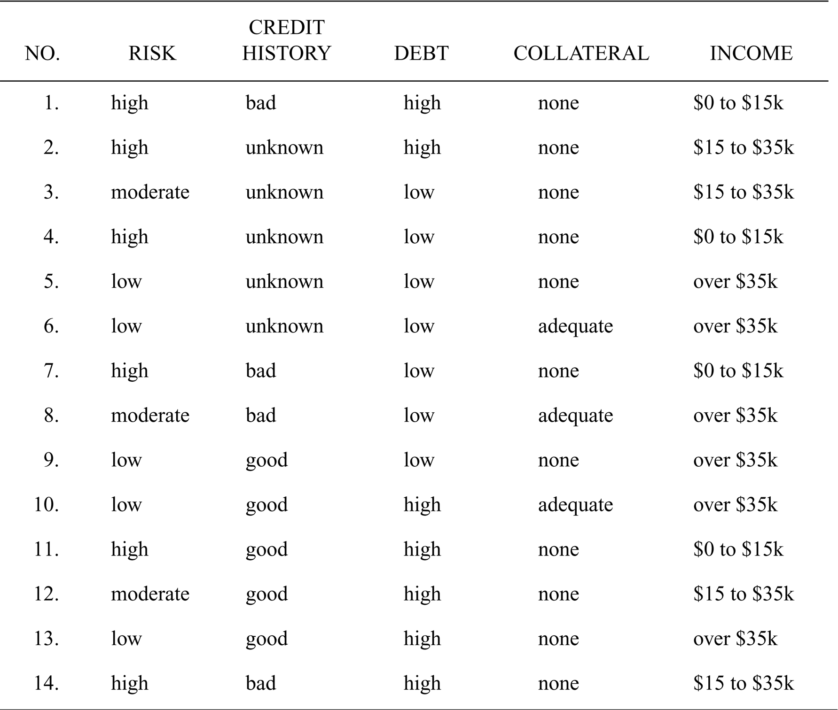

The task is to construct the decision tree for decision classes
RISK = high, RISK = low, and RISK = moderate
using the set of properties

Properties = { CREDIT HISTORY, DEPT, COLLATERAL, INCOME }

Show how this task can be achieved by using the ID3 algorithm.
As the method of the property selection, consider the following:

Selection method: Always select a property, which induces the smallest possible number of the new tree nodes requiring furter analysis (that is: new nodes, for which it is still impossible to determine a unique decision class).

Describe thoroughly every step of the ID3-based decision tree construction for this particular data set.

