M.Sc.Krzysztof Szklanny
Multimedia
Image Processing

Change two pictures(below):

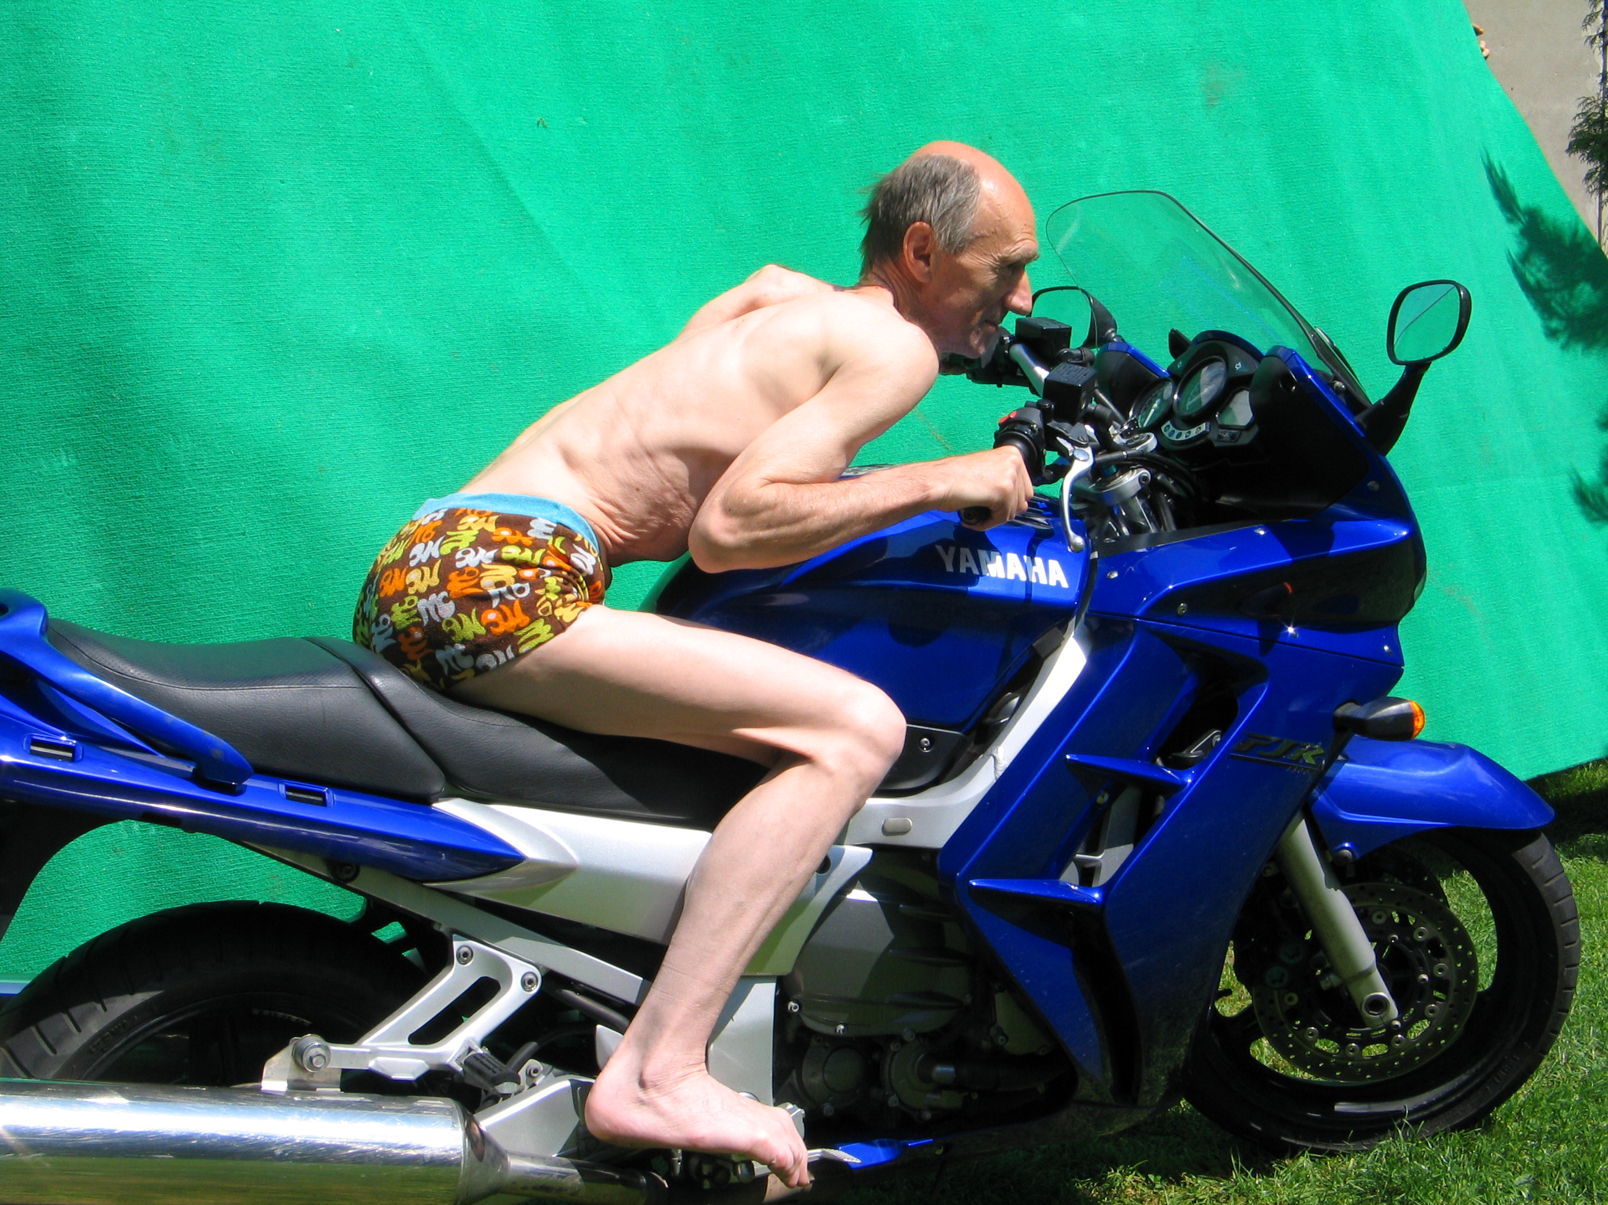

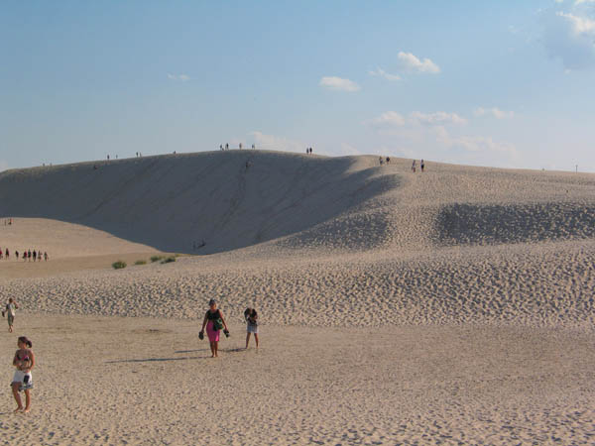

Into:

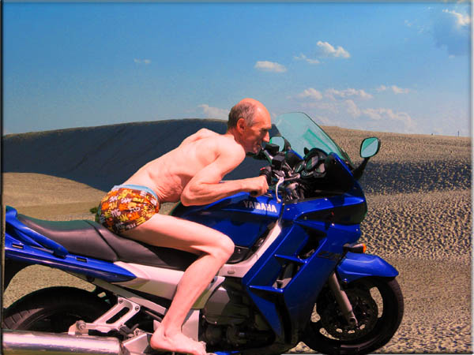

Step 1:

Hints:
Magnetic Lasso
Magic Wand Tool
Deleting Selection
Image-Adjustment-Replace Color
Erase Tool
Selection –Edge Modification – Select-Modify-Border

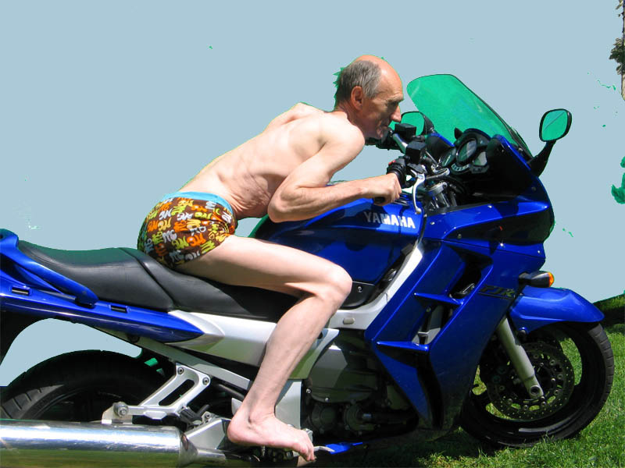

Step 2:

Grass removing - Erase Tool
Change of the wind-screen color - Replace Color or Magic Wand Tool+Paint Bucket Tool
Removing noises – Erase Tool;Clone Stamp Tool (Alt+click)
You can also play with adding hair, removing fat skin.

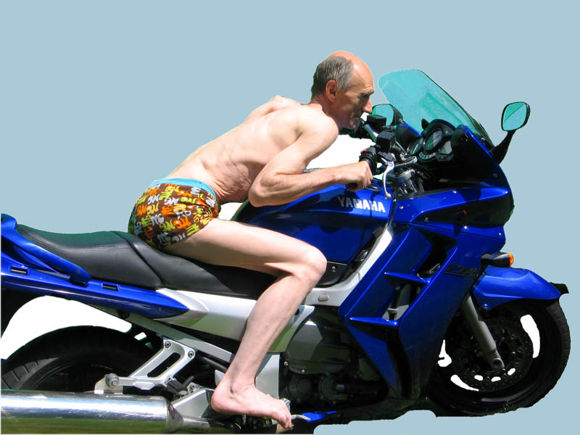

Step 3 :

Removing people – Clone Stamp Tool

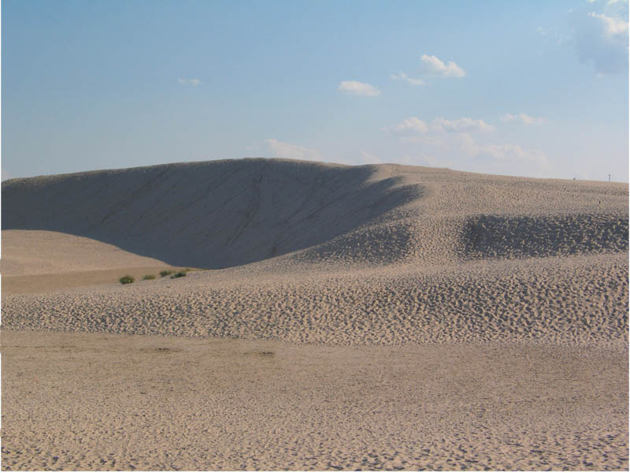
Step 4:

Modification of sky’s color into more saturated (Image adjustment Contrast;Hue/saturation;Variations)
Modification motor-driver color (skin)
Apply shadow to the picture
Adding perspective
Modification of the front wheel -Clone Stamp Tool
Merging layers -Image Merge Visible
Setting Levels for whole picture

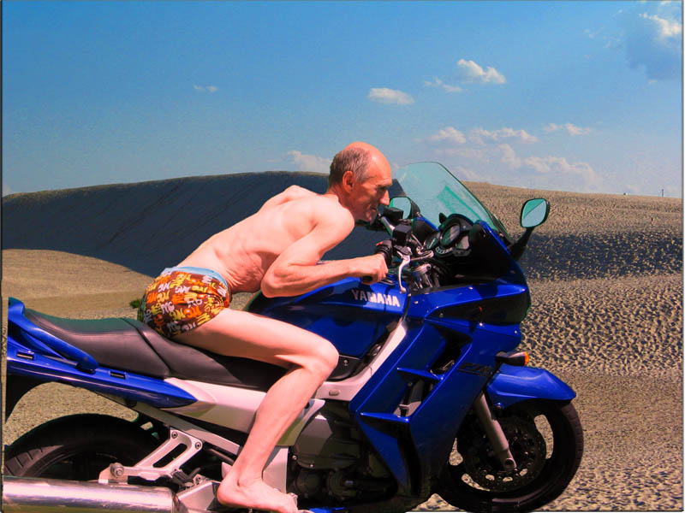

Step 5:

Adding Gradient-Gradient Tool
Frame-Eliptical Marquee Tool-Feataher 150 px - Inverse - Delete
Frame Effect–Texture-Texturizer
Layers Merging -Image Merge Visible
Setting Levels for whole picture

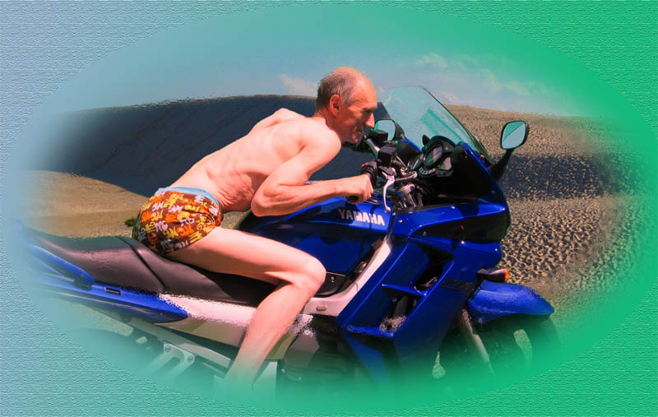
Modify the picture of „bad_kwiatki.jpg”:

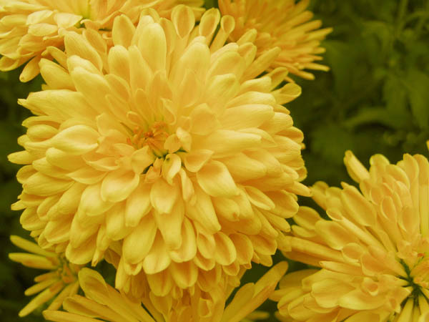

Into:
Hints-Use Variations (Image-Adjustment –Variations)

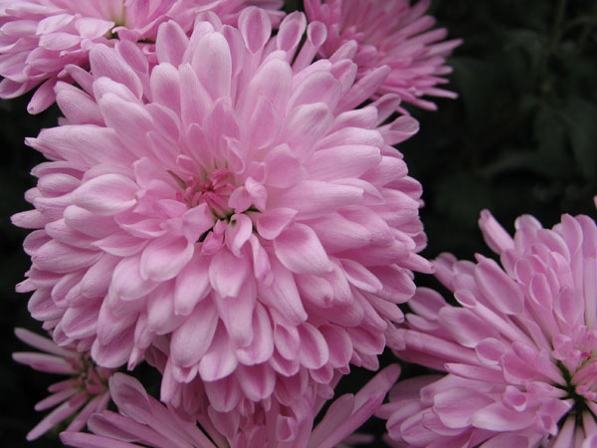

Use Image Adjustment-Hue-Saturation to :

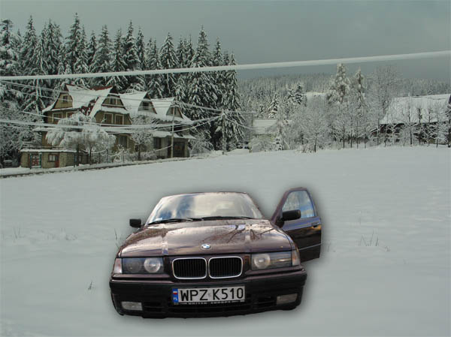

Get:

