### **An Overview of Bible Access in Afghanistan**

Afghanistan’s population exceeds 43 million, but the Christian community is estimated at only a few thousand, equivalent to less than 0.02% of the population. These believers, almost exclusively converts from Islam, remain one of the most hidden and at-risk faith communities in the world. Access to Bibles in Afghanistan is not merely limited; it is nearly impossible. Experts estimate that less than one-third of Afghan Christians have any access to Scripture, underscoring a very significant need.

All forms of Bible importation, printing, storing, distributing, or owning are illegal and punishable with severe consequences, including digital access. While foreign expatriates may be allowed to bring personal copies of the Bible in their own language, such exceptions do not extend to Afghan citizens. The Taliban’s return to power in 2021 has only tightened restrictions, enforcing a harsher interpretation of Islamic law and actively monitoring online activity. As a result, even reading the Bible on a mobile phone is widely considered unsafe. The risk is not just theoretical. Muslim Background believers or MBBs often face pressure from their own families, communities, and local authorities, and exposure can lead to forced marriage, imprisonment, or execution.

These restrictions are compounded by the country’s socio-economic challenges. Over half of Afghanistan’s population lives in poverty, and the country is experiencing a humanitarian crisis with nearly two-thirds requiring urgent aid. With only 18% of the country connected to the internet, and far fewer women using digital platforms, digital Bible access is not a reliable solution. Literacy presents another hurdle, as barely 40% can read, even including the younger population, meaning many grow up with limited educational opportunity and no spiritual resources. For women, the picture is even bleaker. Under Taliban rule, they are banned from attending secondary school or working with NGOs, making it nearly impossible for Christian women to find support or safe access to Scripture.

Further complicating access is Afghanistan’s fractured geography and displacement crisis. Over 3.2 million people are internally displaced, and hundreds of thousands have been deported from Iran and Pakistan in recent months. These refugee communities are often cut off from both infrastructure and networks of support, including Bible access. With tight Taliban control and rising surveillance, even underground church activity has become nearly undetectable, though it still exists.

### **What is Blocking Bible Access in Afghanistan?**

**An Underground Faith in a Hyper-Controlled State**

In Afghanistan, the barriers to Bible access are not merely institutional; they are existential. Christianity is officially denied and socially rejected, and under the Taliban’s strict enforcement of Islamic Sharia law, any form of conversion from Islam is considered apostasy, punishable by death.

Afghan Christians, almost all of whom are MBBs, must practice their faith in absolute secrecy, as even suspicion of possessing a Bible can trigger violent repercussions, arrest, or forced disappearance.

**Constant Surveillance and Fear**

Owning a Bible or even digital Christian materials is extremely dangerous. The Taliban conducts arbitrary phone checks and home raids, and in rural areas where tribal customs and surveillance are even stricter, Christians are often monitored by their own families, neighbors, and local religious leaders.

Any deviation from expected Islamic behaviors, such as failing to attend mosque regularly, can raise red flags, and MBBs risk being reported, interrogated, or executed, especially if found in possession of Scripture.

**Systemic Discrimination and Lack of Freedom**

At every level of life: private, family, community, national, and church, Christians are under intense pressure. They cannot legally register their faith, raise children in Christian values, or meet for worship, and there are no public churches. MBBs often hide their faith from their own families, fearing betrayal.

Attempts to share faith or disciple others are fraught with risk, and house churches, where they exist, operate in near-total isolation and silence.

**The Taliban’s Control Over Media and Education**

All media is state-controlled or heavily censored, and the Taliban has reinforced ideological control through the education system. Religious content in schools is strictly Islamic, and Christian parents must send their children to madrassas or risk exposing their faith.

Taliban propaganda also fuels suspicion against aid groups and NGOs, many of whom have had to suspend work due to restrictions, cutting off humanitarian avenues that might otherwise support Christian communities or discreetly distribute Bibles.

**Technological Limitations and Government Surveillance**

With only 18.4% of the population having internet access and widespread government surveillance through digital networks, even online Bible access is limited and risky. The Taliban has installed tens of thousands of surveillance cameras across Kabul and intends to expand this system nationwide.

Any engagement with Christian content, online or offline, can lead to investigation, especially since biometric data systems from the previous government are now reportedly accessible to Taliban authorities.

### **Unmasking the Forces That Restrict Bible Access in Afghanistan**

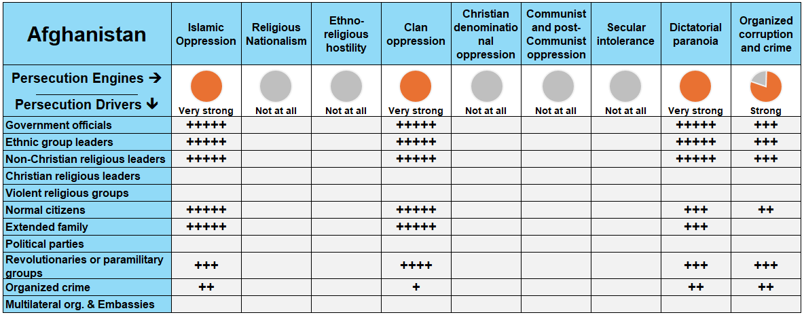

**Reference**: The more fully shaded the circle in orange, the stronger the level of persecution. The number of "+" signs indicates the frequency or intensity of the driving factors behind it.

In Afghanistan, multiple persecution forces operate simultaneously to restrict Bible access, including **Islamic** **oppression**, **dictatorial paranoia**, **clan oppression**, and **organized corruption and crime**. These forces are fueled by Taliban government officials, Muslim religious leaders, ethnic group leaders, ordinary citizens, and extended family members.

### **A Closer Look at Persecution Engines**

A persecution engine is the source of persecution in the country, while a persecution driver (or actor) is the one “driving” the persecution. Taking a closer look at these engines and drivers, in proper context, grants insight on how to solve the problems of Bible access in the country.

**Islamic Oppression: Criminalizing Christian Faith**

Under Taliban rule, Islamic oppression remains the most powerful persecution driver. Afghan citizens are assumed to be Muslim, and conversion to Christianity is seen as an act of treason and apostasy punishable by death. The Taliban government actively enforces radical Islamic law throughout the country, making any deviation from Islamic norms, including the possession or sharing of Bibles, extremely dangerous. MBBs must hide their faith at all costs; being discovered can lead not only to personal harm but also to repercussions against their family and community.

Moreover, Islamic religious leaders, empowered by the Taliban’s ideology, play an active role in monitoring and reporting on suspected MBBs. Mosque attendance is strictly enforced, and any irregularity can raise suspicion. This makes it extremely risky for Christians to possess Scripture, even in digital form, as arbitrary phone checks and local surveillance are common.

The broader radicalization of society under Taliban governance has increased the hostility toward anything perceived as Western, including Christianity and the Bible. Bible access is seen not just as a legal violation but as a betrayal of Afghan and Islamic identity.

**Dictatorial Paranoia: Crushing All Dissent**

The Taliban’s dictatorial rule exacerbates the risks Christians face. After the 2021 takeover, the Taliban dismantled Afghanistan’s constitutional protections and imposed strict Sharia law nationwide. This political environment leaves no room for religious minorities, particularly MBBs, to legally or socially exist.

In practice, this means there is no legal pathway for Christians to gather, distribute Bibles, or even privately own Scripture. Government officials, especially those tied to the Ministry for the Promotion of Virtue and Prevention of Vice, enforce ideological conformity through intimidation, arrests, and, at times, disappearances, and Christians caught with Bibles risk being branded as enemies of the state or agents of foreign powers.

Furthermore, access to information, including Christian materials online, is heavily monitored. While some digital avenues currently remain, the Taliban’s increasing investment in surveillance technologies poses a growing threat.

**Clan Oppression: Loyalty Over Faith**

Beyond governmental oppression, Afghanistan’s deeply entrenched tribal and clan-based society creates another powerful barrier. Loyalty to family, tribe, and ethnicity is paramount, and abandoning Islam is viewed as a betrayal of both religion and family honor.

MBBs face immense pressure from their extended families and local communities. Discovery of a Bible, even through a child, a neighbor, or a relative, can trigger violent retaliation meant to "restore honor". In many cases, families may enforce punishment, resulting in expulsion, forced marriage, imprisonment at home, or death.

This intense clan surveillance means that Bible ownership cannot simply be hidden by discretion. It requires complete concealment of one’s identity and faith life, leaving underground believers extremely isolated.

**Organized Corruption and Crime: Exploiting Vulnerability**

Although the Taliban has made efforts to reduce corruption, organized crime networks remain active, particularly in southern Afghanistan. In this environment, Christians are uniquely vulnerable.

Exposed believers may face extortion or be used as leverage by corrupt local officials, criminal gangs, or paramilitary groups. Smuggling Bibles, either physically or digitally, becomes even more perilous when combined with local corruption, leading to arbitrary arrest, imprisonment, or demands for bribes.

Additionally, Afghanistan’s significant economic collapse and widespread poverty have made survival the priority for most citizens. Amid this desperation, the economic value of turning in a suspected MBB, or exploiting one, has risen, making hidden Bible ownership even more precarious.

### **The Urgent Need for Bibles in Afghanistan**

Despite the long, rich history of Christianity in Afghanistan dating back to the second century, the Gospel has vanished from public view in modern times. Officially, the Taliban government denies the very existence of Christians in the country. Thousands of Christians remain hidden, living under the constant threat of exposure, imprisonment, or death.

For the existing but underground church, mostly made up of MBBs, **less than 10,000 Bibles** are required to meet the current needs of believers, many of whom have never held a copy of God’s Word in their hands.

**A Growing Church, A Growing Demand**

The need is magnified by the remarkable but silent growth of the church. Over the last five years, the Christian community has grown despite the climate of fear and the deadly consequences of conversion. This spiritual awakening has happened not through mass evangelism or visible outreach, but through secret Bible studies, radio broadcasts, and the quiet witness of believers willing to risk everything. To sustain and support this movement, access to Bibles is not just important, it is necessary.

**Bible Formats for Unique Needs**

In terms of format, digital access is a lifeline. **Bible apps**, especially in Dari and Pashto, are the most practical and least risky method of access, followed by **internet resources**. Printed Bibles, while dangerous to possess, remain valuable in certain secure settings.

**The Translation Gap**

Language remains a major obstacle. Christians in Afghanistan speak at least 26 languages. Of these languages:

* Only 15 have a full Bible translation.
* 2 languages have only the New Testament.
* 4 have only portions of Scripture translated.
* 5 more remain completely without a single verse of the Bible in their language.

This leaves entire communities without access to God’s Word in a form they can understand. For a faith that thrives on the personal reading and hearing of Scripture, this gap is critical.

### **The Clarion Call**

Afghanistan stands at a spiritual tipping point. In a country ravaged by war, ruled by fear, and choked by oppression, a quiet hunger for truth is growing. The underground church is not asking for safety or comfort; rather, they are asking for Bibles.

To the global Church, let us respond with urgency, creativity, and courage by laboring in prayer, funding translation projects, and supporting secure Bible distribution to ensure that no believer in Afghanistan is left without the living Word of God to sustain them in their darkest hour.

**How to Pray for Afghanistan:**

* **Pray for Internet Access**: Ask God to open safe digital pathways for believers to access the Bible discreetly and without risk.
* **Pray for Protection**: Intercede for the safety of Afghan Christians, especially women and youth, who are extremely vulnerable under the current regime.
* **Pray for Global Support and Innovative Strategies**: Ask for wisdom, courage, and creative solutions among global Christian networks to reach Afghan believers with Scripture despite restrictions.