### **An Overview of Bible Access in Azerbaijan**

Azerbaijan’s Christian population makes up an estimated less than 3% of its over 10 million people, numbering around a quarter of a million individuals. However, recent estimates show us that just a little less than 60% of these Christians have access to a Bible. This scarcity reflects not just a logistical gap but the result of an environment where Scripture is severely restricted by law, monitored by the state, and feared by many outside the Orthodox tradition.

Access to Bibles in Azerbaijan is heavily regulated by the government. Importing or printing Bibles legally requires a permit, which are rarely granted outside of the Russian Orthodox Church (ROC), which accounts for almost 90% of the Christian population. For all other churches, the process is prohibitive. Without the required state seal of approval, Bibles are deemed illegal, and possession can lead to fines or even imprisonment.

Only ROC congregations are generally permitted to store and distribute Bibles without harassment or bureaucracy. Other Christian communities, especially evangelicals and Muslim Background believers or MBBs, face routine surveillance and, in some cases, state-sponsored intimidation. Informers often infiltrate congregations, church leaders are summoned by police, and raids are not uncommon. For many, the fear of being caught with unapproved Scripture leads to secrecy, silence, or isolation.

Adding to these difficulties is the broader climate of fear and nationalism following the 2023 Nagorno-Karabakh offensive. In just two days, Azerbaijan reclaimed full control over the region, prompting thousands ethnic Armenian Christians to flee to Armenia. Following this, churches, religious buildings, and Christian homes were destroyed in what many describe as a systematic erasure of Christian presence, further deepening national pressure over Christianity.

### **What Is Blocking Bible Access in Azerbaijan?**

Despite Azerbaijan’s official status as a secular republic, the government imposes some of the most restrictive religious regulations in the region, making access to Bibles difficult, particularly for non-Orthodox Christian communities and Muslim Background believers or MBBs.

**Legal and Bureaucratic Barriers**

The root of Bible access restrictions lies in Azerbaijan’s legal framework and regulatory environment. According to the 2009 Law on Freedom of Religious Beliefs, all religious literature must undergo government approval before it can be published, imported, or distributed. These materials require a special stamp from the State Committee for Work with Religious Organizations (SCWRA), and permits for such activities are rarely granted, particularly for groups outside the ROC. For unregistered churches or groups with no legal recognition, the possession and distribution of Bibles, especially those without the official stamp, can result in heavy fines or imprisonment.

Furthermore, the printing of Christian materials is almost entirely restricted. While ROC congregations face fewer obstacles, non-Orthodox churches must navigate a burdensome and often opaque process. In many cases, even repeated re-registrations have led to de-registrations rather than approvals.

**Surveillance and Targeted Raids**

The Azerbaijani state maintains high levels of surveillance over all religious groups, particularly Protestant and Evangelical churches. These communities are often infiltrated by informants, and pastors are routinely summoned for interrogation. Even registered congregations face random raids. Christian activities not sanctioned by the government are considered illegal, and the confiscation of religious materials during raids is common.

This constant scrutiny has fostered a climate of fear and mistrust, with many church leaders and believers choosing to remain silent about their struggles. The oppressive atmosphere makes even small-scale Bible study gatherings risky, especially for MBBs who face pressure from both the state and their immediate social environment.

**Pressure on Muslim Background Believers**

MBBs face the harshest realities. Conversion is widely viewed as a betrayal of national identity and family honor. Families often respond with threats, isolation, or physical violence. Local imams and community leaders may incite pressure or social ostracism, and MBBs are sometimes denied burial rights in traditional cemeteries. Because of this, many MBBs hide their faith entirely, and owning a Bible can be interpreted as definitive evidence of apostasy.

**The Nagorno-Karabakh Factor**

The 2023 military operation in Nagorno-Karabakh led to the mass exodus of around 100,000 ethnic Armenian Christians and the subsequent demolition of churches and religious heritage sites. These actions have further limited access to Christian materials, including Bibles, in regions previously served by Armenian Apostolic institutions.

Though these events occurred outside the main urban centers where most Christians now live, they have deepened national suspicion of Christianity, especially anything perceived as Armenian or Western, further limiting access to Scripture in the region.

### **Unmasking the Forces That Restrict Bible Access in Azerbaijan**

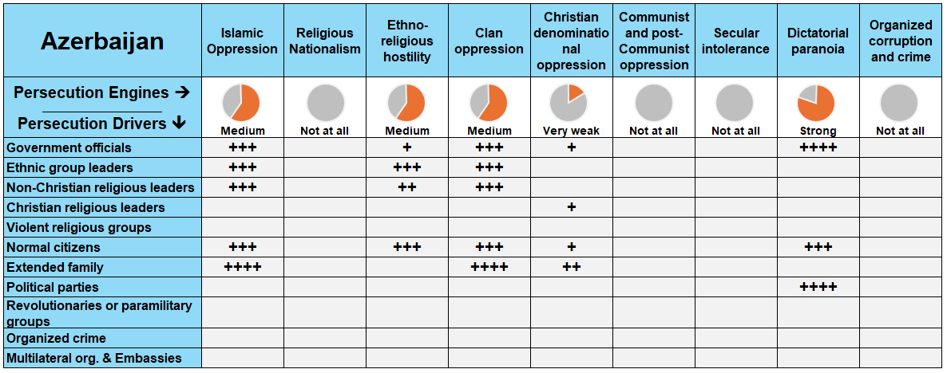

***Reference****: The more fully shaded the circle in orange, the stronger the level of persecution. The number of "+" signs indicates the frequency or intensity of the driving factors behind it.*

In Azerbaijan, multiple forces of persecution converge to limit Bible access, most notably **dictatorial paranoia, Islamic oppression** (often blended with **clan oppression**), and **ethno-religious hostility**. These engines are driven by government officials, political parties, religious leaders, local community members, and even one's own family.

### **A Closer Look at Persecution Engines**

A persecution engine is the source of persecution in the country, while a persecution driver (or actor) is the one “driving” the persecution. Taking a closer look at these engines and drivers, in proper context, grants insight on how to solve the problems of Bible access in the country.

**Dictatorial Paranoia: A State That Controls Religion**

The Azerbaijani government operates under a tightly controlled authoritarian regime that extends its grip over all religious activity. All religious literature, including Bibles, must be pre-approved and sealed by the State Committee for Work with Religious Organizations (SCWRA). Permits to print or import Scripture are almost never granted outside the Russian Orthodox Church. Possessing unsealed Bibles is illegal and punishable by fines or imprisonment.

In 2024, this control continued unabated. Churches reported being fined for possessing unauthorized materials, and religious gatherings of unregistered groups (especially Protestant) were raided and disrupted. The re-registration process remains a tool of attrition: over the years, many congregations have lost legal status simply because their applications are ignored or denied. Leaders of non-traditional churches are also subject to police interrogation, and the fear of surveillance discourages open Scripture sharing.

This tight control extends even to worship gatherings. For example, **a Baptist community in Aliabad was only allowed to meet one time per week for two hours**, after 25 years of denied registration, a vivid example of how the state suppresses access to God’s Word, even among long-standing communities

**Islamic Oppression Blended with Clan Oppression: Weaponizing Cultural Loyalty**

Although Azerbaijan is a secular republic, cultural and familial expectations reinforce Islam as the default identity. Muslim Background believers face the most intense persecution, not just from the state, but from their own families and communities.

In 2024, there have been confirmed examples that Muslim families continued to detain, beat, and ostracize MBBs when Bibles or other Christian materials were discovered. These aren’t isolated incidents. One known case involved a MBB being locked in a room by her family after a Bible was found, illustrating how Scripture possession itself becomes a flashpoint for cultural retaliation.

These pressures are not only personal, they are communal. Local imams preach against conversion, neighbors report Christians to authorities, and in rural areas, Christian burials are often denied, and children of believers are harassed in schools. MBBs are frequently forced into secrecy, becoming “hidden Christians,” unable to own or share Bibles openly.

#### **Ethno-Religious Hostility: Erasing Christian Presence**

Persecution escalated dramatically in areas formerly populated by Armenian Christians. Following Azerbaijan’s takeover of Nagorno-Karabakh in late 2023, widespread destruction of Christian heritage sites was reported throughout 2024.

* In **April 2024**, satellite images confirmed the **demolition of St. John the Baptist Church**, a 19th-century Armenian church in Shusha.
* By July 2024, hundreds of churches, schools, cemeteries, and Christian homes had been razed across the region. These were not war casualties; they were demolished during reconstruction, signaling deliberate cultural erasure.

Such acts send a chilling message: Christianity has no place here. For Christians in Azerbaijan, this hostility makes accessing Scripture in Armenian regions a near-dead end.

### **The Urgent Need for Bibles in Azerbaijan**

Against the backdrop of surveillance, censorship, and sectarian division, the Bible remains out of reach for many believers in Azerbaijan. According to research, at least **25,000 Bibles** can help bridge the gap to meet the current spiritual demand among the Christian population.

**A Growing Church, A Growing Demand**

While Azerbaijan’s Christian community is small, recent trends indicate a slow but steady growth. This growth, though modest, reveals a deep spiritual hunger and makes the need for Bibles even more critical. Without access to Scripture, the maturing faith of new believers, many of whom come from Muslim backgrounds, remains vulnerable in a hostile environment.

**Bible Formats for Unique Needs**

In terms of format, **printed Bibles remain the highest priority.** **Audio Bibles** are also a vital secondary format, particularly for believers who face risks owning physical copies or live in regions where gathering openly for discipleship is dangerous. Although mobile penetration is high, digital engagement is suppressed by surveillance and censorship, making offline formats essential.

**The Translation Gap**

Language diversity also plays a significant role. Christians in Azerbaijan speak at least 23 different languages. Of these languages:

* Only **15** languages have a full Bible translation.
* **4** languages have only the New Testament translated.
* **2** have only portions of Scripture translated.
* **2** languages still have no translation at all.

This means entire communities remain unreached by the Word of God in a form they can understand, meditate on, and share.

**The Clarion Call**

The need for Bibles in Azerbaijan is not just a statistical need we need to fulfill. It’s about the quiet courage of underground church leaders, the silent prayers of brothers and sisters, and the resilience of families trying to raise their children in faith amid growing repression. Azerbaijan is a nation in need of hope, and the Bible brings that hope.

**Now is the time for the global Church to respond.**

By prioritizing translation efforts, investing in discrete distribution strategies, and resourcing churches with Scripture in every format they can safely engage in, we can ensure no believer in Azerbaijan is left without access to the life-transforming power of God’s Word.

**How to Pray for Azerbaijan**

* **For Innovative Opportunities to Access Bibles**Pray for open doors, both literal and digital, that allow Bibles to reach beyond state restrictions. Ask God to inspire creative and secure means of distribution for believers, especially those outside of the Orthodox tradition and in rural areas.
* **For Peace and End of Conflict**Pray for continued peace in the Nagorno-Karabakh region and for healing between ethnic and religious communities. Ask for reconciliation that can make space for religious freedom and access to God’s Word.
* **For Global Support and Resources**Pray that international partners and ministries would rise to meet the unique challenges in Azerbaijan, from translation and printing needs to discreet digital strategies that can bring God’s Word to isolated believers and seekers.