### **An Overview of Bible Access in Burkina Faso**

Burkina Faso’s Christian population comprises nearly 6.2 million believers, around 26% of the national population of almost 24 million people. Yet, despite this sizable community, Bible access remains a significant challenge due to considerable restrictions. Estimates suggest that barely 1 of 5 Christians have direct access to the Word of God, underscoring a pressing need across the nation.

While importing Bibles into the country remains possible, primarily through the capital, Ouagadougou, this alone does not guarantee distribution. Almost half of the country is impacted by the terror and violence of jihadist groups such as JNIM, ISWAP, Boko Haram, and Ansaroul Islam. In these regions, it is dangerous to own, store, or distribute Bibles. Approximately half of the Christian population of Burkina Faso live in these regions and face life-threatening risks for even possessing Scripture. Reports have documented cases of churches being burned down with Bibles destroyed, congregations attacked during worship, and believers displaced en masse due to their faith.

The security situation has dramatically worsened in recent years. Since 2015, Burkina Faso has been gripped by a devastating insurgency. More than 2 million people are internally displaced, and militant jihadist groups now exert their influence and terror in significant portions of the north, east, and increasingly, the central corridor of the country. In these areas, distributing or even visibly owning a Bible could provoke abduction, assault, or worse.

Though there is no official government restriction on owning Christian literature, the volatility of these regions makes safe Bible delivery nearly impossible. Furthermore, Christians from a Muslim background face added pressure, not only from militant groups but also from their own families and communities. Muslim Background believers or MBBs often hide their faith to avoid forced marriage, ostracism, or physical violence.

Beyond the security threats, widespread poverty and infrastructural limitations deepen the crisis. Roughly 80% of the population practices subsistence farming. Literacy stands at barely 50%, and only around 20% of the population has access to the internet. These conditions severely limit the effectiveness of digital, or even printed, Bible distribution.

### **What’s Blocking Bible Access in Burkina Faso?**

**A Nation in Crisis**

Bible access in Burkina Faso is severely hindered by a volatile mix of lack of security, displacement, and economic hardship. Over the past few years, jihadist groups have expanded their influence through terror, particularly in the northern and eastern regions, where violence and intimidation are widespread.

In these areas, Christians are often targeted explicitly because of their faith. Churches have been burned, believers abducted or killed, and entire communities forced to flee. According to recent reports, over 10,000 Christians were displaced for faith-related reasons in just one year.

**Daily Risks for Bible Access**

In territories where jihadist are active, simply owning or reading a Bible can be a death sentence. Believers risk being monitored, abducted, or even executed. Christians are often afraid to express their faith publicly, much less store or distribute Scripture. Homes and churches have been looted or destroyed, and access to Christian media, whether online or in print, is extremely limited due to security risks and fear of reprisal.

**Displacement and Infrastructure Breakdown**

Waves of violence have created a humanitarian crisis. As of early 2024, more than 2 million people, nearly 10% of the population, are internally displaced, with many Christians among them. IDP camps offer little safety or spiritual resources. Infrastructure has collapsed in many regions, with over 5,000 schools and hundreds of health centers shut down due to conflict.

These closures also affect Christian schools and churches, further obstructing Scripture access and discipleship efforts.

**Poverty and Digital Limitations**

Burkina Faso is one of the world’s least developed countries. Nearly 40% of the population lives below the poverty line, and most depend on subsistence farming. Bibles are unaffordable luxuries for many. Compounding the issue is the digital divide, barely 20% of the population has internet access, and Christian content online is often blocked or surveilled in hostile zones. In rural regions, there is little to no digital infrastructure to support access Scripture online.

### **Unmasking the Forces That Restrict Bible Access in Burkina Faso**

***Reference:*** *The more fully shaded the circle in orange, the stronger the level of persecution. The number of "+" signs indicates the frequency or intensity of the driving factors behind it.*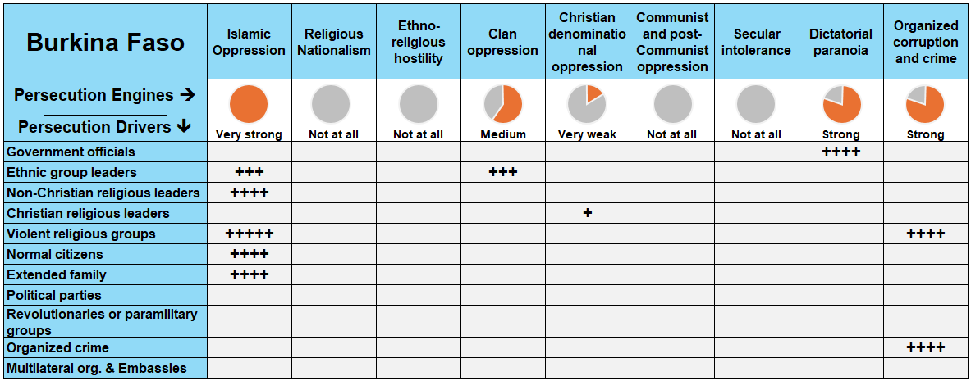

In Burkina Faso, multiple forces of persecution work in tandem to restrict Bible access, most notably: **Islamic oppression, dictatorial paranoia, organized corruption and crime, and clan oppression.** These are driven by violent Islamic groups, ethnic leaders, government officials, and even family members. Their combined influence has created a deeply hostile environment for Christians, especially in the north and east, where violence, fear, and displacement have become a part of daily life.

### **A Closer Look at Persecution Engines**

A persecution engine is the source of persecution in the country, while a persecution driver (or actor) is the one “driving” the persecution. Taking a closer look at these engines and drivers, in proper context, grants insight on how to solve the problems of Bible access in the country.

**Islamic Oppression: A Jihadist Campaign Against Faith**

Islamic oppression is the most dominant force restricting Bible access in Burkina Faso. Since 2016, jihadist groups such as *Ansar ul Islam, JNIM, and Islamic State Sahel Province* have launched violent efforts to “Islamize” the country, often through horrific attacks specifically targeting Christians. In the past year alone:

* **In Essakane (Feb 2024):** Militants stormed a Catholic church during worship, killing 15.
* **In Sanaba (Aug 2024):** 26 Christian men were tied up and their throats slit in front of others gathered for a Sunday service.

In many cases, entire Christian communities are forcibly displaced, churches are burned, and MBBs are ostracized or threatened with death. The use of roadblocks and checkpoints by militants often results in Christians being identified and either kidnapped or executed on the spot.

These conditions leave believers afraid to gather, carry Bibles, or even access Christian material online, severely limiting Bible distribution efforts and access to Scripture in many war-afflicted regions.

**Dictatorial Paranoia: Silencing Christian Witness**

The military regime in Burkina Faso, led by Captain Ibrahim Traoré, actively suppresses dissent and has created an environment where Christian voices are marginalized. Government officials pressure church leaders to avoid public discourse on justice or national policy. Those who speak out risk being branded enemies of the state.

Even worse, the regime has criminalized criticism of the military, preventing humanitarian organizations from negotiating access to affected communities. This makes Bible distribution campaigns nearly impossible in conflict-affected areas and fuels a culture of fear among church leaders, many of whom have been targeted or abducted by armed groups.

**Organized Corruption and Crime: Lawlessness and Impunity**

In many regions of Burkina Faso, criminal networks and jihadist groups operate with impunity. These groups exploit the country’s weak rule of law to carry out kidnappings, extortion, and looting of Christian properties. In 2024 alone, at least 100 churches were attacked or destroyed.

Foreign aid workers, many of whom are Christian, have also been kidnapped for ransom, further discouraging humanitarian involvement and complicating Bible delivery efforts. In some areas, a *parallel state structure* has formed, where militants replace local governments and impose strict religious laws, banning Christian worship and eliminating any form of Bible access.

**Clan Oppression: Pressure from Within**

In rural and tribal communities, clan and family structures are deeply tied to Islamic tradition. MBBs face harassment, forced marriage, and loss of inheritance from their own families. In some cases, female MBBs are married off to Muslim men against their will, while Christian men are cast out of their families or denied community resources.

Christian children are often pressured into Islamic instruction at school or denied access to education altogether. These dynamics prevent families from raising their children in the Christian faith or passing down Bibles for generational discipleship.

### 

### **The Urgent Need for Bibles in Burkina Faso**

Against the backdrop of persecution, displacement, and poverty, Bible access in Burkina Faso remains critically low. To address this, **up to 3 million Bibles** are urgently needed to meet the spiritual needs of both new and established believers across the nation.

**A Growing Church, A Growing Demand**

Despite the escalating violence, the Church in Burkina Faso has expanded over the past five years, a testament to the resilience and hunger for faith among the people. This encouraging growth adds to the urgency of supplying Bibles.

As more believers come to faith, the gap between spiritual hunger and Scripture availability continues to widen. Equipping this expanding body with the Word of God is essential for discipleship, encouragement, and endurance under persecution.

**Bible Formats for Diverse Needs**

**Printed Bibles** remain the most critical format, especially in rural and areas where jihadists are active and electricity and internet access are unreliable or nonexistent. **Audio Bibles** serve an equally vital role, especially in communities with low literacy rates or for displaced Christians living in camps where printed materials are impractical.

While digital Bibles are helpful in urban centers, security concerns and low internet penetration (just under 20%) severely limit their usefulness in high-risk zones.

**The Translation Gap**

Language diversity poses a major barrier to Scripture access. Christians in Burkina Faso speak at least 76 languages. Of these languages:

* Only **20** of these have a full Bible translation
* **24** have only the New Testament
* **14** have just portions of Scripture translated
* **18 languages with no translation whatsoever.**

For many believers, this means they have no access to God’s Word in a language they can understand or relate to. Ongoing translation work and the distribution of mother-tongue Bibles are urgently needed to bridge this gap.

### **The Clarion Call**

The need for Bibles in Burkina Faso is more than a matter of logistics; it is a spiritual emergency. In a country where believers are hunted, displaced, and often left to worship in hiding, the Word of God is a lifeline. It brings hope to the persecuted, guidance to the displaced, and strength to the growing Church.

**How to Pray for Burkina Faso**

* **Protection and Safety:** Pray for God’s protection (Psalm 91) over believers, especially those in areas where owning a Bible could cost them their life. Ask the Lord to make a way for Scripture to reach them—even under the radar of violent actors.
* **Peace and Freedom:** Ask God to bring an end to the violence. Pray for lasting peace across Burkina Faso so that believers can read, share, and live out the Word of God freely.
* **Global Partnerships and Support:** Pray for the global Church to rally in bold support, mobilizing the resources, partnerships, and innovative solutions needed to deliver Bibles into dangerous and hard-to-reach areas.