### **An Overview of Bible Access in Brunei**

Brunei’s Christian population comprises roughly 12% of its nearly 460,000 inhabitants, amounting to an estimated 55,000 believers. On the surface, it may seem that many Christians in Brunei have decent access to the Bible (an estimate of over 70% of believers). However, the reality on the ground shows a stark reality. Severe legal and societal restrictions make access fragile and often dangerous, especially for Muslim Background believers (MBBs) and indigenous believers whose heart language is Malay.

Islam is not just the state religion in Brunei; it is inseparably woven into national identity through the national philosophy, which enshrines Malay ethnicity, Islamic faith, and monarchical rule as pillars of public life. Under this ideology, Sharia law is enforced nationwide. Furthermore, Sharia law criminalizes the distribution or propagation of any non-Islamic religion, including the possession or sharing of Bibles in the Malay language. Violations can lead to confiscation, imprisonment, or steep fines, with penalties reaching up to five years in prison.

Bibles are allowed only within limited contexts. Christians may possess personal copies at home or within church buildings, but any form of distribution, public display, or sharing is tightly controlled. Importing Bibles, especially the Bahasa Malayu translation, is officially banned, and Christian bookstores that once existed have been shut down. There is no legal provision for public Christian literature or online promotion. Surveillance is common, and digital activity, including Bible downloads, is monitored by government authorities, forcing many Christians into self-censorship and secrecy.

Non-Malay ethnic groups and expatriate Christians face somewhat less scrutiny, but indigenous groups, especially those whose native language is Malay, are under strict religious mandates. By law, all ethnic Malays are considered Muslims from birth, and conversion is not recognized. This makes the possession of a Bible in Malay an offense for these believers. For Muslim-background believers and tribal Christians, the danger of fines, arrest, and social ostracism is constant. While some churches may store Bibles for limited use within congregations, even this is vulnerable to confiscation under Sharia enforcement.

### **What’s Blocking Bible Access in Brunei?**

**A Nation Bound by Religious Control**

In Brunei, Bible access is heavily restricted by a legal and political framework designed to reinforce Islamic dominance. The country operates under the national ideology of *Melayu Islam Beraja* (Malay Islamic Monarchy or MIB), which blends Malay identity, Islamic faith, and loyalty to the Sultan. Under this system, Islam is deeply entrenched in daily life, law, education, and governance.

While Christianity is technically permitted, the Sharia Penal Code (SPC), which applies to both Muslims and non-Muslims, imposes severe restrictions on religious expression. Public celebrations of Christianity, including Christmas, are banned, and importing Bibles is prohibited. Christians must practice their faith discreetly to avoid running afoul of laws prohibiting evangelism or public expressions of non-Islamic religions.

**Daily Pressures and Legal Threats**

Christians in Brunei, particularly MBBs, face intense surveillance and social pressure. Sharing faith publicly, posting Christian content online, or even wearing Christian symbols like a cross necklace can result in harassment, fines, or imprisonment. MBBs risk severe penalties under Sharia law, including imprisonment, physical punishment, or forced rehabilitation if their change of faith is discovered.

Church gatherings are closely monitored, and unregistered Christian groups cannot legally establish themselves. Even recognized churches operate under tight restrictions and must routinely submit detailed reports to government authorities.

**Islamization Through Education and Society**

A more subtle but powerful barrier comes through the education system. In November 2023, Islamic religious education was made compulsory even in private and international schools. All students, including Christians, must participate in Islamic practices like the recitation of Quranic verses, contributing to the erosion of distinct Christian identity among young believers.

Additionally, Christians often face pressure to conform socially, such as attending Islamic ceremonies or adhering to Islamic customs, further marginalizing non-Muslim religious life.

**Economic and Social Disadvantages**

Beyond legal and societal pressures, economic incentives further block Bible access. State-supported efforts to convert non-Muslims, especially among indigenous groups, offer financial rewards and social benefits for embracing Islam. Christians face discrimination in employment, public service opportunities, and business activities, making it harder for churches and believers to thrive.

### **Unmasking the Forces That Restrict Bible Access in Brunei**

***Reference:*** *The more fully shaded the circle in orange, the stronger the level of persecution. The number of "+" signs indicates the frequency or intensity of the driving factors behind it.*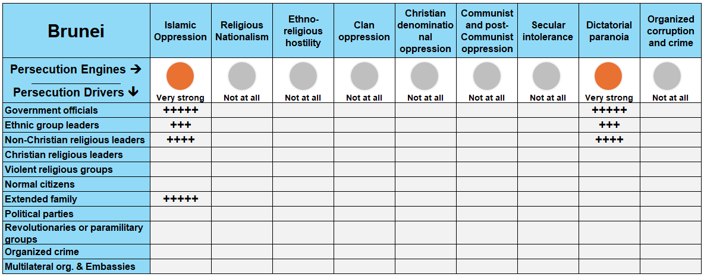

In Brunei, two primary persecution engines, **Islamic oppression** and **dictatorial paranoia**, converge together to restrict Bible access. These engines are driven by government officials, non-Christian religious leaders, ethnic group leaders, and even extended family members. Together, they create an environment of legal intimidation, constant surveillance, and systemic discrimination against Christians, especially MBBs.

### **A Closer Look at Persecution Engines**

A persecution engine is the source of persecution in the country, while a persecution driver (or actor) is the one “driving” the persecution. Taking a closer look at these engines and drivers, in proper context, grants insight on how to solve the problems of Bible access in the country.

**Islamic Oppression: Religious Conformity by Force**

Islamic oppression in Brunei is deeply woven into national identity through the **Malay Islamic Monarchy** philosophy, which elevates Islam as the moral and spiritual backbone of public life. The state actively promotes Islam through mandatory education, state-sponsored media, and aggressive "dakwah" (Islamic proselytization) initiatives, especially in rural districts like **Temburong** and **Tutong**, where Christians are offered welfare incentives to convert.

Christian evangelism and public faith expression are banned outside of church premises. Public displays such as wearing a cross or celebrating Christmas are subject to legal penalties, and even private religious discussions risk being labeled as “propagation” of a non-Islamic religion—an offense that can lead to imprisonment or hefty fines.

MBBs, are the most targeted. Conversion is both socially dishonorable and legally punishable under **Sharia Penal Code Section 112(1)**, which permits imprisonment or even the death penalty, although it has not been enforced to date. Extended families often act as frontline enforcers of religious conformity, reporting MBBs to the Ministry of Religious Affairs or local security services.

**Dictatorial Paranoia: Absolute Control Through Religion**

Brunei has been under a declared **State of Emergency since 1962**, consolidating all power under the Sultan, who is simultaneously the head of religion, government, and military. This centralization enforces the Islamic agenda and suppresses dissent. Religious enforcement officers routinely monitor church activities, particularly those of unregistered or non-traditional congregations. A recent example includes a **Catholic priest being barred from entering Temburong district** after suspicions of evangelism.

Under the guise of preserving harmony and tradition, **public criticism, even on social media**, is viewed as sedition and an affront to the Sultan himself. This creates widespread self-censorship among Christians, who avoid sharing Scripture online or even discussing their faith publicly, even in coded language.

Educational reforms implemented in **November 2023** further entrenched the state's religious dominance by making **Islamic education compulsory** for all students, including in private and international schools. Christian children are now required to participate in Islamic prayers and studies, eroding their religious identity from a young age.

Even practical matters like church registration and Bible importation are affected by the system. Only six churches are officially registered, and no new applications are accepted. Christian literature, including Bibles, is routinely confiscated at airports, and importing printed materials is banned.

### **The Urgent Need for Bibles in Brunei**

With a Christian population of approximately 55,600, this leaves thousands without access to the Word of God. According to recent estimates, less than **10,000 Bibles** are needed to meet the current need; and another couple of thousand to support seekers (those who are looking to explore the Christian faith). While the number may appear small in comparison to other nations, the obstacles facing believers in Brunei make every single copy deeply treasured.

**A Growing Church, A Growing Demand**

The urgency is heightened by some growth in the Christian population over the past five years. Despite tight government controls and societal pressure to conform to Islamic norms, the Church continues to grow quietly and steadily. This growth, however, outpaces the availability of Bibles, creating a critical gap in spiritual need, discipleship, and evangelism. Without an increase in accessible Scripture, the expanding Christian community is left vulnerable and spiritually under-resourced.

**Bible Formats for Unique Needs**

For Brunei, **printed Bibles remain the top priority**, especially for MBBs and house churches that must operate discreetly under strict religious laws. However, **digital access is increasingly viable**. With internet penetration at 99%, many believers, particularly the younger generation, turn to online platforms to read Scripture.

While Christian websites and Bible apps are subject to monitoring, they can still be accessed safely with discretion and care. In this environment, print offers privacy and permanence, but digital formats provide a crucial secondary lifeline, especially for those unable to obtain a physical copy.

**The Translation Gap**

Language remains another significant factor. Brunei’s Christians speak at least **26 different languages**. Of these languages:

* Only **15** of those have the full Bible translated.
* **4** have translations of only the New Testament.
* 1 has only a portion of Scripture translated.
* **6 languages still have no translation at all.**

For believers in these communities lacking translations, the Word of God remains inaccessible in the language of their hearts, a gap that urgently needs to be addressed through translation support.

### **The Clarion Call**

Brunei may be a small country, but the need is no less significant. The cry for Scripture echoes from quiet living rooms, discreet fellowship groups, and the hearts of new believers who risk much to follow Christ. The need for Bibles in Brunei is not just a logistical issue, it is a matter of spiritual survival.

**How to Pray for Brunei**

* **Opportunities to Access Bibles:** Pray for the doors of opportunity to swing wide open, allowing the Word of God to reach the hands and hearts of every believer in Brunei. Ask for innovation and courage to overcome the restrictive barriers, ensuring that every Christian can freely access the Bible to nourish their faith and spiritual life.
* **Growth and Influence of the Church:** Seek the Lord’s intervention for the church in Brunei to flourish beyond the confines of stringent legal restrictions. As they get access to more Bibles, pray for growth not just in numbers, but in influence, enabling the church to become a voice of transformation.
* **Global Partnership and Support:** Pray for strong, global partnerships to enable increased Bible access and support to the local church. May these collaborations pave new ways for Bible access and fortify the church’s presence, ensuring that the life-giving message of the Gospel spreads across the country.