### **An Overview of Bible Access in Bhutan**

Bhutan’s Christian community comprises approximately 2.4% of the nation’s 792,000 inhabitants, equating to a minority just shy of 20,000 believers. Yet, it is estimated that roughly half of these believers have access to a Bible, leaving the other half without access to the Scriptures.

At first glance, Bhutan’s infrastructure seems well-positioned to support Bible access. The majority of the population has access to electricity, and nearly 90% benefit from internet connectivity, offering a potential platform for digital Scripture distribution. However, these opportunities are sharply constrained by Bhutan’s stringent religious restrictions. A literacy rate of just over 70% further complicates the situation, creating barriers to both printed and digital Bible formats for much of the population.

Religious freedom and access to Bibles in Bhutan is tightly regulated, particularly for the Christian minority. While expatriates are permitted a personal Bible, they are strictly prohibited from storing or distributing Scriptures. Bhutanese citizens face even harsher restrictions under anti-conversion laws, which criminalize activities such as sharing Bibles or Christian materials. These laws not only ban the import, printing, and distribution of Bibles but also create a climate of fear, leaving many believers unable to freely practice their faith or access God’s Word. In light of the situation in Bhutan, research reveals a significant need for Bibles, numbering close to 10,000.

### **What’s Blocking Bible Access in Bhutan?**

#### **Religious Nationalism and Cultural Dominance**

Bhutan’s identity is deeply intertwined with Mahayana Buddhism, which is the country’s state religion. While the government asserts religious tolerance, Buddhism’s dominance permeates Bhutanese society. This is evident in the integration of religious and administrative roles within local governance, where Buddhist monks hold significant influence.

Christians are not officially recognized as a religious group, and no Christian congregation has been allowed to construct church buildings, forcing them to worship in private homes. Converts, especially face significant pressure from family and community members to return to Buddhism or their original faith.

#### **Legislative and Legal Barriers**

Laws restricting religious freedom severely impede Bible access in Bhutan. Anti-conversion laws, introduced in 2011, criminalize any act perceived as coercing or inducing someone to change their religion. The terms “coercion” and “inducement” are vaguely defined, granting authorities broad discretion to interpret and enforce these laws.

As a result, Christians are cautious about openly practicing their faith or distributing Bibles, as such activities are easily construed as proselytization, punishable by fines or imprisonment.

#### **Social Stigma and Family Opposition**

Christian converts face the strongest opposition from their families, who view conversion as a betrayal of Bhutanese culture and traditions. This cultural rejection often results in disownment, exclusion from inheritance rights, and loss of family support.

In Bhutan’s communal society, such isolation is particularly devastating. Additionally, local communities often view Christians with suspicion, reporting them to authorities or ostracizing them for disrupting social harmony.

#### **Economic Discrimination**

Christians frequently experience discrimination in employment and access to public services. Many jobs and benefits require a "non-objection certificate" (NOC) issued by local authorities. Known Christians often struggle to obtain these certificates, barring them from opportunities such as property registration, loans, and higher education.

This systemic bias not only impacts individual livelihoods but also restricts the broader Christian community’s growth and access to resources, especially Bibles.

#### **Risk of Possessing and Sharing Bibles**

Owning a Bible or other Christian materials in Bhutan carries inherent risks. Authorities and community members closely monitor Christians, often confiscating religious materials found during inspections or raids. Publicly displaying Christian symbols, such as crosses, invites suspicion and harassment.

Digital access to Bibles is equally fraught, as Christians fear scrutiny of their online activities, which could lead to accusations of promoting Christianity or attempting conversions.

### **Unmasking the Forces That Restrict Bible Access in Bhutan**

The chart below provides a visual representation of the forces of persecution that heavily restrict Bible access. The more fully shaded the circle in orange, the stronger the level of persecution. The number of "+" signs indicates the frequency or intensity of the driving factors behind it.

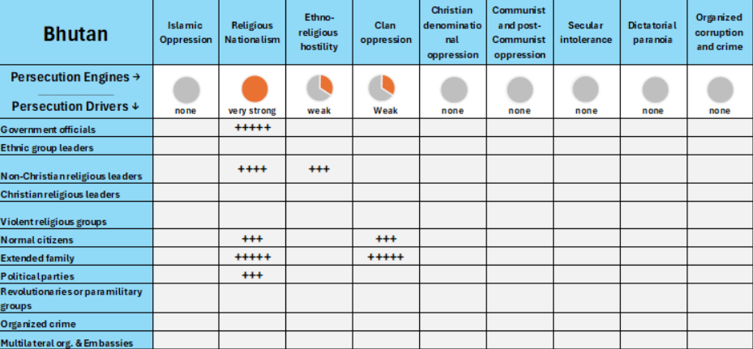

As you can see in the chart, the main source of persecution engine identified in Bhutan is **religious nationalism**, and the main drivers are **government officials** and **extended family.** There is also **clan oppression** driven by **extended family**. But primarily, the government, Buddhist leaders, families, and broader society act as key drivers, perpetuating pressure across every sphere of life for Christians in Bhutan​.

#### **A Closer Look at Persecution Engines**

A persecution engine is the source of persecution in the country, while a persecution driver (or actor) is the one “driving” the persecution. Taking a closer look at these engines and drivers, in proper context, grants insight on how to solve the problems of Bible access in the country.

**Religious Nationalism**

The dominance of Mahayana Buddhism is deeply rooted in Bhutan’s identity, enshrined in Article 3 of the Constitution, which calls Buddhism the "spiritual heritage" of the nation. Religious institutions are tasked with promoting Buddhist values, and the close intertwining of religion and government ensures systemic discrimination against other faiths.

Christians, in particular, face challenges such as the inability to legally register churches, obtain property for worship, or openly distribute Christian materials. These institutionalized restrictions are often reinforced by local authorities and Buddhist monks, especially in rural areas, who oppose the presence of Christians​.

Government officials play a central role in restricting Bible access. They actively ensure that Christian activities are limited, often by denying Christians access to essential documents like non-objection certificates (NOC) required for employment, education, and property ownership. This systematic marginalization isolates Christians from the ideal public life.

**Social and Familial Pressure**

In Bhutan’s communal society, conversion to Christianity is seen as a betrayal of familial and cultural values. Converts are often subjected to intense pressure from their families to return to Buddhism. Families may disown converts, cutting them off from communal and financial support.

This pressure is further intensified by local communities, where Christians are often seen as disruptors of societal harmony. As a result, many believers are compelled to practice their faith in secrecy. Reports indicate that Christians frequently engage in self-censorship, meaning that even those who own a Bible are unlikely to reveal it openly. This deeply entrenched caution significantly compounds the already challenging barriers to accessing Bibles.

**Discrimination in Daily Life**

Christians in Bhutan frequently face discrimination in education and employment. Children of Christian families are often bullied in schools and excluded from extracurricular activities. Employment prospects for Christians are limited, as many jobs require recommendations or approvals from local leaders who are biased against non-Buddhists.

Even in urban areas where digital access is higher, Christians risk backlash for engaging with or distributing digital Bible content​.

The combination of governmental barriers, societal hostility, and familial rejection creates an environment where accessing and sharing the Bible is fraught with risk. While it is technically possible to access Bibles online, doing so must often be done in secrecy to avoid attracting negative attention, further highlighting the precarious situation for Christians. This underscores the urgent need to address these forces, ensuring that Bhutanese believers can safely access God’s Word without fear or restraint.

### **The Urgent Need for Bibles in Bhutan**

Despite Bhutan’s small Christian community of approximately 18,800 believers, the need for Bibles remains critical. With roughly half of the Christian population estimated to have access to the Scriptures, there is an unmet demand for up to 10,000 additional copies. These needs primarily arise within Protestant congregations, as Catholics form a smaller proportion of the Christian population in Bhutan​.

#### **Specific Needs by Format and Language**

The preferred format for Bibles is to have printed Bibles due to their accessibility. However, audio Bibles and Bible apps are also essential, particularly for younger, tech-savvy individuals who benefit from Bhutan’s relatively high internet penetration.

The full Bible is translated in Dzongkha, the national language of Bhutan, and most believers speak this language. However, all of the local believers speak a total of 27 different languages. Out of the 27, only 8 have a complete Bible translated, 8 have only the New Testament, 1 has partial translations, and 10 languages have no Scripture translations at all​.

#### **Additional Needs for Seekers**

Beyond the existing Christian population, there is an opportunity to reach an estimated 2,500 spiritual seekers who would benefit from access to Bibles​. Providing Scripture for these individuals requires careful consideration of formats and content to engage and nurture their curiosity about the Christian faith.

#### **The Clarion Call**

The urgency for Bibles in Bhutan reflects more than a logistical need; it is a spiritual imperative. Addressing these needs requires prioritizing printed Bibles, supporting translation efforts into underserved languages, and innovating with audio and digital formats. With concerted global efforts, every believer and seeker in Bhutan can experience the transformative power of God’s Word.

**How to Pray for Bhutan**

* **For Courage and Provision:** Pray that the believers in Bhutan find the courage to sustain their faith amidst restrictions. May they miraculously find Bibles that not only strengthen their faith but also empower them to build God's kingdom within their communities.
* **For Change in Legislation:** Pray that the government sees followers of Christ not as a threat but as a community capable of contributing positively to Bhutanese society. May there be a divine shift with the current laws in place in order to allow Bibles and Christian literature into the country.
* **For Global Partnerships:** Ask for God's hand in bringing together the global Christian family, inspiring movements and partnerships aimed at supporting the Bhutanese