### **An Overview of Bible Access in the Central African Republic**

The Central African Republic (CAR) is a predominantly Christian country, with nearly 75% of almost 6 million people, approximately 4.4 million, identifying as Christian. Yet despite this strong Christian majority, Bible access remains critically limited due to severe restrictions. Estimates suggest that less than half of believers have access to a Bible, revealing a profound gap in meeting the spiritual needs of millions across the country.

Legally, there are no restrictions on owning or distributing Bibles in CAR. However, this legal freedom is not the reality for vast portions of the population. In regions dominated by armed groups, especially the North and North-East, access becomes nearly impossible. In these high-risk zones, owning a Bible can be dangerous and, in some cases, life-threatening. These areas are plagued by militant violence, with reports of churches being attacked or burned, Bibles confiscated, and believers killed.

For Christians in these regions, particularly Muslim Background believers or MBBs, owning or storing a Bible can result in persecution not only from armed Islamist groups like the ex-Séléka factions but also from one’s own family or community. Daily life for believers is marked by surveillance, intimidation, and at times, forced displacement. The danger is especially acute for women and girls, many of whom are at risk of abduction, forced marriage, or sexual violence due to their faith.

Beyond conflict, poverty and infrastructure collapse further limit Bible access. Majority of the population lives in extreme poverty, and less than 15% have electricity, even dropping to under 1% in rural areas. Only a little over 10% of the population is online, and data costs are among the most expensive in the world. These realities mean that both print and digital Bible distribution are severely hampered.

CAR also faces significant challenges in education and literacy. With a very young population and adult literacy hovering below 40%, many Christians, especially youth, are unable to engage with traditional print Bibles. This underscores the urgent need for creative and accessible Bible formats, such as audio Scripture, oral storytelling programs, and visual Gospel presentations.

The ongoing civil unrest, which began in 2013 and persists to this day, has created a nation fragmented by violence and lawlessness. While the central government controls the capital, Bangui, much of the rest of the country remains under the grip of militant factions, corrupt warlords, and foreign mercenaries. In these areas, access to God's Word is not just limited, it’s actively targeted.

### **What’s Blocking Bible Access in the Central African Republic?**

**A Nation Fractured by Armed Conflict**

Since civil conflict erupted in 2013, the Central African Republic (CAR) has been plagued by violence from both domestic and foreign armed groups. Much of the country is under the control of militias, most notably ex-Séléka factions and Anti-Balaka groups, who regularly target churches, Christian leaders, and communities.

Christian properties have been looted, churches destroyed, and many believers forcibly displaced from their homes. In regions like the north and east, carrying or possessing a Bible can invite life-threatening consequences.

**Daily Risks and Bible Access**

Christians in conflict-affected zones face constant surveillance, threats, and violence. In Muslim-majority areas, simply owning Christian materials is dangerous. Armed groups often confiscate or destroy Bibles, viewing them as symbols of resistance.

MBBs are especially vulnerable; they are often forced to hide their faith and are denied fellowship, access to Christian teaching, or the freedom to own a Bible. In many regions, Christian radio, online content, or physical gatherings are closely monitored or outright banned, making it risky to access or share Scripture, even in private.

**Poverty and Infrastructure Breakdown**

CAR is one of the poorest countries in the world, with over two-thirds of the population living below the poverty line. For many, buying a Bible is more of a luxury than a necessity. Furthermore, the technological infrastructure needed to support digital Bible access is virtually nonexistent: only a small portion of the population has electricity, and internet usage is among the lowest globally.

In rural areas, electricity access drops to just 0.4%, rendering digital solutions ineffective. The cost of mobile data is prohibitively high, at $23.70 for 1GB, making online access to Scripture unattainable for most.

**A Climate of Fear and Impunity**

With more than 14 armed factions active across the country and only the capital city, Bangui, under government control, lawlessness prevails. Christians face not only persecution from Islamic extremists and criminal gangs, but also systemic neglect and injustice. Crimes against Christians, including church destruction, abduction, and sexual violence, often go unpunished, further emboldening persecutors and isolating Christian communities.

In this environment of chaos, conflict, and collapse, access isn’t really the issue; it’s survival.

### **Unmasking the Forces That Restrict Bible Access in Central African Republic**

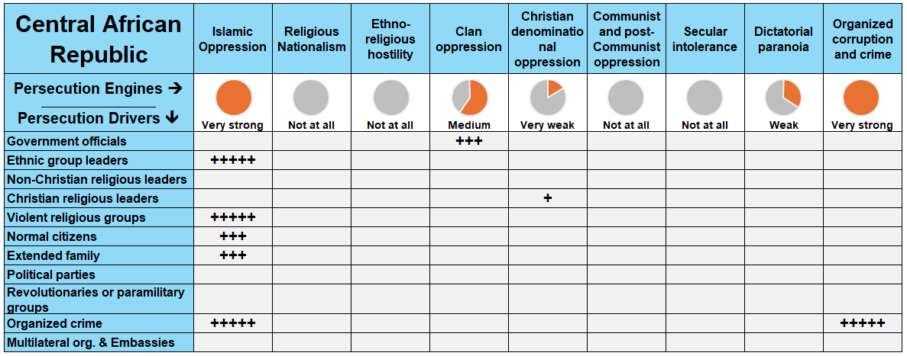

***Reference:*** *The more fully shaded the circle in orange, the stronger the level of persecution. The number of "+" signs indicates the frequency or intensity of the driving factors behind it.*

In the Central African Republic (CAR), multiple forces of persecution converge to severely restrict Bible access, including **Islamic oppression, organized corruption and crime, and clan oppression**. These are mainly fueled by armed Islamic groups, non-Christian religious leaders, criminal militias, ethnic leaders, and even extended families, creating a multifaceted environment of fear and obstruction for Christians.

### **A Closer Look at Persecution Engines**

A persecution engine is the source of persecution in the country, while a persecution driver (or actor) is the one “driving” the persecution. Taking a closer look at these engines and drivers, in proper context, grants insight on how to solve the problems of Bible access in the country.

**Islamic Oppression: Weaponizing Religion to Suppress Scripture**

Islamic oppression is one of the most powerful forces limiting Bible access in CAR. Armed jihadist factions like the Popular Front for the Renaissance of Central African Republic (FPRC) and the Union for Peace in the Central African Republic (UPC) have repeatedly targeted churches and Christian properties, especially in the northern and eastern Muslim-majority regions. These groups confiscate or destroy Christian materials, violently disrupt worship, and instill fear that prevents believers from storing or distributing Bibles.

For instance, in 2024, at least 100 churches and Christian properties were attacked, looted, or destroyed for faith-related reasons. In northern areas bordering Sudan, Christian women were abducted and forcibly married to Muslim men by jihadist groups, an act often preceded by the destruction of churches in the area.

MBBs also faced violent retaliation from their own families and communities in Muslim-majority areas. They were isolated, denied access to shared resources like clean water, and in many cases driven from their homes.

Beyond militant action, Islamic leaders play a major role in systemic suppression. In Muslim-dominated markets, Christian businessmen are taxed excessively and sometimes looted, pushing them into poverty and limiting their ability to acquire Scripture. MBBs face the harshest repression, from family, community, and armed actors alike. In these regions, even private Bible ownership is considered an act of defiance that could lead to death, abduction, or forced marriage.

**Organized Corruption and Crime: Exploiting Chaos for Control**

Lawlessness and criminal exploitation exacerbate the challenges Christians face in accessing Bibles. Groups like the Anti-Balaka militias, once formed as "self-defense units”, have devolved into violent gangs that attack Christians who oppose their ideology. In places like Bangui, these groups harass pastors, loot churches, and violently intimidate Christians.

For example, Anti-Balaka terrorists **looted Christian-owned shops** and attacked churches, especially targeting those that preached non-violence or provided refuge to displaced civilians.

Another example in 2023, Russian mercenaries from the Africa Corps, operating with government forces, killed at least 70 people in the mining towns of Aïgbado and Yanga. Many of the victims were Christian men and boys forcibly conscripted or abducted from churches and communities.

These incidents are not uncommon in CAR. Just in 2024, at least 1,000 Christians were forced to flee theirhomes due to violence from militias and organized crime cartels. With the state unable to enforce law or offer protection, Christian communities remain vulnerable to these armed criminals. The complete breakdown of civil order allows these groups to operate with impunity, blocking any efforts to circulate Scripture in affected areas.

**Clan Oppression: Tribal Loyalty Over Spiritual Truth**

Clan oppression also plays a significant role in persecuting Christians, particularly converts. Many ethnic and tribal leaders enforce participation in traditional religious practices—rituals surrounding birth, death, or protection rites—which often conflict with Christian beliefs. Christians, especially those from smaller ethnic groups like the Ba'aka, are pressured or even forced into labor or militia service.

This tribal expectation extends into religious identity: in areas where Muslim leaders are also tribal authorities (such as among the Fulani), conversion to Christianity is not just a spiritual decision, it’s seen as betrayal. Family members may respond with house arrest, forced marriage, or social expulsion, cutting MBBs off from Scripture and Christian community altogether.

### 

### **The Urgent Need for Bibles in the Central African Republic**

Against a backdrop of violence, poverty, and political instability, Bible access in the Central African Republic (CAR) remains critically low. To meet the needs of CAR, **between five hundred thousand and up to a million Bibles** will make a huge difference for our brothers and sisters who are struggling for survival.

**A Steady and Growing Church**

Despite relentless violence and persecution, the church in CAR continues to grow. Over the past five years, as the population expanded the size of the Christian population expanded as well adding hundreds of thousands of new believers to its ranks. This underscores the urgency of equipping the Body of Christ with Bibles—not just for spiritual maturity and discipleship, but also for comfort and strength in the midst of displacement, trauma, and fear. Without access to Scripture, the Church’s ability to grow in depth and resilience is significantly hindered.

**Bible Formats: Meeting People Where They Are**

Given the high levels of illiteracy and limited access to electricity, especially in rural and conflict-prone areas, **print Bibles** remain the most effective and accessible format. **Audio Bibles** are a vital complement, especially among displaced populations and those who cannot read.

With less than 15% of the population having access to electricity, and internet penetration at just over 10%, digital formats are not viable for most of the country’s Christians.

**The Translation Gap**

CAR’s linguistic diversity presents another major challenge. The country is home to speakers of at least 88 different languages. Of these languages:

* Only **15** of these languages have a full Bible translation.
* **18** have only the New Testament translated.
* **12** have only portions of Scripture translated.
* **43 have no Bible translation at all.**

This leaves nearly half the linguistic groups in CAR without any access to God’s Word in their heart language. Without targeted investment in Bible translation, entire communities will remain cut off from the life-giving message of Scripture.

### **The Clarion Call**

The need for Bibles in the Central African Republic is urgent, but it is not insurmountable. This is a nation that has endured unimaginable suffering; yet, the Church is still standing, still growing, still hoping. Now is the time for the global Church to respond with compassion and conviction. Through strategic partnerships, focused translation efforts, and the distribution of Bibles in print and audio formats, we can ensure that no believer in CAR is left without the hope, comfort, and truth found in God’s Word.

Let us act, not just out of duty, but out of love for our brothers and sisters who are faithfully following Christ in one of the hardest places to be a Christian.

**How to Pray for CAR**

* **Protection Amidst Danger:** Let us fervently pray for the protection of our Christian brothers and sisters in the Central African Republic, especially those dwelling in violence-prone areas. May the Lord provide safe ways to access the Bible, shielding them from harm and ensuring that His Word becomes their refuge and strength in these turbulent times.
* **Global Partnerships and Provision:** Let’s pray that God will raise up the mobilization of global resources and partnerships, aiming to address the dire need for Bibles in CAR. May innovative solutions emerge, breaking down the poverty-related barriers to Bible distribution. Let's ask God to inspire and equip the global Body of Christ to fulfill the pressing need for His Word, ensuring every believer in CAR has the opportunity to hold, read, and cherish the Bible.
* **Peace and Transformation:** Let’s pray for the violence that has long gripped the Central African Republic to finally cease. May God's peace, which surpasses all understanding, prevail across the land, transforming it into fertile ground for the Gospel to flourish. Let us seek the Lord's intervention to establish a favorable environment where people can once and for all access the Bible freely.