### **An Overview of Bible access in Cameroon**

Cameroon’s Christian population comprises over 61% of its 28.6 million inhabitants, amounting to approximately 17.6 million believers. However, it is estimated that only a third of believers have access to a Bible, highlighting a significant need despite the size of the Christian community.

While there are no legal restrictions on owning or distributing Bibles in Cameroon, practical challenges make access difficult. In the Extreme North, Muslim extremist groups like Boko Haram terrorize everything in their path, creating life-threatening situations for Christians and severely limiting access to Bibles. In addition, widespread poverty means many cannot afford a Bible, even if they desire one.

The dual conflicts involving Boko Haram in the Extreme North and violent groups (also known as Anglophone separatists) opposing the government have displaced over 1.5 people, fracturing communities and severely hindering Bible distribution efforts across many regions.

Cameroon’s socio-economic challenges further complicate Bible access. While most of the population has electricity, nearly a third still remains without power, leaving many unable to access digital Bibles. Additionally, less than half of Cameroonians have internet access, further limiting options for Scripture. Though literacy rates are relatively strong among the country’s youth, extreme poverty forces many to prioritize basic needs over purchasing Bibles. Addressing the barriers to Bible access in Cameroon requires overcoming these interconnected challenges of conflict, violence, and poverty.

In light of the situation in Cameroon, research reveals an urgent demand for Bibles, with at least 3 million required to meet the needs of believers. To understand more about the challenges restricting Bible access and the specific needs, continue reading.

### 

### **What’s Blocking Bible Access in Cameroon?**

#### **A Region Under Siege**

In Cameroon’s Extreme North Region, home to approximately 5 million people, owning a Bible can make someone a target. Although the country’s constitution guarantees freedom of religion and worship, regions affected by security challenges—especially those dominated by Boko Haram and ISWAP—face constant threats. These groups use violence to suppress Christianity, burning churches, abducting pastors, and targeting anyone who possesses Christian materials. Entire villages have been destroyed, forcing Christians to flee to IDP camps, where access to Bibles and spiritual resources is scarce.

One report describes how Boko Haram raids often result in the destruction of churches, with stored Bibles confiscated or burned. Christians who remain are forced to practice their faith in secret, often at great personal risk.

#### **Daily Risks and Bible Access**

In northern Cameroon, owning a Bible is a life-threatening risk. Under Boko Haram’s control, both Christian and Muslim communities face relentless danger. Hundreds of Christians have been killed, churches burned, and thousands of homes destroyed. Many are forced to flee, leaving behind their homes and Bibles. Simply storing, sharing, or distributing Scripture puts lives in constant jeopardy.

Where Boko Haram operates, Christians are especially vulnerable during worship or Bible reading. While the Extreme North is the epicenter of their violence, these groups spread fear wherever they go. Without effective law enforcement, believers are left exposed, unable to practice their faith openly or access Scripture safely. Even beyond their reach, fear and insecurity linger, creating ongoing challenges for Christians across Cameroon.

**Poverty and Practical Barriers**

Beyond the immediate threats of violence, systemic issues exacerbate the difficulty of accessing Bibles. While the government does not actively block the import of Christian materials, bureaucratic delays, customs fees, and logistical challenges create significant hurdles.

Economic difficulties compound the problem. With many Cameroonians living below the poverty line, purchasing a Bible is simply not possible for most families as survival and food are the priority. In IDP camps, resources are even scarcer, leaving displaced Christians with no physical access to Scripture.

Digital solutions are equally limited. With only about half of the population having internet access, and rural areas even less connected, online Bibles remain out of reach for most. In areas dominated by Boko Haram, these options provide little relief, as they require both connectivity and safety to use freely.

### **Unmasking the Forces That Restrict Bible Access in Cameroon**

Refer to the chart below. The more fully shaded the circle in orange, the stronger the level of persecution. The number of "+" signs indicates the frequency or intensity of the driving factors behind it.

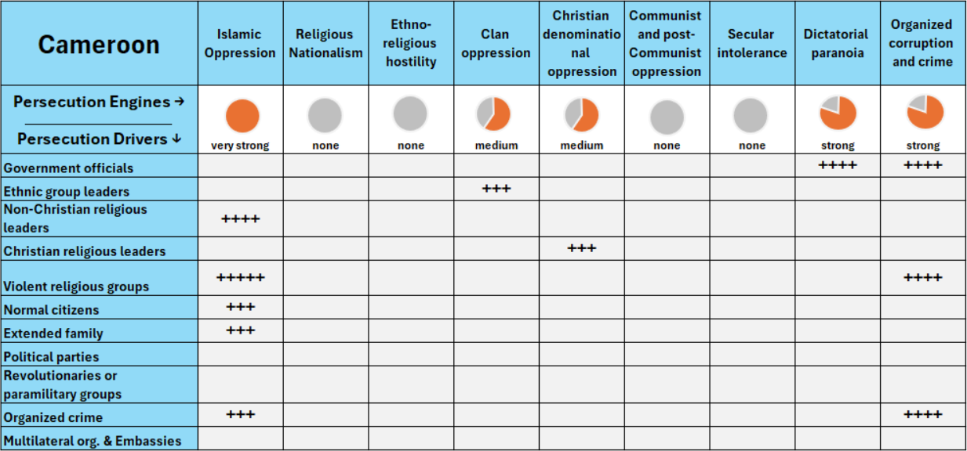

As you can see in the chart, **Islamic oppression** is very strong in Cameroon, this is compounded by **dictatorial paranoia** and **organized corruption and crime,** and to some extent, **clan oppression** and **Christian denominational oppression**. The primary drivers behind these patterns include **violent religious groups** (such as Boko Haram) and **government officials**, whose actions collectively create an environment of significant hostility and danger for Christians.

### **A Closer Look at Persecution Engines**

A persecution engine is the source of persecution in the country, while a persecution driver (or actor) is the one “driving” the persecution. Taking a closer look at these engines and drivers, in proper context, grants insight on how to solve the problems of Bible access in the country.

#### **Islamic Oppression**

In the Extreme North Region, jihadist groups like Boko Haram and ISWAP dominate, targeting Christians and creating an environment of constant terror. These groups attack churches, abduct pastors, and burn Scripture, forcing many Christians to abandon their Bibles and churches. Their actions make it nearly impossible for believers to own, store, or distribute Bibles.

Muslim Background believers or MBBs face even greater risks, as possessing a Bible can lead to life-threatening situations. The terror enforced by these groups leaves communities in the Extreme North without access to Scripture, severely hindering spiritual growth.

#### **Dictatorial Paranoia**

Under the authoritarian rule of President Paul Biya, the government imposes strict control over dissent, creating an atmosphere of fear. Churches that speak out against corruption or advocate for justice face closures, threats, or arrests. In regions where violent groups oppose the government, Christians are often caught in the crossfire, leading to the destruction of church buildings and the displacement of congregations.

These disruptions make it increasingly difficult to store and distribute Bibles, further isolating Christian communities.

#### **Organized Corruption and Crime**

Corruption within the government compounds these challenges, particularly in urban centers. Bureaucratic red tape and bribery delay or block the import, storage, printing, and distribution of Bibles, making access costly and unreliable. Officials exploit these processes, while jihadist groups take advantage of the instability, further threatening Christian communities.

These systemic barriers mean that even outside conflict zones, accessing Scripture remains an uphill battle for many believers.

### **The Urgent Need for Bibles in Cameroon**

Against the backdrop of significant persecution, extreme poverty and other socio-economic challenges, Bible access in Cameroon remains critically low. Based on recent research, it is estimated that only 3 out of 10 believers in the country have access to a Bible. This staggering gap highlights a significant need, as millions of Christians remain without access to Scripture.

Based on research there is a strong demand for Bibles across all major church traditions in Cameroon, Protestant, and independent, both for personal use among believers and for evangelism and seekers.

#### **A Growing Church, A Growing Demand**

The need for Bibles as the total number of believers has expanded over the past five years. When combining the growth with the existing unmet needs, the total demand for Bibles is estimated to be between **1-3 million copies**, emphasizing a critical opportunity to support the spiritual growth of Cameroon’s 17.6 million Christians.

#### **Bible Formats for Diverse Needs**

Given the diverse challenges in Cameroon, providing Bibles in multiple formats is essential. Printed Bibles remain a cornerstone for many, especially in areas without reliable electricity or internet access, where around a third of the population still lacks electricity.

Audio Bibles are critical for those who cannot read or write, allowing them to hear God’s Word in their native languages. In urban centers and connected regions, Bible apps, online platforms, and video resources play an increasingly important role, offering accessibility where digital tools are viable.

#### **The Challenge of Bible Translations**

Cameroon’s linguistic diversity presents another significant challenge. Believers in Cameroon together, speak over 280 languages, but only 38 of these languages have a complete Bible translation, while 102 have only the New Testament, and 38 have limited portions of Scripture. Alarmingly, **107 languages have no Bible translations at all**, leaving entire communities without access to God’s Word in their native tongue.

Efforts to translate the Bible into these remaining languages are critical for reaching the millions of believers and seekers who are still waiting for Scripture they can fully understand.

#### **The Clarion Call**

The expressed needs for Bibles in Cameroon reach far beyond numbers; it reflects a profound spiritual hunger and a cry for hope amidst adversity. For new believers, seekers, and lifelong Christians alike, the need touches every demographic and region, transcending age, denomination, and circumstance. Meeting this need isn’t just about logistics; it’s about bringing the life-changing power of God’s Word to a nation yearning for light in the darkness.

To bridge this gap, we must confront the unique challenges of persecution, poverty, and linguistic diversity head-on. Through strategic efforts: providing Bibles in print, audio, and digital formats, and advancing critical translation projects, we can ensure that every believer in Cameroon receives the hope, strength, and transformation found only in God’s Word.

**How to Pray for Cameroon**

* **Safety and Provision:** Pray for the safety of Christians, particularly those living in the Extreme North (Boko Haram) and the Northwest and Southwest (Anglophone separatists); and for ways to provide Bibles despite the economic and logistical challenges.
* **Global Partnerships:** Ask God to raise strong global partnerships that can overcome financial and logistical barriers, ensuring every believer has access to Scripture.
* **Peace and Restoration:** Pray for an end to the violence and conflicts in Cameroon, asking God to restore peace so that His Word can reach every part of the nation.