### **An Overview of Bible Access in Algeria**

Algeria, with a population of over 46 million people, is home to a small Christian population, numbering less than 1%, just a little over 170,000 believers. Given the already small number, it is estimated that less than a third of Algerian Christians have consistent access to Scripture due to extreme restrictions, revealing a significant and urgent need to bridge this gap to help support the church.

A complex web of legal, political, and societal barriers severely restricts Bible access in Algeria. Ordinance 06-03, enacted in 2006, criminalizes printing, distributing, or possessing religious materials outside government-approved channels, creating an environment of fear and self-censorship. While theoretically, the Algerian Bible Society (branch of the United Bible Societies) is allowed to import Scripture, reports confirm that since 2018, no new shipments have made it through customs due to bureaucratic blockage at Algerian ports.

Even more troubling, there is no legal mechanism for churches to register or operate openly. While Christians may quietly keep a Bible, it still comes with high risk. The pressure is significantly higher for believers from a Muslim background (MBBs), who face not only state monitoring but severe pressure from their families and communities. Confiscation of Bibles during church raids is not uncommon, despite these materials being permitted in theory. On certain occasions, owning Scripture in Arabic or Kabyle can lead to interrogations, imprisonment, or expulsion from one’s home.

Foreign Christians also face discrimination. While Western expatriates may own a Bible with limited scrutiny, Sub-Saharan African Christian students, many of whom live in shared housing, are often pressured or harassed if seen possessing Christian materials.

The lack of access to Bibles is not merely a result of persecution, but also systemic neglect. The closure of churches has halted nearly all forms of communal discipleship. With increased monitoring of online activities and heightened fear of arrest, many Christians are left isolated, cut off from the Word of God that sustains their faith. For a nation where most believers are first-generation converts, the absence of Scripture is devastating.

### **What’s Blocking Bible Access in Algeria?**

**Widespread Suppression of Non-Muslims**

In Algeria, the primary barriers to Bible access are driven by a legal and administrative system designed to suppress non-Muslim worship, alongside deeply embedded societal hostility. The 2006 Ordinance to Regulate Non-Muslim Worship (Ordinance 06-03) criminalizes public expressions of Christianity, prohibits proselytism, and has been used to justify the closure of every Protestant church in the country.

Today, not a single Protestant church, including those affiliated with the Evangelical Protestant Church of Algeria (EPA), is operating openly, and Christians meeting in private homes risk prosecution, fines, and imprisonment under charges of unauthorized religious assembly.

**Daily Risks and Legal Persecution**

Christians face legal prosecution simply for meeting together or discussing their faith publicly. Between 2023 and 2025, more than 50 Christians were prosecuted under Ordinance 06-03. Charges include “practicing worship without prior approval,” “proselytism,” and “holding worship in a building not permitted for worship.” These cases are not theoretical; pastors have received prison sentences and fines for merely gathering with families to worship in closed church compounds.

Muslim Background believers or MBBs, who make up the majority of Algerian believers, are especially vulnerable. Extended families often respond with physical abuse, house arrest (especially for women), and forced expulsion.

**Societal Hostility and Community Pressure**

Beyond government restrictions, social ostracism and mob pressure severely hinder access to Bibles. MBBs are routinely harassed, excluded from community life, and discriminated against in the workplace. In many regions, especially in the Arab-dominated south, public expression of Christianity can provoke threats, job loss, or physical danger. Simply displaying a Bible or Christian symbol can expose believers to questioning or violence.

### **Unmasking the Forces That Restrict Bible Access in Algeria**

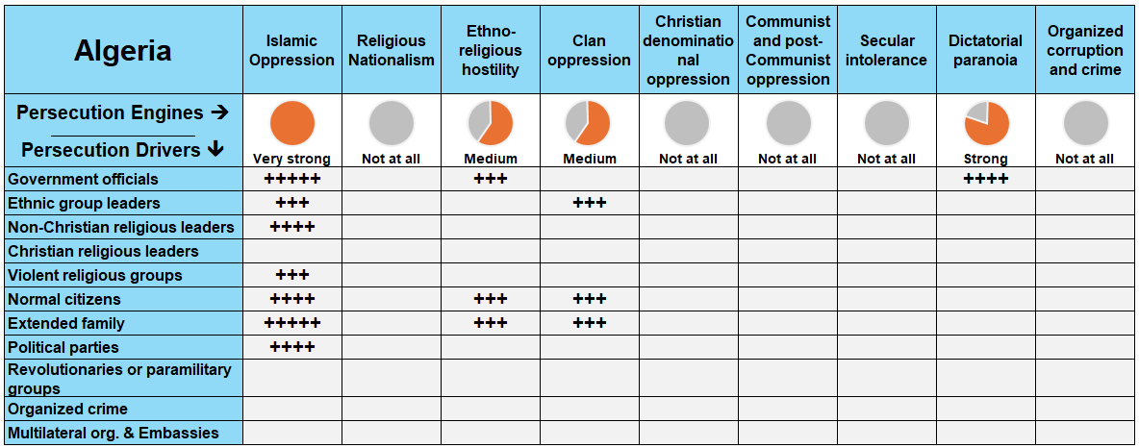

**Reference**: *The more fully shaded the circle in orange, the stronger the level of persecution. The number of "+" signs indicates the frequency or intensity of the driving factors behind it.*

In Algeria, multiple persecution forces operate simultaneously to restrict Bible access, including Islamic oppression, dictatorial paranoia, clan oppression, and ethno-religious hostility. These forces are fueled by government officials, extended family members, radical Islamic leaders, and local ethnic authorities.

### **A Closer Look at Persecution Engines**

A persecution engine is the source of persecution in the country, while a persecution driver (or actor) is the one “driving” the persecution. Taking a closer look at these engines and drivers, in proper context, grants insight on how to solve the problems of Bible access in the country.

**Islamic Oppression: Enforced Conformity Through Fear**

Islamic oppression in Algeria is systemic and deeply entrenched in both law and society. Nearly all Algerian Christians are Muslim Background believers, and for these believers, persecution often begins at home. Family members are the primary enforcers of Islamic orthodoxy, subjecting MBBs to physical abuse, house arrest, inheritance loss, forced divorce, and even the removal of child custody. At least 20 Christians in 2024 faced direct abuse from family and government authorities.

This oppression is further reinforced by religious leaders who preach intolerance and by mobs who report Christians to police. Government rhetoric echoes this sentiment. In one telling example, President Tebboune declared on National Martyr Day that Algeria must resist "conspiracies of Christianization and conversion".

Even Christian literature and media are viewed with suspicion. Laws criminalize anything that might “shake the faith of a Muslim,” with violations carrying harsh prison sentences. In 2024, a pastor’s one-year sentence was upheld for simply gathering Christian families in a closed church compound.

**Dictatorial Paranoia: A State That Controls Faith Expressions**

Algeria’s government, dominated by the National Liberation Front since independence, remains suspicious of religious diversity, especially anything perceived as Western or evangelical. Under the guise of maintaining national identity and unity, the state has forcibly shut down every Protestant church in the country, closing all 47 EPA-affiliated congregations or independent Protestant churches.

This crackdown includes harassment, constant surveillance, and ongoing prosecutions. Christians face legal charges under Ordinance 06-03, which heavily restricts non-Muslim worship. More than 50 believers have been prosecuted in recent years. Online Christian activity is also a target; believers fear that their phones are tapped, and their emails monitored. Christians attempting to import or print Bibles face immediate roadblocks under government watch.

**Clan Oppression: Community Pressure to Conform**

In many Arab regions of Algeria, tribal structures still dominate social life, and clan oppression stems from a cultural code where family honor is paramount. MBBs, especially women, who leave Islam are seen as betraying not only their religion but their entire family and tribe. Village elders often lead the charge in pressuring families to take action, while wider communities shun or retaliate against MBBs through social exclusion or loss of employment.

Female MBBs are particularly subject to extreme restrictions. Some are kept under house arrest by relatives, barred from contacting Christians or even watching Christian TV. This forced isolation cuts them off from spiritual support and any access to Bibles.

**Ethno-Religious Hostility: Suppressing Kabyle Identity**

Most Algerian Christians live in the Kabyle region, a historically marginalized Berber area with a distinct language and culture. The central government has long viewed the Kabyle identity and its openness to Christianity as a threat to national Arab-Islamic unity. Ethnic tensions spill into religious life.

Churches in Kabyle areas are heavily monitored, restricted, or shut down altogether. The state’s refusal to register churches, and accusations of Kabyle Christians supporting separatist groups, further intensify the crackdown.

### **The Urgent Need for Bibles in Algeria**

In many regions, especially among Berber-speaking communities in Kabylia, Scripture is cherished but scarce, while in Arab-dominated areas, possession of a Bible can lead to harassment, imprisonment, or worse. In a country where believers risk everything for their faith, a number fewer than **10,000 Bibles** to meet the need can already spark something great.

**A Growing Church, A Growing Demand**

Despite increasing government pressure, Algeria's underground Church continues to grow. In fact, over the past five years, the Christian population has expanded the last few years, primarily through personal evangelism and the quiet witness of house churches. This expansion has far outpaced the availability of Scripture, making the supply of Bibles a top priority to nurture spiritual growth and disciple the next generation of believers.

**Bible Formats for Unique Needs**

When it comes to format, **printed Bibles** remain the most urgent need, especially for believers in remote and rural areas where digital access is unreliable or unsafe. **Audio Bibles** are also a vital tool, particularly for women, those who are illiterate, and believers in highly restricted communities who must worship in secret.

**The Translation Gap**

Algeria’s believers speak at least 22 languages. Of these languages:

* Only **9** have a full translation of the Bible.
* **5** more translations of the New Testament only.
* **4** languages have only a portion of the Bible translated.
* **Another 4 languages have no translation at all.**

That means entire ethnic and linguistic communities remain unreached by the Word of God. Translation projects are urgently needed to ensure that every Algerian believer can encounter Scripture in a language that speaks to their heart.

### **The Clarion Call**

The need for Bibles in Algeria is not simply an access problem; it is a lifeline for a persecuted and resilient Church. Amidst church closures, legal intimidation, and family rejection, Algerian Christians are crying out for the Word of God. This is a moment for the global Church to respond with prayer, provision, and partnership.

Let us commit to putting Bibles in the hands of our brothers and sisters in Christ, standing with Algeria’s courageous believers by investing in translations, effective formats, and delivery methods that will break through the barriers of fear, language, and law.

**How to Pray for Algeria**

* **For Protection:** Pray for Algerian believers, especially new believers, that they may find strength and encouragement through underground fellowship and digital resources. Pray for the safety of those facing threats from both state and society.
* **For Provision and Open Access:** Ask God to reopen doors for the import and distribution of Bibles, and for the Bible Society’s shipments to be released. Pray for creative and secure ways to get Scripture into the hands of believers and seekers.
* **For the Growth of the Body of Christ:** Despite severe pressure, the Algerian Church continues to exist. Pray for believers to be nourished in their faith and for the Spirit to move through homes, small groups, and digital platforms so that God’s Word can continue to transform lives.