### **An Overview of Bible Access in Chad**

Chad’s Christian population accounts for around a third of its almost 19 million inhabitants, amounting to over 6 million believers. Yet despite this significant number, access to Bibles remains limited and often dangerous due to considerable restrictions. Estimates show that only 1 of 5 Christians in Chad own a Bible, leaving millions without regular access to God’s Word.

Across the country, access to Bibles is shaped by a stark regional divide. While Christians in the south may practice their faith more openly, believers in at least ten provinces, particularly in the North and East, face daily risks and sometimes real danger. Terrorist groups like Boko Haram and ISWAP actively operate in these areas, and importing or transporting Bibles through them can be life-threatening. These regions, which affect over a quarter of the national population and roughly 14% of all Christians, are classified as high-risk zones for Bible access.

For Muslim Background believers or MBBs, the danger is even more pronounced, many are forced to hide their faith, and owning a Bible can be a death sentence. Attacks on churches, homes, and believers are reported yearly, including killings and forced displacements.

Restrictions impact mostly the northern and eastern parts of the country. Printing, storing, or distributing Bibles draws suspicion and is met with varying degrees of resistance depending on the local context. While some workarounds exist, the climate of fear fosters a culture of self-censorship. Christians often refrain from openly sharing their faith or reading the Bible in public.

Economic hardship compounds these challenges. Nearly half of the population is under poverty. In such conditions, buying a Bible, if available, is financially out of reach for many families. Chad also suffers from one of the world’s lowest electricity and internet penetration rates. This drastically limits the feasibility of digital Bible distribution or online Scripture access. Additionally, with only a third of the country literate, there's an urgent need for creative and innovative formats to engage the nation’s young, largely unreached population.

Further, ongoing conflicts with jihadist insurgents and rebel groups have displaced over 200,000 people internally, while nearly a million refugees from Sudan’s civil war have flooded into eastern Chad. In areas like Lake Province, where Boko Haram is active, Christian communities have been repeatedly targeted, resulting in loss of life, destruction of churches, and forced displacement. MBBs face not only social ostracism but systemic discrimination. being denied jobs, education, and government services.

### **What’s Blocking Bible Access in Chad?**

**A Region on the Brink of Collapse**

Chad’s geographic position, surrounded by conflict zones like Sudan, Nigeria, and the Central African Republic, has made it a hotbed for instability and violence. This external chaos spills across borders and collides with internal fragility, leaving Christian communities especially vulnerable.

In regions like the southwest and Lake Chad Basin, armed groups including Boko Haram and ISWAP routinely target Christians, displacing thousands and creating deep fear. Entire Christian villages have been burned, homes looted, and believers forced into hiding or IDP camps, where discrimination often continues and access to Bibles is virtually nonexistent.

**Violence, Fear, and Daily Risks**

Across Chad, violence against Christians has surged. From abductions and killings to church burnings and forced displacements, the threat landscape is worsening. In 2024 alone, over 1,000 Christians were forced to flee their homes for faith-related reasons, and hundreds of Christian homes and properties were attacked.

MBBs suffer especially brutal backlash, often disowned, confined, or attacked by their own families. In some areas, just accessing a Christian radio program or carrying a Bible can trigger community surveillance, harassment, or worse.

**Legal Hurdles and Bureaucratic Suppression**

Even where violence isn’t overt, legal and administrative restrictions silently strangle Bible access. Churches must go through a complicated registration process and often operate in legal limbo for months or years. Without legal status, they can’t open bank accounts, own property, or freely distribute Scripture. Activities outside church buildings are tightly regulated, and permissions are rarely granted.

**Poverty and Infrastructure Gap**

Almost half of the population live in poverty, internet penetration is very low, and electricity access can even be lower in rural regions. These infrastructural gaps limit access not only to digital Scripture, but also to printed and audio formats.

For many Christians, even if Bibles were available, the cost alone makes them unreachable. In a country where over 5 million people live in extreme poverty and more than 1 million are refugees or displaced, survival takes priority over spiritual resources.

### **Unmasking the Forces That Restrict Bible Access in Chad**

**Reference:** *The more fully shaded the circle in orange, the stronger the level of persecution. The number of "+" signs indicates the frequency or intensity of the driving factors behind it.*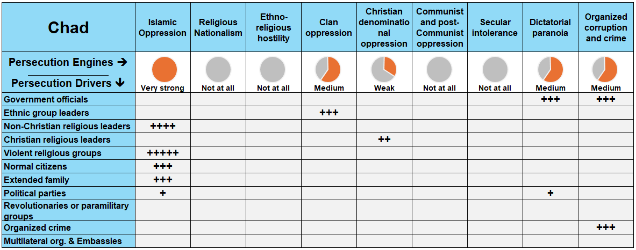

In Chad, multiple persecution engines operate simultaneously to restrict Bible access, including **Islamic oppression**, **dictatorial paranoia**, **organized corruption and crime**, and **clan oppression**. These engines are driven by a mix of violent jihadist groups, corrupt government officials, local imams, ethnic leaders, and even family members.

### **A Closer Look at Persecution Engines**

A persecution engine is the source of persecution in the country, while a persecution driver (or actor) is the one “driving” the persecution. Taking a closer look at these engines and drivers, in proper context, grants insight on how to solve the problems of Bible access in the country.

**Islamic Oppression: The Rising Threat of Radicalization and Violence**

Islamic oppression is the most dominant force driving persecution in Chad, heavily affecting Christian communities on multiple levels. Radical groups like Boko Haram and the Sanusiyya Brotherhood are known for their violent campaigns against Christians, particularly in the Lake Chad region and the southwest. From 2023 until today, armed groups intensified their attacks in the southwest, killing Christians, burning down homes, and displacing thousands into IDP camps.

In the north and northeast, where Islam is deeply rooted, MBBs are especially vulnerable. Families and communities respond with intense pressure, often evicting MBBs, cutting off financial support, or subjecting them to house arrest. For instance, one Muslim father physically assaulted his son after his conversion to Christianity and cut off all financial support for his university education. In some areas, even the use of Christian media or wearing symbols of faith is enough to invite threats.

Despite constitutional protections, authorities often refuse to recognize name changes for MBBs, making it nearly impossible for them to update ID documents or access public services. As a result, these believers must practice their faith in hiding, with little to no access to Bibles or communal worship.

**Dictatorial Paranoia: Authoritarian Rule and Silencing of Christian Voices**

Chad’s government, under Mahamat Idriss Déby, operates with growing authoritarianism. The 2021 coup that brought him to power was followed by election delays, the violent suppression of protests, and the assassination of opposition figures. These political tensions affect Christians by shrinking the space for free worship, evangelism, and even church registration.

Churches are subject to heavy surveillance, particularly if they speak out on justice or social issues. Some congregations report delays or outright denial of permits, while Christian teaching materials are monitored for “anti-state” messaging. For example, in the Wadai and Salamat regions, Catholic authorities were denied access to land they had acquired for building a church and hospital, effectively blocking Christian presence and services in the area.

This environment of fear and suppression discourages open faith expression and severely restricts access to physical Bibles, especially in regions outside the capital.

**Organized Corruption and Crime: A System That Punishes Christian Presence**

Rampant corruption in Chad further blocks access to Scripture. With a Transparency International score of just 20/100, Chad ranks among the most corrupt nations globally. Government officials exploit church registration processes, delay permits, and harass Christian leaders, especially in areas where the church is growing or seen as influential.

In practice, this means churches may go months or years without legal status, making them ineligible for property rights or financial accounts. Meanwhile, organized criminal groups, often in collaboration with corrupt officials, loot Christian properties and attack believers with impunity. Reports indicate that police often release individuals implicated in violent crimes against Christians, including those accused of killings, without formal investigation or prosecution.

Perpetrators are rarely punished, and in some cases, they disappear entirely from custody.

**Clan Oppression: Ethnic Pressure and Ritual Coercion in Christian Communities**

In southern Chad, where many Christians reside, ethnic and clan loyalty often trumps religious freedom. Christian converts from indigenous religions face pressure from local leaders to participate in traditional rituals. Those who refuse may be ostracized or cut off from community benefits and support.

In the northeast, particularly among the Zaghawa people, Christians face ethnic marginalization that compounds religious discrimination. In one reported incident in 2024, a convert was forcibly driven from his home by his local community, resulting in traumatic separation from his wife and children. In rural areas, children of converts are harassed in schools, and spouses are pressured to divorce or disown believers. These deeply embedded social norms make it especially difficult to sustain a Christian identity, and by extension, hinder efforts to distribute or share Bibles.

### **The Urgent Need for Bibles in Chad**

Despite making up nearly a third of Chad’s population, Christians face an alarming lack of access to Scripture, with a little over 20% having direct access to a Bible. With over 6 million Christians nationwide, this means millions are without one. To address this gap, it’s estimated that up to **a million Bibles** are needed to meet the needs of believers in the country.

**A Steady Church In Need of More Bibles**

Over the past five years, as the population expanded the size of the Christian population expanded as well adding hundreds of thousands of new believers to its ranks. This underscores the urgency of equipping the Body of Christ with Bibles.

Without access to Scripture, discipleship and spiritual growth become severely hindered, particularly in areas affected by persecution, conflict, or displacement.

**Bible Formats for Diverse Needs**

In Chad’s context, **printed Bibles remain the top priority**. Many believers live in areas with limited or no access to electricity or the internet, making digital or audio alternatives challenging.

Nonetheless, in regions with rising mobile phone usage, **Scripture accessed through the internet** can provide a valuable supplement, especially among youth and urban populations.

But for the vast majority, print is still the most reliable and tangible form of access to God’s Word.

**The Challenge of Bible Translations**

Chad is home to immense **linguistic diversity, with at least 109 spoken languages** across the country. Of these languages:

* Only **22 languages** have a full Bible translation.
* **29** have the New Testament only.
* **13** have just a portion of Scripture translated.
* Alarmingly, **45 languages** **still have no Scripture translation at all**.

This leaves entire communities unable to encounter God’s Word in their mother tongue. This translation gap not only slows evangelism and discipleship but also reinforces marginalization, especially among ethnic minorities and oral cultures.

### **The Clarion Call**

The need for Bibles in Chad is urgent and unmistakable. Behind every statistic is a believer praying for the strength to endure, a church longing to disciple its flock, and MBBs risking everything to follow Christ. This is more than a logistical challenge; it is a spiritual emergency.

To answer this call, the global Church must act with boldness, compassion, and commitment. That means prioritizing translation work, scaling print and digital Bible distribution, and working alongside local churches to ensure that every believer has access to Scripture in a language they understand and a format they can use.

**How to Pray for Chad**

* **Provision and Access:** Pray for the doors of opportunity to open for the distribution of Bibles. Ask for innovative solutions that navigate the harsh restrictions and leverage the limited connectivity, ensuring that every believer in Chad has access to the Word.
* **Global Partnerships:** Let’s believe that God would raise up global partnerships that address the unique challenges of Bible distribution in Chad. Pray for collaborative efforts that bring together resources, wisdom, and creativity to overcome the barriers to Bible access.
* **Peace and End of Conflict:** Lift up Chad in prayers for peace, especially in regions afflicted by the conflict with Boko Haram. Pray for stability and safety that paves the way for not just the free movement of people but also the unhindered distribution of Bibles across the country.