# Lesson 5

# PAUL COMPLETED THREE MISSIONARY JOURNEYS:

* Acts 13:1-15:35: First Missionary Journey
* Acts 15:36-18:22: Second Missionary Journey
* Acts 18:23-21:14: Third Missionary Journey

1. **CHAPTER THIRTEEN**
2. Barnabas and Saul are sent to preach. vs. 1-3

Paul, Barnabas and John Mark all begin this mission. (12:25)

1. The Apostles Preach in Cyprus. vs. 4-12
2. Paul and Barnabas visit Antioch of Pisidia vs. 13-52

v.13 John Mark departed and returned to Jerusalem.

v. 14-40 Paul’s First Recorded Sermon

1. **CHAPTER FOURTEEN**
2. Paul and Barnabas in Iconium vs. 1-7
3. Paul and Barnabas in Lystra and Derbe vs. 8-20
4. The Return to Antioch in Syria vs. 21-28
5. **CHAPTER FIFTEEN**
6. The Council at Jerusalem vs. 1-21

(Acts 15:12) God willed this meeting because of their wrong thinking and to settle any disputes later.

Galatians 2:2—*And I went up by revelation, and communicated unto them that gospel which I preach among the Gentiles, but privately to them which were of reputation, lest by any means I should run, or had run, in vain.*

1. The Council’s Letter to Gentile Believers vs. 22-35
2. Paul and Barnabas Separate vs. 36-41

1) Antioch 2) Syria & Cilicia

v. 36 “Paul said let us go again” “See how they do”. This marks the beginning of Paul’s 2nd Missionary Journey. They depart from Antioch to Syria and Cilicia.

Paul and Barnabas determined to go, but a sharp contention arose between them. Barnabas took John Mark to Cyprus with him. Paul took Silas with him through Syria and Cilicia confirming the churches. (**Personal conflicts are often harder to deal with than doctrinal differences**.)

1. **CHAPTER SIXTEEN**

*3) Derbe 4) Lystra 5) Iconium 6)Antioch of Pisidia 7) Troas 8) Neopolis 9) Philippi*

1. Timothy Joins Paul and Silas vs. 1-3

From Cilicia they journey to Derbe and Lystra. Lystra is where Paul was stoned to death in Acts 14:19. It was important to Paul to witness and encourage the Believers there especially because he had left them in the midst of such conflict his last time there.

At Iconium young Timothy joins the mission troop. Timothy had a good reputation even though his home was shared by a devout Christian mother and a Greek father.

1. Paul Delivers the Papers from Jerusalem vs. 4-5

The ‘decrees’ were the judgments made by the Apostolic council at Jerusalem (15:1-35) primarily concerning the ill-advised circumcision of Gentiles. (Despite this fact, Paul still circumcised Timothy for their sakes. v. 3. Consider also, I Cor. 8:7-13. )

1. Paul’s Vision of the Man of Macedonia vs. 6-10

Paul is learning to follow the leading of the Spirit. After being forbidden to preach in Asia by the Holy Ghost (v. 6), Paul is given the vision of the Macedonian call (A man saying “Come over and help us”) Acts 16:9.

1. The Conversion of Lydia at Phillipi vs. 11-15

Lydia’s conversion was a very important part of Paul’s ministry.

**Acts 16: 10 – 15 the Lord had called us for to preach the gospel unto them.** One of those listening was a woman from the city of Thyatira named Lydia, a seller of purple. She was a worshiper of God. The Lord opened her heart to respond to the Gospel.

Lydia was a **“a seller of purple” (**dealer in purple cloth) and so she probably would be a wealthy and well known person in the city of Thyatira. Women in the times of Jesus were not given the same kind of respect and status in society as men. Women were often considered as second class citizen. They were allowed to have bare minimum education and their role was limited to the chores of the home and children.

Lydia had an education and skill, she also possessed strength and determination to work in a male dominated society. She was an influential person in her family.  
“she was baptized, and her household”- “she besought us saying, If ye have judged me to be faithful to the Lord, come into my house, and abide there”

**Purple cloth** was valuable and expensive, it was claimed to be worth its weight in silver. It was usually worn as a sign of nobility or royalty. (i.e., mockery of Christ in Matt. 27:28 “scarlet” = faded purple.)

Lydia was a woman of prayer as she met Paul at the place of prayer and she was also eager to learn from Paul, a worshiper of God (v.14). She received the gospel with an open heart. After receiving the message, Lydia responded by getting baptized. She constrained them to abide in her home. She was a faithful and hospitable woman. (Acts 16:40)

1. Paul and Silas in Prison vs. 16-40

Paul cast out a devil out of a woman and were beaten and cast into prison Paul and Silas sing and praise at the midnight hour. Everyone’s bands were loosed. The jailer was saved. Paul being a Roman asked them to come to him. Paul was asked to leave.

1. **CHAPTER SEVENTEEN**

*10) Amphipolis 11) Appolonia 12) Thessalonica 13) Berea 14) Athens*

1. The Uproar in Thessalonica vs. 1-9

Three days reasoning out of the Scripture of the risen Christ. Some Jews believed and a great multitude of Greeks believed. Some Jews rejected the Gospel.

1. Paul and Silas in Berea vs. 10-15

Thessolonian Jews stirring up the people. Timothy and Silas stay at Berea while they sent Paul to Athens. Berean students searched the Scriptures daily.

1. Paul in Athens vs. 16-33

#### Paul’s spirit stirred because of the idolatry v. 16-18

#### The philosophers of the Epicureans brought Paul to Areopagus v. 19

#### Athenians like to hear world news “tell/hear some new thing” v. 21

#### Paul’s sermon at Mars Hill vs. 22-31

#### “Certain believed” v. 34

1. **CHAPTER EIGHTEEN**

*15) Corinth 16) Cenchrea 17) Ephesus 18) Caeserea 19) Jerusalem 20) Tyra 21) Sidon 22) Antioch of Syria*

1. Paul in Corinth vs. 1-17
2. Meets Aquila and Priscilla (tent makers) vs. 2,3
3. Paul taught in synagogue every Sabbath v. 4
4. Silas and Timothy came to Corinth from Macedonia and helped Paul testify. v. 5
5. Some opposed and some believed. v.6-8
6. A night vision v. 9
7. One and a half years of teaching the Word of God. v. 11
8. Paul’s Return to Antioch vs. 18-22
9. Ephesus vs. 18-20

Left Priscilla and Aquila there and reasoned with Jews in the Synagogue.

1. Jerusalem 18:21,22

Landed at Caesarea and went to Jerusalem

1. Antioch 18:22

Saluted the Church and reported the results as he did after his first journey.

**3rd Missionary Journey: 18:23-21:14.**

FACT: Paul traveled about 2700 miles on the third missionary journey. This is almost the same as traveling the width of the Sahara Desert. Lasting nearly three years, the *Third* is the longest and broadest of Paul’s missionary journeys. *1) Antioch 2)Tarsus 3) Derbe 4) Lystra 5) Iconium 6) Antioch of Pisidia 7) Galatia 8)Phrygia*

1. Paul Begins Third Missionary Journey v. 23
2. The Ministry of Apollos vs. 24-28
3. **CHAPTER NINETEEN**

*9) Ephesus*

1. Paul in Ephesus vs. 1-10
2. The Sons of Sceva vs. 11-20
3. The Riot in Ephesus vs. 21-41
4. **CHAPTER TWENTY**

*10) Philippi 11) Thessalonica 12) Berea 13) Greece or Corinth 14) Berea 15) Thessalonica 16) Philippi 17) Neopolis 18) Troas 19) Assos 20) Mitylene 21) Trogyllium 22) Miletus*

1. Paul Goes to Macedonia and Greece. vs. 1-6
2. Paul’s Farewell Visit to Troas. vs. 7-12
3. The Voyage from Troas to Miletus. vs. 13-16
4. Paul Speaks to the Ephesian Elders. vs. 17-38
5. **CHAPTER TWENTY-ONE**

*23) Coos 24) Rhodes 25) Patara 26) Tyre 27) Ptolemies 28) Caeserea 29) Jerusalem*

1. Paul’s Journey to Jerusalem vs. 1-16

After completing his Third missionary journey, Paul begins a different kind of missionary journey. This journey although it is begun by Paul’s own free choice, is marked by Paul’s bonds. Even though he is under Roman custody and arrest, God uses Paul mightily during this period to the glory of God. It is because of the great testimony Paul lives during this period of his life, many call it his “Fourth Missionary Journey.”

Paul’s journey to Rome doesn’t officially begin until Acts 27, but 21:15-26:32 are important steps leading to the famous voyage to Italy. In these passages, we see time and time again where Paul had opportunity to avoid personal loss and trouble, but he chose to be a testimony for Christ instead. His ultimate vision to go to Rome was that he might preach Christ there, as well. (Romans 1:8-15)

1. Paul Visits James at Jerusalem vs. 17-26
2. Paul Arrested in the Temple vs. 27-36
3. Paul Requests to Speak to the Multitude vs. 37-40
4. **CHAPTER TWENTY-TWO**
5. Paul Defends Himself vs. 1-5
6. Paul Tells of His Conversion vs. 6-16
7. Paul Sent to the Gentiles vs. 7-21
8. Paul and the Roman Tribune vs. 22-30
9. **CHAPTER TWENTY-THREE**

*1) Jerusalem 2) Antipatris 3) Ceaserea*

1. Paul Before the Council (22:30) 23:1-11
2. The Plot to Kill Paul vs. 12-22
3. Paul Sent to Felix the Governor vs. 23-35
4. **CHAPTER TWENTY-FOUR**

*3) Ceaserea*

Paul goes before Felix at Caesarea. Paul stands Before Felix. Paul is held in Custody.

1. **CHAPTER TWENTY-FIVE**
2. Paul Appeals to the Emperor vs. 1-12
3. Festus Consults King Agrippa vs. 13-22
4. Paul Brought Before King Agrippa vs. 23-27
5. **CHAPTER TWENTY-SIX**
6. Paul Defends Himself Before Agrippa vs. 1-11
7. Paul Tells of His Conversion vs. 12-18
8. Paul Tells of His Preaching vs. 19-23
9. Appeals to Agrippa to Believe vs. 24-32

v. 32 Some appealed to Caesar just as Paul did.

* 1. Some were condemned to gladiatorial shows of the Roman arena.
  2. Believers are counted among the worthless outcasts of society.

1. **CHAPTER TWENTY-SEVEN**

*3) Ceaserea 4) Sidon 5) Cyprus 6) Myra 7) Cnidus 8) Crete 9) Malta*

1. Paul begins Sailing for Rome vs. 1-12
2. The Storm Euroclydon vs. 13-38
3. The Shipwreck vs. 39-44

The ship was broken into 2 pieces. 276 souls were aboard the ship and they all escaped to land safely! This is a picture of a believer's great trust and of God's great care. Like Paul we must live by faith through the trials and troubles of life.

1. **CHAPTER TWENTY-EIGHT**

*9) Malta 10) Syracus 11) Rhegium 12) Puteoli 13) Forum Appius 14) Three Taverns 15) Rome*

1. Paul on the Island of Malta vs. 1-10

Melita or Malta were inhabited by “barbarians” but those with **diseases were healed: God's** Providential Care, PowerandProtection is seenthroughtrial upon trial upon trial 28:1-15

1. Paul Arrives at Rome vs. 11-16
2. Paul and Jewish Leaders in Rome vs. 17-22
3. Paul Preaches in Rome vs. 23-31

Paul stays two years at Rome in his own hired house (though under guard) preaching and teaching the Lord Jesus with all confidence. The text of the Book of Acts ends, but its narrative continues on. Acts is an ‘unfinished’ record of the works of the Holy Spirit through Believers. “Acts” is still being written today!

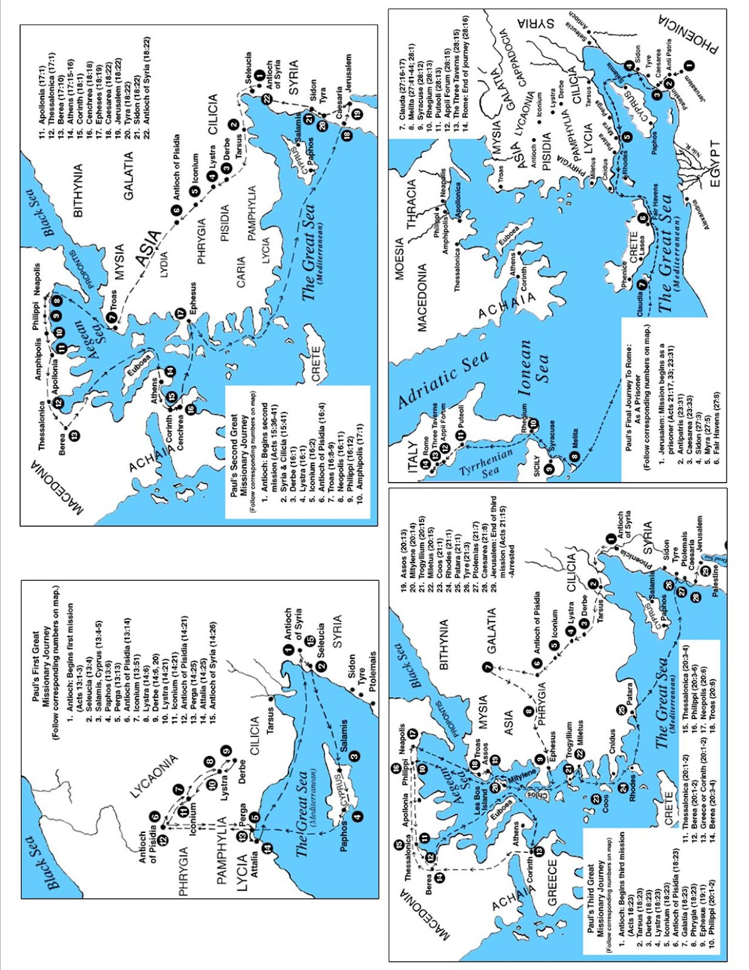

**Lesson 5 Study Questions**

1. Ch. 13
2. Ch. 14
3. Ch. 15
4. Ch. 16
5. Ch. 17
6. Ch. 18
7. Ch. 19
8. Ch. 20
9. Ch. 21
10. Ch. 22
11. Ch. 23
12. Ch. 24
13. Ch. 25
14. Ch. 26
15. Ch. 27
16. Ch. 28