Happy Father’s Day

2014

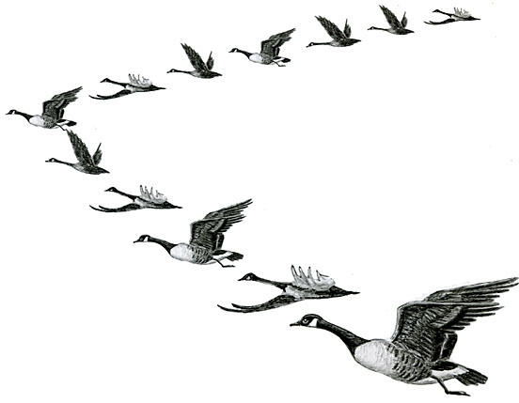I Love You and Appreciate You!

**Ecclesiastes 4:9-10**

Two are better than one;

because they have a good reward for their labour.

For if they fall, the one will lift up his fellow:

but woe to him that is alone when he falleth;

for he hath not another to help him up.

1. When geese fly together, each goose provides additional lift and reduces air resistance for the goose flying behind it. (Can fly 70% farther as a team.)

2. When a goose drops out of the v-formation it quickly discovers that it requires a great deal more effort and energy to fly.

3. Geese rotate leadership.

4. Geese honk at each other.

5. Geese help each other.