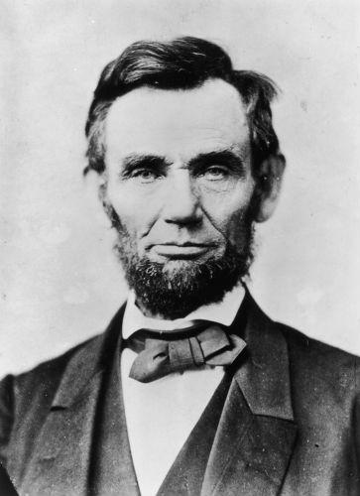

Le 19:27 Ye shall not round the corners of your heads, neither shalt thou mar the corners of thy beard.
Le 21:5 They shall not make baldness upon their head, neither shall they shave off the corner of their beard, nor make any cuttings in their flesh.

1Sa 21:13 And he changed his behaviour before them, and feigned himself mad in their hands, and scrabbled on the doors of the gate, and let his spittle fall down upon his beard.
2Sa 19:24 ¶ And Mephibosheth the son of Saul came down to meet the king, and had neither dressed his feet, nor trimmed his beard, nor washed his clothes, from the day the king departed until the day he came again in peace.
2Sa 20:9 And Joab said to Amasa, Art thou in health, my brother? And Joab took Amasa by the beard with the right hand to kiss him.

Ezra 9:3 And when I heard this thing, I rent my garment and my mantle, and plucked off the hair of my head and of my beard, and sat down astonied.
Ps 133:2 It is like the precious ointment upon the head, that ran down upon the beard, even Aaron's beard: that went down to the skirts of his garments;

