r��t'..:·-.,-1,·��l��..-

*·'lie* ,,. if! *'"I

I REMARKABLE INCIDENT

ooo=ooo

**Showing that it is dangerous i:o oppose the ''Second Blessing" or Sanctifica­**

**tion as a definite experience subsequent to regeneration**

**the t_.ragic end of preach- er i'�t having ruined**

1. **whole family­ vtty farnenca­**

**ble affair**

1'111

•�

*Publiabed by*

**:(JIPEON 0. DE MERCHANT**

BATH, N. B•• CANADA.

lQ **llfnts each $2.00 a dozen. $10.00 a handred.** I

��- .. ���=.,,r�

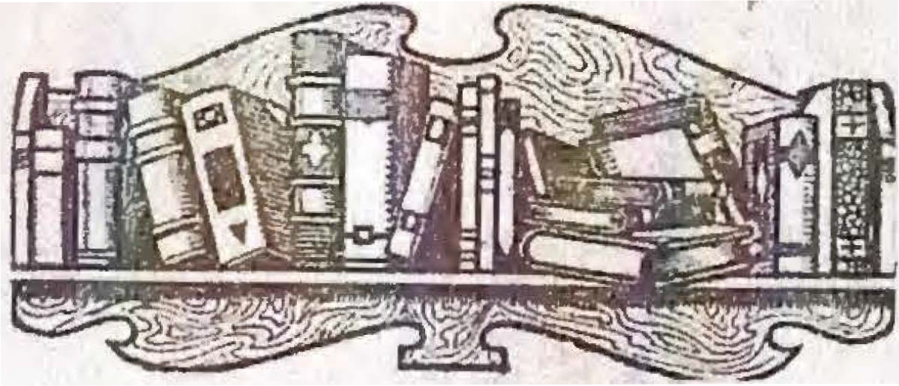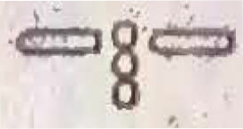

*cJubscribe ,/or*

*u/J!ished �onthly*

*�by-*

GKDEON 0. DeMERCHANT

*at "Bath, :A(, "B., @anada*

*every earnest Chri'stian should have this, one ofthe best christian*

*papers published, on their list to assist them in a deeper andmore conseeirated life. unto Christ.*

**live it.**

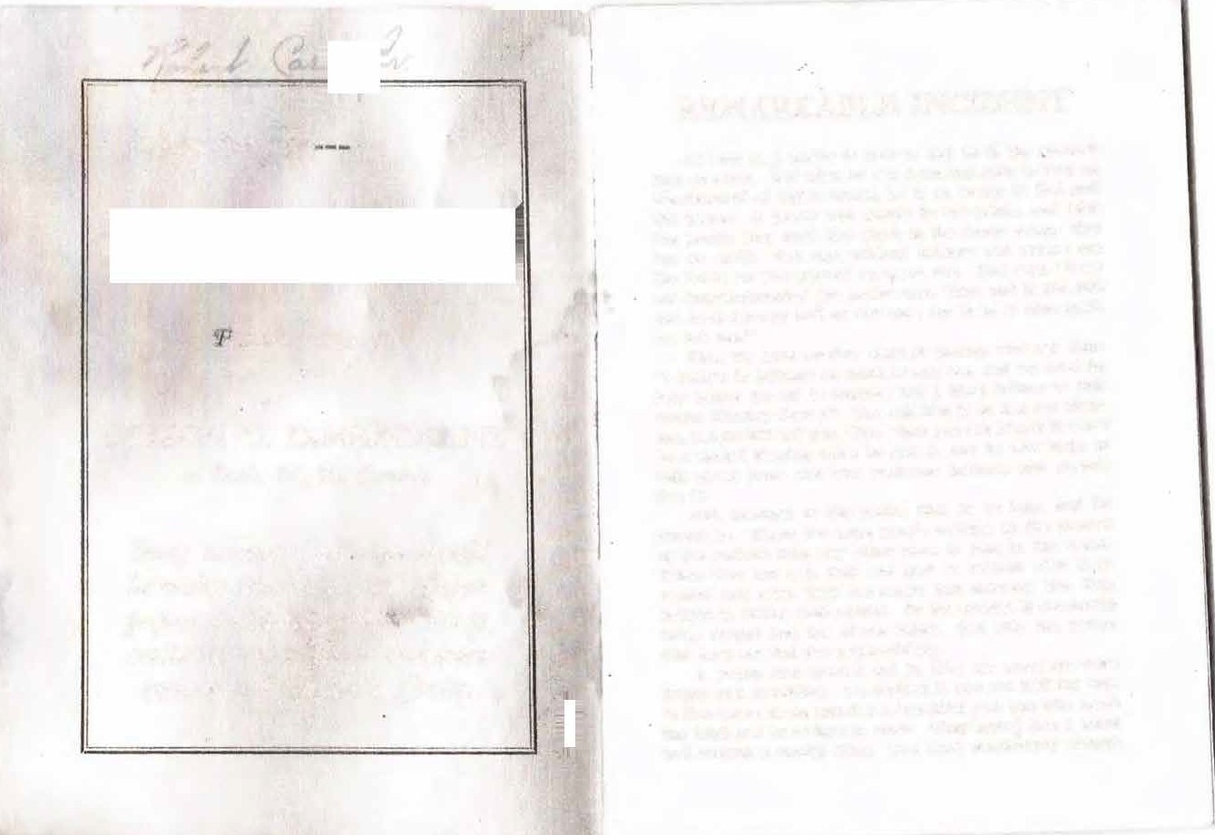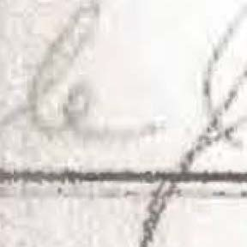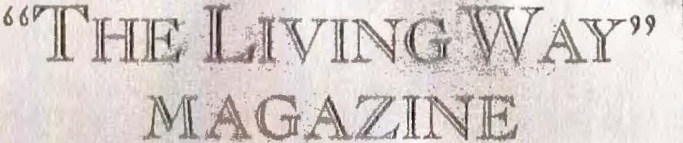

**the Lord an<l knew how to work.**

2 REMARKABLE INCIDENT

REMARKABLE . I

them. They built a nice home, a son was born, named, the pastor sent for and little Walter christened: So Brother A. and wife started out with energy and .zeal to make life a success, be a blessing to the world and get to heaven. They frequently counseled with their pastor in re­ gard to the training of their little one. Of course he was

through to victory. Sister A. t Brother A. was highly pleased the way home he and his wife "Oh, if Ihad .the experience t I would give the world I" "I bel wife. "I know ,ve need it; we

always ready to advise them. children, and we don't have the

Time passed and the Lord blessed Brother A. with a we ought to have." The mothe

good honie, bank account nnd two more children. He was said, "We must have the blessin

a praying member ln the church, n Sunday School super­ intendent, and hie wife wns n fine worker. She knew how to get down by a penitent in the altar and pray him through to victory.

Walter 'now was twelve years old, and hnd been taught to read blR Bible, pray, and go to church and was a very religious child. Brother A. and his wife cherlshed the thought that oome day Walter would be a precher: One beautif ul May morning, when all nature seemed to be praising God, Brother A. nnd wife began to talk ·of the

Walter listened eagerly to innocent little heart was hungeri So he joined in the conversatio want the blessing too. Iget ma er, andIknow when Iget mad ought not to sny, feel bad and and then God forgives me und

Ipromise the LordIwon 't do t

Ithink Inm macl again." They drove home, the tea m

goodnesR of God. They looked at their sweet little chil­ their Bibles amt rend the Scr

dren, their nice home, and everything they needed at their them to read. They were convln

door, and praised the Lord for His goodness. right and the blessing wus for

4 REMARKABLE INCIDENT

all retired believing they would soon have the desire of

REMARKABLE INCIDENT

laughed her to scorn and said, "How foolish

their hearts. ing a second blessing." The poor woman's hea

The morning dawned and the- sun was blessing the

earth with red glittering rays again. Breakfast was ready, prayer was offered, the Lord blessed, and again they were

in her.

Brother A. tried to convince the pastor t right, but he didn't pay any attention to hi

prepnring for meeting. Dinner was prepnred and packed pastor turned loose on the evangelist and said

in a basket. The teum was harnessed 1111<1 the carriage good to stay in the church, and now he is o

was driven outside the front gate. Walter l'Ume skipping muny church<'S he can break up. This second

down the stairs sln1r,J.ng, "I want to be like .Jesus in my heart." The song filled the mother's heurt with joy, and

trine is a new thing gotten up by a few ignor all they are trying to do is to tear up ch

shl' breathed ·u prnyer that this would be the day when Brother A., I nm your pastor, and I love you,

they would be fllled with nll the fullness of God. Her heart stand the Bible, and I know there is no such d

was punting after Ood, "the living God." aR that 11econd blessing preacher is preaching.

So she stol<i IIwny to the closet for a few moments uud prayed over this thing until I have learn

pmyPr hefore stnrtlng to church. ·And thus she prayed: "O Lord, according to Thy Word, Thou art able to cleanse from all sln and satisfy every longing of the heart. And now, Holy Father, help me this morning to make the con­

I was foolish enough to go to the altar and s blessing in a holinei;is tm>(>tiug n few years was at the altar the Lord slww<'d me thnt I up from thnt ultur or I woul<l hnve to give

secration required that I may be filled ,vith all the full­ and He showed me that I mrnit get out nncl g

ness of God. I hear people say they are ready to meet Je­ sus, and would be glad to see him. Now, Holy Father, Thou

and not be seeking a R<lCond blesRl11g." "\.Vell," said Broth<Jr A.• "how 111nny <·o

knowest I love thee, but I can't say that I would be glad you had since you began to preach ngulmit Ur

to see Jesus. Help me to get to the place where I can say

ing?"

amen to the entire will of God." "Well-well-I-I-well, I have received

About this time one of the ehildren came running in ber into the church, and baptized several, a

and eaid, "Yonder comes our pasto1·." She arose from her

knees delighted, thinking that her pastor would help her

our church paper."

"Now, pastor, you didn't answer my que

0 REMARKABLE INCIDENT

"Now, pastor, that holiness preacher last night proved

REMARKABLE INCIDENT

but poor, weak worms of the dust, and by

that we could be free f rom the carnal mind and the Lord

Word we learn that we will have to sin as lo

could keep us in perfect peace. So I want nll the Lord

But we thank Thee that when we sin we hav

has for me."

with the Father, Jesus Christ the righteou

The pastor was getting a little uneasy so he decided to try flnttery. Just like the enemy of souls; if he can't

Holy Father, this family is about to be led

new fangled doctrine, and I pray Thee hel

get you nny other way he will flatter you almost to death.

their mistake and stay with their church and

So he snld : "Now, Brother .A., I never saw 11 family

to the world. Now, Father, forgive our m

that I loved ns I do you and your family. You are the

help us to be true to our church and help

backbon e of the church, and the whole church looks to

foolishness of seeking n second blessing. H

you for counsel, and they all say we could not get along

that sanctification and regeneration are one

without Brother A. and family. Now, Brother A., listen

thing. All this we ask in ,Jesus name. Ame

to me. God blesR you, I want to help you to be a greater mnn thnn you have been, nnd you will make no mistake in taking my advice. You tum thnt team back in the lot and

Brother A. listened to the prayer, but

much. When the prayer was over Brother pastor why he believed that we were sancti

st.ny away f rom that holiness meeting. If you will stay

fied at the same time. The evangelist prove

away awhile you will get to the place where you will not

standards of all the churches teach that th

want to go. The idea of our getting so good we won't get

remains in the heart of the believer and the

mad ls rid knlous. We never will get to the place where

plainly that we must be Sllll('tlfl ed before w

we won't get mnd. That prencher ls preachinig a false

baptism with the Holy Ghost.

doctrine n nd he knows lt."

"Well, said the pastor, "I um not 1nu<·h

The mother 's henrt sank within her nnd Wolter dropped

Ghost baptism ln this age. You see, we h

bis head and left the room with a heavy, breaking heart.

and knowledge that the apostles didn't have.

He went to the barn and climbed up in the lof t and prayed

to have this extrn bless.Ing to do the work

that God would let them go to meeting. In a short time

done at that time. Don't you ever get it I

he wns sent for. The pastor wns going to pray with them

that we wlll be ns good ns the apostles."

and leave.

"Well," said Brother .A.., "the Bible says

8 RE:\IARKABLE INCIDENT

pastor, "there is no one professing this blessing but a few

REMARKABLE INCIDENT

will too. Great God !open the eyes of the p

.ignorant folks, and Iwarn :you again to stay away from dent people. We see people today as much u

their meetings." ence of the pastor as th Catholics are under

Brother A. had the team put back in the lot and Sllt down and had a long talk about the evangelist and about holines. and then said, "Now we know that our pastor is a good man and well educated, and he knows much more than we do, and it looks like foolishness for us to try to be better than our pastor." So the father and mother de<·lded to walk in the counsel of their pastor and

Walter left the room very sad Indeed, Lord to let them go to the night service.

About night Brother Graves and famil their way to church. They didn't understan

A. and family were not at church. They Gou for the 1ww foun<l joy , and ai-ke<l Brot cli<ln't i:o to the morning service.

stay 11way from the holiness meetings. "Well, our pastor came out this mornin

Walter listNwd nttenth·ely, then said, "Papa, Iknow our pastor ls tt good man, and very wise, and Ilove him; but I n<'ecl Urn t•x11erlence the evangelist talks about. If I could keep from getting mad IknowIwould be happy and

ROnll' thingR we dicln't know." Then he told all about that hollnl'KK preacher running of man's wife, ancl wamed him to stay a,vay ing.

more usef ul. Ilove Goel and Iwant to live right and help "Well," said Brotbpr Grnves, "we all g

others to Jesu!-1 ; and Iknow when Iam mad Idon't feel la:,;t night, and It !:,; too goorl to give up, u

like praying for sinners. Ifirst have to ask God to for­ give me before Ican pray for others. ·Then suppose a sin­ ner comes up und hears me pi·aylng to God for pardon, will

the other fellow did." But Broth<'!' A., inf pastor, st.outed it imt, ond wonld not. go.

While the older peo11le W('l't' tnlklnJ.:,

be want that kind of religion? Now, papa, our pastor bert went upstairs to \Valter'H room, 1wd A

said that aft.er we accept Christ our bodies do all the sin­ tPr that ht• loved his pastor, hut Hillel, "I l

ning and our souls are clean nnd holy. 'l'he Bible says taken about holinest1. .I know we 1:uu ha

every sin committed ls without the body. Now, are we bpc•1rnse Ihave it." He told Walter bow

going to belle,·e Goel or our pastor? Now, papa, Ithink that awful, hatef ul anger out, and how hupr

we ought to go back to the meeting and get all the re­ it. Walter wept while Albert talked. Then

ligion we want, nnd let our pastor have what he wants. bert to beg hh; papa to go to the meeting th

REMARKABLE INCIDENT

The father scolded the child · and told him it wus settled : they would never attend another holiness meeting.

REl\IA.RK ABLE INCIDENT

Walter thought of himself he wus at the altar cr mercy.

That night at family prayer Walter noticed that papa The service wus over und Walter rode home

didn't pray for the meeting as he promised ; in fact, his prayer wus short and dry.

The meeting continued, und God blessed many hearts.

heavy heart. He wept and cried, and regretted didn't get the blessing when Albert did. Next at the breukfust table Walter began to compliment

A holiness church was organized, also a Sunday School

serruon. The father und mothei· were now holine

and prayer meeting, which proved a great blessing to the ers, us many become when they full to wulk in

community. The Lord put his hand on Albert, Walter's ilnd get the blessing. So they began to ridicule the

chum, and called him to preach.

folks, und say thut it was foolishness for us to th

The crop wns gathered and Brother Graves moved to a good holiness Rchool and denied himself und worked hard to give Albert nn Pducution.

Brother A. sent Walter to the highest schools in the country ; but they don't honor the Lord in these schoois us

we cun be perfect In this life. Walter contended inust be holy before we can ever see God.

The father became enraged und suid, "Son, prised ut you, with your good sense und educatio

ing in such u doctrine."

they should, und Wolter became a little skeptical. Time

The mother joined In und snid, "Now, son, i

passed on. ,vulter cume home well educated, and secured

off with the holiness pnoplc you wlll have to give

a position in the high school for the next yeur.

position in the school, nnrl If Iwcre1 you Iwould

Albert Graves finished his education and returned to

before you go too fur. You rcuHmthPr our goo

his home to hold u meeting. The meeting began, and the

don't believe in thut doctrine, uncl I lmow he is

power fell, und people were fulling in the altar und pray­

mun in the world. He is going to preach 1111 u s

ing through to ,•ictory. So one night Walter decided to

holiness next Sunday und I want you to hNtr lt."

go o,•er to the meeting und hear his old chum preach.

Walter dropped his heud and the tours ruin<

Walter wus now a backslider and skeptic. He hud

'decided that religion was n failure, und the best thing for

plute and he said : "You muy be right ; but I w

him to do wus to get all out of the world possible. The

the world if I hud the experience that Albert has.

father and mother were not the least bit uneasy now, us Walter was educated und wouldn't puy attention to holi­

He W('nt to his room, counted the cost an

to wulk in the counsel of his father and mother.

12 RE:\IARKABLE INCIDEN T

Walter Mid to hh1 mother, "That don't look much like

REMARKABLE INCIDEN

Brother A. said to his wife : "I am so

a follower of ,Jesus to me." didn't go off with t.he holiness craze. Ith

"\Veil," 1mld the mother, ."our pastor is so fleshy If lc>ading ; it just ruins a young mlncl fo

he didn't smoke he couldn't do the work ·he has to do." They entered the church and Walter took n front

poor Albert Gran!S ! He Is gone ; he will nuything ln this world." The mother sa

sent with his father. The pastor walked Into the pulpit trne; Walter's education will take him th

smelling like the batk door of n buck alley saloon, and all right."

took his text, "We have all sinned and come short of the Albert continued hit; meeting and s

glory of Goel." He snicl to the sinner, "Yon mm1t give up 1:!11\'t'<l all <>Yer the country. The week pa

J·our slus If you eyer expect to get to heaven." Then he now Rn tnrclay morning. Walt<'r took hii; s

snicl to th<' Chr!Rtians, "You must sin as long ns you live. Isin eYery day and every hour in' the day, and Iknow I nm ready for heaYen, n poor sinner saved by grace."

He slashed the holiness folks, and told of a good man

faRt ta!Jle, but clid not c>nt nny brenkfus pale. ancl his lips qui v<'I'C'd. The mother nucl asked him the trouble.

Walter, with quh'ering \"oice, l'llicl :

that professed the second ble:.slng, but saw his mistake awf ul agony of sonl all night. I fPel like

and cnnm hack to the church, and what a light he had been ever since. He warned the people against young Mr. Graves' meeting, and told them he \YRS looking for the whole business to go crazy. ·

me my last call. Oh. how 1 rl•j.•, Tet thnt I feel like I ought to go o\'<'r to Albe morning ancl glYc my h<•n1·t· to God."

The fathN' b<'gau tc• 1,wolcl him, n ncl t

Brother A. and family were soon seated around the be wai;, and the bt•i;t thin!( lw <·onhl clo w

dinner table, and the mother said, "Son, how did you like holiness meeting and 1,to 011 nl1out hlti bu11l

the H<'rmou ?" ,vnlter replied : "If that is gospel, I don't The mother told him to wait 111ul go t

want to ht>nr any more of It. If that ls all there ts In: tor Sunday, and if he wanted to he 1•oulcl

religion I don't want It. 'l'hnt i>rc>nched said he sinned chun•h and they wonlcl fellowship him ngn

every dny, and that Is nil the dul'il can do. I can't see

that he 11:1 any .better than any other sinner. The Bible

be nil right. ·

,valter said : "Mother, that won't do

14 REMARKABLE INCIDENT

real sorry thnt young mnn ever came to our neighborhood preaching that dangerous doctrine.- He has carried sev­ eral of my best members off with l).im. Ancl not 11 few

are all torn UJl and in trouble like you are. rdon't know

REMARK-ABLE INCIDENT

it so nice for young men to play ball ; it Is such cise. Now she turned to her easy chair and to daily paper hoping that the league would beat

C. A.

whut steps to take in regard to the meeting. Several of

.About this time Albert, the young preache

my members will look me right in the face and say they

are sanctified, and I can't do one thing with them. I feel like we ought to run him out of the country. It Is so silly for educated people to go off with that lgnoraut crowd."

When he snid ignomut, trashy crowd, that mnde Wal­ ter mad and hiR com·iction lef t him, and he said : "You need not try to make me believe uny such stuff. I know there is not u nic-er young man living than Albert Graves, I have known him nil my life, and I know he is 11 gentle­ man in every respect., and the best preacher I ever heard.

So if you are going to talk about holiness folks be sure you

in. Sil;ter A. was surprised, as she had sent hi stay uwuy and quit t.alklng holiness to Walter. see from the expression of his face that he was awf ul burden. She wus son·y that he came, wa:,; there she was nnxions for him to explai '.!.'he young man of course begged her pardon an he. ooulcl Hl)eak to Wulter.

l\Iri;i. A. with a hnrcl rough reply said : "No, to lnforn1 you that you can't S!'e ruy boy tod sony you ever came back to this country prea

tell the truth."

claugerous second blessing cloctrine. Walter wa

The pastor saw he was beaten, and turning off with

bled this morning he couldn't ('at llny breakfast, a

11 big luugh began to talk about the ball game, which the

wus so bothered he clidn't Hlf'cp any lust night

Y. l\I. C. A. nnd the league were to play thnt af ternoon ,

sent for our pastor this morning, and he straigh

He bragged 011 the leugue team, and Insisted that Walter

out, and we sent him to the ball g1uuc thls uf te

go over and join them. The father and mother joined in

I am real glad he is away. It ltl suc:h a pity tha

nncl begged him to go to the ball game Instead of the holl­

became infatuated with that foolish second ble

uef!H meeting. So Walter decided to go to the ball game. The pastor took his hat and lef t, tickled to think the hol­

trine. You were such a bright boy, I thought

make a mark in the world, but you ha.ve certai



ues,1 people wouldn't get that young mun.

It. Wolter has a position in the high school, b

The mother p1·epnred Walter's ball suit, and at one o'clock he mounted his line horse and rode away to the

hall ground. The mother's heart leaped with joy as her

you, strolling around the country preaching

blessing. I am ashamed of you. Walter was so lively when he enme from school, but your pre

REMARKABLE NCIDENT RE!lfARKABLEJ NCIDE

self .about him. So if that iii all, you can take your hat began to read, but these words thundere

and be gone." have profaned the holiness of the Lord

Albert's eyes filled with tears as he said : "Sister A., daughter of a strange Goel!"

Ilove you, the Lord bless you, and Ilove Walter as a

She jumped from her chair and p

brother. Please hear me a moment and then Iwill be

gone. La11t night about midnight Iwas on my knees in agony for 1muls und ,valter seemed to pass right before

room, but the words k<'[)t ringing lu her altumccl and walked the floor, wringing "Whut does thiR mean! What does this

me and something whlspenid to me, "I am giving him his

to pray, but the heavPnR seemed brnss.

last call." Itried to get rid of the impression, but the

J>hone uml called her pastor, told him

n1oreIprayed tlie more intense It grew. Iprayed for him the 1·e11t of the night, and felt like he would be at the morn­

ask!'d him what it meant.

ini: serYlce. Sin<·e Hie momlug service, I have had such

H<' laughed in hN' enr and said : "

an awful hurcleu 011 my heart. Idon't under1,1tand It. We .

attention to such tlll iu1(1r<'s,ilo11. Now

hnd . n preclo111,1 Rt•rvlce, the Lot·d did wonderf ully bless,

not be weak mln<lccl. Brn<·e UJI, throw i

several were saYed null three were sanctified."

c·1trriaJ?:e brought out nml clrlve over t

·"Oh, that mnlces me tired!" exclaimed Mrs. A. "The

We are now ready to start. 'L'here is

idea of us being holy in this world. Idon't believe a word

pression ; don't you think *t* hN·c> i11. Th

of it. A.way with 1mch stuft', Idon't want to hear any

those second bleHslng folktt ; llwy a1·e

more of it."

pressions, aucl lt mnkc•s me• tlrc•cl to heu

"Well, Sistet·A., Iknow you think Iam wasting my

thing about htt[m·sHlons. Ho <·0111P on t.o

life, but Inm in touch with God and Iknow it, and He is womlerfully blessing .my life und ministry. I have .

we will have a nice time."

The poor womall contlntwcl tu wu llc

bought father nnd mother a nice little home anll they are

The burden grew -very heavy. Hite trk'<

happy, ancl Ihave more calls than Ican fill. Iam really

not. She went to the phone nnd call

18 REMARKABLE INCIDENT

REMARKABLE INCIDEN

never did advise you wrong, and my advice is to get out into the ope_n _ air, drive OV(lr here and go home with us for supper, nnd I assure you thnt you will go back home all

. The father thought : "A few hours

boy was begging to go to church where heart to God. I ref used to let him go,



right. Don't give wn y to that weakness."

prisoner in jail, and I am afraid lost fo

The broken hearted womnu hung up the receiver and

the father's heart, and he went to the ja

these words swept through her mind, "You knew your

When Walter heard his father's voice he

duty and did it not." Grent darkness hovered o'l"er her

and refused to see him. He told him he

soul. She sank to the floor and these awful words pierced

see him again and asked him to leave th

her hE>art and mind, "Ye have profaned the holiness of the

more than the father could bear. He w

Lord nnd m1uTie<l the daughter of a strange God."

nnd begged his precious boy to forgive h

Walter paid no attention to his fa

The gume was ou nnd waxed hotter and hotter and walked the floor of his cell, cursing hi

the Y. l\I. C. .A.. boys were getting mad. Walter was play­

pastor and everybody who teaches thnt

ing his part so well, and the people were cheering so much

livered from that hellish temper that caus

that it kindled such uu anger in one of the boys, that he

decided that If .he could not beat them they would fight it out. Ho he began to pick at Walter, and do everything

thh; crime. Walter called for paper and p his mother :

"Well, mother, I thought I would w

possible to get a fight out of him.

letter. I want you to know what you nnd

Walter stood it like a man for quite n while, but at

for me. I will never be 11 free mnn ag

last his awful temper got the best of him, and he turned

law, and my doom Is sealed In this world

on the young man with a bat and hit him such a terrible

come. The pangs of hell arc getting hol

blow that it crushed his skull as If it had been an egg

repent to save my life. You wi.ll rememb

shell. The young .man vas picked up and a doctor called, but in ten minutes .he was pronounced dead. Poor Walter fell on his knees beside the boy aud cried, "Oh, I did not

mean to kill him, I know I didn't. Anger is the cause of it. Great God, forgive me!"

morning that God was giving me my la

reallze now that it was. I will never ha to give my heart to God. Instead of bei you have been my worst enemy.



"You will remember years ago when

20 REMARKABLE INCIDENT

ball game. From the ball game, Iwent to jail, and Iwlll go f rom here to the penitentiary, and f roni there to hell. I

REMARKABLE INCIDE

ing ; I'll run and open the gate." He only a dream. The poor boy walked the

hope Iwll never see you again. Tell my little brother

exhausted again, and wished thnt he co

and sister to be good and go to heaven. Don't treat them

ns you have treated me. Itrust that God will forgive you, but Ine'l"er will. Iwant you to remember this: 'You and

father inflneueed by the pastor sent me to hell'."

The night passed, and it was Sun llirdH were singing, the sky was clear, . mys of the morning sun wt,re streaming

"You know how you n ud father prayed for the bless­

and dnnciug 011 the window. \Valker wa

ing of holineNs, nnd hN•nn,ie our pastor did not believe in

It, you gn,•e It 1111. I wns a . child, but knew you were doing wrong. I f<•nr .rou will never be saved.. This is

<·oul<I i<ee the happy <'hlldreu as they

Hchool. '.rh,• poor boy took a retl'Ospectl rememllered how ·happy he was when he

t.he laNt lPt!"t>r you will ever get f rom me. I hope I will

dny School, and how happy he could ha

never hi>nr from you ngaln. Don't come about the jail ;

not walked In the c•ouni,;el of that un

I will not s,,e you. 1''u rewell forever. Your lost boy, Wal­

thought wns more t han he could bear. H

ter."

HP 1w11led tlw lptter and handed It to the jailer. He then turnPd 1rncl ht!gnn to walk the floor, tear his hair and

for morphin e that be might end his life.

Brother A. 11ho1wd Io the pastor,

vh,it \Valter nnd rn·ny wl t.lt him. Abo

cry : "Oh, If I bud only controlled my temper, how happy pa stor w11lkt'd Into tlw Ju i! nud asked t

I could have been ! Anger did It, and I nm ruined forever. God pity my poor, lost soul. I loved that boy, God knows

walked up to the wiuclow wlwre he cou tor. Th!-' pnt1tor reac-hell hi hn nd to

I did, nnd I woul!l not have killed hiiii for the world. Oh, \Vnlter, but he rpf used to take tlw pastor

·how I hnte thiH anger that rs sending me to hell !"

* Supper wus brought In, but ,vnlter ref used to ea t. He walked t.he floor until he was exhausted. The city

tor was surprised and said, "Well, my bo hardly know what- to say. I always loo of the nicest young men In the country.

clock struck two. He fell acroRs the couch, and finally ready to advise you, and I think I under

slept. Don't let this bother you now, because

22 REMARKABLE - INCIDENT

"Now, pastor, listen to me u moment, then you can go. To be sure I don't want you to pray for 1:11e, I huve heurd you say that you sinned every day und every hour in the duy, and I don't doubt it in the leust. I would us

REMARKABLE INCIDEN'.r

your life. Albert walked in the counsel of the go u blessing to the world. I walked in your coun am n poor, God forsaken, heart-broken prisoner. one my of hope. I will go from the prison to hell,

soon send for u bnrtender to come und pruy for me us

I meet you I can point my bony finger in your fac

you. He don't do unything but sin, and thnt is ull you do: und thut is ull the devil wunts you to do. Don't you men­ tion prayer to me.

you thnt you gave me advice thut sent me there.

"You know thut God clemands holiness, and that you are unholy. You know thut the blood

"Several years ugo when father and mother und I were cleanses the heart, nncl thut it is received by faith

wanting nll the Lord hnd for us, you lnughed us to scorn und Rltid we were• foolish for seeking the Lord for clean

nre trying to make people believe they will be at death, when you lcnow you haven't one verse

hearts. You said WI' would have to get mud us long us we ture t:o BnRtain the doctrine. Now you cnn go. D

lived, und it WUR folly to think thnt we could be cleansed of the cnmul minil. I soon buckslid nnd went to the world for pleasure, hut fouud none. Then u few days ago, whe

any more. I dou't want your counsel nor pruye

The pastor dropped his head und .walked ou

Albert Graves beitun to preach in our community, you

curse of God upon him. He could plainly see wh

wunted to run him out of the country, and snid things about

done. The whole thiug loome<l up before him.

him you knew were untrue

himself : "I know I hnve clone wrong, but I don't

C!hurch to know it. I know it. I know the Bib

"Now this Is pluin tulk, but I want you to know what

holiness, but it is so uupopular I cun't afford to

I think of you before you go. You nre a dlsgruce to the pul­

now. The Bible suys that "There is tht•refore no

pit, nu enemy to God, and the cause of my ruin. I was

demnntion to them that nre in Christ Jesus," u

once a bright, happy, Christiun boy, but I hud un awf ul

condemnation. According to the Scripture I u

temper, and I wanted the Lord to take the tiger ·out of

Christ Jesus. Oh, I nm so sorry I ever tried to p

my breast so I could serve Him in holiness nnd righteous­

ness ull the days of my life, nnd you hindered me. And you know yesterday morning when God wus pleading with my

By this time he was in the church door. into the pupit uncl rend a short lesson, said it sh

24 REMARKABLE INCIDENT

The jailer sent Mrs. A. Walter's letter, and with trem­ bling hands she broke the seal and rend the awful fate of her precious boy. This was more than the poor mother

REMARKABLE INCIDENT

so much to say on that snbject, I have gott where I almost despise it. So don't worry

"Yes, but how cnn I keep from worryin

could stand. She fainted again ; the doctor was called, and

ize I will soon be in eternity? Such Scri

her mse pronounced hopeless.

She sent for her pastor for the last time. He came in

keeps ringing in my ears 'Every sin com out the body,' 'Be ye holy, for I am holy,'

with a sad, heavy heart. Mrs. A. could hardly 11peak, but ness no man sbnll see the Lord.' Now, pas

rallied enough to tell the sad, sad story.

"Now," said Mrs. A. to her pastor, "I have looked to you for yenrH for co11mwl and help. I thought you were

trine will do to live by, maybe, but it gives n poor dying, lost soul. If I were you I wou ing such stuff. Souls are too precious, nn

n mun of God, an<l n tme friend to me and my family. n­

long, for n preacher to waste his time preac

flte!ld of your bPlug our f riend, you have proven to be our

I hn ,·e tried to flncl Scl'iptore to sustain thi

worst <>nemy. W<> walked In your counsel, and you see

failed. I thought you were too good and to

wh<>rP we are todny. My darling boy is n poor, hopeless,

mllitnken about it, and I was ignorant enou

hell-bound prisonm·, and I nm dying with a broken heart,

soul on what you said. But I see now that y

without the IPaRt hope of heaven.

"I have one request to make of you. Never try to keep people from getting the blessing of holiness. Oh, if I could only call bnek the day when you first talked to us about holiness, nncl had Ul! turn our team back Into the lot I woul<l give 11 thousaud worlds, if possible. ,Just look at Mr. Graves and his family ; bow Go<l ls blessing them ! They have a nice home, nncl Albe.rt is such a flue preacher, yet

anything about the deep things of God.

"Ob, my prcelous, <lnrling boy! How I to make a success In lifl' ! And to think be I jall ! It Is more than I c·nu henr !

"You remember you told him that God him f rom that awful temper, nnd that ls

where he ls. How foolish we were for listeni holy counsel. Now, pastor, I never beard of

yesterday morning I triPd to insult. him, and drove him

soul to Christ, but I want yon to 1·emembe

out of my house.

"Now, pastor," contlnul'd Mrs. A., "you have been preaching here for twenty-seven yea rs, and you have been

one family that you have ruined. We were and hopef ul. Everything seemed to go our

26 REMARKABLE INCIDENT

REMARKABLE INCIDENT

an ·awful shriek she went into , eternity, _ crying, "Lost! .Albert, I want you to tell the people where

Lost !"

I felt the Lord calling me to holiness, bu

The poor, unfortunate pastor tried to pray, but these

and walked in the counsel of that pastor a

,vords kept ringing in his ears, "Ye are weighed in the bal·

Preach the truth, tell the people that God

onces and found wanting." He bade the heartbroken hus­ band and children good-bye, and left the room. As he

f rom the evil temper that put me where I

.Albert's heart was bleeding, a.nd the

walked away he groaned in spirit, and we heard him say, ing down his face. He asked Walter i! he

"I would give the world if I had never tried to preach. I know a preacher without the Holy Ghost is a fallure. I

him before he left. Walter said : "Yes, y

me but it is too late now. I appreciate yo

Bee my mistake and I believe with all my heart that holi­ and I have all confidence in you ; but I am

ucss is right, bu't I would rather die than to give up now."

In a few days the p11!1tor was off for a vacation.

Albert read a short lesson and tried poor boy, but the heavens seemed brass.

The s1td newH reached .Albert of Walter's misfortune,

heart he told his f rieu<l good-bye for the

so he hurried to town so he could see hlm before he took the train for his next meeting. He went to the jell and

turned away his face heavenward like a f

mined than ever to preach holiness.

asked for Walter. The jailer turned the key and Albert

Mr. .A. employed the heRt counsel po

walked in, and Walter rushed up to the window and reached did everything they <'ould to clear the boy



for Albert's hand. It almost broke Albert's heart to look carried from court to court. Mr. .A.'s ba

the poor boy in the face. His eyes were sunken, the skin gone. The farm was sold and the money

tight across his pale face, and his whole frame in a quiver. poor boy was sent to the penitentiary. Th

Albert sympathized with the poor boy, and told hlm how drink and one cold winter night he fell fro

be prayed for him Friday night, and how his i,oul was bur- died ln the mud.

dened for him. Walter lived only a short time. Ho die

28 REMARKABLE INCIDENT

One cold winter night a few met in a little cottage for prayer. The night was dark, the ' snow was falllng thick

REMARKABLE INCIDENT

In a meeting where the Lord blesses the pe time power."

and fast, and the wind was singing her lonesome song in

The husband, in an angry tone, said, "

the forest, and all nature seemed burdened for a lost world.

think that the Lord don't bless my meetings

The saints prayed that God would remove the trouble and

save souls at any cost.

Two blocks down the street was the parsonage, and the pastor was at his desk pret,aring a sermon on sanc­ tification. HP was going to prove. that we get it all at re­

"Now, husband, Ium going to bring a your remembrance . You rPmember years a were young and you had been preaching only thnt dear old saint, D1·.-, came to our town meeting, and so many souls were saved, and

generation. HI! hnd his wife going through his library sanctified ; and you remember how we enjoyed

searching for help, but everything she foun.d was some­ and prayed for the blessing, and you testif

thing about the <·11rn11l mind In the heart of the believer. were not sanctified, und would never amount

So the good wlft• gave up the search, laid down her book ancl said : "Husbnucl, you are certainly wrong. Ihave been searching for years to find Scripture and history to sus­

u:-1 far ns soul-saving was concerned without You remember the moming when your ch came to you and told ynn If you professed the

tain your doctrine, hut Ihave failed. Ifind all the great ing, they would ne,·er have nnything to do w

men are against you, f rom the apostles down to thf's day: would see thnt you W<'re located at once. So

Another thing Ihave noticed : Ihave never heard of a up and began to preach ogalust thP doctrine, a

second blessing mnn or ,vollllln that ever regretted on their that your preaching lurn been very dry a nd

deathbed that they had the blessing. It does look like if since. It ls true thnt you have built up a grl

it were wrong some one would acknowledge it on their number, but how many do you think would be

deathbed. Now don't you think you had better give It up and preach a gospel that saves?"

"Not for my right arm," said the pastor. "If Iwere to

should the Lord come tonight ?"

The poor, unfortunate husband didn't llku talk, and he said : "Wife, you make me tired

begin to preach that the carnal mind remained in the heart

that Ihave the best church in the city, and th

of the believer, Iwoul<l be located at once, and classed with

than all the other churches combined. And yo

3() REMARKABLE INCIDENT



had been talking about wns trµe. He saw the Arnold fnmi-, ly in their new home, happy nnd· free, and he remembered the morning when he had them to put the te11:m back in the lot, and kept them from going to the holiness meeting. He remembered the advice he had given them, and how they loved him and walked in his counsel; and he could

REMARKABLE INCIDENT

have not bad a spark of grace in my soul

I preached against the doctrine of sanctificati ing wrong. ButIwanted to be popular nnd but it cost me my soul. I can't find God. O dnrk, and I have to go alone!"

Then he reached out nnd took Brother

hear the groans of the mother, and could see the heart­ old saint thnt he had turned out of the ch

broken father straggling nnd dying in the mud. He could hnnd nnd said : "I knew you people were r

see the poor, friendless, Godforsaken boy as he plunged turned you out of the church. How God ·did c

from one side of the prison to the other, dying, fighting it! But I made myself believe that Icou

devils and crying, "Lost! Lost!" church, fight holiness, and finally get to heave

Then another picture cnme up before him. There was plainly thatIhave failed. I want you people t

the Graves family, poor renters, but they obeyed God, nnd and be tl'lle to God at any cost. In n few ho

would not walk ln the counsel of thelr pastor, nnd h in hell to burn forever. Oh, what a fool I h

could see Albert a great preacher, and his mother and father in n nice 'home, happy ns they could be and a real

blessing to the world He got out of the bed and walked the

have wasted my life trying to please nn ungod want you people to tell wherever you go th be true to God at any cost. My church loved

floor. His wife tried to comfort him, but all in vain. He If I hnd been true to God they would hnve bee

walked the floor, wringing bis hands nnd saying "I would_ Iam sureIwould. Now, bretheren, you all k

give the world if I hnd obeyed God instead of mnn." He walked untll he was exhausted. He was ·taken ill; the doc­ tor wns called, hls case wns diagnosed and pronounced

generation don't destroy the carnal mind ; it for a soul to get to heaven without holines soul is mnde holy after regeneration it is b

pneumonia. The third day his case was pronounced hope­ second work of grace. Ihave known this for

less. The poor man saw his doom. He sent for n number have played the fool at the cost of my soul.

of his church members, and then sent for the holiness a great preachr. Ihave been anything bu

folks thnt he had turned out of the church, and they brac­ preacher ."