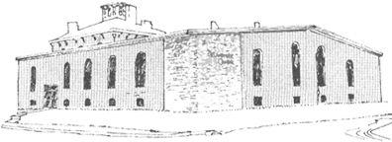

****

Pastor James Reynolds, Sr.

Asst. Pastor Stephen G. Reynolds, Sr.

1008 Congress St. Portland, ME 04102

Tel. (207) 774-8192

[www.**thedeliverancecenter**.com](http://www.thedeliverancecenter.com)

*From the Desk of Pastor Stephen Reynolds, Sr.*

Dear John,

Thank-you for the respect you show by requesting for permission, this request sounds like you want permission to go to the Seadogs.

Yes you may go to the seadogs Monday and Tuesday but do not miss any prayer time.

Prayer is from 7:00 to 8:00 every morning and night.

Thursday everybody will be helping with setting up the tent, we will be leaving the Deliverance Center right after breakfast in the morning Thursday at 8:30 A. M.

July 9th -18th we will be having services in the Tent every night for ten days, these meetings have been scheduled and announced and posted.

What is your plan for an apartment? It sounds like from this request that you are planning to be staying here for another week.

Assuming that it is all right for you to stay here and writing, “provide us with more paper, I don’t have none” is not a request.

Asking for permission to stay here another week would be a request.

Asking if there were any paper available for you to use would be a request.

I don’t mind you staying here for one more week, until Monday morning as long as you

are involved with what we are doing but if we see that you’re here for yourself apart from what we are doing we will have to make a decision before Monday.

Absolutely no working on Sunday.

You will find that total surrender to the Lord is a blessing.

Sincerely,

Stephen G. Reynolds, Sr.

Assistant Pastor