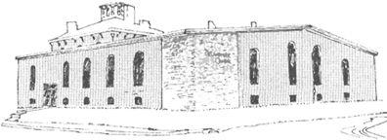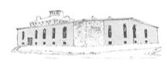

****

Pastor James Reynolds, Sr.

Asst. Pastor Stephen G. Reynolds, Sr.

1008 Congress St. Portland, ME 04102

Tel. (207) 774-8192

[www.**thedeliverancecenter**.com](http://www.thedeliverancecenter.com)

Dear , Residents: Let me remind you, this is the gospel of Jesus Christ, **there will be no assistance from the heathens.**

Mat. 6:7 But when ye pray, use not vain repetitions, as the heathen do: for they think that they shall be heard for their much speaking.

Psalm 33:10 The LORD bringeth the counsel of the heathen to nought: he maketh the devices of the people of none effect.

Psalm 141:4—*Incline not my heart to any evil thing, to practise wicked works with men that work iniquity: and let me not eat of their dainties.*

“Incline not my heart to any evil thing”

1. Devil's desires.

“to practise wicked works with men that work iniquity”

1. Devil's deeds.

“let me not eat of their dainties”

1. Devil's dainties.

Gal. 6:14 But God forbid that I should glory, save in the cross of our Lord Jesus Christ, by whom the world is crucified unto me, and I unto the world. 1Peter 2:11 Dearly beloved, I beseech you as strangers and pilgrims, abstain from fleshly lusts, which war against the soul;

**Total Abstinence** from drinking, smoking, worldly music, entertainment cursing, swearing, carousing, movies of any kind, immoral or unbiblical magazines or books, charismatic influences from books, person, letters, No prescription drugs of any kind, No support from government assistance, No Jewelry, crosses, beads, no worldly words or signs on clothes, No counsel from the world about your souls need in any fashion. Absolutely no worldly hang-ups or habits of any kind.

**Group Prayer** is to be at **7:00 A.M. to 8:00 A.M. and 7:00 P.M. to 8:00 P.M.**

Psalm 2:8—*Ask of me, and I shall give thee the heathen for thine inheritance, and the uttermost parts of the earth for thy possession.*

*Joshua 24:15—And if it seem evil unto you to serve the LORD, chose you this day whom ye will of the Amorites, in whose land ye dwell: but* ***as for me and my house, we will serve the LORD.***

Sincerely, Stephen G. Reynolds, Sr.