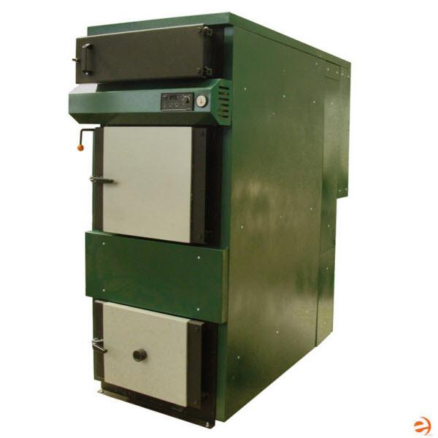

|  |  |  |
| --- | --- | --- |
| **Your Price:** | **$9,995.95** |  |
|  |  |  |

New Horizon BioMass 100 High Efficiency Wood/Coal Burning Gasification Residential Boiler 91% - 340,000 BTU

BioMass 100 Wood/Pellets/Wood Chips/Saw Dust/Coal/Corn Cobs with Kernels Burning & Gasification Combustion Steel Boiler provide a convenient, safe and environmentally friendly way to heat your home and domestic hot water with wood. [Biomass boilers](http://blank) assure the independence and self-reliance that heating with several different fuel options-wood, 50% coal/wood chips, saw dust, pellets and corn cobs with kernels. Because the boilers use wood gasification combustion, they give unusually high overall heating efficiency up to 91% and will hold heat from single load up to 12 hours. They use substantially less wood or other burning material than conventional boilers and outdoor water stoves with no visible smoke when fully operating. 91% efficiency BioMass wood burning and gasification combustion boilers may be used for heating any kind of building. They are mostly used in one-family houses, drying houses, workshops, halls, or greenhouses. However, boiler placement is not limited to these applications; the above are just examples of where BioMass boilers have worked with success.

The BioMass wood burning boilers has a large finned firebox and secondary combustion chamber maximize the burn time and minimize wood consumption. Easy adjustments to the automatic temperature control, secondary air regulator, and flue gas damper enhance fire maintenance. The BioMass line uses negative draft technology which means that air is pulled, rather than pushed, through the gasification chamber. This design keeps any emissions (smoke) from exiting the chamber while refueling the boiler. BioMass 100 Gasification Boilers are an ecological and efficient source of heat for closed pressurized or open radiant systems.

BioMass wood burning boilers extracts maximum heat form the fuel source for your system by using gasification process and secondary combustion, which results in complete practically emission free burning. BioMass boilers come with a new digital programmable controller, RK2001, which allows for customization of the operation.