Bibliography Reference Manual

(last updated: 5 July 2018)

# Motivation

The research project **Biblia Arabica** The Bible in Arabic among Jews, Christians and Muslims, conducted by researchers from Ludwig-Maximilians-Universität Munich and Tel Aviv University, investigates Jewish, Christian, and Samaritan traditions of Arabic Bible translation under Muslim rule. These translations, their stylistic and didactic features, vocabulary, scripts and ideologies, as well as the extent to which they were influenced by the Qur’an and used by Muslims in their discussions with members of the other Abrahamic religions are the focus of the international project. It charts the countless manuscripts and fragments that are nowadays found in monasteries throughout the Middle East and libraries across the globe, analyzes the different methods of translation from Hebrew, Aramaic, Syriac, Latin, Greek and Coptic, and examines the mutual influences, both religious and cultural, between the different religious communities. In addition, it deals with the historical and social repercussions of discourse and polemic that are still alive today. An important tool for researching these topics is a comprehensive bibliography of text editions and research in the field. The following guidelines are intended to help build and maintain such a bibliography.

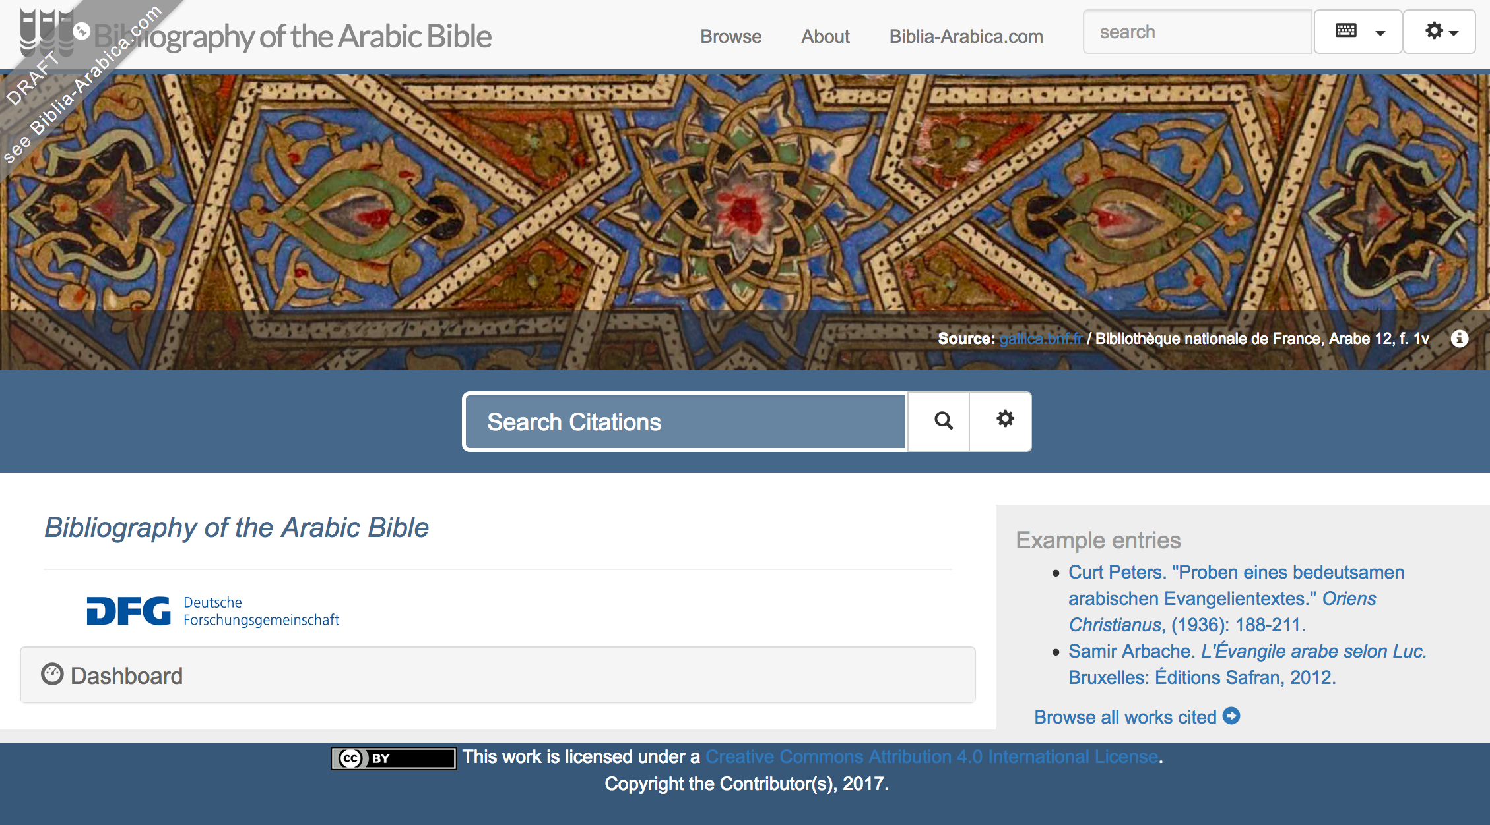

Image 1: Preliminary mock-up of the bibliography home page

# Technicalities

The **Biblia Arabica** bibliography module is a customizable software framework for displaying bibliographic records on the web in an open-access, searchable interface. Records are created and maintained in Zotero, a widespread and easy-to-use open-source bibliography manager, and exported to TEI-XML. The data is compliant with linked-open data standards and may be easily exchanged with or linked to other projects that use either Zotero or TEI formats. The module uses an eXist-db server to display XML records as HTML web pages and to allow advanced searching, browsing, and filtering. The **Biblia Arabica** bibliography module is open-source software (CC-BY-3.0 license) and is freely accessible on Github.

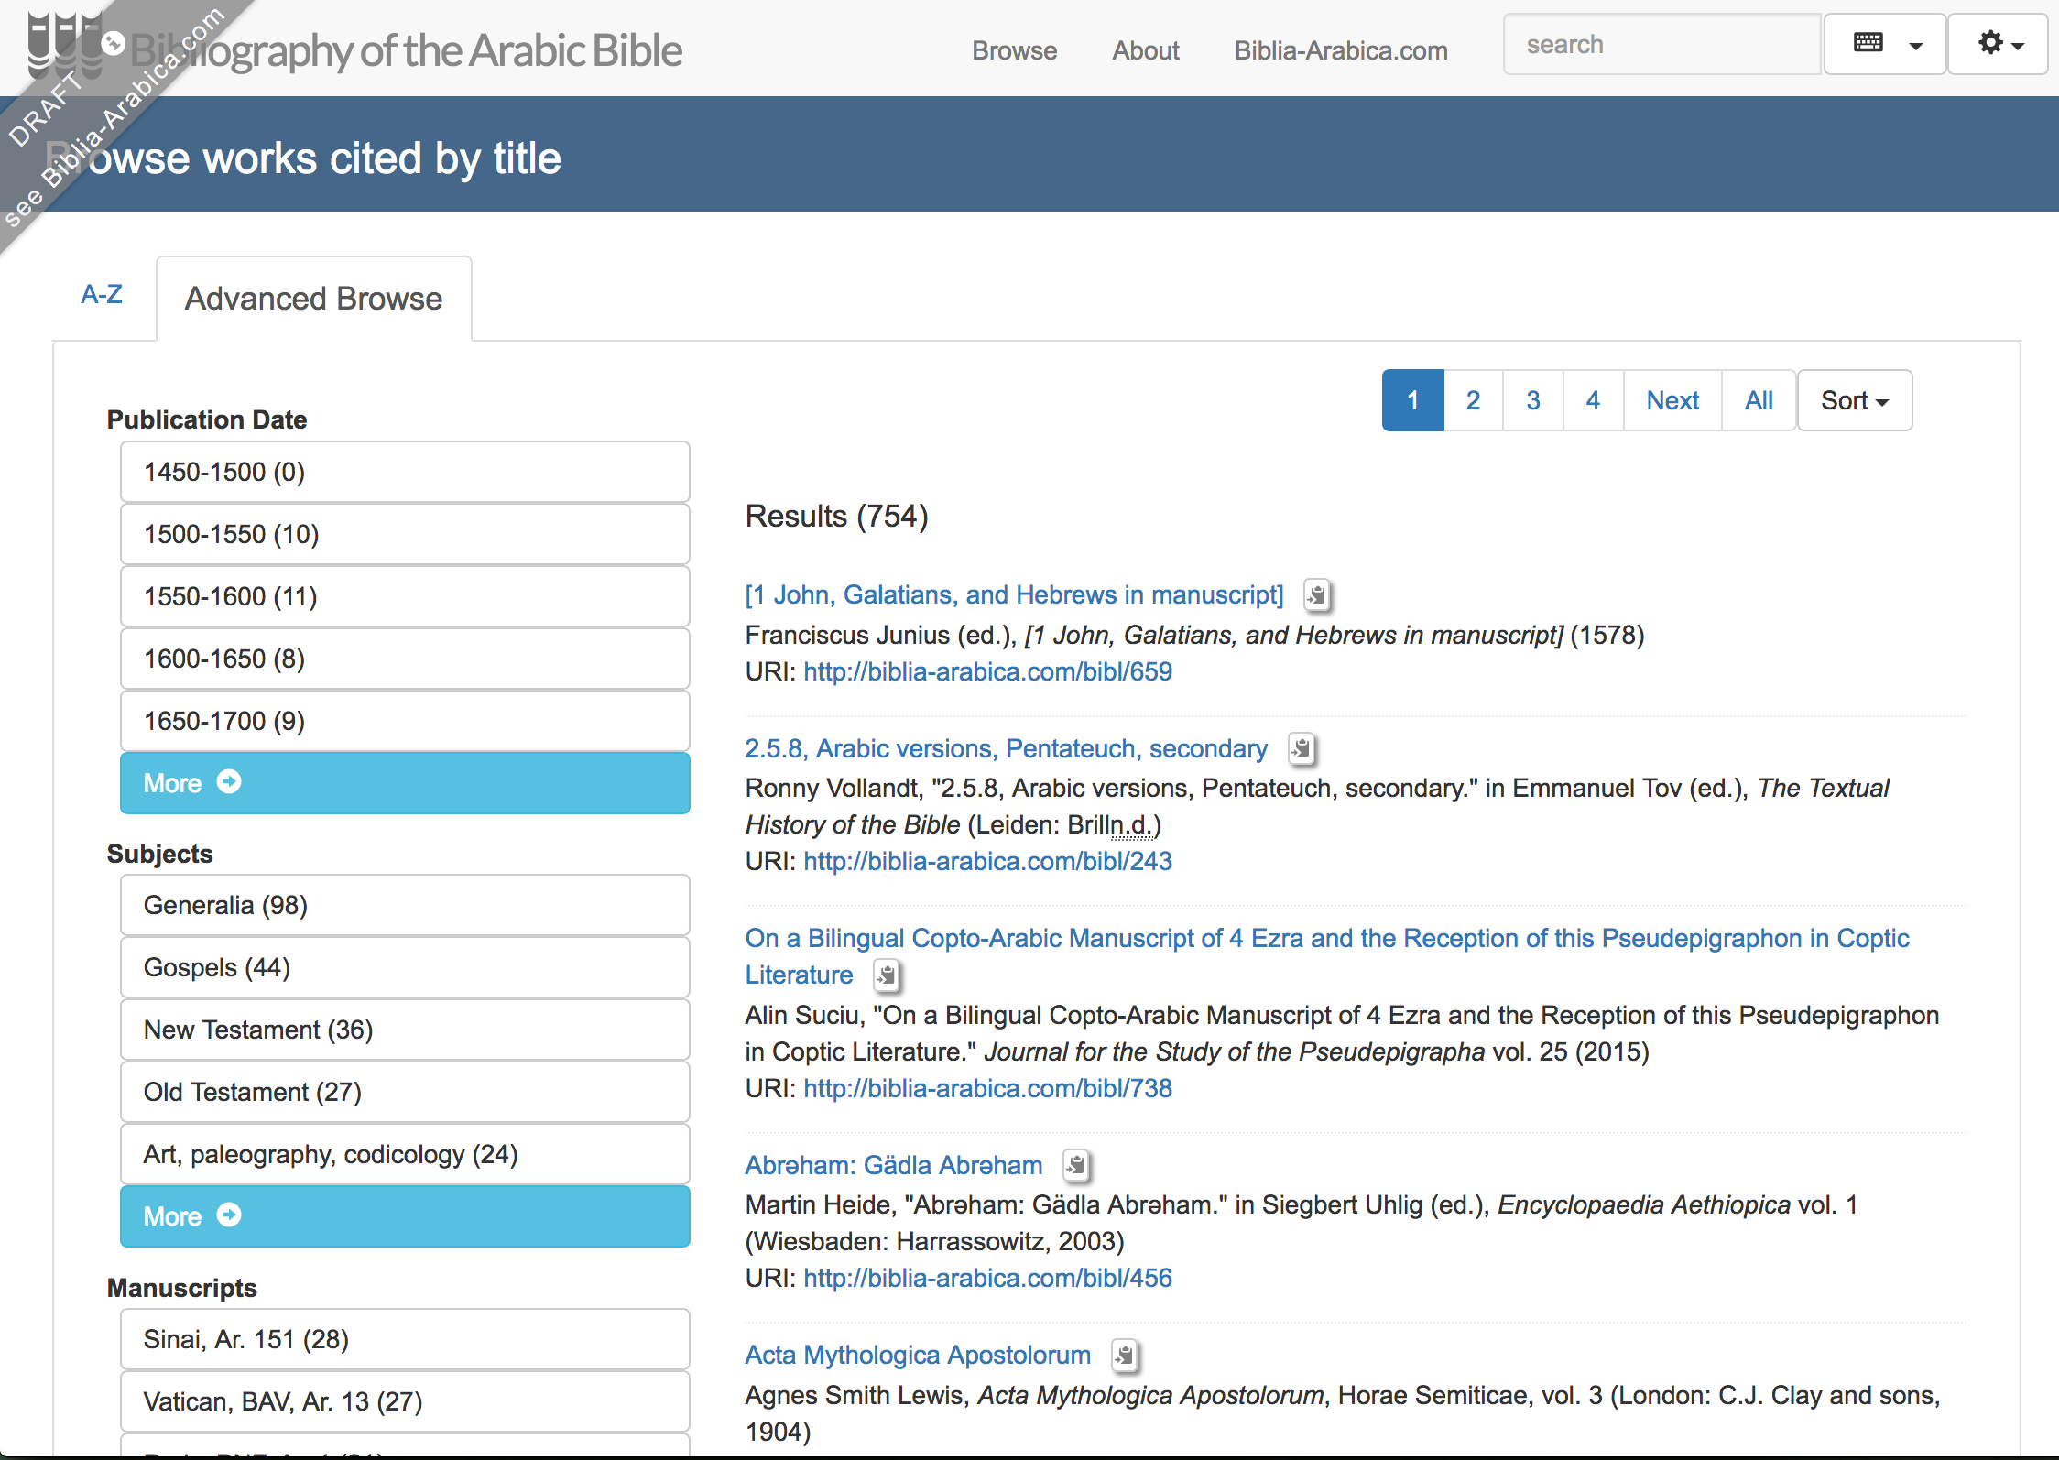

Image 2: Preliminary mock-up of browsing by tag

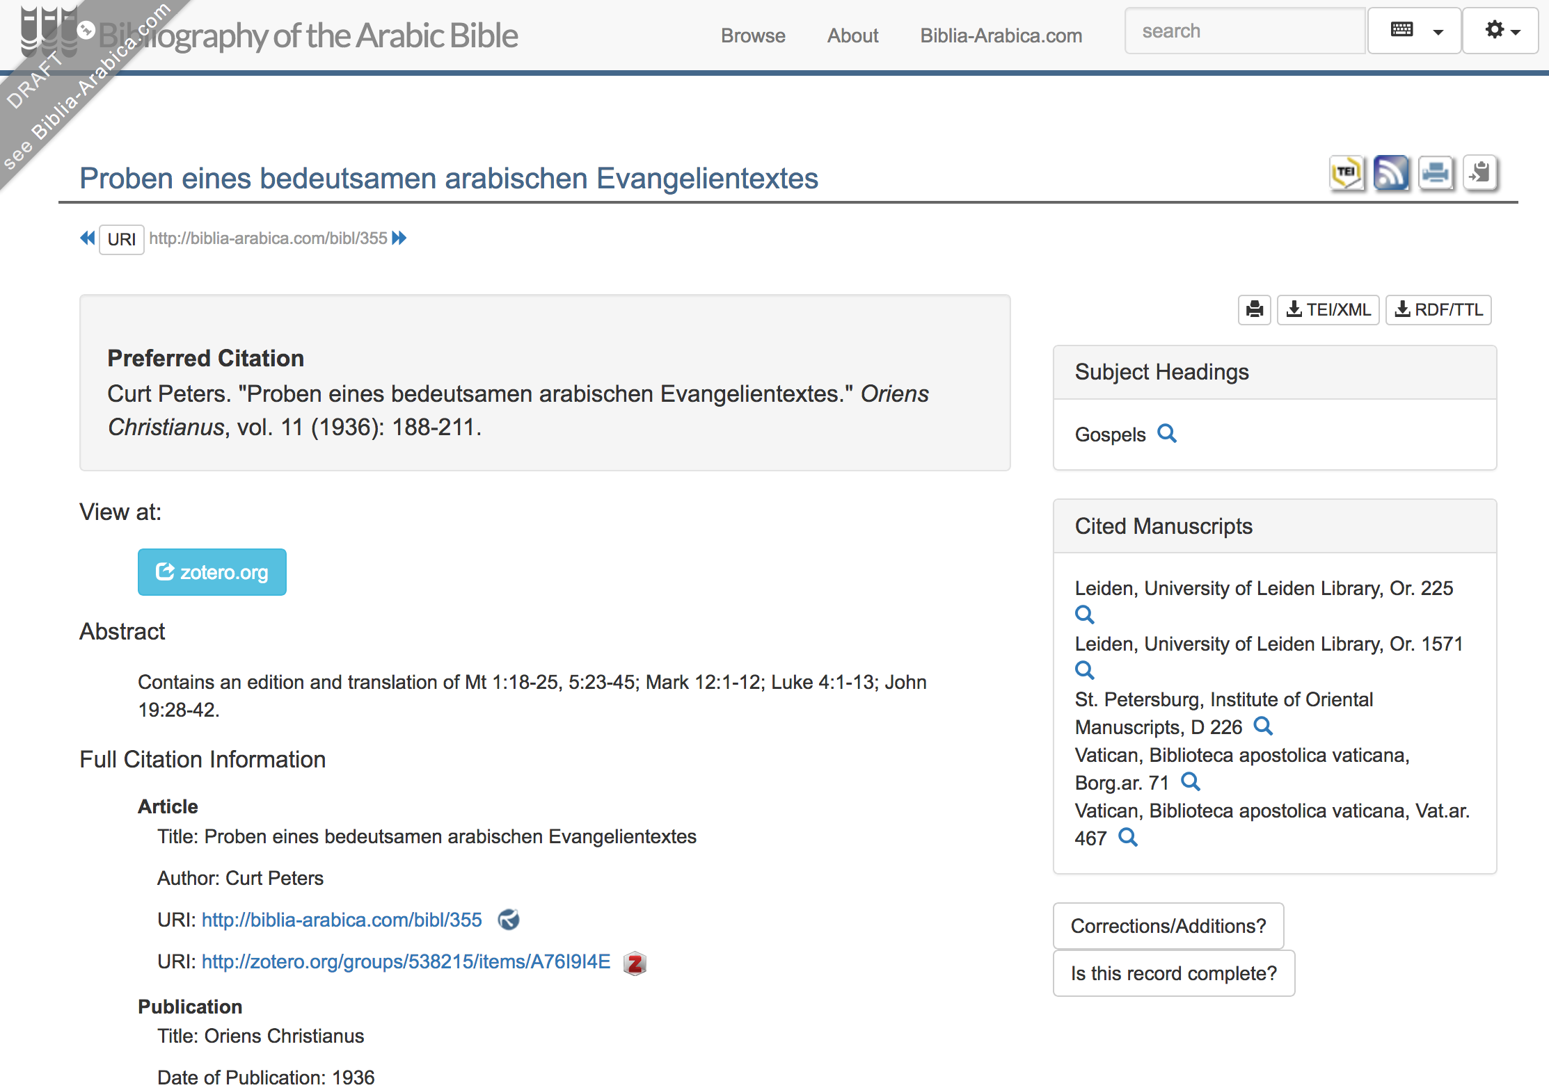

Image 3: Preliminary mock-up of an entry record with an abstract and tags

# Bibliographical Entries

There are two ways to create bibliographical entries in Zotero. The easiest is to find your item e.g. via [worldcat.org](http://worldcat.org/) or [scholar.google.com](http://scholar.google.com/) and use the Save to Zotero button  in your browser toolbar. Double-check the information for the added item to make sure it is accurate. Sometimes there are misspellings, strange transliterations, or extra punctuation. Also check that the “item type” is correct. The second is to add entries manually, by clicking the  button in Zotero.

Entries are grouped under the following five categories: a. **Book** (includes monographs, editions, translations, collected volumes), b. **Book Section**, c. **Journal Article**, d. **Thesis**, e. **Encyclopedia Article**. Exemplary entries are given below (3.2-6).

For each entry we give information on title, author(s)/editor(s)/translator(s), journal, series, volume number, printing (2nd, 3rd edition etc.), place, publisher, date, pages (for journal/encyclopedia articles or book sections), ISBN/ISSN (if at hand), university (for theses). The URL section should be used to link your item, if available, to one of the following digital repositories (see “5 | Linking”):

* [archive.org](http://archive.org/)
* [books.google.com](http://books.google.com/)
* <http://digitale-sammlungen.ulb.uni-bonn.de/topic/titles/16475>
* <http://gallica.bnf.fr/>
* <http://hathitrust.org/>

As concerns punctuation, titles and subtitles are separated by colons (:). Entries within the Title section *must not* end with quotation marks, unless used in the actual title, *nor* with any other punctuation mark, unless used in the actual title (as e.g. !, ?).

## Abstracts

The Abstract section should contain a short description for each item. All entries will be tagged according to the system explained below (see section 4). The aim of this section is to briefly describe the content of the respective item, on which basis research was done, or which editions scholars were using.

For example, here are two entries with their abstracts:

Adler, Jacob Georg Christian. *Kurze Uebersicht seiner biblischkritischen Reise nach Rom*. Altona: J.D.A. Eckhardt, 1783

**Abstract:** The author reports and describes his manuscript finds in various libraries on his journey to Rome.

Frank, Richard M. *The Wisdom of Jesus Ben Sirach (Sinai Ar. 155 IX-X Cent.)*. 2 vols. CSCO 357-358 = Scr. Arb. 30-31. Louvain: Secrétariat du CorpusSCO, 1974.  
  
**Abstract:** Contains an edition and translation of the Arabic Ben Sira, as based on Ms. Sinai, St. Catherine’s Monastery, Ar. 155.

Sometimes abstracts may refer to other items in the bibliography. In this case, they should include in curly braces “{}” a link to the item they mention, taken from the Zotero.org version of the bibliography at <https://www.zotero.org/groups/538215/biblia_arabica>. This identifier is the portion of the URL reading “https://www.zotero.org/groups/538215/biblia_arabica/items/itemKey/[8 character code]”. (In future, these links will be converted to <http://biblia-arabica.com/bibl> links.) Items that derive from or are based on other items are the ones that should contain the link in the abstract, that is, reprints, reviews, etc. (Although Zotero has a “Related Items” feature, we are not currently using this feature since [1] this data is not available for export to the Biblia Arabica website, and [2] it is not possible to specify what the relationship between the items is.) For example,

Otho, Georg. *An Arabic Version of the Acts of the Apostles and the Seven Catholic Epistles from an Eighth or Ninth Century MS. in the Convent of St. Katherine on Mount Sinai, with a Treatise on the Triune Nature of God, and Translation from the Same Codex*. Vol. 7. Studia Sinaitica. Piscataway: Gorgias Press, 2004.

**Abstract:** Reprinted from the 1899 edition {https://www.zotero.org/groups/538215/biblia_arabica/items/itemKey/T3BM5FJS}.

## Book

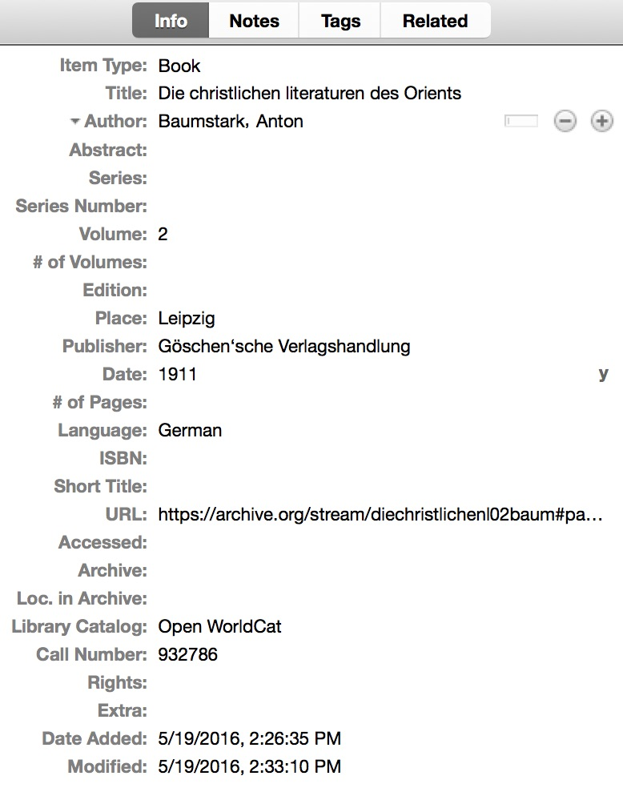

## Book Section

### Section in Book by Single Author

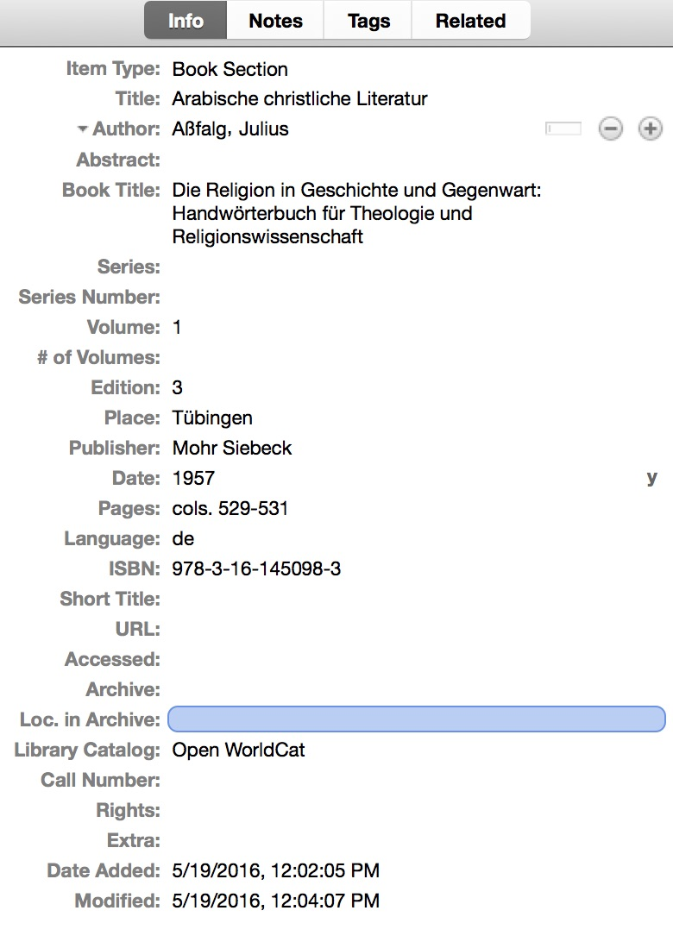

### Article in Collected Volume

To enter an item contained in a collected volume, choose “Book Section” as the item type and enter the title and author of the article. Then click the “+” button beside the author and change the type to “Editor” for each of the volume editors. Enter the book’s title under “Book Title” and be sure to include the page numbers of the article in “Pages.”

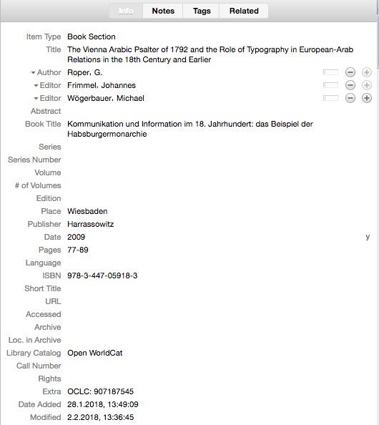

## Journal Article

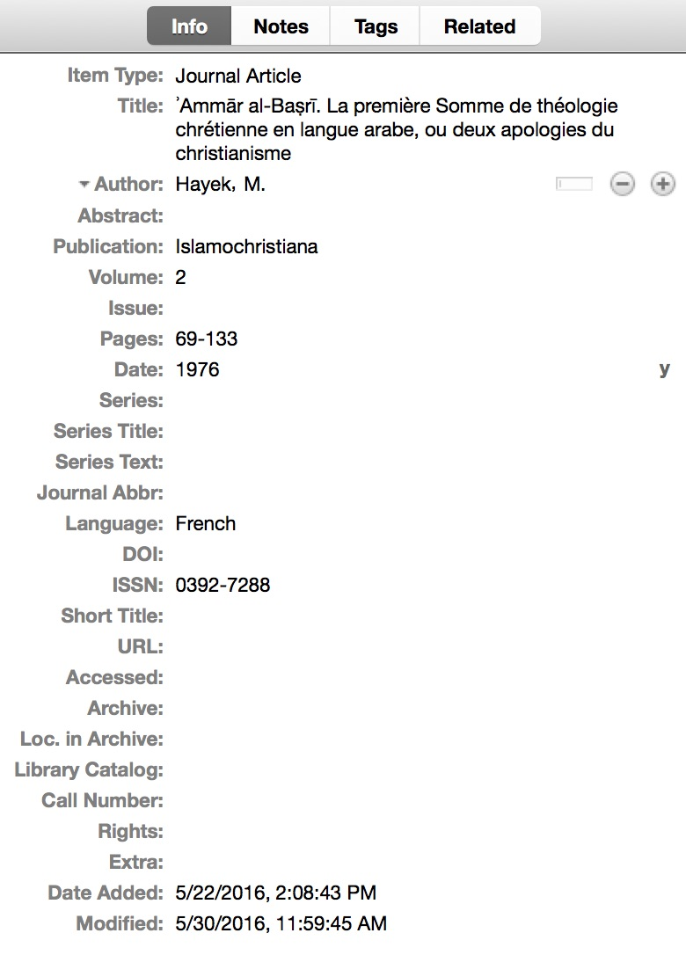

## Thesis

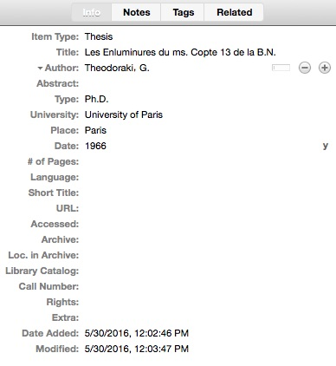

## Encyclopedia Article

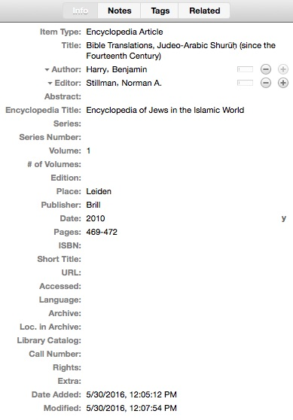

## Non-Latin Scripts

Items should always be entered using the script of the title page. In no case should transliterations (i.e., Romanizations) be used, unless information in the original script is unavailable.

Both Zotero and the web application used to display the bibliography support right-to-left scripts. The web application currently automatically recognizes Latin, Arabic, and Hebrew letters (i.e., characters in the corresponding Unicode ranges) and allows the user to browse by script. Other scripts (such as Cyrillic and Greek) are sorted into an “Other” category.

When a publication provides titles, names, or other information in multiple languages with different scripts (as, for example, with Hebrew publications that have corresponding English titles), all of the languages should be entered.

For author or editor names provided in multiple scripts, the name should be entered as a separate person for each script.

For other information provided in multiple scripts, the scripts should be entered in a single field separated by two pipe characters with spaces on either side (“ || ”).

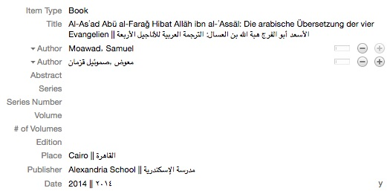

Image 4: Example of information in multiple scripts

# Tagging

We use Zotero’s “tags” to associate each item with specific topics. Click on the item you just added, and then click on the “Tags” tab above it. Add the respective tag there.

## Bible Tags

### Biblical Books

The item should be tagged according to the part of the Bible it deals with. If it relates to one particular biblical book or passage within a book, it should be tagged with “Book: [name of book]”, for example, “Book: Leviticus”. If it relates to multiple books (such as Exodus and Leviticus), then it should be given one tag for each book.

Names of biblical books are given according to the following list. Abbreviations must not be used.

*Old Testament*

Genesis Ecclesiastes

Exodus Song of Songs

Leviticus Isaiah

Numbers Jeremiah

Deuteronomy Lamentations

Joshua Ezekiel

Judges Daniel

Ruth Hosea

1-2 Samuel Joel

1-2 Kingdoms Amos

1-2 Kings Obadiah

3-4 Kingdoms Jonah

1-2 Chronicles Micah

Ezra Nahum

Nehemiah Habakkuk

Esther Zephaniah

Job Haggai

Psalms Zechariah

Proverbs Malachi

*New Testament*

Matthew 1-2 Thessalonians

Mark 1-2 Timothy

Luke Titus

John Philemon

Acts Hebrews

Romans James

1-2 Corinthians 1-2 Peter

Galatians 1-2-3 John

Ephesians Jude

Philippians Revelation

Colossians

*Apocrypha and Septuagint*

Baruch Judith

Additions to Daniel 1-2 Maccabees

Prayer of Azariah 3-4 Maccabees

Bel and the Dragon Prayer of Manasseh

Song of the Three Pslam 151

Young Men Sirach/ Ecclesiasticus

Susanna Tobit

Additions to Esther Wisdom of Solomon

Epistle of Jeremiah

For *Old Testament Pseudepigrapha*, see SBL Style Guide, pp. 74-5:

<http://wwwlibe.ces.org.tw/library/download/The%20SBL%20Handbook%20of%20style.pdf>

### Biblical Sections

On the basis of the biblical book tags (see above), items will be automatically tagged with the section to which they relate using “Section: [name of section]”, for example, “Section: Pentateuch” so that users may search for anything relating to a particular section. There is no need to add this tag manually.

E.g.,

* Pentateuch
* Historical Books
* Prophets
* Gospels
* Pauline Epistles
* Catholic Epistles

### Biblical Parts

Items will be automatically tagged with the part of the Bible they relate to on the basis of the biblical book or section tags they have. The tag format is “Part: [name of part]”.

* Old Testament
* New Testament
* Apocrypha
* Pseudepigrapha

## Community of Origin

If the community in which the translation under discussion was produced can be identified, it should be labeled using “Provenance: [name of community]”.

* Christian
* Jewish
* Qaraite (*not*: Karaite)
* Samaritan
* Muslim

## Source Language

The language(s) from which the translation under discussion was made should be tagged with “Source: [language]”. Multiple source tags may be used for each item.

* Coptic
* Greek
* Hebrew
* Latin
* Syriac

## Translators

Any known translators of texts under discussion should be tagged with “Translator: [name of translator]”.

* al-ʿAlam
* ʿAlī b. Sulaymān the Qaraite
* al-Asʿad Hibbat Allāh b. al-ʿAssāl
* Ḥafṣ ibn Albar al-Qūṭī al-Qurṭubī
* al-Ḥārith b. Sinān
* Ibn al-Ṭayyib
* Isaak Velasquez
* Marqus b. al-Qunbar
* Pethion b. Ayyūb
* Saadiah Gaon
* Yefet ben ʿEli
* Yeshuʿah ben Yehudah

## Manuscripts

We also use tags for mss (“MS: [shelfmark]”). The aim is to draw the attention of scholars to previous research that has been carried out on respective mss. So all mss. alluded to (even if only in footnotes) should be tagged. Please name mss according to the following order:

City, Institution, Collection, Shelf Number

Example: MS: Munich, Bayerische Staatsbibliothek, Cod. arab. 234

## General Tags

Tags not relating to a biblical passage, community of origin, source language, translator, or manuscript may be tagged with the generic “Subject: [name of subject]”. So far, these reflect the following chapter headings:

* Generalia
* Historic Printings
* Biblia Sacra Arabica
* Paris Polyglot
* London Polyglot
* Shidyaq Psalter
* Shidyaq NT
* Smith Van Dyck NT
* Jesuit Bible
* Chrestomathies
* Art, paleography, codicology
* Violet Fragment
* Diatessaron
* Biblical quotations in Christian Arabic writings
* Biblical quotations in Muslim writings
* Erpenius (NT 1616)
* Erpenius (Pent 1622)

## Workflow Tags

Tags are also used to indicate the status of entries in the bibliography.

Tags beginning with “!” indicate a possible problem with the entry, such as “!no abstract” indicating that an abstract needs to be added.

Tags beginning with “Assigned: ” are used to assign entries to specific people to edit (e.g., “Assigned: Nathan”). Upon finishing the entry, the assigned person should remove the “Assigned: ” tag and add a “Check: ” tag, assigning the entry to someone to check. Once the entry has been checked and is ready for publication, the person checking should add the tag “!done” and remove the “Check: ” tag.

The editors will move items marked “!done” to the “Publish” folder and review them again before publishing them to the website.

# Linking

A crucial part of making research on the Arabic Bible more accessible is providing links and identifiers for items entered in the bibliography, but these links must be ones that are likely to remain accessible in the future.

**Do include:**

Stable links to open-access items, such as in

* libraries, **if** no login is required (e.g., [digitale-sammlungen.de](http://digitale-sammlungen.de/), [gallica.bnf.fr](http://gallica.bnf.fr/))
* publisher’s collections or online journals, **if** they show the entire item or a substantial preview without login (such as „Cambridge Open“ titles at [cambridge.org/core](ttps://www.cambridge.org/core))
* institutional repositories (e.g., <https://epub.ub.uni-muenchen.de/>)
* subject repositories (e.g., [http://menadoc.bibliothek.uni-halle.de](http://menadoc.bibliothek.uni-halle.de/))
* self-archive websites, **if** the link is to the poster’s own work and is unlikely to change (e.g., [hcommons.org](http://hcommons.org/), scholar’s own website)
* public and commercial digitized collections (e.g., [archive.org](http://archive.org/), [books.google.com](http://books.google.com/), [hathitrust.org](http://hathitrust.org/)), **only if**
  + the link is likely to become inaccessible (or stop being free)**and**
  + the full item can be viewed without logging in (e.g., [archive.org](http://archive.org/) and some items at [hathitrust.org](http://hathitrust.org/)) **or**
  + a substantial preview is shown (e.g., [books.google.com](http://books.google.com/)) **or**
  + the full item can be viewed with a free user account available to anyone ([jstor.org](http://jstor.org/))

**Do not include:**

Items with unstable links or which are not open-access, such as

* items that require an institutional or paid login
* items whose links can easily change, be removed, or require payment in the future (e.g., [academia.edu](http://academia.edu/))
* items that have only a one- or two-page preview (e.g., many [brillonline.com](http://brillonline.com/) items)
* items whose posting seems to clearly violate copyright (e.g., some newer items at [archive.org](http://archive.org/) which do not have a statement explaining their copyright status)

**Which link to choose:**

* Try to include the **most stable link available**. This might be listed as a „Permalink,“ „Persistent Link,“ or „Stable URI.“ It might also be listed under a „Share“ feature. Do not simply copy the URL of the search result!
* **Do not use proxy links**, which you may get by going through your library, such as [http://brillonline.com**.emedien.ub.uni-muenchen.de**/](http://brillonline.com.emedien.ub.uni-muenchen.de/)…. You may have to manually remove the proxy part of the link, such as ".[emedien.ub.uni-muenchen.de](http://emedien.ub.uni-muenchen.de/)“. You can test it to make sure it works by pasting your new link into a different browser where you are not logged into the library.
* Stable URIs are often in the form of identifiers that can be “resolved” using „resolvers.“ For URNs, the resolver depends on the site, so an item from the Bayerische Staatsbibliothek with the URN “nbn:de:bvb:12-bsb10141292-2” has the Permalink <http://www.mdz-nbn-resolving.de/urn/resolver.pl?urn=urn:nbn:de:bvb:12-bsb10141292-2>. Another popular resolver is [handle.net](http://handle.net/).
* NOTE: Include DOIs in the DOI field, not as links, since the link will be created automatically using [doi.org](http://doi.org/). As of 5.7.2018, Zotero does not currently have a DOI field for book sections. You can add a note to the item instead, with the format “DOI: …”. OCLC numbers in the “Extra” field in the format “OCLC” will be automatically linked to <http://worldcat.org/oclc/>.