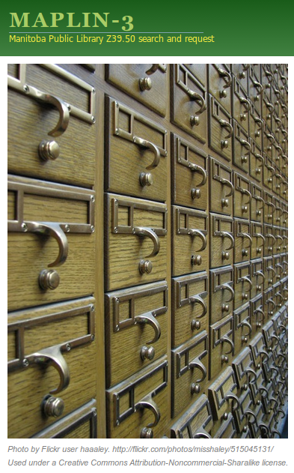

Librarian's Guide to Maplin

Table of Contents
Welcome to Maplin! 3
Federated Search 3
You, your clients, and Maplin 3
Logging in 4
Using the Menu 4
Types of searchable resources 5
Leave your zServer turned on 5
Maplin and your email address(es) 6
How do I... 6
...request an Interlibrary Loan? 6
...handle a client request? 7
...answer another library's ILL request? 8
...change which types of resources Maplin searches? 8
...change my Maplin password? 8
...mark my library as “temporarily unavailable”? 8
...tell Maplin that certain items are restricted / not for loan? 9
...find contact information for another library? 10
...check if Maplin can search my library? 10
...tell if other libraries are down, and why? 10
...verify patron registrations? 10
...give a patron a new password? 10
...stop a patron from making ILL requests? 11

Welcome to Maplin!
Maplin is a librarian's Interlibrary Loan tool which lets you search for books and make ILL requests for your clients.
Your clients can also use Maplin to find books themselves; Maplin will send their requests to you for processing.

Federated Search
What, exactly, is Maplin? Although Maplin has been around in one form or another for a long time now, it actually fits nicely under a relatively recent term: Federated Search.
From Wikipedia: “[F]ederated searching consists of (1) transforming a query and broadcasting it to a group of disparate databases or other web resources, with the appropriate syntax, (2) merging the results collected from the databases, (3) presenting them in a succinct and unified format with minimal duplication, and (4) providing a means, performed either automatically or by the portal user, to sort the merged result set.”
Or, more simply: You enter your search terms. The system accesses all of the Z39.50 servers of Manitoba Public Libraries (and potentially other resources), acquires the records that match your search, and lets you sort and filter the results... helping you to find what you need to satisfy your client's requests.

You, your clients, and Maplin
The previous version of Maplin did not have a public-facing search component; instead, your clients would ask you directly to find and request materials for them.
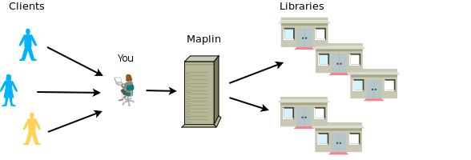
Maplin can now be used by your clients. It enables them to find materials for themselves, and will send all of your client's requests to you (rather than directly to the holding libraries). This allows you to integrate “Public Maplin” requests into your normal ILL workflow.
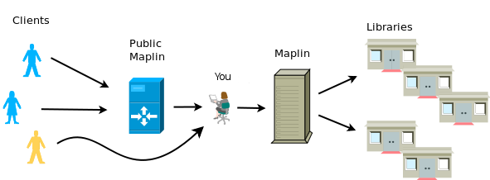
Of course, there will always be patrons who still come to you....

Logging in
You can get to the login page either by going to http://maplin.gets-it.net/ and clicking the “Library staff” link, or by going directly to http://maplin.gets-it.net/cgi-bin/maplin3.cgi (you can bookmark this page).
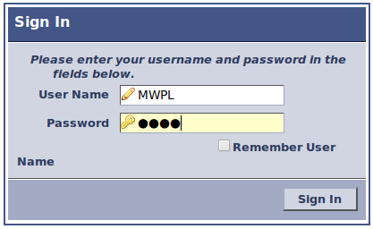
Text entered into the login page is case-sensitive - “MWPL” is different than “mwpl” or “Mwpl”.
Enter your user name (typically your library's institution code) and password.
If you want Maplin to remember you (so you don't have to re-enter your user name each time you log in), click the “Remember User” checkbox.
Click the “Sign In” button to log in.

Using the Menu
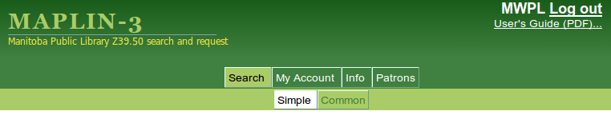
The Maplin menu is at the top of every page.
Main tabs (“Search”, “My Account”, “Info”, and “Patrons”) are in dark green; the currently selected main tab is displayed in light green – the same colour as the submenu band below it.
Subtabs (in this case, “Simple” and “Common”) are in light green; the currently selected subtab is displayed in white.
As a shorthand for describing which page you're on (and, incidentally, how to get to a specific page), this manual will use the form “Main tab => Subtab”. For example, the page shown in the picture above would be called:
Search => Simple
If a page lists many things you can choose to do or see, we'll add that after the subtab. Again, for example:
Info => Documents => “Library Governance”
...means go to the Info tab, Documents subtab, and click on the “Library Governance” link.

Types of searchable resources
Maplin searches for more than just physical books at other libraries (i.e. for interlibrary loan).
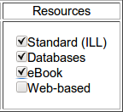
Standard Resources are whatever each library has in their catalogues. Usually physical items, but can also include eLibraries Manitoba (eLM) titles (from PLSB) or other electronic documents (eg: from the Legislative Library).
Database Resources include all of the EBSCOhost databases.
eBook / Electronic Resources include various free digital books or journal articles catalogued by reputable sources such as the Open Content Alliance (http://www.opencontentalliance.org/), OAIster (http://www.oclc.org/oaister/), and Project Gutenberg (http://www.gutenberg.org/wiki/Main_Page).
Finally, the little-used Web-based Resources include Wikipedia (http://www.wikipedia.org/) and the Open Directory Project (http://www.dmoz.org/about.html). These are searchable through Maplin simply to give you some extra options when trying to answer reference questions; they are never searched by default (you must explicitly select them).
You can change which types of resources you search by default on the My Account => Settings page.

Leave your zServer turned on
You should always have your server running, and connected to the Internet. The benefit is that your patrons can search your catalogue even when the library is closed – a huge convenience for them. It's an easy way of providing service to your municipality without additional cost. Patrons can log into the OPAC, place holds, check what they've got out (and when it's due), etc, without needing to wait for the library to open (and without needing to take up your time by asking you directly!).
Oh, and it lets Maplin search your library, too.

Maplin and your email address(es)
There are two places (three, if you are the headquarters library for a region) where you need to set your email addresses.
- The email address that gets put into ILL requests that you make to other libraries (a.k.a. “Send from”). This is set by going to My Account => Settings.
- The email address where other libraries send ILL requests to your library (a.k.a. “Send to”). This is set by going to My Account => zServer.
If your library is the headquarters of a region, you can also set the “Send to” addresses for your branches by going to My Account => Locations / Branches and choosing the branch from the list along the left-hand side.
Maplin matches the location / branch to the email address based on the Holdings location subfield (set in My Account => zServer) that it finds in the MARC record. If the value in the MARC record does not match any locations / branches that you have set up, Maplin will send the request to the “default” email address set in My Account => zServer.

How do I...

...request an Interlibrary Loan?
- Go to either Search => Simple or Search => Common (the difference is that Simple only searches one index (like Title=ducks), where Common lets you search multiple indexes together (such as Title=ducks AND Subject=wetlands).
- On the search results page, find the item you'd like to request. If there are a lot of results, you can filter them to show only a specific author, subject, or publication date, and sort by title or author.
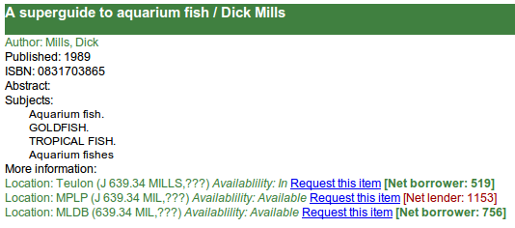
- Click on the “Request this item” link beside the location. Remember that you should make your request to the highest net borrower (the library that has borrowed the most). If there are no net borrowers, choose the lowest net lender (the library that has lent the least).
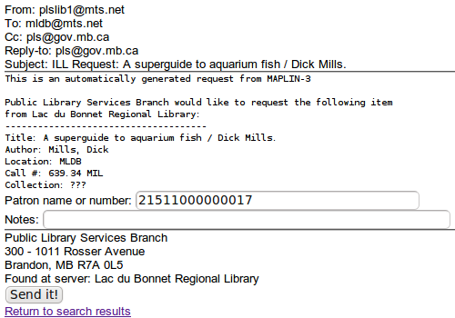
- Enter your client's barcode (this is for your reference, so you know who requested the book). Enter any special notes you may have (eg: “patron requests extended loan” or “for a project due in one week”.
- Click the “Send it” button. Maplin will send the email to the library you selected, and Cc: you.

...handle a client request?
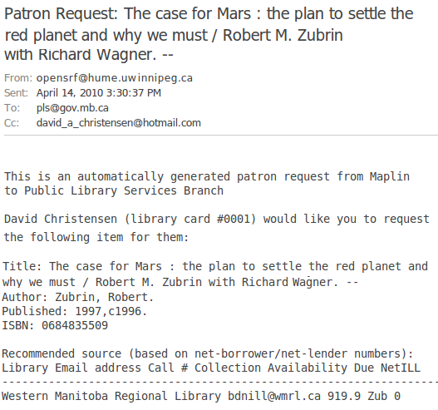
A client request will show up in your email inbox, looking something like this:
The request includes the patron name and barcode, information about the item they are requesting, and a recommended source for the ILL.
Notice that the subject line starts with “Patron Request:” rather than “ILL Request” (as it would if this were a request coming from another library).
At this point, no request has been made – your patron has just let you know that they want you to make one.
Follow the steps in “How do I request an Interlibrary Loan?” to actually place the request.
The “recommended source” is a recommendation from Maplin as to which library has the highest net-borrower/lowest net-lender number, at the time the patron did their search.
Don't just forward the email to the holding library. It's a bad idea, for a few reasons:
- The email header (To: and Cc: fields) is set up as a conversation between your library and your client. If you follow the steps in “How do I request an Interlibrary Loan?”, you get a new conversation (between your library and the holding library), and still have the original one... so you can reply to your client's email to let them know the book is in.
- The client's name and email address are part of the email; for your client's privacy, that information should be kept confidential.
- Maplin adjusts your library's net-borrwer/net-lender status based on you placing the requests.

...answer another library's ILL request?
You've probably already got a procedure in place for handling ILL requests from other libraries – we won't try to tell you how to do that :-)
ILL requests mediated by Maplin will show up in your email inbox with a subject line starting with “ILL Request:”, followed by the title of the book being requested. This is to make them easy to identify at a glance; you can (if you'd like) set up an inbox rule to move any mail starting with “ILL Request” to a separate folder.
These email requests are set up in such a way that you can simply reply to them; the replies go to the requesting library, not back to Maplin.

...change which types of resources Maplin searches?
From the Maplin menu, choose My Account => Settings.
At the bottom of the page is a section called “Search these resources by default.” Click in the checkboxes beside the types of resources (Standard, Electronic, Database, Web) that you'd like to have as the default search types for Maplin, and then click the “Update” button.
See the section of this manual called “Types of searchable resources” for more information.

...change my Maplin password?
From the Maplin menu, choose My Account => Settings.
You can change your password on this page. Remember that it is case-sensitive; “SECRET” is different than “Secret” or “secret”. When you've entered your new password, click the “Update” button.

...mark my library as “temporarily unavailable”?
From the Maplin menu, choose My Account => zServer.
About halfway down the page is a setting called “Available” - change it from 1 to 0, and click the “Update” button. Don't forget to change it back when your library is available for ILL again!

...tell Maplin that certain items are restricted / not for loan?
From the Maplin menu, choose My Account => Local Use.

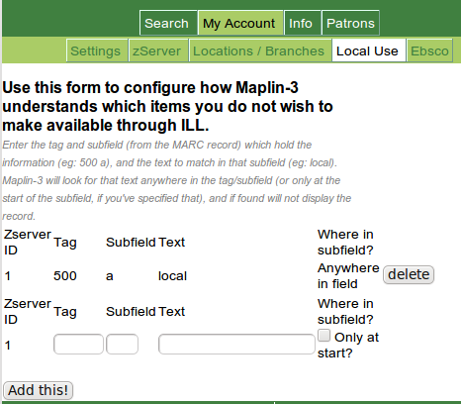
You will need to identify some field in your MARC records that uniquely identifies the items that you wish to restrict to local use (many libraries add a 500$a field with the text “local”).
If you have a non-circulating collection (eg an archive), you could specify the collection code (for example, if you have a collection called “Archives” and your library's MARC records have the holdings' collection in 949$c, enter “949” in the Tag box, “c” in the Subfield box, and “Archives” in the Text box).
The “Where in subfield?” column lets you specify for Maplin to look for the text at the start of the field (or, if unchecked, then anywhere in the field/subfield).
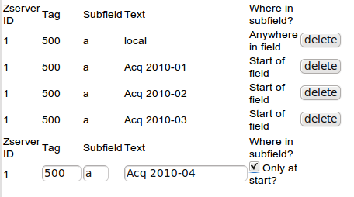
For example, if you have a policy to not let other libraries ILL newly-purchased material for three months, you might add a 500$a field with the word “Acq” followed by the date. If you put the date in year-month-day format (eg: “Acq 2010-04-19”), you can set the Text field on the local use page to “Acq 2010-04” and check “Only at start”.
When an item is old enough that you are willing to ILL it, just click the “delete” button beside the field (in this example, “Acq 2010-01”) to remove that restriction.

...find contact information for another library?
From the Maplin menu, choose Info => Contacts.

...check if Maplin can search my library?
From the Maplin menu, choose Info => My zServer Status. Click on the “test” button. This will run a quick check: connect to your zServer, search for title keyword “dinosaur”, and report whether the connection was successful (and how many records were returned).

...tell if other libraries are down, and why?
From the Maplin menu, choose Info => All zServers. Click the “Start the status check” button.
This a fairly long test – it individually checks each zServer and reports their status. This is the same test that Maplin does every half hour (8:00am-5:00pm, Monday through Saturday) to keep the list of zServers up-to-date.

...verify patron registrations?
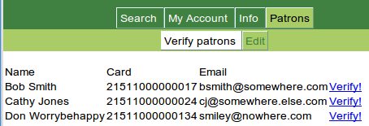
From the Maplin menu, choose Patrons => Verify patrons.
This will give you a list of all newly-registered patrons that are waiting for verification.
Check the patron's name, card number, and email address, and (if the information is good), click on the “Verify!” link beside that line.
If you don't have a record of this client in your ILS, it may be that this is someone in your community who hasn't come into the library – congratulations! Use the listed email address to encourage them to get a membership.
It may also be someone who mistakenly selected the wrong library; send them an (nice) email about it.

...give a patron a new password?
From the Maplin menu, choose Patrons => Edit. You'll see a list of your clients who have registered on Maplin. (You can sort the list by clicking on the various column headings.)
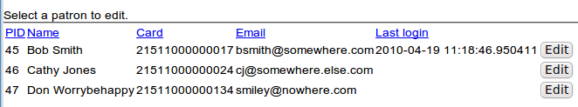
Click the “Edit” button beside the patron to bring up the patron edit page.
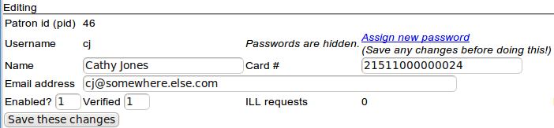
Click the “Assign new password” link, enter a new password for the patron, and click “Save these changes.”
Make sure to tell the client to log in and change their password!

...stop a patron from making ILL requests?
From the Maplin menu, choose Patrons => Edit. Find the patron in the list (see the section “How do I... give a patron a new password”).
Change the value in the “Enabled?” field from 1 to 0, and click the “Save these changes” button. (You'll probably want to send them an email letting them know this, and why.)

