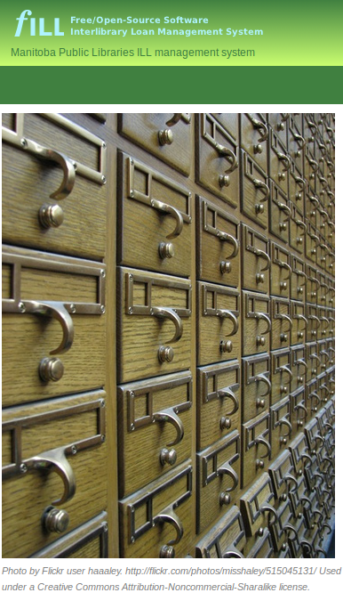

Public Access

to the next evolution of the

Manitoba Public Libraries Network

fILL

A Federated Search system for clients of public libraries in Manitoba.

Can't find the book

you're looking for

in our collection?

We can try to borrow it for you from another Manitoba public library.

Our library participates with all other public libraries in Manitoba in an “Inter-library loan” agreement to loan books to each other, wherever possible.

Last year, Manitoba public libraries loaned each other over 30,000 books.

Using fILL you can search the collections of all 59 Manitoba public libraries – over 100 library branches! – and ask us to request specific books for you.

If another library has the book and is able to lend it at that time, they will. We will usually hear back within a few days, with the book arriving here in about a week.

Interested?

Here's how you can use fILL to fill your reading needs!

Request Interlibrary Loans
Library members can now easily search all Manitoba public libraries for books to request through Interlibrary Loan.
This is not required for ILL requests – you can always come into the library! – but is an option for anyone who is interested.

http://fill.gets-it.net

Registration is easy
You will need to register with fILL in order to use the system. (If you had an account on the old Maplin system, that account has already been added to fILL)

- From the login page, click on Register!
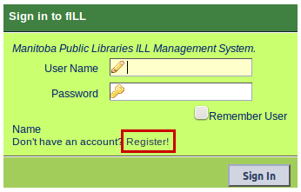
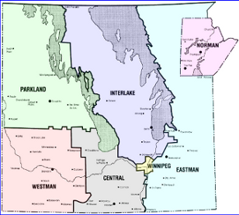
- Click on the area of the province that you live in.

- This will show a list of communities which have public libraries in that area. Click on the community where you are a member of the library.

- Fill in the requested information (your name, library card #, and email address). Choose a user name and password; if the user name is not available, you'll need to choose another. When you click Submit, you will return to the fILL Sign In box.

This information is used only to set up transactions between you and your library; no personally identifiable details of your transactions are stored on fILL after your ILL is returned. Some non-identifying data may be retained for statistical purposes.

Searching is easy

- Once you have set up an account you will return to the fILL Sign In box. Login and read the information on the welcome page.

- To start searching, click the Search and Request button. Enter the Title and/or Author or other information in the simple, Google-like search bar at the top of the page.

- When fILL has finished searching, click on the title you'd like to borrow. You'll see a “Request” button – click on it to request the book.
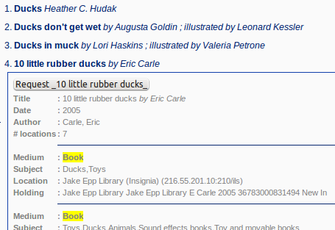

- You'll see a new window or browser tab letting you know that the request has been placed. (You can close this window once you've seen it)
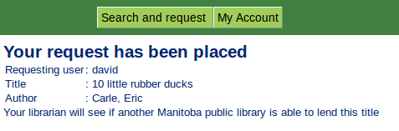
Our ILL department will notify you when your book arrives, as usual.

Please call the Library if you have any questions.

Simple, Powerful Results

Refining your search

The search results page enables you to quickly refine your search by subject or author.

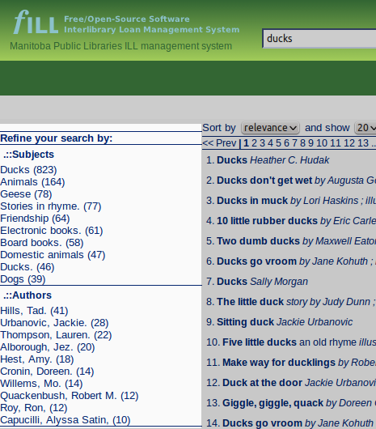
The left-hand column of the results page shows the subjects or authors you can choose. These are filled in automatically from information in the records returned from your search.

The numbers in parenthesis show how many books from your original search have that subject or author.

When you refine your search this way, fILL combines your original search terms with your chosen refinement.

You can keep refining your search, until you find exactly what you're looking for.

Simple, Powerful Results

Sorting

Search results are sorted by relevance by default. This should place the books that most closely match your search terms at the top of the list.

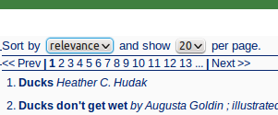
You can choose to sort by title or by publishing date clicking the “Sort by” button.

Keep in mind that most libraries won't lend out books that are very new – they'll want to let their own patrons read them first!

You can also choose how many results to show per page.

Moving from page to page

You can page through your results by clicking on the “<<Prev” and “Next >>” links, or by choosing a page number to jump to.

For more information, contact the library.

