|  |
| --- |
|  |
| **RTL_EXERCISE_1 BOUND FLASHER** |
|  |
| |  |  | | --- | --- | | Author | L02 – Group 4 | | Date | 2022/03/07 | | Version | 1.2 | |
|  |
|  |

|  |
| --- |
|  |

Contents

1. Interface 2

2. Functional implementation. 3

3. Internal implementation. 5

3.1. Overall. 5

3.2. State Machine 6

4. History 7

# 1. Interface

|  |
| --- |
| 1  1  1  **bound_flasher**  flick  16  clk  rst |
| Figure 1: the figure of Bound Flasher System |

|  |  |  |  |
| --- | --- | --- | --- |
| Signal | Width | In/Out | Description |
| flick | 1 | In | - Consider go back to previous min led state when at kickback point.  - Positive level triggering. |
| rst | 1 | In | - Turn off all led.  - Positive edge triggering. |
| clk | 1 | In | - Clock signal.  - Positive edge triggering |
| led | 16 | Out | - The state of LEDs [0:15].  - Active indicate led on, otherwise indicate led off. |

Table 1: Description of signals in Bound Flasher

# 2. Functional implementation.

* Implement a 16-bits LEDs system
* System’s Operation base on three input signal
  + Reset
  + Clock
  + Flick
* The system specification
* Clock signal is provided for system inspire of function status. The function operate state’s transition at positive edge of the clock signal.
* Reset signal:
* LOW-ACTIVE Reset = 0: System is restarted to Initial State.
* HIGH-ACTIVE Reset = 1: System is started with initial state.
* Flick signal: special input for controlling state transfer.
* At the initial state, all lamps are OFF. If flick signal is ACTIVE, the flasher start operating:
* The lamps are turned ON gradually from LEDs[0] to LEDs[5].
* The lamps are turned OFF gradually from LEDs [5] (max) to LEDs[0] (min).
* The lamps are turned ON gradually from LEDs [0] to LEDs [10].
* The lamps are turned OFF gradually from LEDs [10] (max) to LEDs [5] (min).
* The lamps are turned ON gradually from LEDs [5] to LEDs [15].
* Finally, the lamps are turned OFF gradually from LEDs [15] to LEDs [0], return to initial state.
* Additional condition: At each kickback point (LEDs [5] and LEDs [10]), if flick signal is ACTIVE, the LEDs will turn OFF gradually again to the min lamp of the previous state, then continue operation as above description. For simple, kickback point is considered only when the lamps are turned ON gradually, except the first state.
* Some insulations:
* When flick = 0 at kickback points

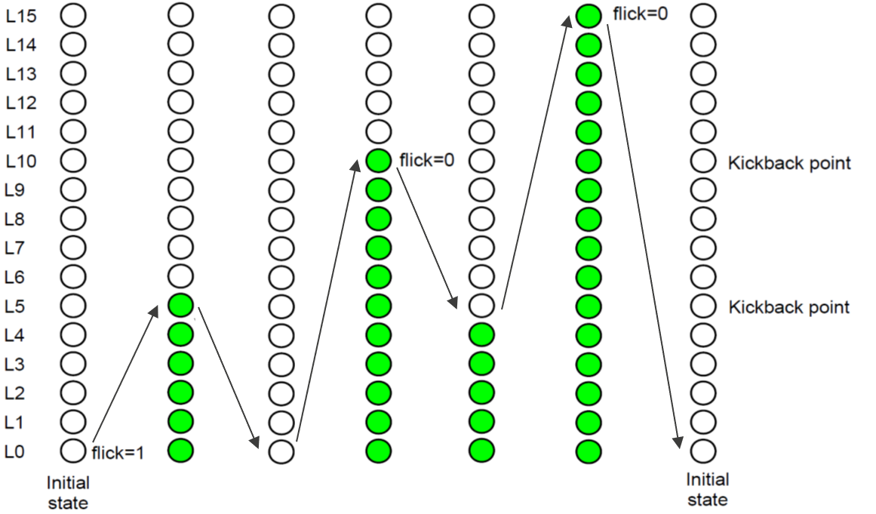

* When flick = 1 at kickback points (LEDs[10])

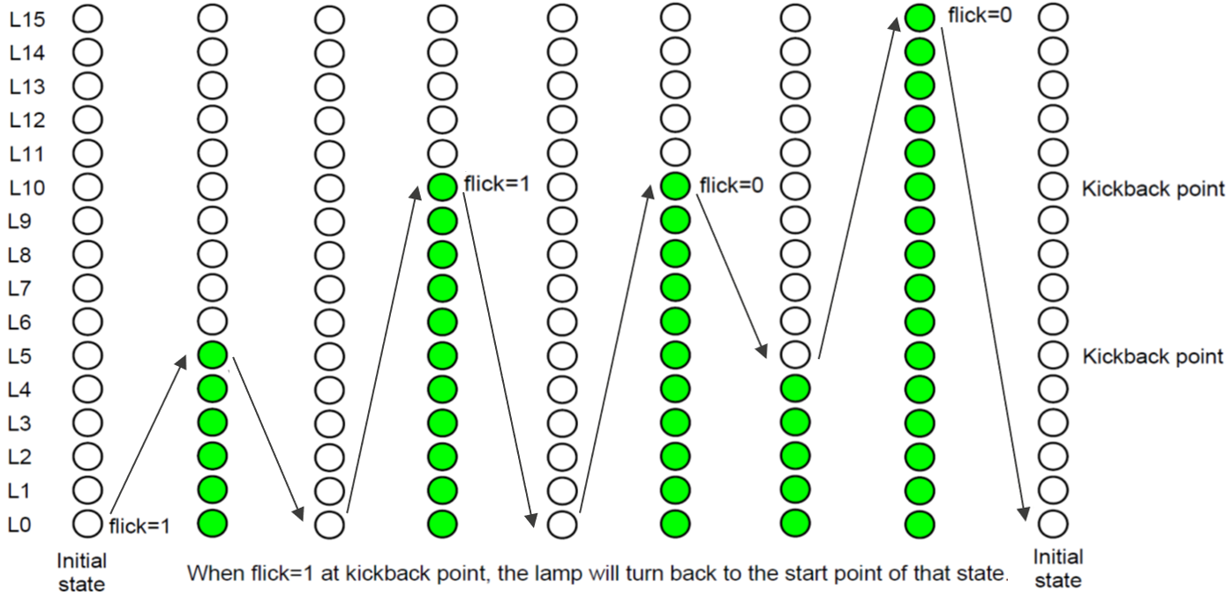

# 3. Internal implementation.

## 3.1. Overall.

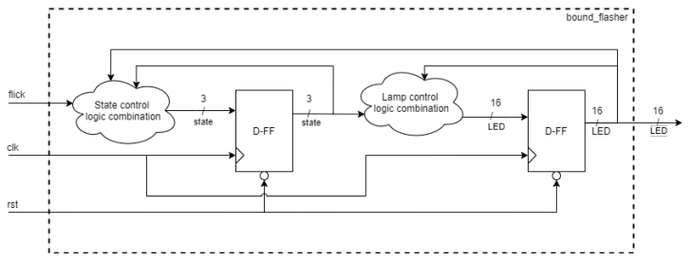

1

1

1

Figure 3.1: Block diagram of Bound Flasher

|  |  |  |  |  |  |  |  |  |  |  |  |  |  |  |  |  |  |  |  |  |  |  |  |  |  |  |  |  |
| --- | --- | --- | --- | --- | --- | --- | --- | --- | --- | --- | --- | --- | --- | --- | --- | --- | --- | --- | --- | --- | --- | --- | --- | --- | --- | --- | --- | --- |
| |  |  |  |  | | --- | --- | --- | --- | | Block diagram | type | width | Description | | State control logic combination | Combination logic | 16 | In this block, there are sequence of logic states. Each state describes the status of current lamps based on the value of flick. | | Lamp control logic combination | Combination logic | 16 | The block diagram based on the current state to display the status of 16 LED signal and there changeable direction. | | flick | Input | 1 | - Consider go back to previous min led state when at kickback point.  - Positive level triggering. | | rst | Input | 1 | - Turn off all led.  - Positive edge triggering. | | clk | Input | 1 | - Clock signal.  - Positive edge triggering | | led | Output | 16 | - The state of LEDs [0:15].  - Active indicate led on, otherwise indicate led off. | |

Table 3.1: Block diagram of Bound Flasher Description

## 3.2. State Machine

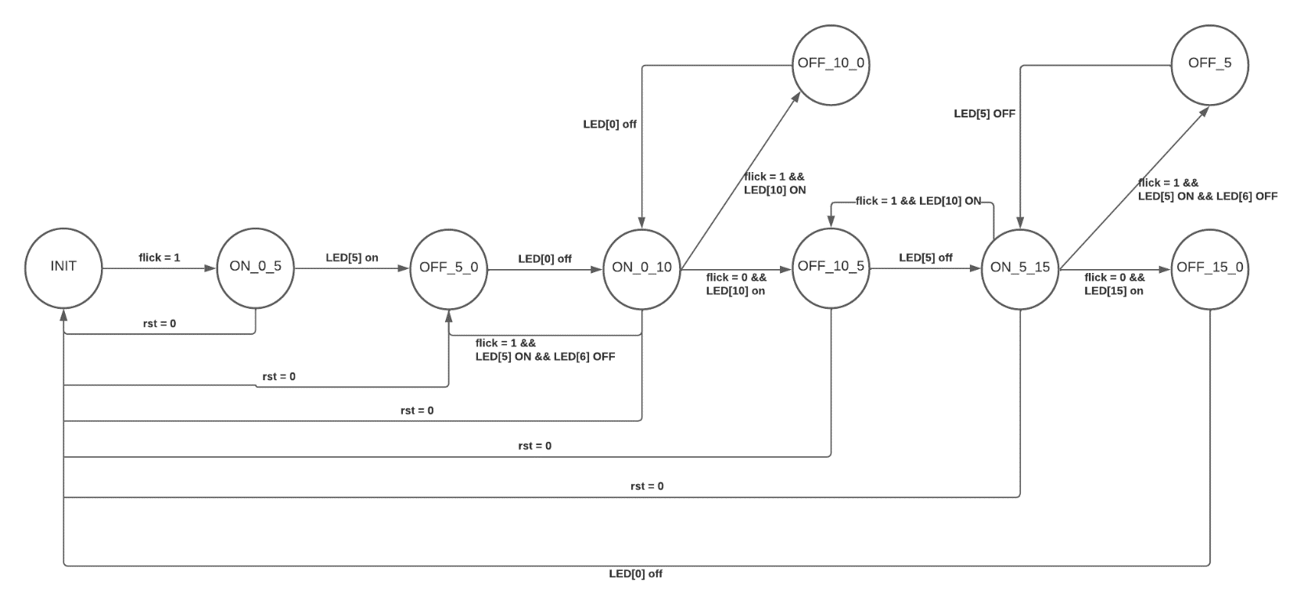

Figure 3.2: State Machine of Bound Flasher

|  |  |  |  |  |  |  |  |  |
| --- | --- | --- | --- | --- | --- | --- | --- | --- |
| |  |  | | --- | --- | | Variable name | Description | | flick | The input signal to start the system at the beginning or return to previous state in some cases | | LED | Indicate the state of led, 1 is ON, otherwise is OFF. | | rst | If reset = 0, the system will be reset immediately and return to the initial state | |

Table 3.2: Variable name of State machine

|  |  |  |  |  |  |  |  |  |  |  |  |  |  |  |  |  |
| --- | --- | --- | --- | --- | --- | --- | --- | --- | --- | --- | --- | --- | --- | --- | --- | --- |
| |  |  | | --- | --- | | State name | Description | | INIT | Initial state, which all LEDs are OFF state, all LEDs turn off. | | ON_0_5 | The LEDs are turned ON gradually from LED [0] to LED [5] while the others still turn off. | | OFF_5_0 | The LEDs are turned ON gradually from LED [5] to LED [0] while the others still turn off. | | ON_0_10 | The LEDs are turned OFF gradually from LED [0] to LED [10] while the others still turn off. | | OFF_10_5 | The LEDs are turned OFF gradually from LED [10] to LED [5] while the LEDs from LED[0] to LED[5] still turn on. | | ON_5_15 | The LEDs are turned ON gradually from LED [5] to LED [15] while the others still turn on. | | OFF_15_0 | The LEDs are turned OFF gradually from LED[15] to LED[0]. | |

Table 3.3: State name of State machine

# 4. History

|  |  |  |  |
| --- | --- | --- | --- |
| Date | Author | Modified part | Description |
| 2017/03/28 |  | All | New creation |
| 2022/02/28 |  | All | Change state machine, interface. |
|  |  |  |  |
|  |  |  |  |