Credit Card Portfolio Analysis
Power BI Dashboard — Executive Summary

Preview
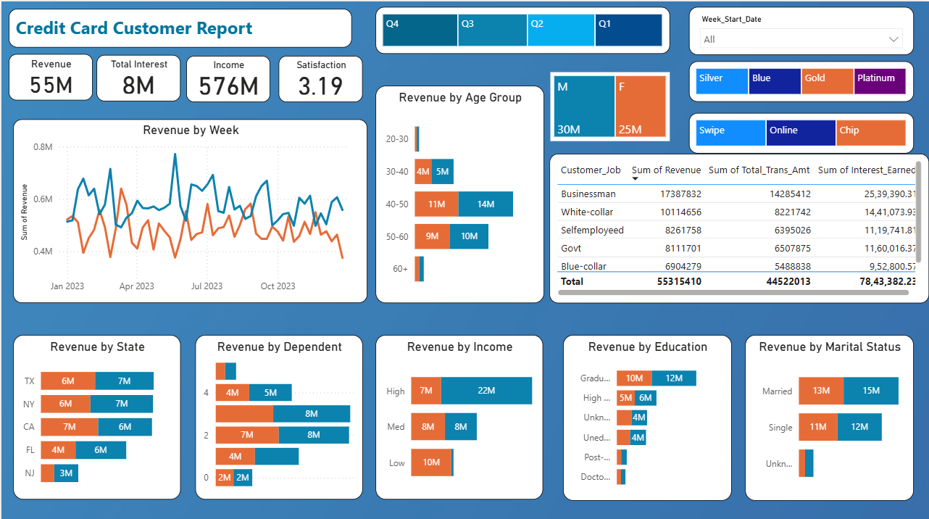
Customer Report — who the revenue comes from
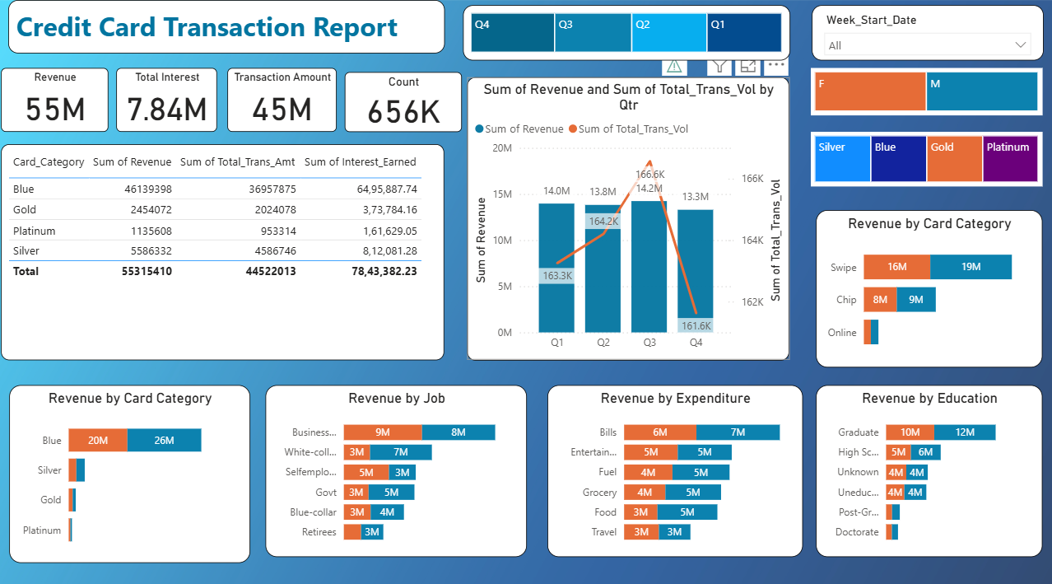
Transaction Report — how that revenue is generated

S — SITUATION

The Business Problem
Credit card operations teams need a single, real-time view of revenue, interest income, and transaction activity — but that data typically sits scattered across raw customer and transaction records, with no easy way to see which segments or card tiers are actually driving performance week to week.
The project brief: Develop a comprehensive credit card weekly dashboard that provides real-time insights into key performance metrics and trends, enabling stakeholders to monitor and analyze credit card operations effectively.
T — TASK

What the Dashboard Needed to Answer
- What is the overall revenue, interest earned, and transaction volume across the portfolio?
- How does performance trend on a weekly and quarterly basis, and which card tier drives the most revenue and interest?
- Which customer segments (occupation, age, income, education, marital status, state) are most valuable?
- Which spending categories (Bills, Entertainment, Fuel, Grocery, Food, Travel) drive the most revenue?
- How satisfied are customers, and how does it relate to the rest of the portfolio?
A — ACTION

What Was Built
A two-page interactive Power BI dashboard, split so each page answers a different half of the brief:
- Customer Report — demographics, job, income, and satisfaction, so stakeholders can see who the revenue comes from.
- Transaction Report — card tier, quarterly trend, and spend category, so stakeholders can see how that revenue is generated.
Design and build choices:
- KPI cards surfacing Revenue, Interest, Transactions, Income, and Satisfaction, for an instant read on both pages.
- Cross-filtering slicers (Quarter, Week, Card Category, Gender, Channel) so every visual on a page reacts together.
- A combo chart to track Revenue against Transaction Volume by quarter in one view.
- Column and bar breakdowns across job, age, income, education, marital status, dependents, and state.
- Tools: Microsoft Power BI Desktop — data modeling, KPI cards, slicers, and cross-filtered visuals.
R — RESULT

Key Findings
- $55.3M total revenue · $7.84M interest earned · 656K transactions
- Blue-tier cards drive 83% of all revenue — Gold + Platinum combined are just 6%
- Businessmen are the top customer segment — 31% of revenue, ~2x the next-largest (White-collar)
- Revenue tracks transaction volume almost 1:1 by quarter — both peak in Q3, dip in Q4
- Bills (24%) and Entertainment (18%) are the top two spend-linked revenue categories
- High-income customers drive ~52% of revenue; the 40–50 age band alone drives ~45%
- Average customer satisfaction: 3.19
LOOKING AHEAD

Where This Goes Next
- Add a legend and a rolling average to the weekly revenue trend, to separate real movement from week-to-week noise.
- Cross-filter satisfaction score against card tier and segment, to see whether the Blue-tier, high-income skew is also the happiest group.
- Investigate why Gold/Platinum underperform Blue so heavily — worth testing whether it's a marketing gap or a pricing one.

Tech Stack
- Microsoft Power BI — Dashboard development and visualization
- Power Query — Data cleaning and transformation
- DAX — Calculated measures and KPIs
- Data Modeling — Customer and transaction analysis
- Power BI Slicers & Filters — Interactive analysis
- Charts, KPI Cards & Tables — Data visualization and reporting

.

