E-Commerce Customer & Sales Analysis
Power BI Dashboard | Executive Summary
EDA • Customer & Transaction Frequency Analysis • RFM Customer Segmentation

Project Overview
This project analyzes e-commerce sales and customer transaction data to understand overall business performance, purchasing behavior, and customer value. The Power BI dashboard combines Exploratory Data Analysis (EDA), Customer & Transaction Frequency Analysis, and RFM (Recency, Frequency, Monetary) Customer Segmentation to turn transactional data into actionable insights.

Dashboard Overview

1. Exploratory Data Analysis (EDA)
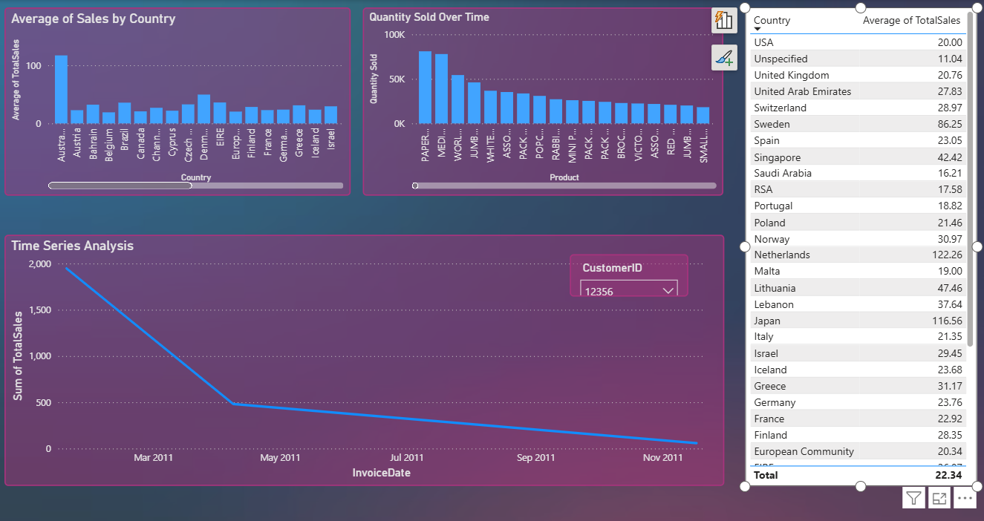
Overall sales, product, country, and time-based exploration.

2. Customer & Transaction Frequency Analysis

Customer purchasing frequency, revenue contribution, and customer-level transaction analysis.

3. Customer Segmentation — RFM Analysis
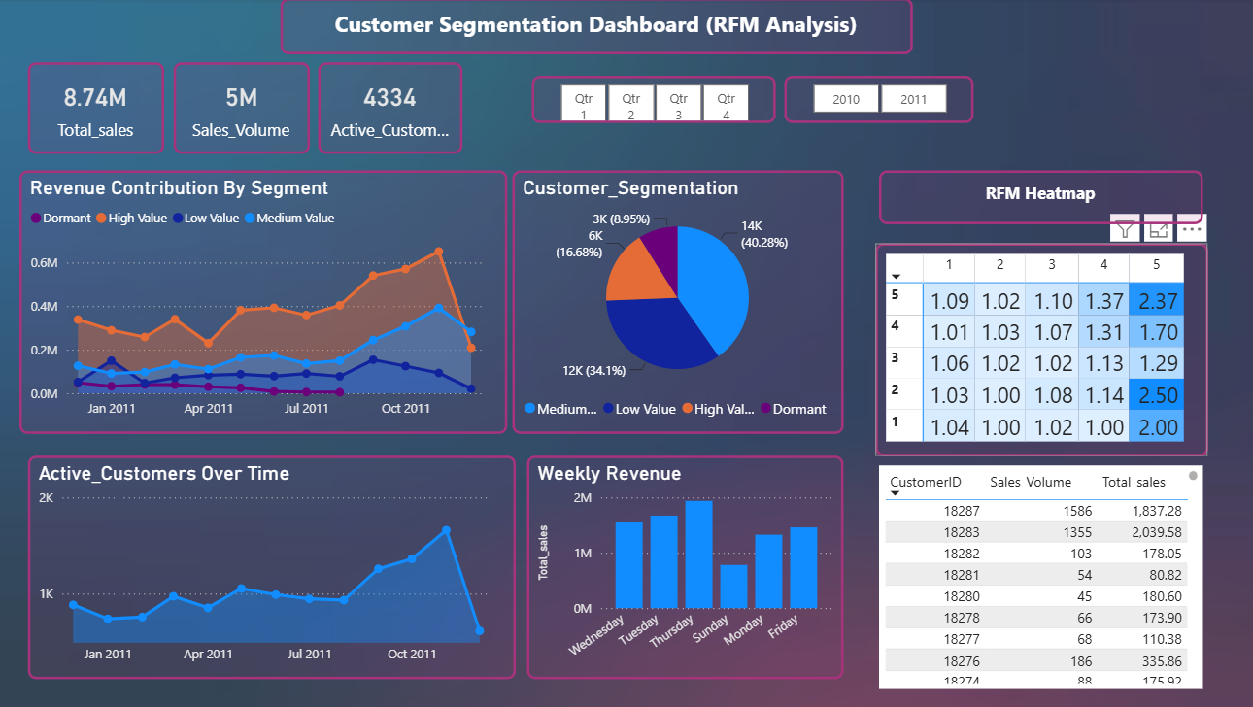
RFM-based customer segments, revenue contribution, customer distribution, activity trends, and RFM scoring.

Analytical Summary

1. Exploratory Data Analysis (EDA)
- Examines overall sales performance across countries, products, and time periods.
- Highlights differences in quantity sold and sales contribution across products and markets.
- Uses time-series and country/product views to establish the overall business context before customer-level analysis.

2. Customer & Transaction Frequency Analysis
- Analyzes how frequently customers transact and how much revenue they generate.
- Compares transaction frequency with customer revenue and average purchase value.
- Uses customer-level analysis and sales distribution to distinguish frequent purchasers from higher-revenue customers.
- Supports identification of customer groups that may require different engagement or retention approaches.

3. Customer Segmentation — RFM Analysis
- Segments customers using Recency, Frequency, and Monetary value.
- Identifies High Value, Medium Value, Low Value, and Dormant customer groups.
- Compares revenue contribution and customer distribution across segments.
- Uses RFM scoring and customer activity trends to understand customer value and engagement.

Key Findings
- Customer purchasing behavior varies significantly across the customer base.
- Customers with higher transaction frequency generally tend to generate higher cumulative revenue, although some customers generate significant revenue from fewer purchases.
- Revenue contribution differs across customer segments, making segmentation useful for prioritizing customer-focused actions.
- Low-value and dormant customers represent potential opportunities for targeted re-engagement, while higher-value customers are important for retention.
- Sales patterns vary across products, countries, and time periods, providing additional context for understanding overall business performance.

Business Questions Answered
What is happening in the business? EDA identifies overall sales, product, geographic, and time-based patterns.
How do customers purchase? Transaction-frequency analysis shows how often customers transact and how purchasing behavior relates to revenue.
Which customers are most valuable? RFM analysis identifies customer groups based on recency, frequency, and monetary contribution.
Where are the opportunities? Customer segmentation highlights groups that can be approached differently for retention, re-engagement, and value growth.

Tools & Techniques
Power BI • DAX • Power Query • Data Visualization • Exploratory Data Analysis • Transaction Analysis • RFM Analysis • Customer Segmentation

Project Outcome
The project transforms raw e-commerce transaction data into an interactive analytical dashboard that connects overall business performance → customer purchasing behavior → customer value segmentation. The result provides a structured view of sales drivers, customer behavior, and opportunities for more targeted customer strategies.

