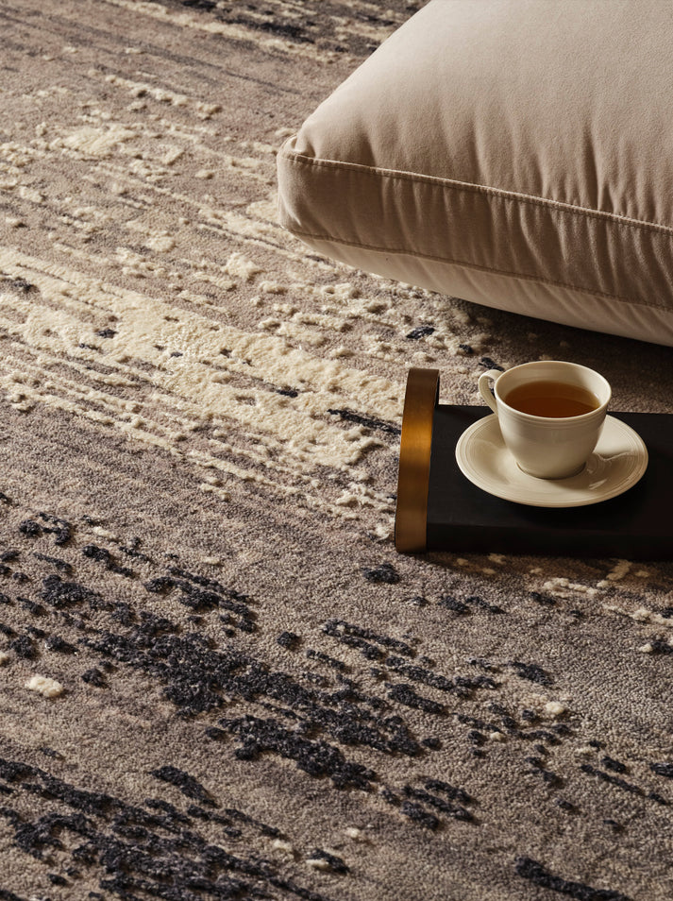

$4,945.00

ROU Black & White  
Hand Knotted, Wool & Bamboo Silk

Collection:[Contemporary](https://handscarpets.asia/collections/contemporary)

Making Type: Hand Knotted

Material: Wool & Bamboo Silk