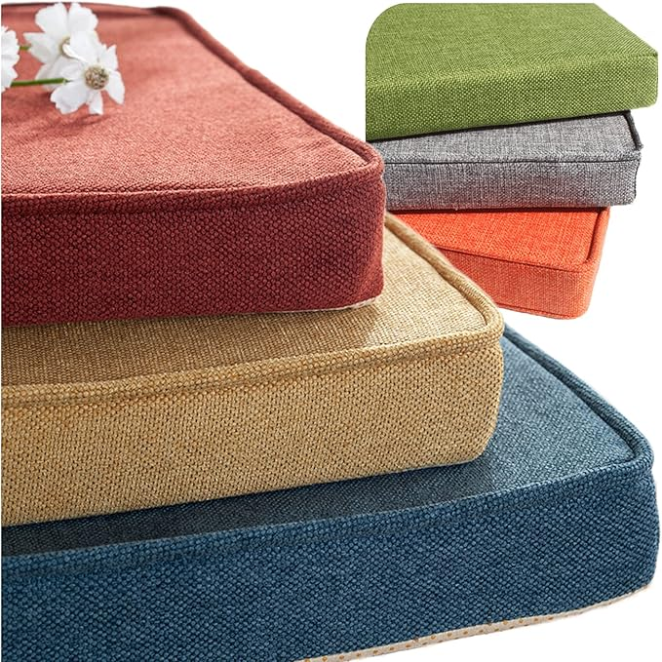

$13

Custom Bench Cushion, Chair Cushions, Indoor Furniture Cushion, Personalized Cushions, Optional Waterproof, Optional Addition Piping and Non-Slip Bottom and Straps and Velcro