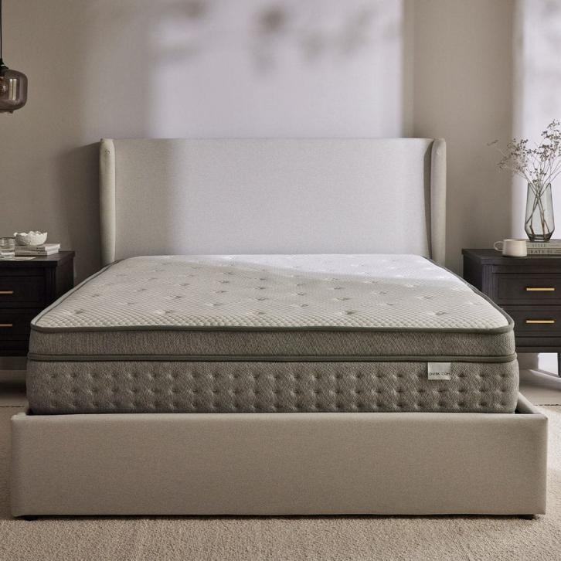

$629.00

Expertly crafted, this memory foam hybrid mattress combines all the ingredients you need for a dreamy night’s sleep.

Finished with a luxurious, soft to the touch knitted casing in white and grey, this wipe clean memory foam mattress has 2 layers of pocket springs, and handles on each side for quick and easy rotation. With a 4000 spring count and a depth of 31cm, it provides medium to firm support, and unrivalled comfort as you sleep, snooze and relax.