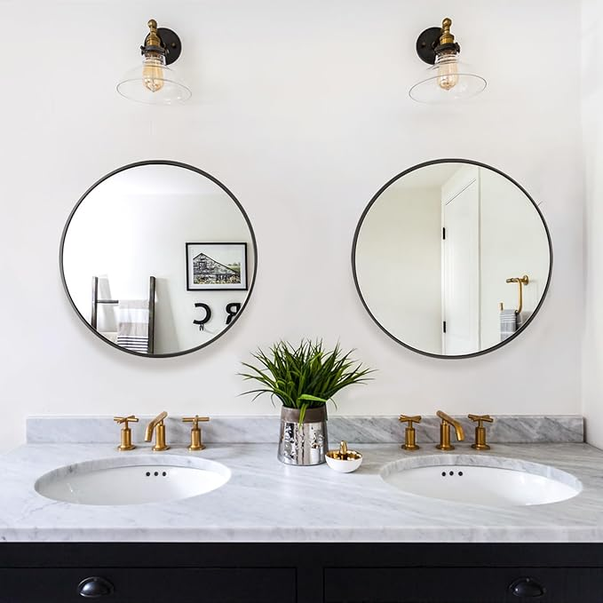

$69.9

Fabuday Black Circle Mirror for Wall 20 inch - Round Mirror for Bathroom, Entryway, Living Room, Hallway, Bedroom Decor, Small Matte Frame Mirror