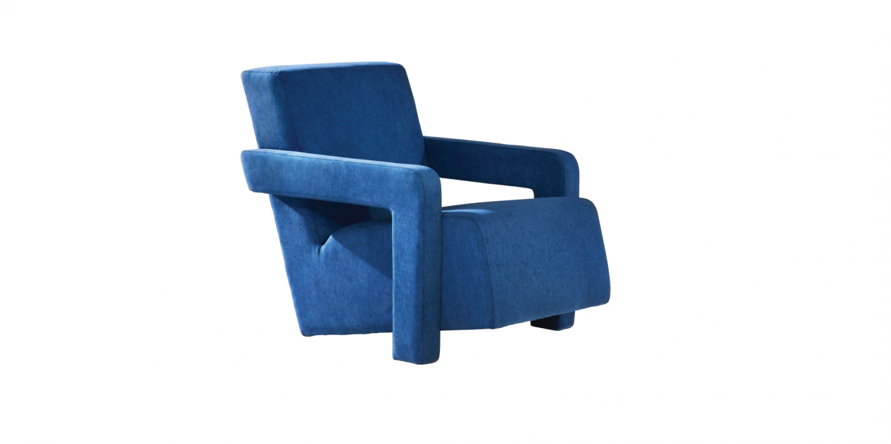

$304,07An armchair that couldn't be more comfortable with the entire seat designed to recline slightly, giving you an all-out relaxation, along with a well-adjusted armrest for you to completely wind down and experience a sense of peace in mind after a hard-working day, or simply to enjoy a good book.

