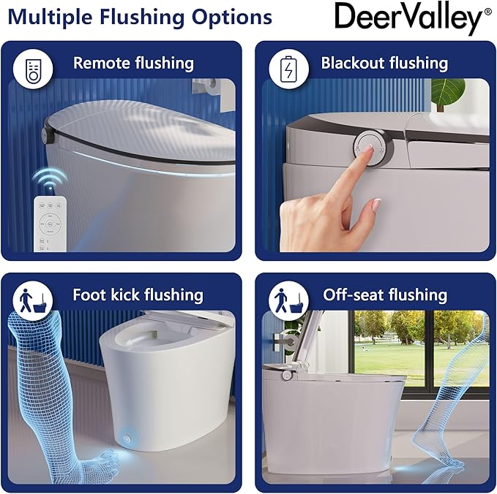

$369

Smart Toilet, DeerValley Tankless Toilet with Bidet Built in Chair Height One Piece Smart Bidet Toilet 1.28GPF Auto Flush,Foot Kick,Blackout Flush,Remote Control Modern Toilets for Bathrooms