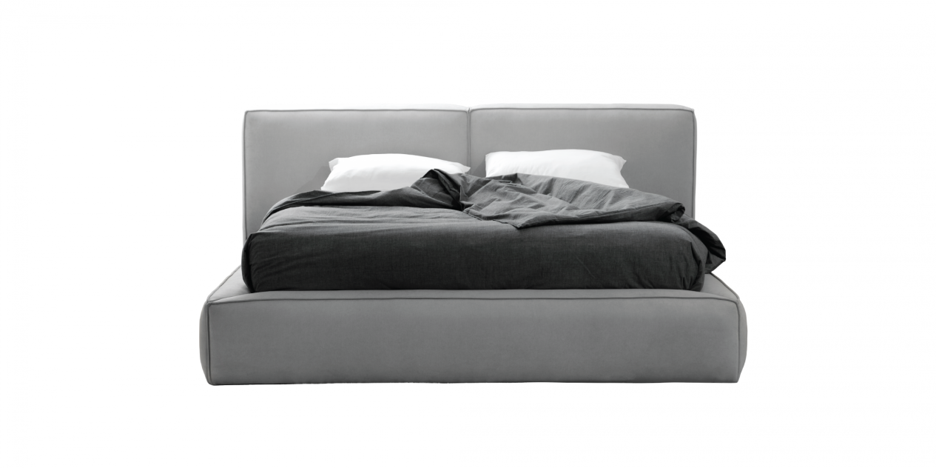

$668,42

Designed with a full foam and down padding frame, the Z-B01 bed will no doubt give you an all-out relaxation that you won't mind spending a whole day tucking under blankets and watching some TV series, or maybe working at home.

