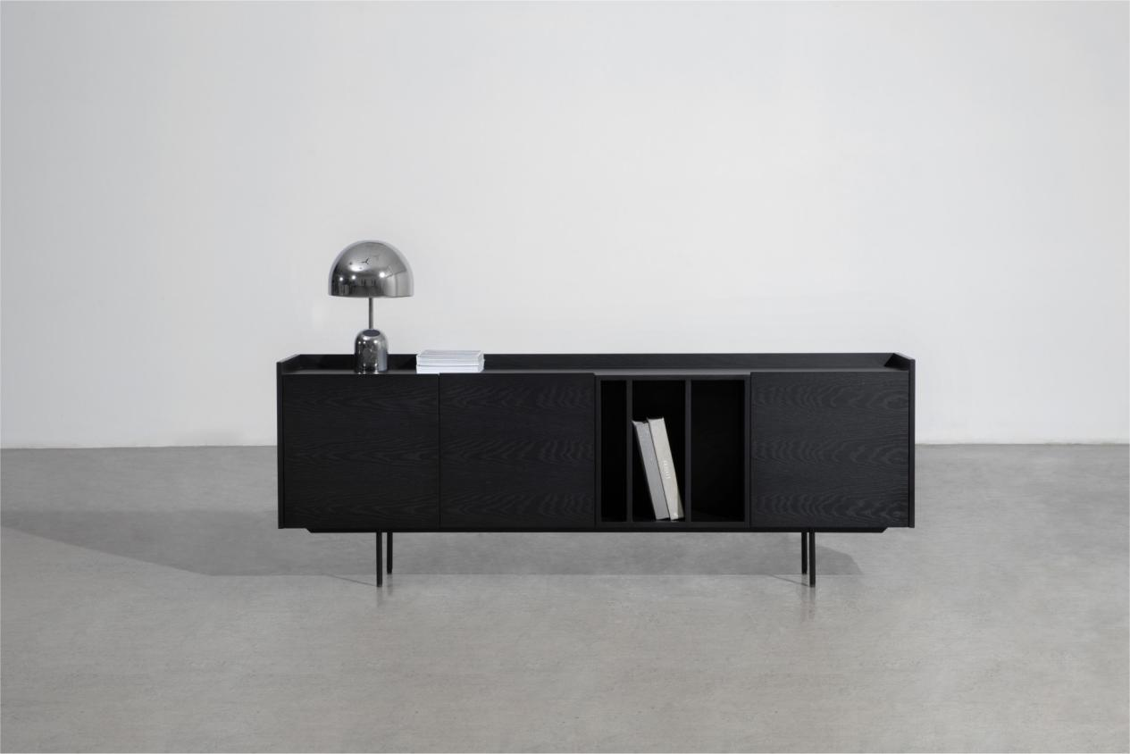

$644,51

With minimal design, delicate veneer finish, and slender yet sturdy metal legs, this cabinet brings the space a strong and attractive look. Open cases with storage and flexible display functions for vinyl records, large books, and magazines allow you to organize your books or separate your unfinished ones effortlessly. This Keeper cabinet also doubles as media furniture where you can place TVs or audio players, making it the perfect place to bring your family and friends together to enjoy daily moments.

