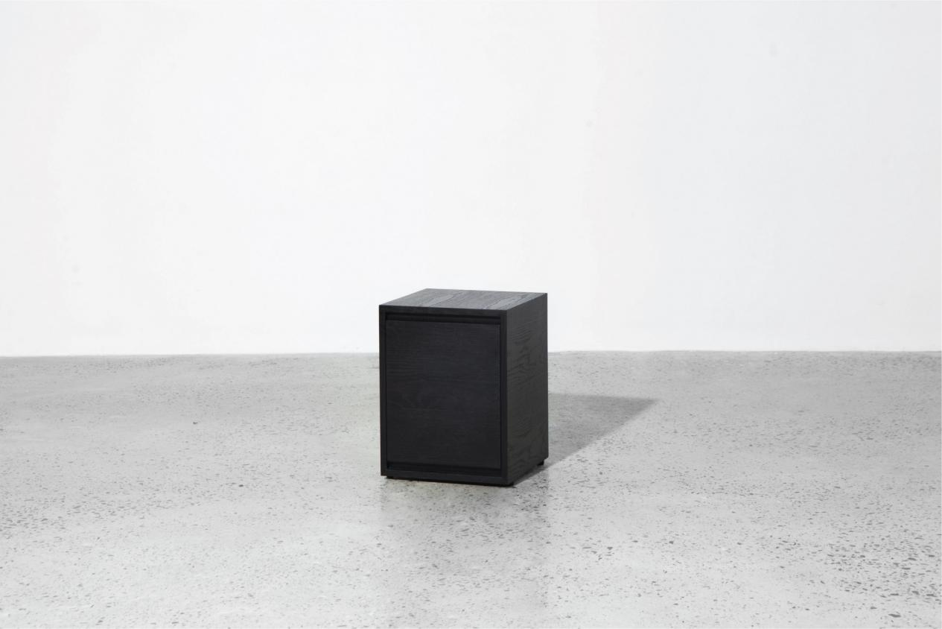

$174,34

Approaching a volumetric aesthetic, our new Box collection functions as a coffee table and a storage. Contemporary yet lean design comes with cleverly hidden drawers that will suit any space.

