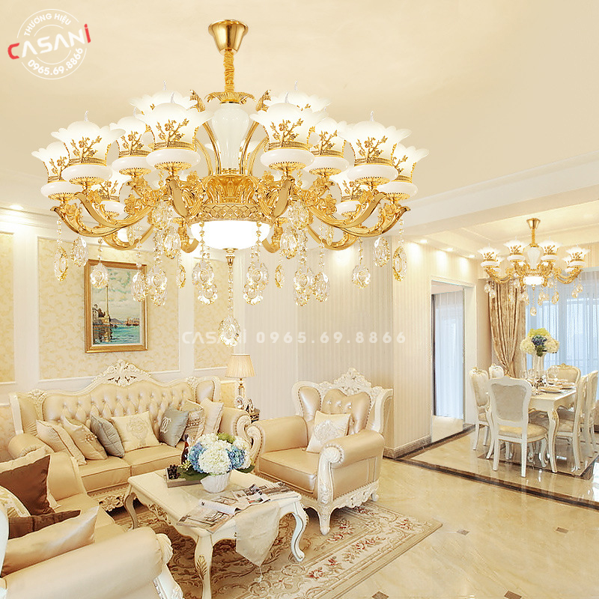

$550

In the world of interior decoration lamps, DCT-2966-15 Living Room Decorative Chandelier is attracting attention with its sophisticated combination of luxurious materials and unique design. Made of copper, natural stone bowl and glass shade, this chandelier is not only a light source but also a classy work of art.

Technical parameters

Material: electrostatically plated alloy, natural stone bowl, glass shade

Bulb: E14 Strawberry bulb, screw base

Light: Yellow (can replace 3-color bulb)

Room area: 15-25m2

Ceiling height: Over 3m3

Suitable for: Living room, bedroom, restaurant, hotel....