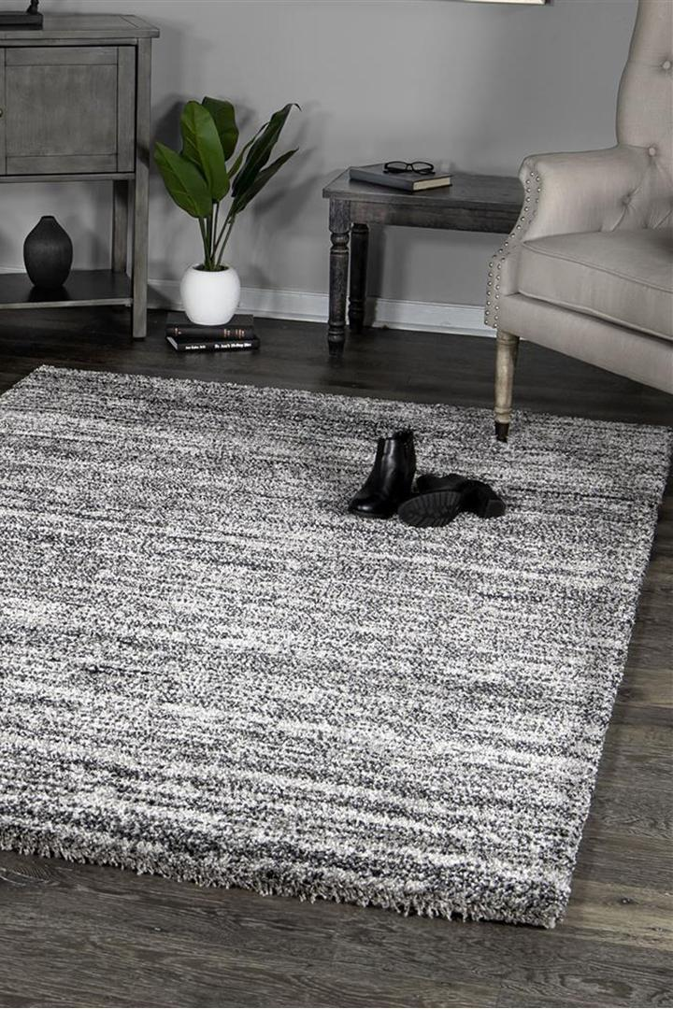

$255

A premium thick heavy rug the luxury Palace collection weighs 5kg per m2 which feels super soft underfoot. Clean and simple these solid colour rugs make decorating easy as they can match any interior style.