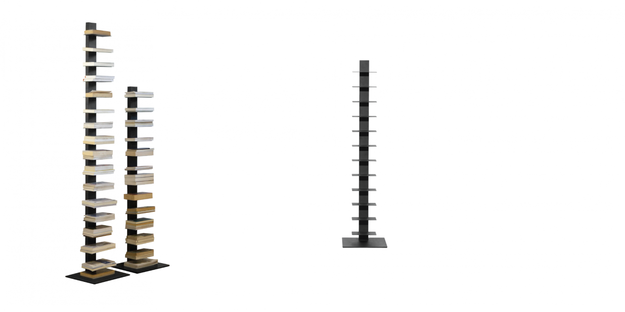

$182,41

"Small in size, wide in knowledge" is what to describe our Ladd bookcase. With a design that simulates stairs, the Ladd bookcase offers a visual performance that makes books seem to float in space; combined with the sturdy stainless steel construction, it allows you to store all your favorite books without making a mess.

