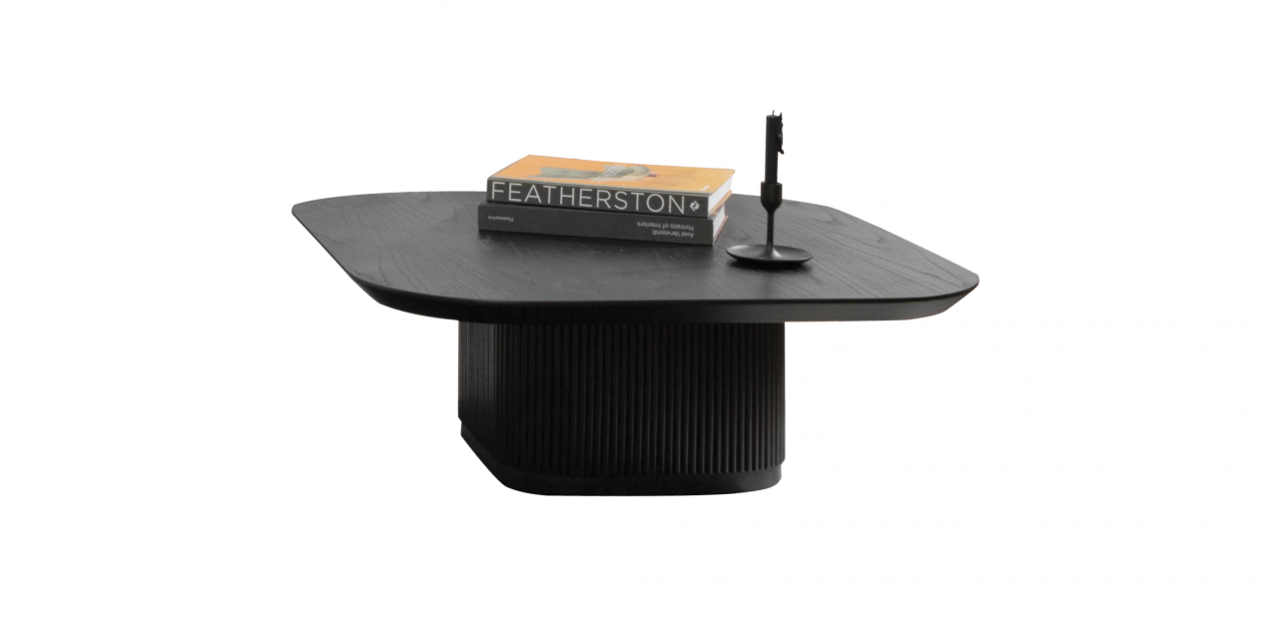

$170,28

Our Mun table collection offers 04 different sizes to help you diversify your using purpose. With a striking design, strong lines, highlighted by legs made from striped wood detailing in oak, the Mun table collection will bring an elegant, warm beauty to any space.

