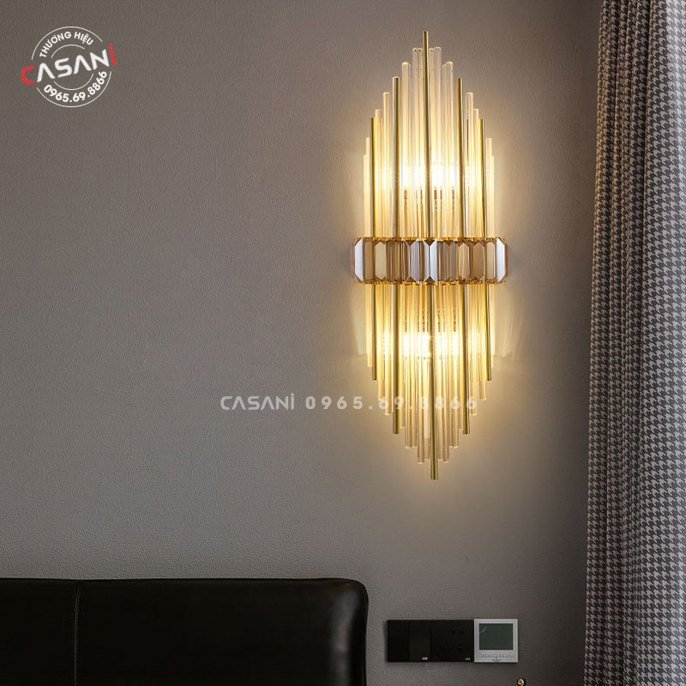

$509

Welcome to the perfect combination of class and sophistication - Modern Wall Lamp DDT-2646V. Let the Modern Wall Lamp DDT-2646V highlight your space and create a unique highlight with the perfect combination of high-quality materials and sophisticated design!

Specifications:

Size: D250 \* H600MM

Material: Alloy & crystal

Bulb: screw base

Light: Yellow (can replace 3-color bulb )

Warranty: 12 Months (for bulb )

Suitable for: Living room, bedroom, restaurant, hotel....